User Guide – CNB Features

Aithent Fraud Manager

Reference Number: AITHENT-AFM-CNBFRMUG
Version: 1.0
Date of Release: August 19, 2013



This document contains proprietary information of Aithent and is tendered subject to the condition that the information be retained in confidence.
Document Information

Author(s) | : | Hari Srinivasan, Sunil Reddy
Document Status | : | Final
Compliance Status | : | NA

Document Control Information

Total Pages | : | 45
Review Period | : | NA
Distribution | : | Customer, PL, TL and team members

Revision History

Version No. | Author | Release Date | Description of Change | Approved By
1.0 | Hari Srinivasan | 8-Aug-13 | First Release | Swami
1.0 | Hari Srinivasan | 14-Aug-13 | Added new sections 8, 9 and 10 | Swami
1.0 | Hari Srinivasan | 19-Aug-13 | Added new sections 11, 12, 13 and 14 | Swami
2.0 | Sunil Reddy | 21-Jun-14 | Updated changes made in the application after 19-Aug-13

Table of Contents

1 Introduction 7
2 Policy Exception Request Form 8
2.1 Workflow 8
2.2 Steps for Account Officer at the Retail /Branch Location 9
2.3 Steps for Business Line Executive at the Retail /Branch Location 10
2.4 Steps for AFM User 10
3 Foreign Entity Profile 13
3.1 Workflow 13
3.2 Steps for Account Officer at the Retail /Branch Location 13
3.3 Steps for Supervisor (Branch) 14
3.4 Steps for AFM User 15
4 Enhanced Due Diligence Request Form 17
4.1 Workflow 17
4.2 Steps for Branch User 17
4.3 Steps for AFM User 18
5 Asset Recovery Due Diligence Review Form 20
5.1 Workflow 20
5.2 Steps for the Branch User 20
5.3 Steps for AFM User 21
6 Unusual Activity Referral Form 23
6.1 Workflow 23
6.2 Steps for Branch User 23
6.3 Steps for AFM User (Manager) 24
7 AFM Forms Search 25
8 CTR Screen 27
9 Review Screen 29
10 Alerts Review 30
10.1 Alerts Search Page 31
11 Wire Reports 34
12 Setup Import of Patriot Officer Alerts into AFM 39
13 Security Group Forms 40
13.1 Workflow 40
13.2 Steps for Branch User 40
13.3 Steps for AFM User (Manager) 41
14 CRA Forms 42
14.1 Workflow 42
14.2 Steps for the Branch User 42
14.3 Steps for AFM User 43
15 Customer Experience Forms 44
15.1 Workflow 44
15.2 Steps for the Branch User 44
15.3 Steps for AFM User (Manager) 45

List of Figures

Figure 1: Policy Exception Request form - Workflow Overview 8
Figure 2: Branch user - Forms Index page 9
Figure 3: Policy Exception Request form - Back Office Use section 9
Figure 4: Branch user form - Attachments section 9
Figure 5: Branch user form - Mail section 10
Figure 6: Mail section grid - Showing approval request email from branch user 10
Figure 7: Forms Search - Policy Exception Request form 11
Figure 8: Submitted form - Mail section showing 2 emails for approval request and approval 11
Figure 9: Forms Search grid - Reason popup 12
Figure 10: Branch user forms index - Foreign Entity Profile 13
Figure 11: Policy Exception Request form - Back Office Use section 13
Figure 12: Branch user form - Attachments section 13
Figure 13: Branch user form - Mail section 14
Figure 14: Mail section grid - Showing approval request email from branch user 14
Figure 15: Forms Search page - Foreign Entity Profile 15
Figure 16: Submitted form - Mail section showing 2 emails for approval request and approval 15
Figure 17: Forms Search grid - Reason popup 16
Figure 18: Branch user forms index - EDD Request form 17
Figure 19: EDD Request form - Back Office use section 18
Figure 20: Forms Search page - EDD Request form 18
Figure 21: EDD Request form - Mail section 19
Figure 22: Forms Search - EDD Request form Reason popup 19
Figure 23: Branch user forms index - ARDD Review form 20
Figure 24: EDD Request form - Back Office use section 21
Figure 25: Forms Search page - ARDD Review form 21
Figure 26: Forms Search - ARDD Review form Reason popup 22
Figure 27: Branch user forms index - Unusual Activity Referral form 23
Figure 28: EDD Request form - Back Office use section 24
Figure 29: Inv. Unit Summary portlet - Unassigned Cases tab 24
Figure 30: AFM Forms Search page grid 25
Figure 31: Forms Search grid - Assign Multiple forms 25
Figure 32: Forms Search grid - Show/Hide Columns 26
Figure 33: CTR Screen 27
Figure 34: CTR update Screen 27
Figure 35: CTR Error popup 28
Figure 36: Grid Filtering 28
Figure 37: Review screen – Review Criteria 29
Figure 38: Review screen - Alert Status 29
Figure 39: Alerts page 30
Figure 40: Alerts Search - EDD Request form Reason popup 30
Figure 41: Alerts Search page 31
Figure 42: Forms Search grid - Assign Multiple forms 31
Figure 43: Alert page grid - Transaction Search 33
Figure 44: Reports - Wire Reports 34
Figure 45: Wire Board Risk - Report Filter 34
Figure 46: Wire Board Risk - Risk Filter 35
Figure 47: Wire Board Risk - Filtered Report Output 35
Figure 48: Wire Board Risk - Graph 36
Figure 49: Remove Report FIlter 36
Figure 50: Wires Accounts Excluding US report - Graph 37
Figure 51: Report - Export to Excel 38
Figure 52: Branch user forms index – Security group forms 40
Figure 53: Manager Dashboard – My Cases portlet 41
Figure 54: Branch user forms index - CRA forms 42
Figure 55: Forms Search page - CRA forms 43
Figure 56: Forms Search – Forms Reason popup 43
Figure 57: Branch user forms index – Customer Experience forms 44
Figure 58: Manager Dashboard – Investigative Unit Summary portlet 45

Introduction
The document is an end-user guide for the following built-in or integrated modules in Aithent Fraud Manager:
- Forms Integration workflow for the BSA AML forms listed below:
- Policy Exception Request form
- Foreign Entity Profile
- Enhanced Due Diligence Request form
- Asset Recovery Due Diligence Review form
- Unusual Activity Referral form
- CTR Screen
- Review Screen
- Alerts Review
- Wire Reports
- PO SAR Scenario Report
- Forms Integration workflow for the following Security forms:
- Incident Report
- Unusual Activity Referral form
- Forms Integration workflow for CRA forms that includes:
- Community Services and Activities form
- Community Development Donations form
- Community Development Loan Report
- Forms Integration workflow for Customer Experience that includes:
- Client Experience Form

Policy Exception Request Form

Workflow
Branch user environment
AFM environment
Branch user fills electronic form and submits it.
Branch user sends email to Business line executive using Mail section in form.
Business line executive opens the form link present in the email received from branch user.
Using the Mail section in form Business line exec. replies to the email received from branch user. Approval or rejection of form is communicated in the email message.
A back office user assigned to BSA AML Customer Risk Inv. Unit logs in into AFM. Opens the form submitted by Branch from the Form Search page.
The form is taken up for processing by the user only if reply email from the Branch line exec. is present in the Mail section of form.
a) If the reply email conveys approval the user can approve or reject it at his/her end. Changes form status to Approved or Rejected.
b) If the reply email conveys rejection the user changes the form status to Rejected. There is no need for further action in this scenario. No email is sent by back office to branch.

Using the Mail section in form the user replies to the email sent by branch line executive. Approval or rejection of form is communicated in the email message.
Figure 1: Policy Exception Request form - Workflow Overview

Steps for Account Officer at the Retail /Branch Location
- Open the “Branch User Forms” page in your browser.
- Under “BSA AML” section click on “Policy Exception Request Form” hyperlink.

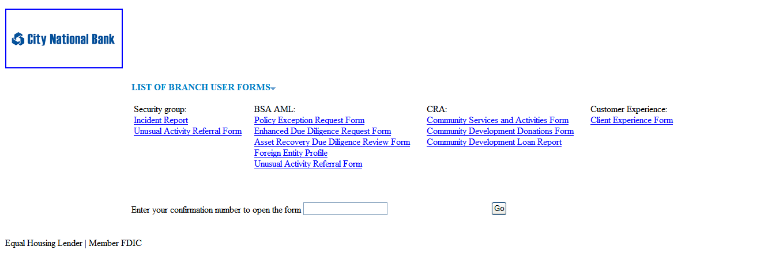
Figure 2: Branch user - Forms Index page
- Fill in the form with necessary data. Note: Fields marked with asterisk (*) are mandatory and needs to be filled in to submit the form
- Do not fill in the section “To be filled by BSA AML group (For Back office use only):”
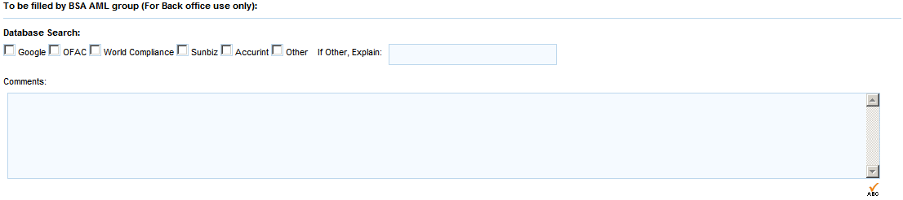

Figure 3: Policy Exception Request form - Back Office Use section
- Click Attach button in the Attachments section to attach supporting documents.

Figure 4: Branch user form - Attachments section
- Click Submit at the bottom or on the right side of page.
- Note down the confirmation number for future reference.
- Fill in the Mail section. This section is used to seek approval from Business Line Executive in your Branch. This section should be filled only after the form is submitted. This will allow creation of the hyperlink to the form filled out.
  - In the “From” field enter your email address.
  - In the “To” field enter email address of Business Line Executive in your branch.
  - Enter data in “Subject” field.
  - Message box below the “Subject” field is pre-filled with the link to access the form that you submitted. You can enter additional text.
  - Click Send Mail at the bottom of page.

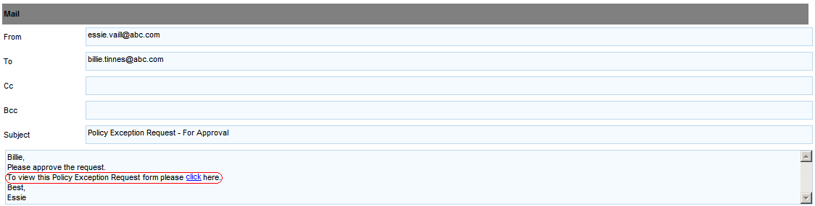
Figure 5: Branch user form - Mail section
- To print or save the form you filled as a PDF file in your hard drive, click Print PDF at the bottom of page.

Steps for Business Line Executive at the Retail /Branch Location
- Click hyperlink present in email received from branch user to open the form in your browser.
- Review the details entered.
- In the Mail section click on icon to view and reply to the message received from the branch user.
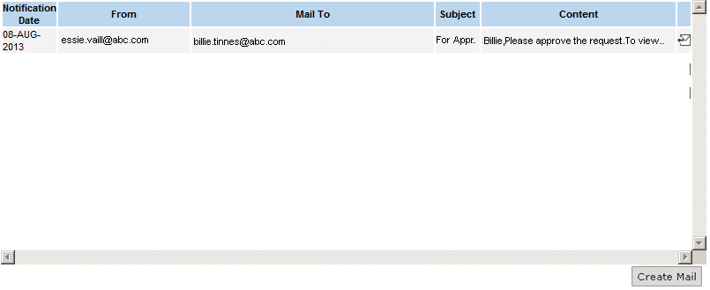
Figure 6: Mail section grid - Showing approval request email from branch user
- In the popup window that opens up, enter text in the message box to convey approval or rejection of form.
- Click Reply.

Steps for AFM User
- Open AFM application in your browser and log in using credentials provided by Administrator.
- Go to Search > Forms Search in the menu.
- Click “Policy Exception Request Form” in the left pane.

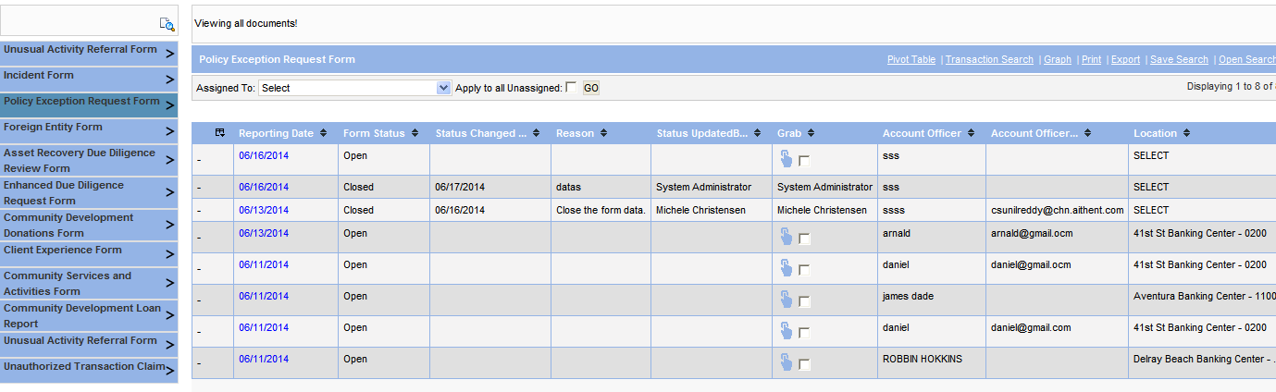
Figure 7: Forms Search - Policy Exception Request form
- Click on hyperlink in Reporting Date column to open the form submitted by Branch that you want to review. Note this is only a preliminary review.
- Go to Mail section in the form and check if there are two emails in the grid.
  - First one from branch user who filled the form to the Branch Line Executive requesting for approval.
  - Second one “reply mail” from Branch line executive that conveys approval or rejection.
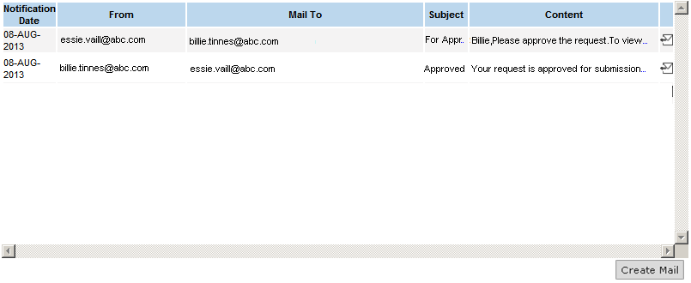
Figure 8: Submitted form - Mail section showing 2 emails for approval request and approval
- Do not proceed further if these two emails are not present in the form.
- Click icon in the Grab column corresponding to the form. This assigns the form to you.
- Click on hyperlink in Reporting Date column to open the form.
- In the Mail section see the reply email from Branch Line Executive.
  - If the email conveys rejection do not review the form further and reject the form straight away.
  - If the email conveys approval:
    - Review the form in detail.
    - Fill in the section “To be filled by BSA AML group (For Back office use only):”.
    - Click Submit.
- Double click Form Status column to change status from Open to Approved or Rejected.
  - In the popup, enter the reason for approval or rejection in the Reason field.
  - Click Save. Current date is shown in “Status Changed Date” column. Your name is shown in “Status UpdatedBy” column.
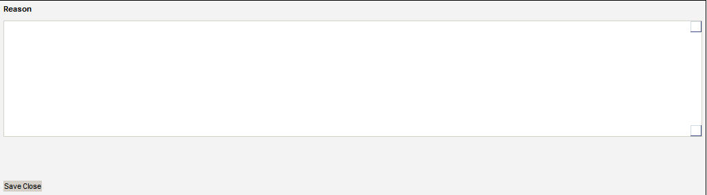
Figure 9: Forms Search grid - Reason popup
- Click on hyperlink in Reporting Date column to open the form.
- In the Mail section click on icon to view and reply to the message received from the branch line executive.
- In the popup window that opens up, enter text in the message box to convey approval or rejection of form at your end. Ensure to enter the Account Officer Email address in the Cc field.
- Click Reply.
- Close the form.

Foreign Entity Profile

Workflow
The workflow involved in processing Foreign Entity Profile is same as that of Policy Exception Request form. The only difference here is that the Supervisor at the branch approves the form.

Steps for Account Officer at the Retail /Branch Location
- Open the “Branch User Forms” page in your browser.
- Under “BSA AML” section click on “Foreign Entity Profile” hyperlink.

Figure 10: Branch user forms index - Foreign Entity Profile
- Fill in the form with necessary data. Note: Fields marked with asterisk (*) are mandatory and needs to be filled in to submit the form.
- Do not fill in the section “To be filled by BSA AML group (For Back office use only):”
Figure 11: Policy Exception Request form - Back Office Use section
- Click Attach button in the Attachments section to attach supporting documents.

Figure 12: Branch user form - Attachments section
- Click Submit at the bottom or on the right side of the page.
- Note down the confirmation number for future reference.
- Fill in the Mail section. This section is used to seek approval from Business Line Executive in your Branch. This section should be filled only after the form is submitted. This will allow creation of the hyperlink to the form filled out.
  - In the “From” field enter your email address.
  - In the “To” field enter email address of Business Line Executive in your branch.
  - Enter data in “Subject” field.
  - Message box below the “Subject” field is pre-filled with the link to access the form that you submitted. You can enter additional text.
  - Click Send Mail at the bottom of page.
Figure 13: Branch user form - Mail section
- To print or save the form you filled in your local, click on Print PDF at the bottom. The form will be saved as PDF file.

Steps for Supervisor (Branch)
- Click hyperlink present in email received from branch user to open the form in your browser.
- Review the details entered.
- In the Mail section click on icon to view and reply to the message received from the branch user.
Figure 14: Mail section grid - Showing approval request email from branch user
- In the popup window that opens up, enter text in the message box to convey approval or rejection of form.
- Click Reply.

Steps for AFM User
- Open AFM application in your browser and log in using credentials provided by Administrator.
- Go to Search > Forms Search in the menu.
- Click “Foreign Entity Form” in the left pane.

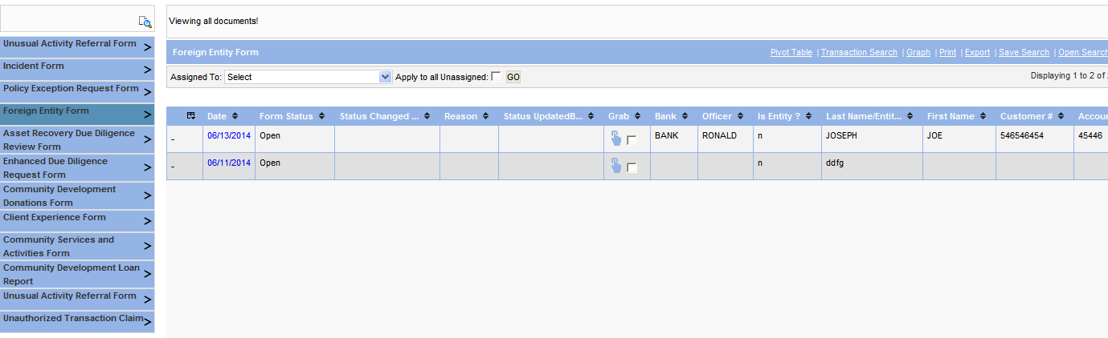
Figure 15: Forms Search page - Foreign Entity Profile
- Click on hyperlink in Reporting Date column to open the form submitted by Branch that you want to review. Note this is only a preliminary review.
- Go to Mail section in the form and check if there are two emails in the grid.
  - First one from branch user who filled the form to the Branch Line Executive requesting for approval.
  - Second one “reply mail” from Branch line executive that conveys approval or rejection.
Figure 16: Submitted form - Mail section showing 2 emails for approval request and approval
- Do not proceed further if these two emails are not present in the form.
- Click icon in the Grab column corresponding to the form. This assigns the form to you.
- Click on hyperlink in Reporting Date column to open the form.
- In the Mail section see the reply email from Branch Line Executive.
  - If the email conveys rejection do not review the form further and reject the form straight away.
  - If the email conveys approval:
    - Review the form in detail.
    - Fill in the section “To be filled by BSA AML group (For Back office use only):”.
    - Click Submit.
- Double click Form Status column to change status from Open to Approved or Rejected.
  - In the popup, enter the reason for approval or rejection in the Reason field.
  - Click Save. Current date is shown in “Status Changed Date” column. Your name is shown in “Status UpdatedBy” column.
Figure 17: Forms Search grid - Reason popup
- Do not proceed further if form is rejected by Branch line executive.
- Click on hyperlink in Reporting Date column to open the form.
- In the Mail section click on icon to view and reply to the message received from the branch line executive.
- In the popup window that opens up, enter text in the message box to convey approval or rejection of form at your end. Ensure to enter the Account Officer Email address in the Cc field.
- Click Reply.
- Close the form.

Enhanced Due Diligence Request Form

Workflow
Branch user environment
AFM environment
Branch user fills electronic form and submits it.
A back office user assigned to BSA AML Customer Risk Inv. Unit logs in into AFM. Opens the form submitted by Branch from the Form Search page.
Using the Mail section in form the user communicates the EDD response to the Account Officer.
User dispositions the form by changing status to “Closed” or “Promote to case”.

Steps for Branch User
- Open the “Branch User Forms” page in your browser.
- Under “BSA AML” section click on “Enhanced Due Diligence Request Form” hyperlink.

Figure 18: Branch user forms index - EDD Request form
- Fill in the form with necessary data. Note: Fields marked with asterisk (*) are mandatory and needs to be filled in to submit the form.
- Do not fill in the section “To be filled by BSA AML group (For Back office use only):”
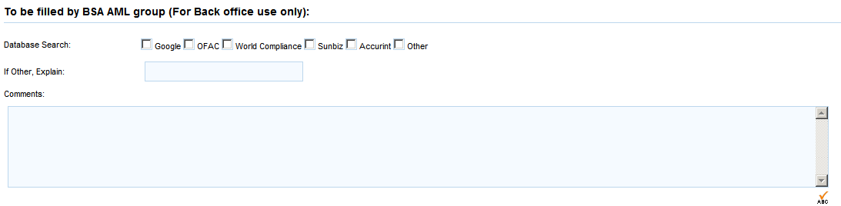
Figure 19: EDD Request form - Back Office use section
- Click Attach button in the Attachments section to attach supporting documents.
- Click Submit at the bottom or on the right side of the page.
- Note down the confirmation number for future reference.
- To print or save the form you filled in your local, click on Print PDF at the bottom. The form will be saved as PDF file.

Steps for AFM User
- Open AFM application in your browser and log in using credentials provided by Administrator.
- Go to Search > Forms Search in the menu.
- Click “Enhanced Due Diligence Request Form” in the left pane.
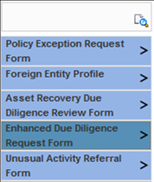
Figure 20: Forms Search page - EDD Request form
- Click icon in the Grab column corresponding to the form. This assigns the form to you. That is, your name appears in this column. Once a form is assigned to a person it is locked for access by other users.
- Click on hyperlink in Reporting Date column to open the form.
  - Review the form in detail.
  - Fill in the section “To be filled by BSA AML group (For Back office use only):”.
  - Fill in the Mail section. This section is used to convey EDD response to the Account Officer at Branch.
    - In the “From” field enter your email address.
    - In the “To” field enter email address of Business Line Executive in your branch.
    - Enter data in “Subject” field.
    - Message box below the “Subject” field is pre-filled with the link to access the form that you submitted. You can enter additional text.
  - Click Submit at the bottom of page.
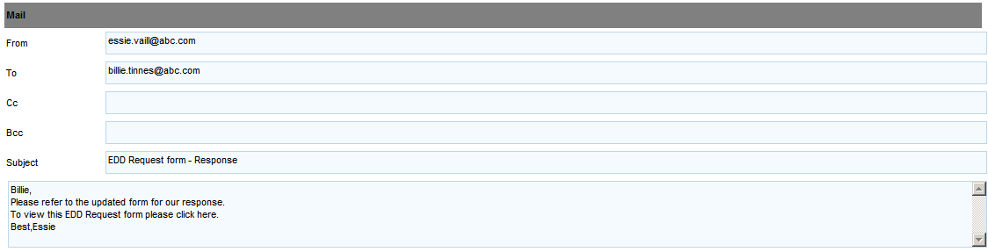
Figure 21: EDD Request form - Mail section
- Double click Form Status column to change status from Open to Closed or Promote To Case.
- Do the following in the popup:
  - Enter reason for closure or promoting to case in the Reason field.
  - The following fields are applicable only if you promote to case.
    - Select Investigative Unit to which the case has to be assigned.
    - Select Investigator to whom the case has to be assigned.
  - Click Save. Current date is shown in “Status Changed Date” column. Your name is shown in “Status UpdatedBy” column.
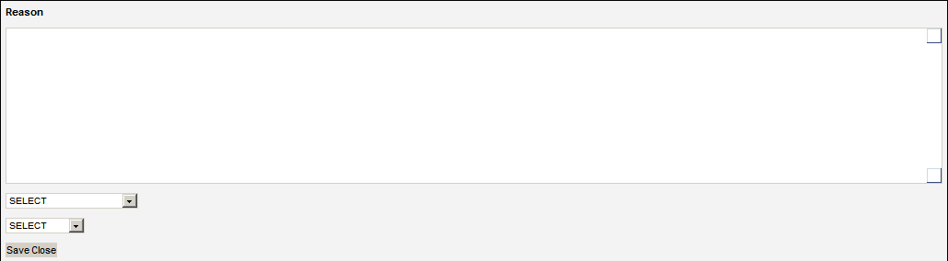
Figure 22: Forms Search - EDD Request form Reason popup
- Click the case number hyperlink in the Reason column to go to the Case Summary Dashboard. Case number is automatically appended to the content in Reason field if form is promoted to case.

Asset Recovery Due Diligence Review Form

Workflow
Branch user environment
AFM environment
Branch user fills electronic form and submits it.
A back office user assigned to BSA AML Customer Risk Inv. Unit logs in into AFM. Opens the form submitted by Branch from the Form Search page.
User dispositions the form by changing status to closed.

Steps for the Branch User
- Open the “Branch User Forms” page in your browser.
- Under “BSA AML” section click on “Asset Recovery Due Diligence Review Form” hyperlink.

Figure 23: Branch user forms index - ARDD Review form
- Fill in the form with necessary data. Note: Fields marked with asterisk (*)are mandatory and needs to be filled in to submit the form.
- Do not fill in the section “To be filled by BSA AML group (For Back office use only):”
Figure 24: EDD Request form - Back Office use section
- Click Attach button in the Attachments section to attach supporting documents.
- Click Submit at the bottom of page.
- Note down the confirmation number for future reference.
- To print or save the form you filled in your local, click on Print PDF at the bottom. The form will be saved as PDF file.

Steps for AFM User
- Open AFM application in your browser and log in using credentials provided by Administrator.
- Go to Search > Forms Search in the menu.
- Click “Asset Recovery Due Diligence Review Form” in the left pane.

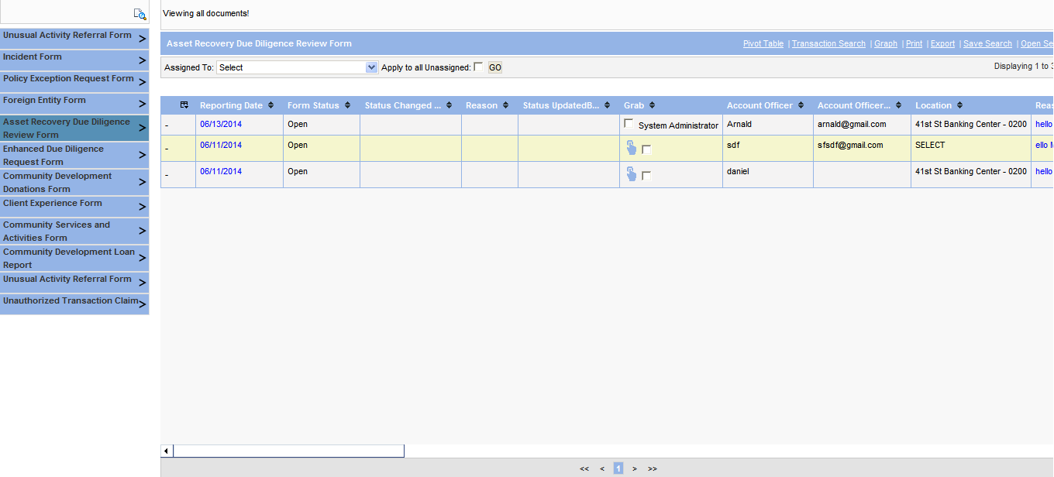

Figure 25: Forms Search page - ARDD Review form
- Click icon in the Grab column corresponding to the form. This assigns the form to you. That is, your name appears in this column. Once a form is assigned to a person it is locked for access by other users.
- Click on hyperlink in Reporting Date column to open the form.
  - Review the form in detail.
  - Fill in the section “To be filled by BSA AML group (For Back office use only):”.
  - Click Submit.
- Double click Form Status column to change status from Open to Closed.
- Do the following in the popup:
  - Enter reason for closure in the Reason field.
  - Click Save. Current date is shown in “Status Changed Date” column. Your name is shown in “Status UpdatedBy” column.
Figure 26: Forms Search - ARDD Review form Reason popup

Unusual Activity Referral Form

Workflow
Branch user environment
AFM environment
Branch user fills electronic form and submits it.
Form is auto-converted to a case assigned to Investigations Inv. Unit in AFM.
The case is listed in the Investigative Unit Summary portlet – Unassigned Cases tab of the manager’s (who is assigned to Investigations Inv. Unit) home page dashboard. The manager assigns the case to an investigator for review.

Steps for Branch User
- Open the “Branch User Forms” page in your browser.
- Under “BSA AML” section click on “Unusual Activity Referral Form” hyperlink.

Figure 27: Branch user forms index - Unusual Activity Referral form
- Fill in the form with necessary data. Note: Fields marked with asterisk (*) are mandatory and needs to be filled in to submit the form.
- Do not fill in the section “To be filled by BSA AML group (For Back office use only):”
Figure 28: EDD Request form - Back Office use section
- Click Attach button in the Attachments section to attach supporting documents.
- Click Submit at the bottom or on the right side of the page.
- Note down the confirmation number for future reference.
- To print or save the form you filled in your local, click on Print PDF at the bottom. The form will be saved as PDF file.

Steps for AFM User (Manager)
- Open AFM application in your browser and log in using credentials provided by Administrator.
- Go to Investigative Unit Summary portlet – Unassigned Cases tab.
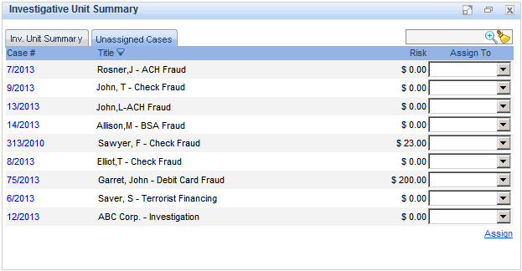
Figure 29: Inv. Unit Summary portlet - Unassigned Cases tab
- Select a value in the Assign To column to assign the case(s) to an investigator.
- Click Assign hyperlink at the bottom left of the grid. After the case gets assigned it is not listed in this tab.

AFM Forms Search
This section explains some of the prominent features of the grid in the AFM Forms Search page.
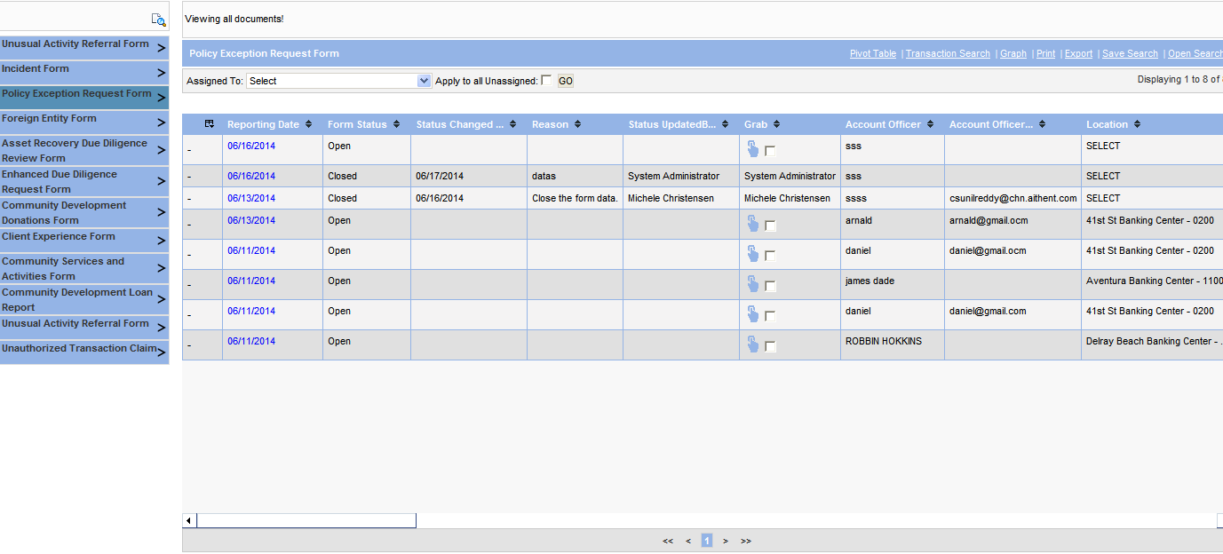
Figure 30: AFM Forms Search page grid
- Grab
Click icon in the Grab column corresponding to the form. This assigns the form to you. That is, your name appears in this column. Once a form is assigned to a person it is locked for access by other users.
- Assign multiple forms
- Select the checkbox in the Grab column to assign one or more unassigned forms in the grid to an investigator. Select the “Apply to All Unassigned” checkbox above the grid to select all the unassigned forms in the grid.
- Select the person to be assigned in the Assigned To drop-list above the grid. This drop-list will list the users in your investigative unit.
- Click GO.

Figure 31: Forms Search grid - Assign Multiple forms
- Show/Hide Columns in grid
- Click icon in the first column header of grid.
- The following popup appears:
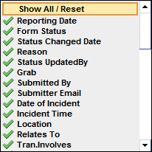
Figure 32: Forms Search grid - Show/Hide Columns
- Click on the icon before the column name that you want to hide. The icon changes to icon.
- Click on the icon before the column name that you want to show. The icon changes to icon.
- Click “Show All/Reset” link on the top of the popup to reset the grid to show all the columns.
- Change Form Status
- Double click Form Status column to change status from Open to Closed or Promote To Case or Approved or Rejected. Note, not all statuses are applicable for all the forms.
- In the popup, enter reason for status change in the Reason field.
- The following fields are applicable only if you promote the form to a case.
    - Select Investigative Unit to which the case has to be assigned.
    - Select Investigator to whom the case has to be assigned.
- Click Save. Current date is shown in “Status Changed Date” column. Your name is shown in “Status UpdatedBy” column.
- Click the case number hyperlink in the Reason column to go to the Case Summary Dashboard. Case number is automatically appended to the content in Reason field if form is promoted to case.

CTR Screen
- Open AFM application in your browser and log in using credentials provided by Administrator.
- Go to Operations > CTR in the menu.
Figure 33: CTR Screen
- Select Month and Year. Year is defaulted to current year.
- Select the Select Investigator button and select the investigator in the Investigator field against whom the CTR record needs to be added. Note: It is not required to select the investigator for viewing the already created CTR records. (This is only for Admin and Manager access).
- Click Go.

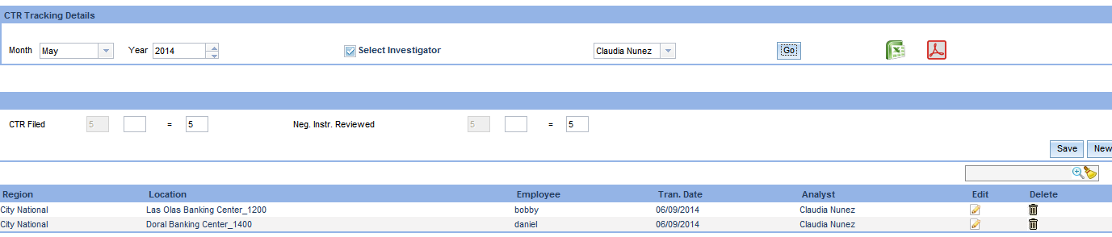
Figure 344: CTR update Screen
- The first box of CTR Filed field shows the number of CTR’s filed and this is not editable. Enter a value in the second box of CTR Filed field to increase or decrease the number of CTRs filed for the selected month and year
For example if CTR’s already filed is showing as 5 (Value in the first box of CTR filed) and if CTR’s filed needs to be increased to 7, enter 2 in the second box of CTR filed field. If CTR’s filed needs to be decreased to 3, enter -2 in the second box of CTR filed field.
- The first box of Neg. Inst. Reviewed field shows the number of Neg. Inst. Reviewed and this is not editable. Enter a value in the second box of Neg. Inst. Reviewed field to increase or decrease the number of Neg. Inst. Reviewed for the selected month and year.
For example if Neg. Inst. Reviewed already is showing as 5 (Value in the first box of Neg. Inst. Reviewed field) and if Neg. Inst. Reviewed needs to be increased to 7, enter 2 in the second box of Neg. Inst. Reviewed field. If CTR’s filed needs to be decreased to 3, enter -2 in the second box of Neg. Inst. Reviewed field.
- Click Save.
- Click New to enter new CTR error record details.
- In the popup,
  - Select a value in Location field.
  - Region field is a read-only field that is populated based on value selected in Location field.
  - Enter employee name in Employee field.
  - Enter transaction date in Tran. Date field.
  - Select all the errors that apply to this CTR.
  - Enter your comments if any in the Comments field.
  - Click Save.
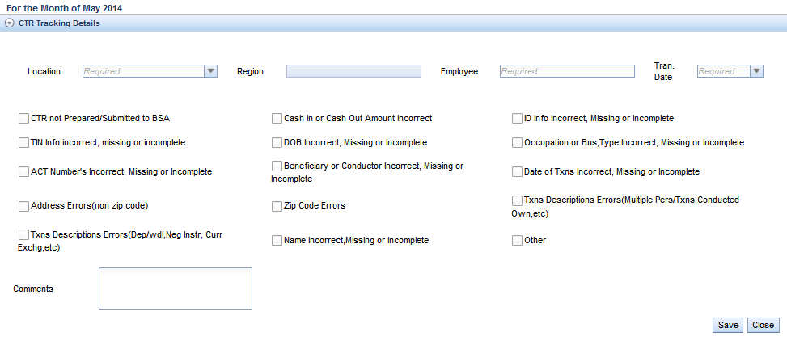
Figure 355: CTR Error popup
- The CTR error record you just entered is shown in the grid in CTR screen.
  - To edit an existing CTR error record, click on the icon in the Edit column of the grid.
  - To delete an existing CTR error record, click on the icon in the Delete column of the grid.
- To filter grid data:
  - Enter required value for filtering in the edit control present in top-right corner of grid.
Figure 366: Grid Filtering
  - Click icon.
  - Click icon to remove filter applied on a grid.

Note: Clicking on or symbol in CTR filed screen will open CTR details report till date in the respective formats.

Review Screen
- Open AFM application in your browser and log in using credentials provided by Administrator.
- Go to Operations > Review in the menu.
- Select a value in Review Type field.
- Select Month and Year. Year is defaulted to current year.
- Select the Select Investigator button and select the investigator in the Investigator field against whom the alerts need to be added. Note: It is not required to select the investigator for viewing the already created alerts. (This is only for Admin and Manager access).
- Click GO.

Figure 377: Review screen – Review Criteria
- In the Alert Status box,
  - Enter value in second box of # of New Alerts field.
  - Enter value in second box of # of Completed Alerts field.
  - Enter value in second box of # of Positive Alerts field.
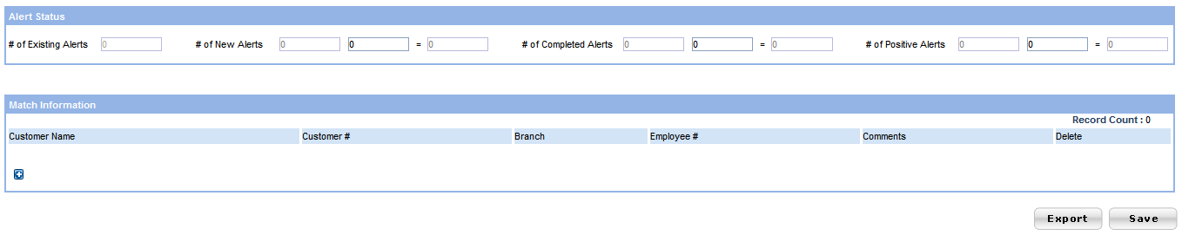
Figure 388: Review screen - Alert Status
- In the Match Information box add as many customers as the number of positive alerts. System validates this condition.
  - Click to enter
  - Enter value in Customer Name field.
  - Enter value in Customer # field.
  - Select value in Branch field
  - Enter value in the Employee # field.
  - Enter comments if any in Comments field.
  - Click on the icon to delete any record which is added.
  - Click to enter another set of customer details and repeat from step b to step f.

Note: Investigator will be allowed to edit previous month's data till 5th of current month however, manager and administrator can edit ant any time. This is configurable through property file.

Alerts Review
- Open AFM application in your browser and log in using credentials provided by Administrator.
- Go to Search > Alerts Search in the menu.
- Click the alert type in the left pane that you want to review.
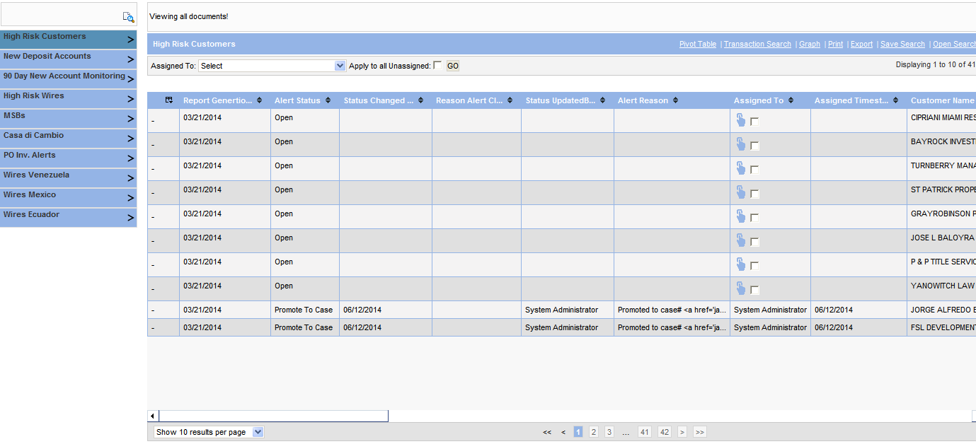
Figure 39: Alerts page
- Click icon in the Grab column corresponding to the alert. This assigns the alert to you. That is, your name appears in this column. Once an alert is assigned to a person it is locked for access by other users.
- Double click Alert Status column to change status from Open to Closed or Promote To Case.
- Do the following in the popup if status is changed to Promoted to Case or closed:
  - Enter reason for closure or promoting to case in the Reason field.
  - The following fields are applicable only if you promote to case.
    - Select Investigative Unit to which the case has to be assigned.
    - Select Investigator to whom the case has to be assigned.
  - Click Save. Current date is shown in “Status Changed Date” column. Your name is shown in “Status UpdatedBy” column.
Figure 40: Alerts Search - EDD Request form Reason popup
- Click the case number hyperlink in the Reason column to go to the Case Summary Dashboard. Case number is automatically appended to the content in Reason field if alert is promoted to case.

Alerts Search Page
This section explains some of the prominent features of the grid in the Alerts Search page.
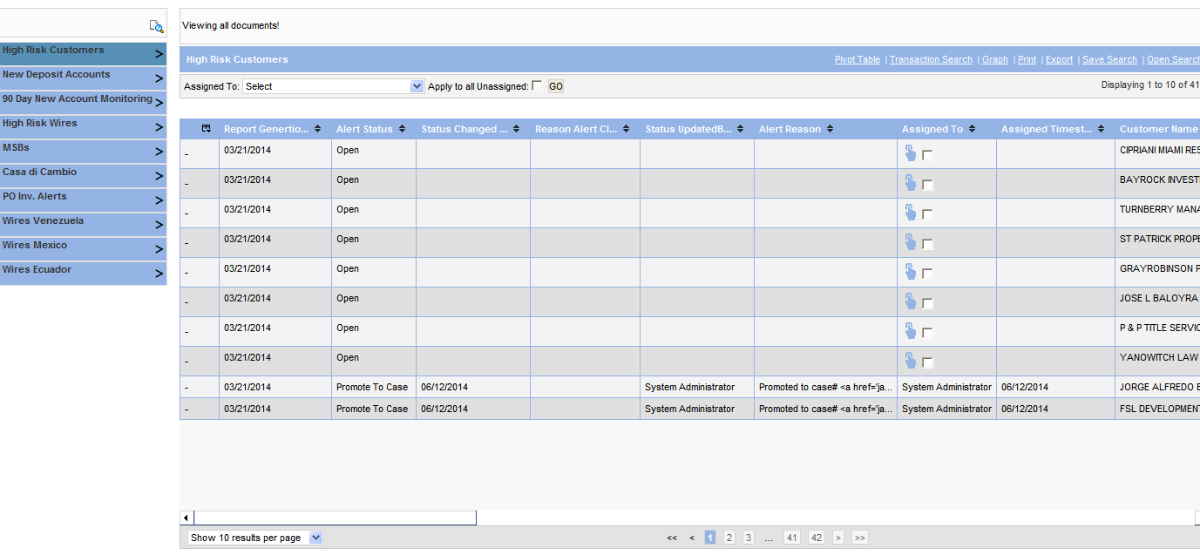
Figure 41: Alerts Search page
- Grab
Click icon in the Grab column corresponding to the alert. This assigns the alert to you. That is, your name appears in this column. Once an alert is assigned to a person it is locked for access by other users.
- Assign Multiple alerts
- Select the checkbox in the Grab column to assign one or more unassigned alerts in the grid to an investigator. Select the “Apply to All Unassigned” checkbox above the grid to select all the unassigned alerts in the grid.
- Select the person to be assigned in the Assigned To drop-list above the grid. This drop-list will list the users in your investigative unit.
- Click GO.

Figure 42: Forms Search grid - Assign Multiple forms
- Show/Hide Columns in grid
- Click icon in the first column header of grid.
- The following popup appears:

Forms Search grid - Show/Hide Columns
- Click on the icon before the column that you want to hide. The icon changes to icon.
- Click on the icon before the column that you want to show. The icon changes to icon.
- Click “Show All/Reset” link on the top of the popup to reset the grid to show all the columns.
- Change Alert Status
- Double click Alert Status column to change status from Open to Closed or Promote To Case or Approved or Rejected. Note, not all statuses are applicable for all the alerts.
- In the popup, enter reason for status change in the Reason field.
- The following fields are applicable only if you promote to case.
    - Select Investigative Unit to which the case has to be assigned.
    - Select Investigator to whom the case has to be assigned.
- Click Save. Current date is shown in “Status Changed Date” column. Your name is shown in “Status UpdatedBy” column.
- Click the case number hyperlink in the Reason column to go to the Case Summary Dashboard. Case number is automatically appended to the content in Reason field if alert is promoted to case.
- Transaction Search
- Click on any column in the grid of any alert type with the exception of columns Alert Status and Grab.
- In the popup, enter search criteria.
- Click Search.
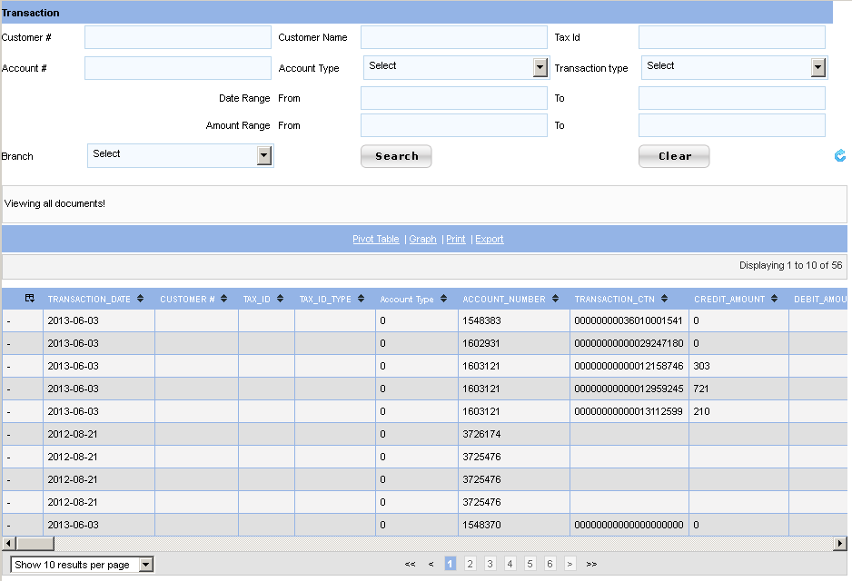
Figure 43: Alert page grid - Transaction Search

Wire Reports
- Open AFM application in your browser and log in using credentials provided by Administrator.
- Go to Reports > Wire Alerts in the menu.
- Click the wire report in the left pane that you want to view.
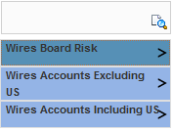
Figure 44: Reports - Wire Reports
- Click on Wire Board Risk report to see the country wise distribution of wire transactions based on count and amount corresponding to a risk level.
  - To filter the report based on a risk level, move your cursor over the report name in the left panel. You see the following popup.
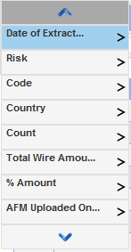
Figure 45: Wire Board Risk - Report Filter
  - Move your cursor over the column name, RISK. You see the following popup.
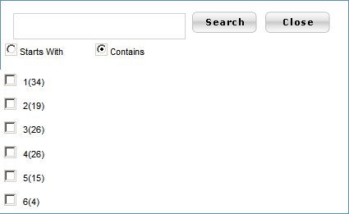
Figure 46: Wire Board Risk - Risk Filter
  - Select the risk level based on which you want to filter the report.
  - Click Search. You see the report that is filtered based on the selected risk level.
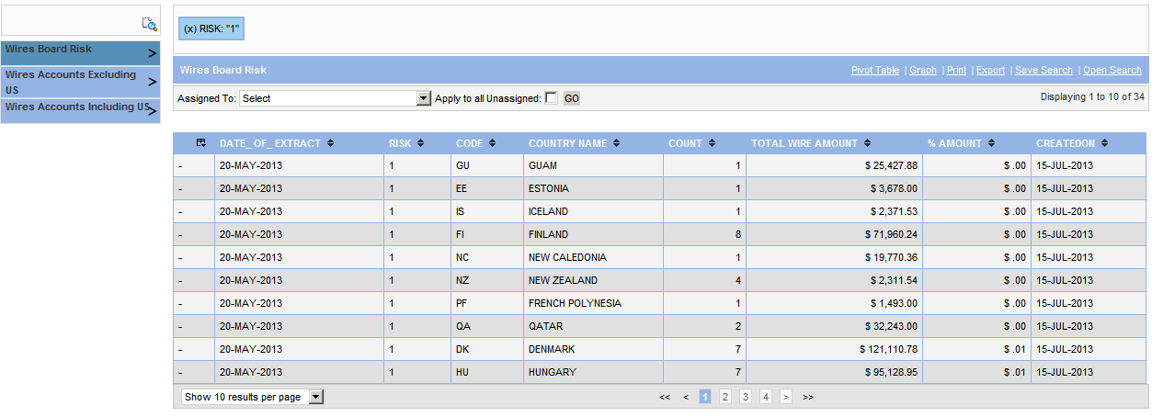
Figure 47: Wire Board Risk - Filtered Report Output
  - To generate a pie chart based on the filtered report output, Click on the link, Graph at the top right above the report output.
  - In the popup, drag the field CODE to the placeholder for row below the list of column names.
  - Drag the field %AMOUNT to the placeholder for column. You see the graph that is generated as shown below.
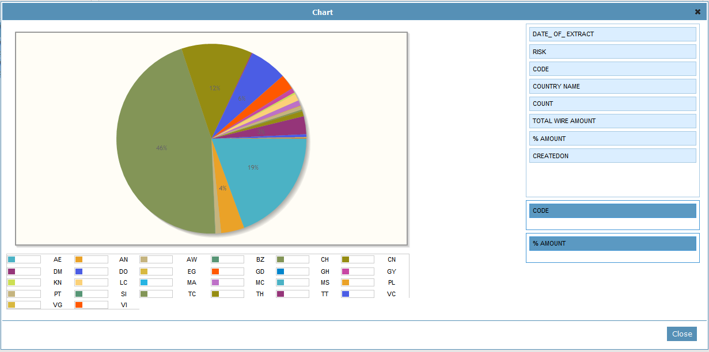
Figure 48: Wire Board Risk - Graph
  - Click Close.
  - To remove the report filter, click on the criteria that is displayed on the top left of the report output that is seen as shown below.
Figure 49: Remove Report FIlter
- Click on Wires Accounts Excluding US report in the left pane to see the distribution of wire transactions based on count and amount across risk levels 1 through 6, excluding US.
  - To generate a pie chart based on the report output, Click on the link, Graph at the top right above the report output.
  - In the popup, drag the field RISK LEVEL to the placeholder for row below the list of column names.
  - To see the risk level distribution based on %COUNT, drag the field %COUNT to the placeholder for column. You see the graph that is generated as shown below.
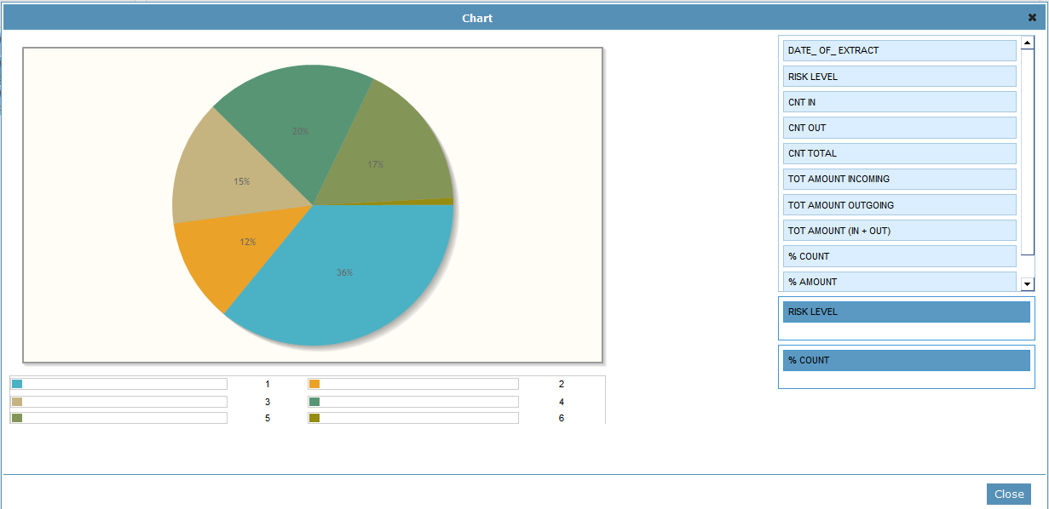
Figure 50: Wires Accounts Excluding US report - Graph
  - To see the risk level distribution based on %AMOUNT, drag the field %AMOUNT to the placeholder for column.
  - Click Close.
- Click on Wires Accounts Including US report in the left pane to see the distribution of wire transactions based on count and amount across risk levels 1 through 6, including US.
  - To generate a pie chart based on the report output, Click on the link, Graph at the top right above the report output.
  - In the popup, drag the field RISK LEVEL to the placeholder for row below the list of column names.
  - To see the risk level distribution based on %COUNT, drag the field %COUNT to the placeholder for column. You see the graph that is generated as shown below.
  - To see the risk level distribution based on %AMOUNT, drag the field %AMOUNT to the placeholder for column.
  - Click Close.
- To export the report to excel, click on the Export link at the top right above the report output.
  - You see a popup as shown below.
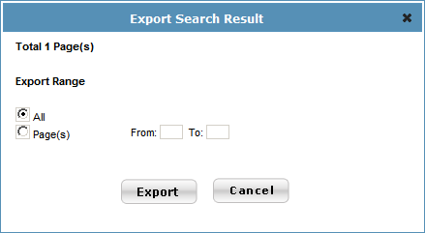
Figure 51: Report - Export to Excel
  - Enter the export options.
  - Click Export. You see the File download window.
  - Open the excel file or Save it to your hard-drive.

Setup Import of Patriot Officer Alerts into AFM
- The Patriot Officer (PO) alert files in the pre-defined excel format must be available in the folder that is configured in the tag <SRCFOLDER> of alertfileinfo.xml. There is a set of details corresponding to every PO alert file that is defined in this xml.
- After the file is imported, the file name is appended with the current date and the file is moved to the folder that is configured in the tag <DESTFOLDER> of alertfileinfo.xml.
- The interval period in days between consecutive processing of PO alert files is configured in the tag <SCHINTERVAL> of alertfileinfo.xml.
- ExcelRead.bat file must be configured as a scheduled service in the server box where the PO alert files are available. This triggers processing of the alert files based on the defined interval period that is explained above.

Security Group Forms

Workflow
Branch user environment
AFM environment
Branch user fills electronic form and submits it.
Form is auto-converted to a case assigned to a manager in the Security Inv. Unit in AFM.
The case is listed in the My Cases portlet of the Manager Dashboard in AFM.

Steps for Branch User
- Open the “Branch User Forms” page in your browser.
- Under “Security group” section click on the form hyperlink that you want to fill and submit.
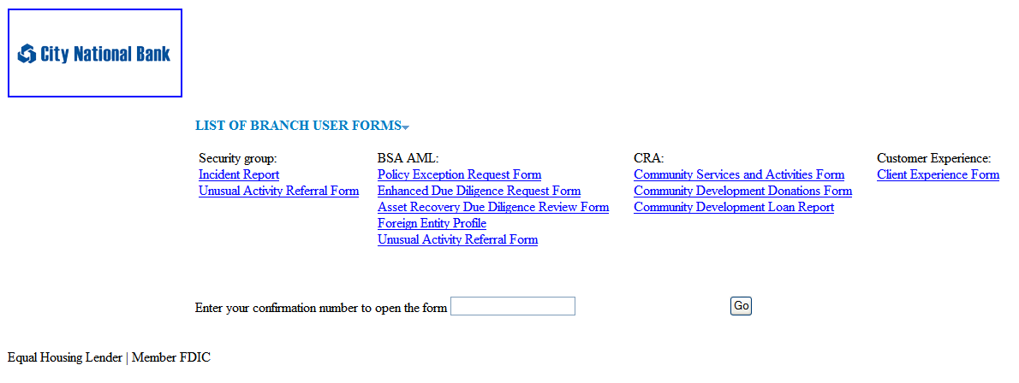
Figure 52: Branch user forms index – Security group forms
- Fill in the form with necessary data. Note: Fields marked with asterisk (*) are mandatory and needs to be filled in to submit the form.
- Click Attach button in the Attachments section to attach supporting documents.
- Click Submit at the bottom or on the right side of the page.
- Note down the confirmation number for future reference.
- To print or save the form you filled in your local, click on Print PDF at the bottom. The form will be saved as PDF file.

Steps for AFM User (Manager)
- Open AFM application in your browser and log in using credentials provided by Administrator.
- In the Home page dashboard, go to My Cases portlet.
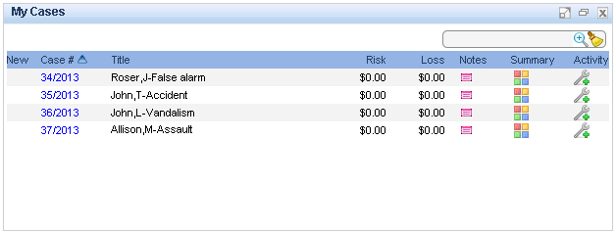
Figure 53: Manager Dashboard – My Cases portlet
- To see the case details, click hyperlink in Case # column to open the case summary dashboard.
- To see the original form submitted by the branch user, click on the url in the Attachments portlet of case screen.

CRA Forms

Workflow
Branch user environment
AFM environment
Branch user fills electronic form and submits it.
A back office user assigned to CRA Inv. Unit logs in into AFM. Opens the form submitted by Branch from the Form Search page. User enters the details to be filled by back office and saves the form.
User dispositions the form by changing status to closed.

Steps for the Branch User
- Open the “Branch User Forms” page in your browser.
- Under “CRA” section click on the form hyperlink that you want to fill and submit.
Figure 54: Branch user forms index - CRA forms
- Fill in the form with necessary data. Note: Fields marked with asterisk (*) are mandatory and needs to be filled in to submit the form.
- Do not fill in the fields marked as “(For Back office use only)”.
- Click Attach button in the Attachments section to attach supporting documents.
- Click Submit at the bottom of page.
- Note down the confirmation number for future reference.
- To print or save the form you filled in your local, click on Print PDF at the bottom. The form will be saved as PDF file.

Steps for AFM User
- Open AFM application in your browser and log in using credentials provided by Administrator.
- Go to Search > Forms Search in the menu.
- Click the form type that you want to review in the left pane.
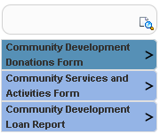
Figure 55: Forms Search page - CRA forms
- Click icon in the Grab column corresponding to the form. This assigns the form to you. That is, your name appears in this column. Once a form is assigned to a person it is locked for access by other users.
- Click on hyperlink in Reporting Date column to open the form.
  - Review the form in detail.
  - Fill in the fields marked as “(For Back office use only)”.
  - Click Submit.
- Double click Form Status column to change status from Open to Closed.
- Do the following in the popup:
  - Enter reason for closure in the Reason field.
  - Click Save. Current date is shown in “Status Changed Date” column. Your name is shown in “Status UpdatedBy” column.
Figure 56: Forms Search – Forms Reason popup

Customer Experience Forms

Workflow
Branch user environment
AFM environment
Branch user fills electronic form and submits it.
Form is auto-converted to a case.

The case is listed in the Investigative Unit Summary portlet (Unassigned Cases) of the Manager/Administrator Dashboard in AFM.

Steps for the Branch User
- Open the “Branch User Forms” page in your browser.
- Under “Customer Experience” section click on the form hyperlink that you want to fill and submit.
Figure 577: Branch user forms index – Customer Experience forms
- Fill in the form with necessary data. Note: Fields marked with asterisk (*) are mandatory and needs to be filled in to submit the form.
- Click Attach button in the Attachments section to attach supporting documents.
- Click Submit at the bottom of page.
- Note down the confirmation number for future reference.
- To print or save the form you filled in your local, click on Print PDF at the bottom. The form will be saved as PDF file.

Steps for AFM User (Manager)
- Open AFM application in your browser and log in using credentials provided by Administrator.
- In the Home page dashboard, go to Unassigned Cases tab of Investigative Unit Summary portlet.
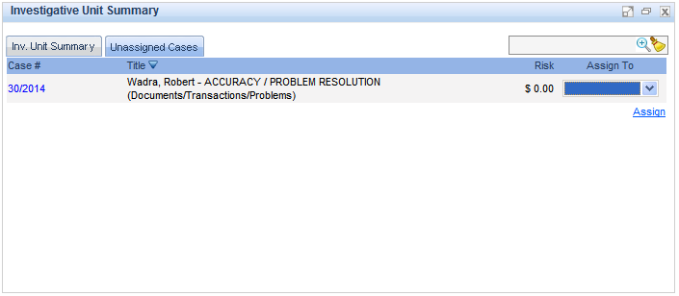
Figure 588: Manager Dashboard – Investigative Unit Summary portlet
- To see the case details, click hyperlink in Case # column to open the case summary dashboard.
- To see the original form submitted by the branch user, click on the url in the Attachments portlet of case screen.

