

Aithent Power Point Template
Installation Guide
19 Fulton Street, Suite 408
New York, NY 10038
www.aithent.com
This document contains proprietary information of Aithent and is tendered subject to the condition that the information be retained in confidence.
Table of Contents
1 Loading the templates 2

Loading the templates
Copy the PPT templates “.potx” under the below path

C:\Users\Name\Documents\Custom Office Templates

After adding the template go to New and click on Personal select the template from list.

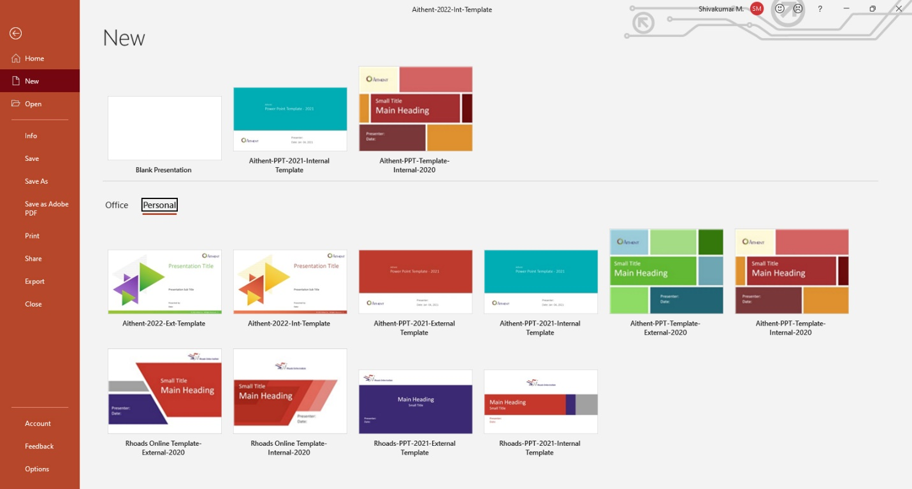

After adding the template go to New and click on Personal select the template from list.

