Aithent Fraud Manager

Single Sign-On Implementation

January 31, 2012



This document contains proprietary information of Aithent and is tendered subject to the condition that the information be retained in confidence.
Document Information

Author(s) | : | Hariharasubramaniam Srinivasan
Document Status | : | Draft
Compliance Status | :

Document Control Information

Total Pages | : | 18
Review Period | :
Distribution | :

Revision History

Version No. | Release Date | Description of Change | Approved By
1.0 | 20-Jan-2012 | First Release | Swami
1.1 | 31-Jan-12 | - “Description” attribute made as optional.  - Added section 3.1.1; Quick Reference – Mandatory User Attributes.  - Added note in section 5; Exception Handling-to state that AFM doesn’t impose any restriction on group names in AD. | Desh(PUB)

Table of Contents
1 Introduction 4
2 Disclaimer 4
3 Active Directory Configuration 4
3.1 Create User 4
3.1.1 Quick Reference – Mandatory User Attributes 11
3.2 Create Group 11
3.2.1 Logical Group Creation 13
3.3 Modify User 14
3.3.1 Investigator or Manager Moves from One Investigative Unit to Another 14
3.3.2 Manager is assigned to additional Investigative Units 14
3.3.3 Investigator is promoted to Manager 15
3.4 Delete/Disable User 15
4 Scheduler Configuration 17
5 Exception Handling 18
5.1 Exception Scenarios 18

Introduction
The document describes how users are managed in a Single Sign-On (SSO) implementation using Microsoft Active Directory (MS AD) in the context of Aithent Fraud Manager (AFM) application. User creation in the Active Directory involves adding a user to AFM specific groups, which are created in the AD, for delegating the authentication function.
This implementation also requires a Scheduler that is developed to maintain the AFM database in synchronization with the user configuration in Active Directory.

Disclaimer
The AFM user does not see any changes in the application after the SSO implementation. The user has to hit the login page and enter the login credentials as before. Only the background process changes in a manner that the authentication is done in the LDAP server, where the AFM users exist in the Active Directory.
Note:
The “Change Password” menu item will not be available in AFM after the SSO implementation.

Active Directory Configuration
The Active Directory Configuration includes various scenarios to be considered as part of User Management. These scenarios are explained in the following sections.

Create User
The following steps are required to create a new user in the Active Directory.

- Open the Active Directory Manager in the LDAP server as mentioned below.

StartAll ProgramsAdministrative ToolsActive Directory Users and Computers

- Navigate to the Users folder in the directory tree.
- The users and groups are listed in the console to the right of the directory tree. Right click in this console and select new user option as shown below.

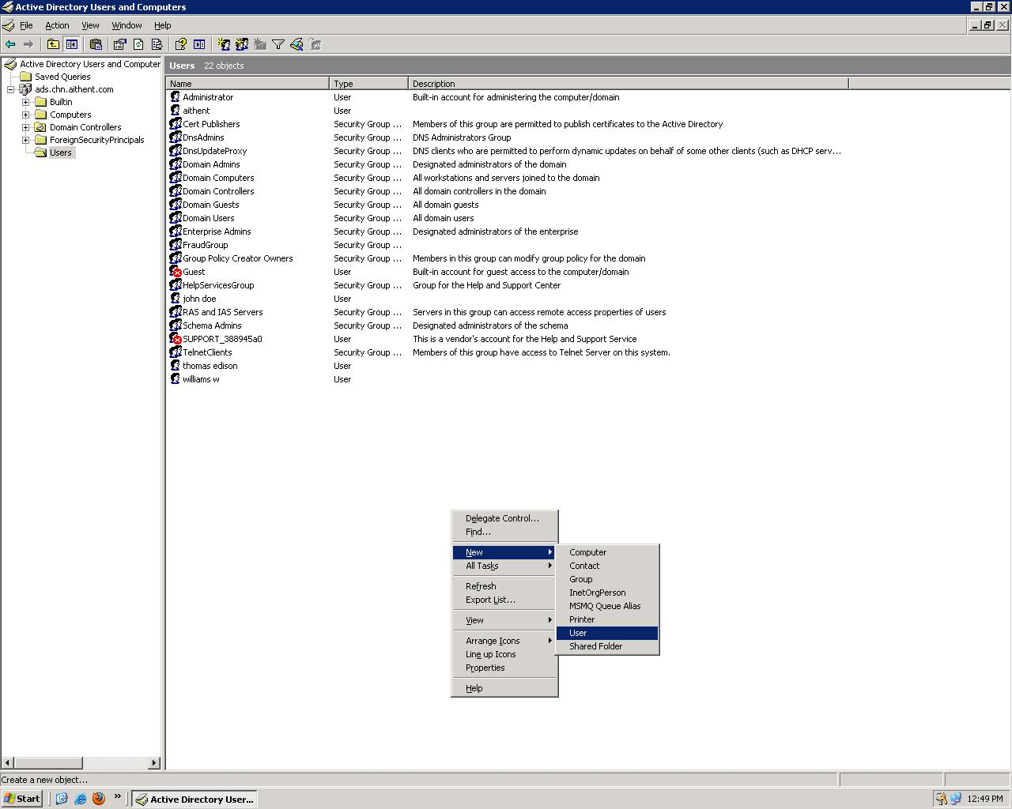

- The New Object – User popup window appears.
- Enter the First name, Last name and User logon name. Only if these three values are entered Next button is enabled.
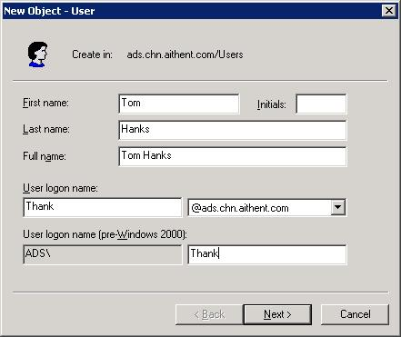

- Click Next button and the following popup appears, where the Password is set. By default User must change password at next logon option will be selected. This has to be unchecked and Password never expires must be selected.

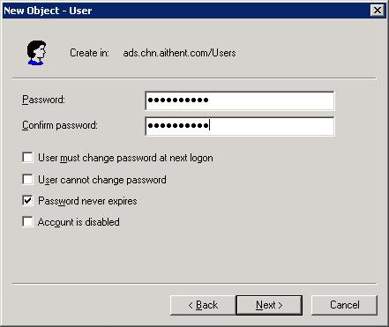
Note:
“Passwords must meet complexity requirements” setting determines whether password complexity is enforced. If this setting is enabled, user passwords meet the following requirements:
- The password is at least six characters long.
- The password contains characters from at least three of the following five categories:
  - English uppercase characters (A - Z)
  - English lowercase characters (a - z)
  - Base 10 digits (0 - 9)
  - Non-alphanumeric (For example: !, $, #, or %)
  - Unicode characters
- The password does not contain three or more characters from the user's account name.
- Click Next button and the following popup appears for confirmation.

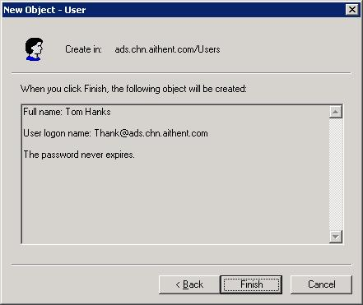

- Click Finish button to complete user creation. The user created appears in the list of users shown in the console.

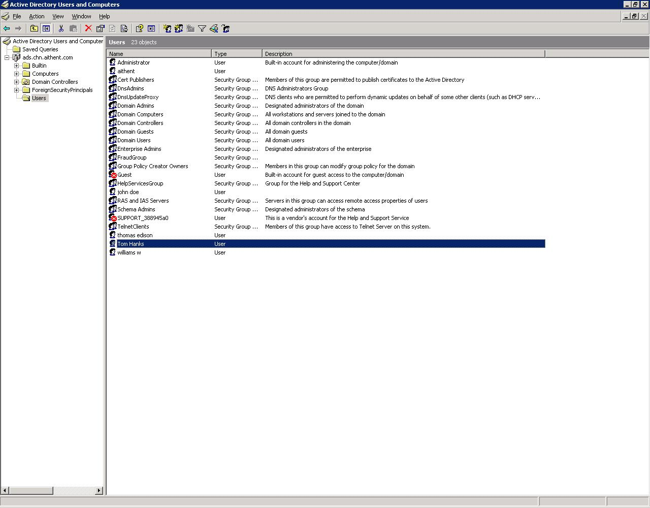

- Right click the created user and select Properties.
- Enter the following fields:
  - E-mail- mandatory attribute.
  - Description – optional attribute. This can be of the format: “AFM <Role name> for <IU name(s)>”
Example: AFM Investigator for Claims Management
If there is more than one IU then enter them as comma-separated.
Note: The format specified above to enter the value for “Description” attribute is just a suggested format, which can be used to identify the role and IU of the user. AFM doesn’t impose any constraint on the “Description” value.
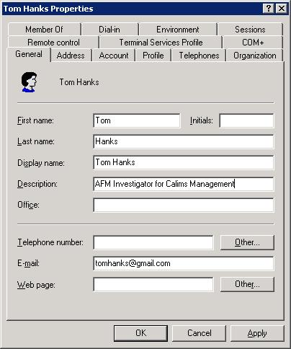

- Right click the created user and select the option Add to a group…
- The Select Group popup appears. Type the full group name or part of it and click Check Names button (disabled by default). If the group name entered exists in the Active Directory then it appears underlined else an error is thrown.

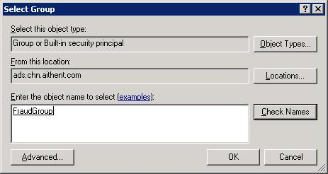
- To view the list of users in a group select the group name in the console and right click to select Properties. Click the Members tab in the popup.

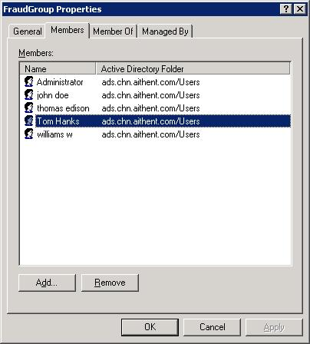
Note:
Click on “Add”/“Remove” button to add/remove the user from the group.
- To view the groups in which a user is a member select the user in the console and right click to select Properties. Click the Member Of tab in the popup.

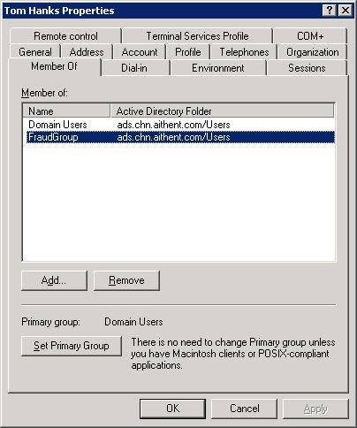
Note:
Click on “Add”/“Remove” button to add/remove the user from the group.

Quick Reference – Mandatory User Attributes
The following attributes are mandatory and must contain valid data to create a user in AFM database.
- First name
- Last name
- User logon name
- Email
- Group

Create Group
The following steps are required to create a new group in the Active Directory.

- Open the Active Directory Manager in the LDAP server as mentioned below.

StartAll ProgramsAdministrative ToolsActive Directory Users and Computers

- Navigate to the Users folder in the directory tree.
- The users and groups are listed in the console to the right of the directory tree. Right click the console to the right of the directory tree and select new group option.
- Enter the Group name in the popup that appears.

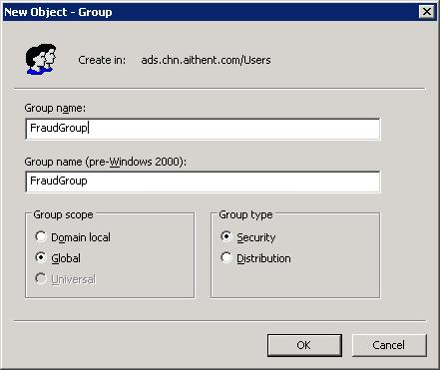

- Click OK button. The group is created and is listed in the console as shown below.

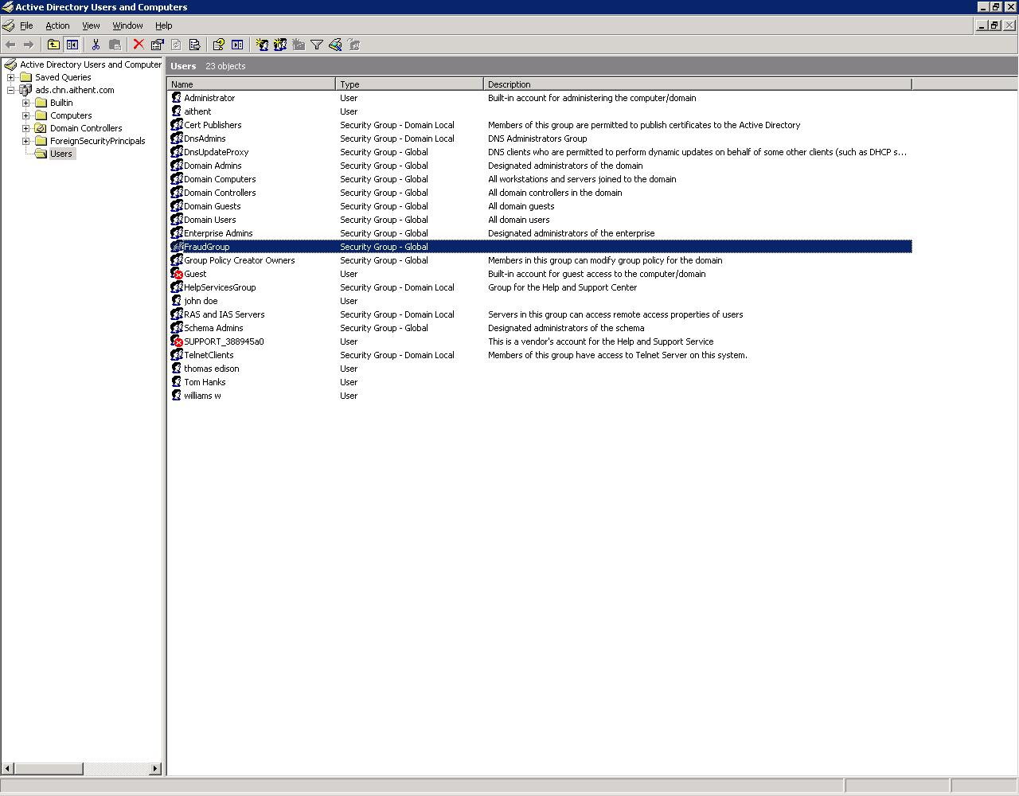

Logical Group Creation
Group Creation in AD governs the user’s access to AFM. Following is the list of governing business rules:
- The AFM specific Group names must be configured in the LDAPserver.xml. Following are the tags that are used to specify the Group Names:
  - <afmgroup > </afmgroup>
  - <afmadmingroup> </afmadmingroup>
  - <groupname> </ groupname>
- Any user of AFM must be a member of “AFMFraudGroup”. This Group name must be configured in the “afmgroup” tag
- A user of Administrator role must be a member of “AFMAdminGroup”. This Group name must be configured in the “afmadmingroup” tag.
- Other Groups must be created to categorize users of a particular role (Investigator/Manager) and IU. These Group names must be configured in the “groupname” tag. If there are 3 IUs then there exists 6 Groups in AD, 3 representing Manager in each IU and 3 representing Investigators in each IU. Hence there shall be twice the number of “groupname” tags as there are IUs.
Example:
Assume there are two IUs,
- Loss Prevention
- Investigation
In this case following groups are created in AD:
- Loss Prevention Management – for Managers
- Loss Prevention – for Investigators
- Investigation Management – for Managers
- Investigation – for Investigators
Note:
The mapping of logical Group names created in AD with AFM is maintainable by means of a database table in AFM. This is to facilitate naming of groups in AD as per the organization’s standard naming convention.

Modify User

Investigator or Manager Moves from One Investigative Unit to Another
The scenario where an investigator or manager moves from one Investigative Unit (IU) to another, add the user to the group that pertains to the same role but different IU.
Example: (Refer to steps 11 to 14, section 3.1)
Assume that an Investigator moves from “Loss Prevention” to “Investigation” IU. The changes that are to be done in AD are:
- Remove the user from “Loss Prevention” group.
- Add the user to “Investigation” group
After this change is effected in AFM, the Administrator has to perform the following steps in AFM in order to setup the necessary IU permissions.
- Login as Administrator in AFM.
- Go to menu MaintenanceSecurity Permissions.
- Enter the search criteria and click Search button.
- Click the record corresponding to the user, who’s IU has been changed in the Active Directory.
- Click the Investigative Units tab.
- In the Add Permission section,
  - Select Investigative Unit.
  - Select Sub Level as “Consultant”.
  - Click on Add button.
  - This configuration gets added to the IU permissions list above.
  - Select the Read checkbox corresponding to the IU just added. Other checkboxes are disabled for Consultant level.
  - Repeat steps a to e with the following modifications:
    - Select the same IU.
    - Select Sub Level as “Owner”.
    - Select the Read/Update/Close/Delete checkboxes as required.
- Click Save button. Only on clicking the Save button the IU permissions are saved for the user.

Manager is assigned to additional Investigative Units
The scenario where a manager is assigned to additional IUs, add the user to the group that pertains to the Manager role in the new IU to be assigned.
Example: (Refer to steps 11 to 14, section 3.1)
Assume that a Manager is assigned to “Loss Prevention” in addition to “Investigation” IU. The changes that are to be done in AD are:
- Add the user to “Loss Prevention Management” group.
After this change is effected in AFM, the Administrator has to perform the steps 1 to 7, section 3.3.1 in AFM in order to setup the necessary IU permissions.

Investigator is promoted to Manager
The scenario where an Investigator is promoted to a manager, add the user to the group that pertains to the Manager role in the required IU.
Example: (Refer to steps 11 to 14, section 3.1)
Assume that an Investigator in “Loss Prevention” IU is promoted to Manager. The changes that are to be done in AD are:
- Remove the user from “Loss Prevention” group.
- Add the user to “Loss Prevention Management” group.
After this change is effected in AFM, the Administrator has to perform the steps 1 to 7, section 3.3.1 in AFM in order to setup the necessary IU permissions. Also the Administrator needs to perform the following steps to setup the necessary Menu permissions.
- Login as Administrator in AFM.
- Go to menu MaintenanceSecurity Permissions.
- Enter the search criteria and click Search button.
- Click the record corresponding to the user, who’s IU has been changed in the Active Directory.
- The Menu Items tab is shown by default.
- In the Add Permission section,
  - Select Menu Item
  - Click on Add button.
  - This configuration gets added to the Menu permissions list above.
  - Select the Add/Read/Update/Delete checkboxes as required corresponding to the Menu Item just added.
- Click Save button. Only on clicking the Save button the Menu permissions are saved for the user.

Delete/Disable User
The following steps are required to delete a user in the Active Directory.
- Open the Active Directory Manager in the LDAP server as mentioned below.

StartAll ProgramsAdministrative ToolsActive Directory Users and Computers

- Navigate to the Users folder in the directory tree.
- The users are listed in the console to the right of the directory tree.
- Select the user to be deleted/disabled and right click to select the delete/Disable Account option as shown below.

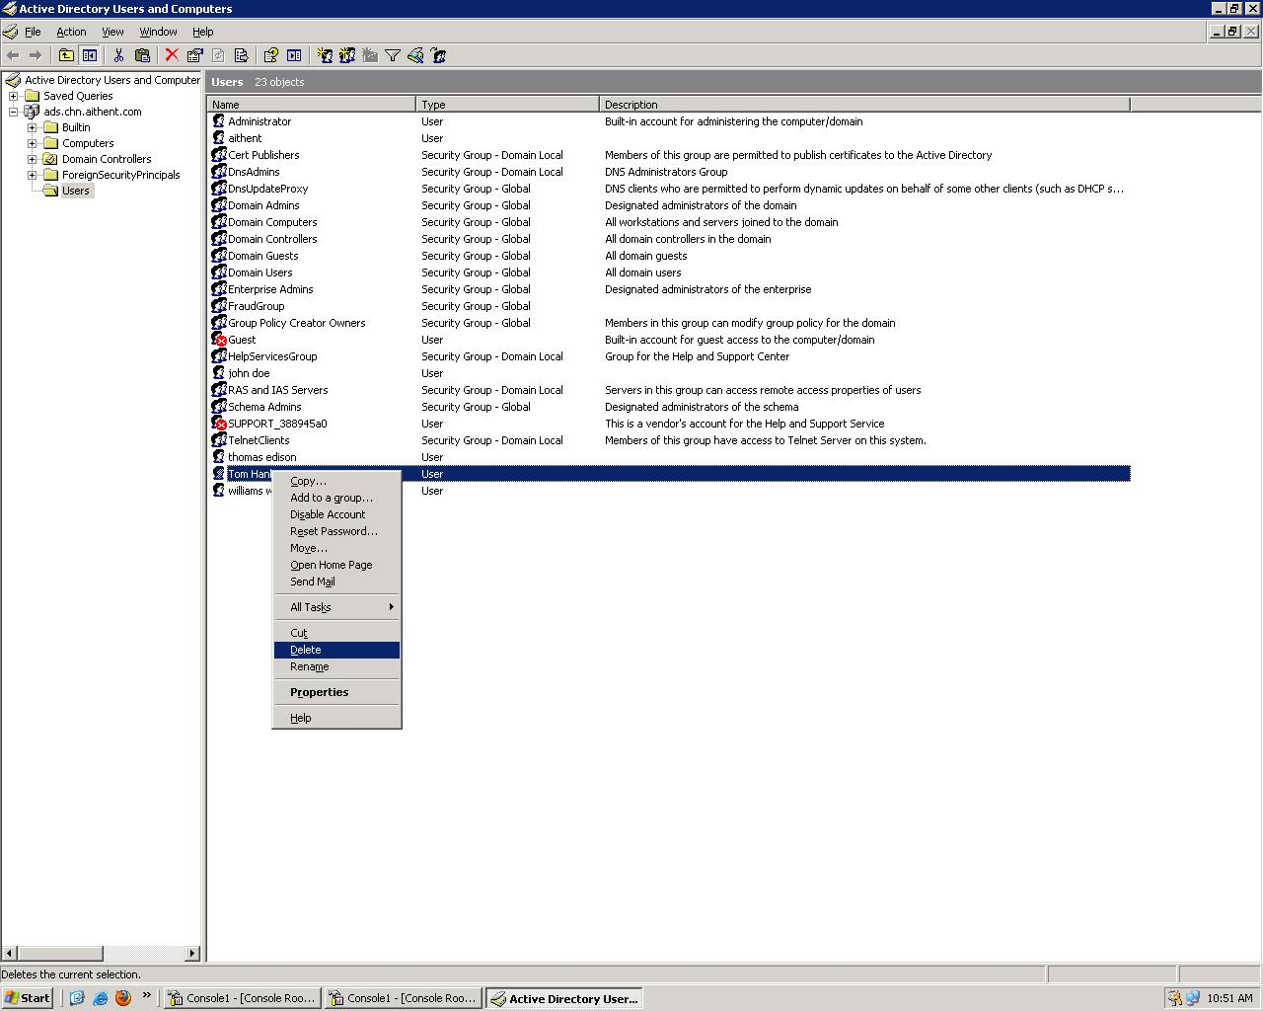

- If Delete option is chosen then perform the following steps:
- A popup for confirmation appears.

  - 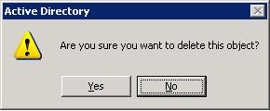

- Click Yes button to delete the user.
- The user is removed from the Active Directory users list.
- If Disable Account option is chosen then the below confirmation popup shows up.

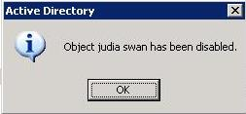

Note:
- If a user is deleted in AD then it is also deleted in the AFM database.
- If a user is disabled in AD then “End Date” is set in AFM database.
- In both the cases mentioned above the user cannot login into AFM.

Scheduler Configuration
The Scheduler is required to maintain the AFM database in synchronization with the user configuration in Active Directory.
- The Scheduler property file,“ldapscheduler.properties”, is located in the below server path.
"jboss-4.2.0.GA\server\default\deploy\nwm.war\WEB-INF\classes\config\properties\en"
- To schedule the start time change the "scheduler.starttime" property.
- The format in which value is required is:
<seconds><minutes><hours> ? * *
- For example, to schedule the time as 3.30 pm the property is set as shown below.
scheduler.starttime=00 30 15 ? * *
The scheduler runs every day at the time configured, which is explained above, to either
- Insert new users; or
- Update existing user details in AFM.
The scheduler can also be run adhoc by making the configuration changes as explained above and restarting the application server. The application server would be configured as a service in the client box. This can be accessed as mentioned below.
- Go to StartControl PanelAdministrative ToolsServices.
- All the services that exist in the client box are listed.
- Select the service corresponding to AFM – <service name>.
- Right click and select the Restart option.

Exception Handling
The errors that occur during the authentication process are logged in <file name> in the following location:
- /jboss-4.2.0.GA/bin/log/AFM/<filename>.log

Exception Scenarios

Exception Scenario | Message
Username or password is entered incorrectly during login. | - UI & Error log  Authentication failed. Username or Password is incorrect.
Email is not configured for user in Active Directory (LDAP server) | - UI  Authentication failed. User does not exist.  - Error log  Email is not configured for <First name><Last name>.
If Investigator is added to more than one IU group. | - UI  Authentication failed. User does not exist.  - Error log  <First name><Last name>: Investigator cannot be assigned to more than one Investigative Unit.
If Administrator is added to groups other than “AFMFraudGroup” and “AFMAdminGroup”. | - UI  Authentication failed. User does not exist.  - Error log  <First name><Last name>: Administrator cannot be assigned to an Investigative Unit.
User not added to “AFMFraudGroup” in Active Directory.  AFMFraudGroup – This is the group name configured in LDAPserver.xml  (location: /jboss-4.2.0.GA/bin) | - UI  Authentication failed. User does not exist.  - Error log  <First name><Last name>: User not a member of AFMFraudGroup.
If user is not added to group other than “AFMFraudGroup”. | - UI  Authentication failed. User does not exist.  - Error log  <First name><Last name>: Role not assigned.
Note:
- If there is any faulty configuration in Active Directory (LDAP server) as mentioned above, the changes will not take effect in AFM.
- The group names mentioned above is only for representation purpose in the document. AFM doesn’t impose any restriction on the group name. However the required configurations, which are mentioned in the previous sections, need to be done.

