

Aithent Word Template
Installation Guide
19 Fulton Street, Suite 408
New York, NY 10038
www.aithent.com
This document contains proprietary information of Aithent and is tendered subject to the condition that the information be retained in confidence.
Table of Contents
1 Load templates or add-ins 2

Load templates or add-ins
When you load a template or add-in, it remains loaded for the current Word session only. If you quit and then restart Word, the template or add-in is not automatically reloaded.

In Word 2010, 2013, or 2016, select File > Options > Add-Ins.

In Word 2007, click the Microsoft Office Button image, and then select Word Options > Add-ins.
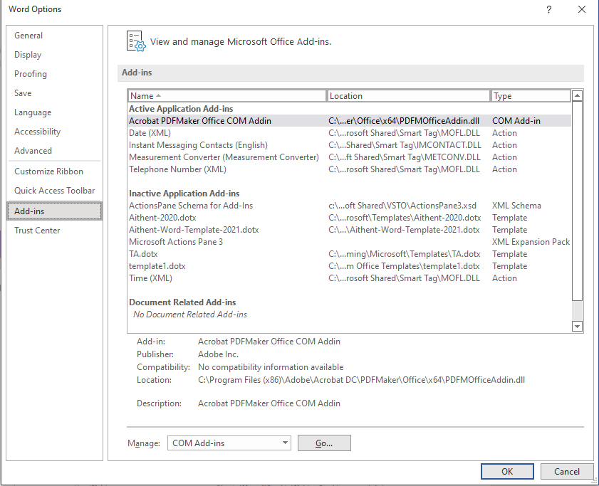

In the Manage list, select Word Add-ins, and then click Go.
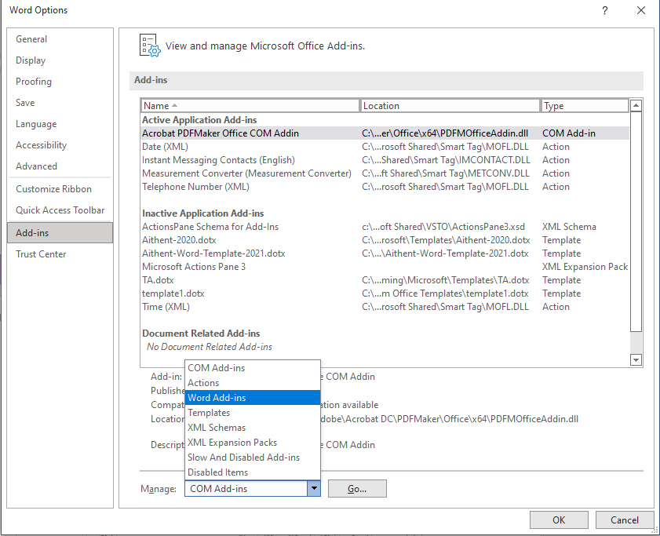

Click the Templates tab.

Under Global templates and add-ins, select the check box next to the template or add-in that you want to load.
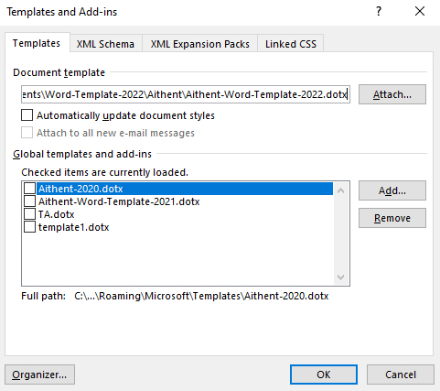

If the template or add-in you want does not appear in the box, click Add, switch to the folder that contains the template or add-in you want, click it, and then click OK.

After adding the template go to New and click on Personal select the template from list.

