[Type the document title]

User Manual

[Type the Version No]
[Type the Edition Date]


This document contains proprietary information of Aithent and is tendered subject to the condition that the information be retained in confidence
Table of Contents

Table of Figures ii

List of Tables iii

Introduction 3

System Overview 3

System Requirements 3

User Access Level (UAL) 3

Main Menu 3

Toolbar 3

Workflow Overview 3

Getting Started 3

1. Title 1 of the Application 1-3

1.1 System Function Name 1 1-3
1.1.1 System Sub Function Name 1 1-3
1.1.2 System Sub Function Name 2 1-3

1.2 System Function Name 2 1-3
1.2.1 System Sub Function Name 1 1-3
1.2.2 System Sub Function Name 2 1-3
1.2.3 System Sub Function Name 3 1-3

2. Title 2 of the Application 2-3

Table of Figures

Figure 1: References Menu 3

List of Tables
No table of figures entries found.

Introduction
This section describes the system and the purpose for which it is intended. The description shall include: major functions, user access mode, general description, system name, and operational status.

System Overview

System Requirements
Briefly describe and depict graphically the equipment, communications, and networks used by the system. Include the type of computer input and output (I/O) devices.

User Access Level (UAL)
Describe the different users and/or user groups and the restrictions placed on system accessibility or use for each.

Main Menu
This section describes each menu features in brief.

Toolbar
This section is applicable only for desktop application. Narrate the toolbar that gives you quick access to many of the application features you will use most frequently.

Workflow Overview
This section provides general guide for the sequence to be followed using the application.

Getting Started
This section provides a general walkthrough of the system from initiation through exit. The logical arrangement of the information shall enable the functional personnel to understand the sequence and flow of the system. Use screen prints to depict examples of text under each heading.

Title 1 of the Application
This section describes in general terms the system menu first encountered by the user, as well as the navigation paths to functions noted on the screen. Each function under this chapter is described in detail.

System Function Name 1
Provide a system function name 1 and identifier here for reference in the remainder of the subsection. Describe the function and pathway of the menu item.

System Sub Function Name 1
Provide a system sub function name 1 and identifier here for reference in the remainder of the subsection. Describe the function and pathway of the menu item.

System Sub Function Name 2
Provide a system sub function name 2 and identifier here for reference in the remainder of the subsection. Describe the function and pathway of the menu item.

System Function Name 2
Provide a system function name 1 and identifier here for reference in the remainder of the subsection. Describe the function and pathway of the menu item.

System Sub Function Name 1
Provide a system sub function name 1 and identifier here for reference in the remainder of the subsection. Describe the function and pathway of the menu item.

System Sub Function Name 2
Provide a system sub function name 1 and identifier here for reference in the remainder of the subsection. Describe the function and pathway of the menu item.

System Sub Function Name 3
Provide a system sub function name 1 and identifier here for reference in the remainder of the subsection. Describe the function and pathway of the menu item.

Title 2 of the Application
This section describes in general terms the next system menu encountered by the user, as well as the navigation paths to functions noted on the screen. Each function under this chapter is described in detail.

Glossary
Provide a list of the acronyms and abbreviations used in this document and the definitions of each.
For e.g.:
UAL | User Access Level is a level of user to access the system’s functions in a restricted manner.

Index
Provide an alphabetically arranged list of term with page numbers on which the item can be found. For e.g.: Refer the below index.
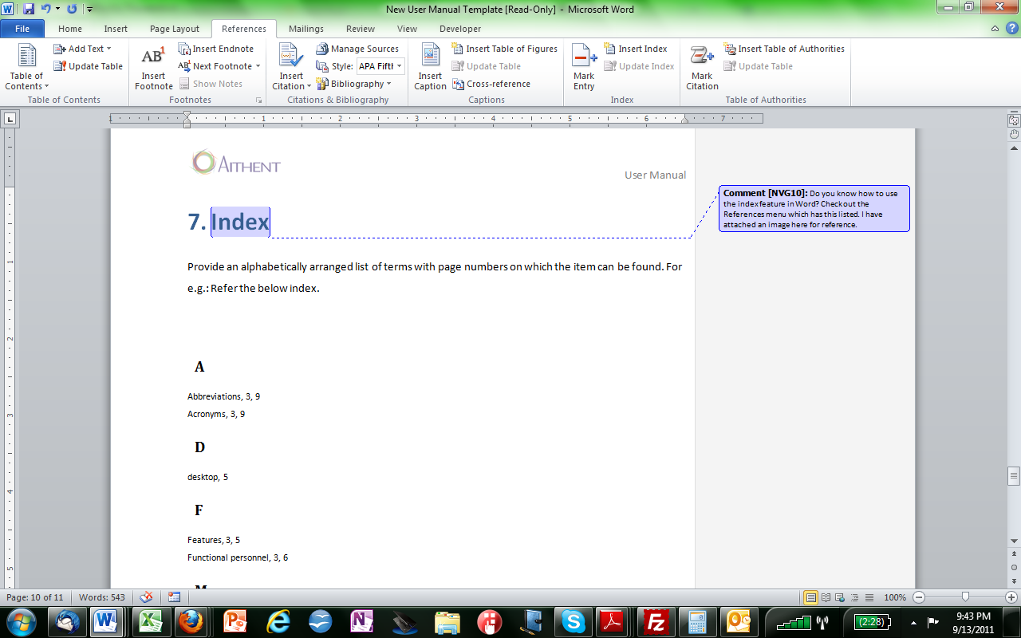
Figure 1: References Menu

A
Abbreviations, 1
Acronyms, 1
C
Computer, 2
D
desktop, 2
F
Features, 2
Functional personnel, 3
G
Guide, 2
I
Identifier, 1-1
Index, 1
Item, 1
M
Menu, 1-1
O
Operational status, 1
P
Pathway, 1-1
R
Restrictions, 2, 1
S
Screen, 3
Section, 3
system, 1, 2, 3, 2-1
System, i
System Accessibility, 2, 1
T
Terms, 1
U
User Access, 1
W
Walkthrough, 3

