Aithent Fraud Manager

Integration Capabilities
Reference Number: AITHENT-AFM-IC
Version: 1.2
Date of Release: 07/26/2011



This document contains proprietary information of Aithent and is tendered subject to the condition that the information be retained in confidence.
Document Information

Author(s) | : | Hariharasubramaniam Srinivasan
Document Status | : | Review
Compliance Status | :

Document Control Information

Total Pages | : | 7
Review Period | :
Distribution | :

Revision History

Version No. | Release Date | Description of Change | Approved By
1.0 | 03/21/2011 | Initial Release | N.Venu Gopal, CEO
1.1 | 07/21/2011 | - Modified “Introduction” section  - Included section 2.1 “Integration Data”  - Renamed section 2.3 as “Batch Handling of External Files”  - Removed section “Image Integration” and included it as part of section 2.1 | N.Venu Gopal, CEO
1.2 | 07/26/2011 | - Modified Fig.1: AFM Integration Mechanisms - Process Flow Diagram – Changed line (Web Service Call to Adaptor ) color from orange to black  - Modified section 2.2.1 – Import On Request – mentioned the benefits of this mechanism to the user  - Included comments – A3,A10

Table of Contents

1 Introduction 4
2 Integration Mechanisms 4
2.1 Integration Data 5
2.2 Web Service Calls 6
2.2.1 Import On Request 6
2.2.2 Automatic Import 6
2.3 Batch Handling of External Files 7

List of Figures

Figure 1: AFM Integration Mechanisms - Process Flow Diagram 5

Introduction
AFM is an internet-based investigative case management solution. It has been designed to support the efforts of investigative units. One key design feature of AFM is the ease with which it can be integrated with 3rd party systems. This document describes the integration capabilities of the Aithent Business Integration (ABI) module to tightly couple AFM with core banking and other banking systems.
The mechanisms supported by AFM to integrate data from external systemsare:
- Web Services
  - Pull Method
  - Push Method
- File-based
  - XML file
  - Excel
  - Flat file
- Image integration
This document discusses these mechanisms in detail.

Integration Mechanisms
The following diagram illustrates the process flow of the Integration Mechanisms supported by AFM.

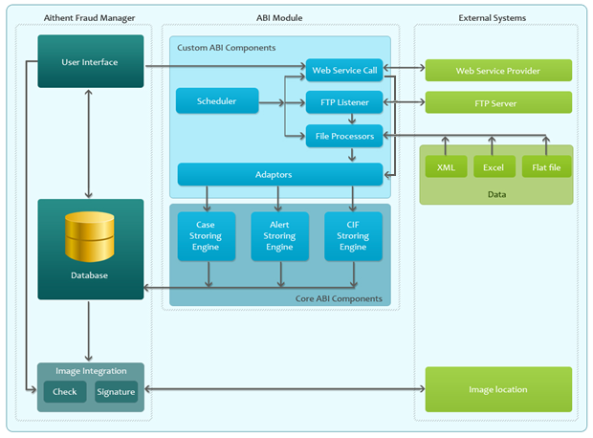
Figure 1: AFM Integration Mechanisms- Process Flow Diagram

Integration Data
The data that is integrated with AFM from external systems that are related to a case is,
- Account
Transaction data may be integrated with AFM either through Web Service or from a file.
Either it can be associated with an existing case or a new case can be created from it.
- Subject
Subject may be associated to a casefrom the data in a CIF (Customer Information File).
- Transaction
Transaction data may be integrated with AFM either through Web Service or from a file.
Either it can be associated with an existing case or a new case can be created from it.
Example:
- Check fraud data from a detection system
- It may be required to show check or signature images in AFM. The image URL required for retrieving the image is formed either from the parameters entered by the user in the UI or from the transaction data already available in AFM i.e. the data that is got from the customer data feeds through the ABI module.Encryption logic is incorporated if the image retrieval is over the internet.

Web Service Calls

Import On Request
The Import On Request capability implemented through Web Service offers the following benefits:
- The external data retrieved can be analyzed and then saved in the system. This prevents data redundancy in the system.
For example, if account information got from an external system needs to be associated to a case. The user can decide to associate the account with case or not based on the data relevancy.

- Periodic update is done by scheduled requests and hence eliminating manual intervention.
For example, it is required to periodically import case information from a "check fraud detection" system. In this case scheduled requests are made to import case information from this system routinely.
The Web Service Call pulls the customer data into AFM. If the customer has hosted a Web Service in their server, AFM has the ability to make a Web Service call to retrieve customer data through the ABI module. The customer data is retrieved from their proprietary system by the Web Serviceand it sends back the xml response. The xml response is then processed and data is dumped into the AFM database.Adaptors perform the process of mappingthe xml response with the AFM data model. The Case Storing Engine or Alert Storing Engine stores the mapped data as an alert or a case in the AFM database.
The Web Service calls can be triggered either from the AFM User Interface or via a scheduled request to be generated at periodic intervals. Examples of Web Service call triggered from the:
- AFM User Interface - If in AFM the account details such as account owner, branch and address are needed from an external system, say a Core Banking System, provide the account number in the request of Web Service call. The AFM user enters the account number in the UI and the account related data returned by the Web Service provider of the customer is displayed.
- Scheduler - The scheduler component can trigger periodic requests to retrieve case data from external systems that are continuously updated.Adaptors perform the data mapping and the Case Storing Engine stores the data in database.The Case Storing Engine stores the customer data into relevant entities such as Case, Account, Transaction and Subject in AFM.
The Alert Storing Engine stores the alerts from Web Service provider of the customer.The AFM user can later translate these alerts into cases.A typical example for such alerts could be data related to check fraud data from a detection system.

Automatic Import
The Web Service Call can also be such that the customer data is pushed by the Web Service Provider at the customer’s end. AFM can also support this type of Web Service Call. The ABI module handles the data sent by the Web Service Provider in the same manner as mentioned in the Pull method.

Batch Handling of ExternalFiles
AFM has the capability to read files containing customer data and store it in the AFM database through the ABI module. The customer data is commonly provided in one of the following file formats,
- Excel
- Flat file (with delimiters)
- XML
The files containing the customer data is usually posted on ftp sites. Hence the Scheduler component fetches the files in the FTP Server through FTP Listener. The data extracted from these files is parsed and then stored in the AFM database. The File Processor does the data extraction and parsing. The Scheduler controls the File Processor component to support processing of files periodically.Adaptors perform data mapping from the customer specific format to the AFM data model prior to saving to the AFM database. The customer can provide data in two ways,
- Customer data provided at regular intervals or
- One time load of customer data and the subsequent loads with only delta of the data.
The AFM database is updated post these feeds based on certain business rules being applied. Some entities may require an update while others may need an addition. Audit tables are maintained in the AFM database to track the changes that happen to the customer data that is given through feeds.
The Case Storing Engine stores the customer data into relevant entities such as Case, Account, Transaction and Subject in AFM. The Alert Storing Engine stores the alerts from Web Service provider of the customer. The AFM user can later translate these alerts into cases. In case the customer data is provided as a CIF (Customer Information File) the CIF Storing Engine stores the customer data into AFM database.

