


AGORA
Technical Design Document
Version: 3.0 Draft
Date of Release: 07-SEP-2020

Document Information
19 Fulton Street, Suite 408
New York, NY 10038
www.aithent.com
This document contains proprietary information of Aithent and is tendered subject to the condition that the information be retained in confidence.

Author(s) | : | M. Lakshmi Kala, Praveen Putta
Document Status | : | Definitive
Compliance Status | :

Initial Release Information
 | Name | Date
Reviewed By
Approved by
Released By

Document Control Information
Total Pages | : | 14
Review Period | : | As and when required
Distribution | : | Project Team, SQA

Introduction

Purpose of this document
The purpose of this document is to describe the data flow and object interactions between presentation, service, and persistence layers of the Agora.

AGORA system will be used to
- Schedule a meeting
- Create note/decision/task while the meeting is on-going or post meeting
- Generate meeting minutes
- Send notifications
- Provide search for meetings, minutes of meeting, action items, attendees and agenda

ABBREVIATION, ACRONYMS AND DEFINITIONS

Term used | Definition
MOM | Minutes of Meeting
SRS | System Requirement Specifications.
Note Taker | Person responsible for taking meeting minutes.
* | Items to be part of next iteration.

USE CASE DRIVEN APPROACH OF AGORA

ACTORS

Meeting facilitator– Person who organizes the meeting. Define list of attendees and agenda's

Chairperson – Person who controls the meeting.

Note taker – Person who takes the meeting notes and creates MOM.

Attendee - Person who participates in the meeting.

AGORA – System which sends MOM, action item reminders and status to all attendees.

USE CASES

Login validation - Validates the authentication of the user logging in.

Create/View/Edit Meeting (Schedule Meeting) – Explains about scheduling new meeting and update existing meeting.

Create/View/Edit Note/Decision/Task – Explains about capturing note/decision/task while meeting is in place or once meeting is completed.

Generate Minutes – Explains about generating minutes

Sending reminders – Explains about sending reminders about meetings or action items.

Search – Explains about search for action items, meetings, MOM etc.

SYSTEM DETAILS

COM.AITHENT.AMMS.SERVICE

This package contains all services that the system exposes to external clients (front-end or web service). It consists 1 sub-package that contains the service implementation

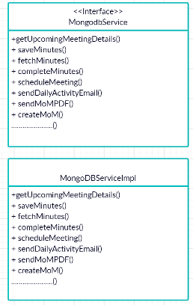

MongodbService - An interface exposing required methods to clients

MongodbServiceImpl - Implementing the interfaces declared in the interface.

COM.AITHENT.AMMS.HELPER

This package contains all helper objects. Helper class contains business logic validations.

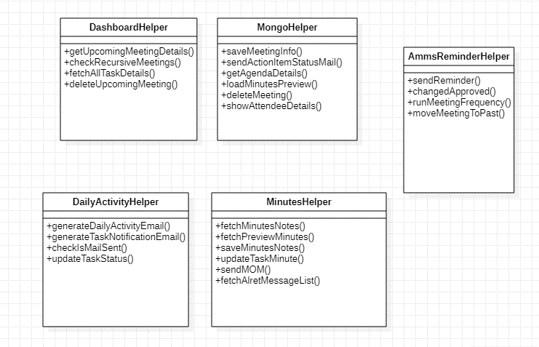

DashboardHelper – Responsible for displaying meeting information into the dashboard.

MongoHelper – Responsible for performing save, update, delete, view operations on the meeting information and the objects associated with it like meeting, minutes, and minutes attributes.

AmmsReminderHelper - Responsible for sending the email reminder information.

DailyActivityHelper - Responsible for sending daily activity emails.

MinutesHelper - Responsible for create/edit/delete minutes details.

COM.AITHENT.AMMS.DAO

This package contains all DAO objects. These classes are responsible for interacting with the database.

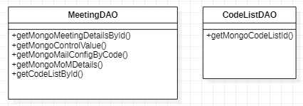

MeetingDAO – Responsible for storing and fetching meeting details

MongoDAO – Responsible for storing minutes and contains common methods like saving any document in Mongodb.

CodeListDAO – Responsible for storing and fetching data from CODELIST collection.

COM.AITHENT.AMMS.DOMAIN

These classes represent table in a database

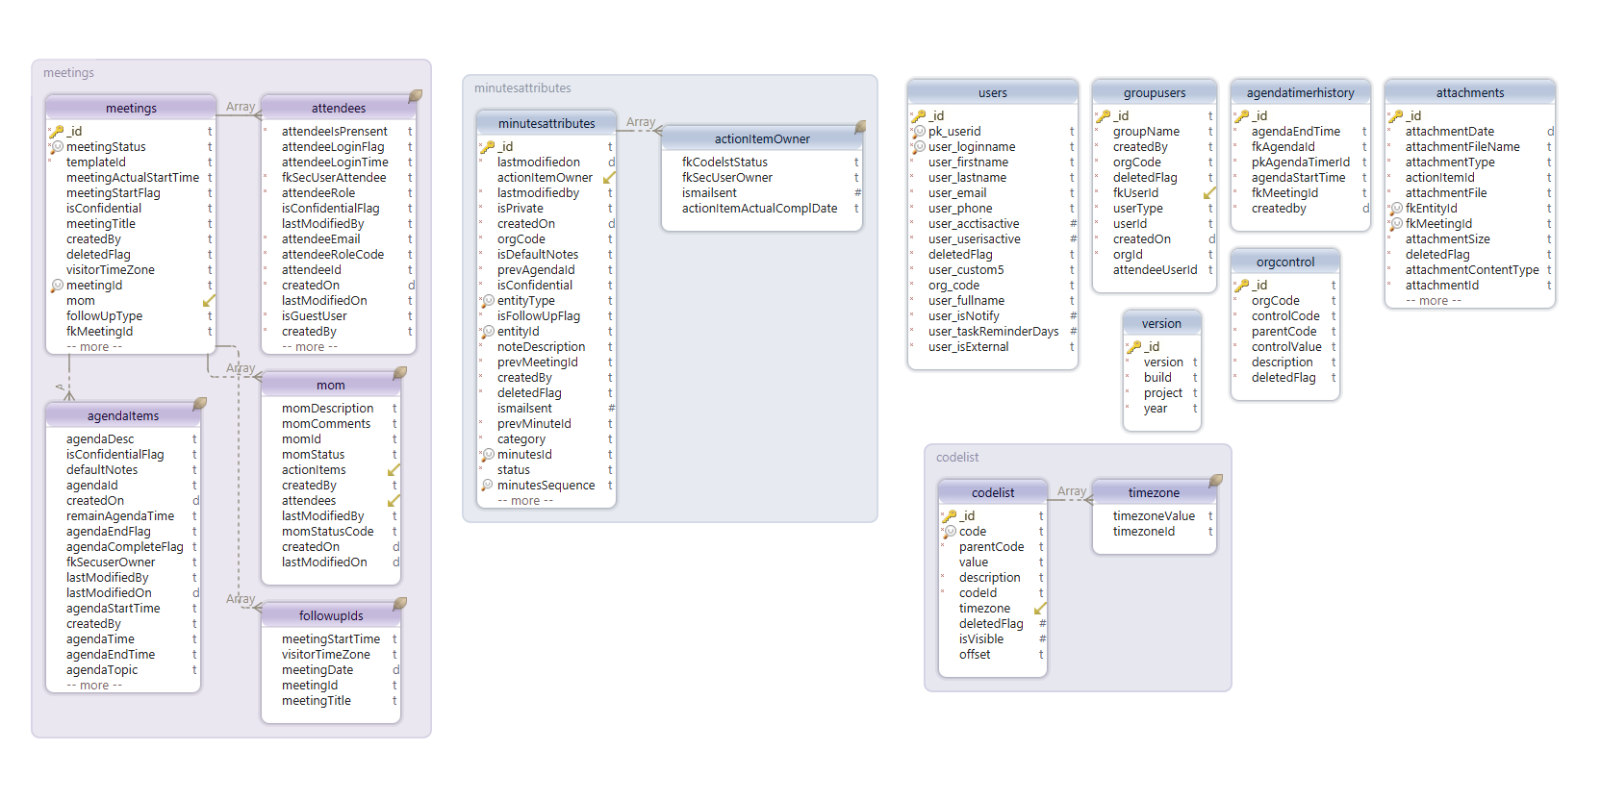

COM.AITHENT.AMMS.POJOOBJECTS

This package contains the model objects used as containers of request and response information passed between web-tier and the System

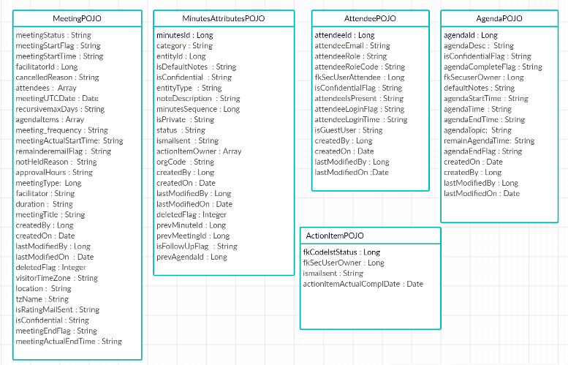

COM.AITHENT.AMMS.EXCEPTION

This package contains common exception classes.

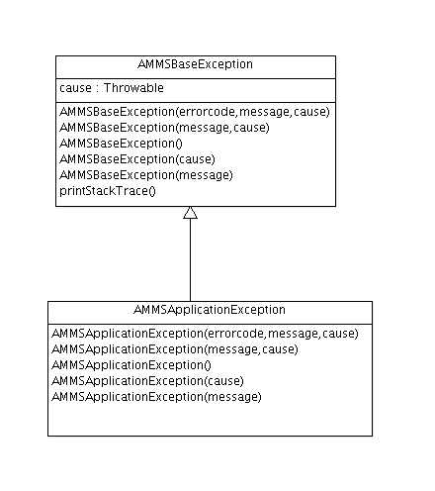

AMMSApplicationException - It will throw this exception if any known application related exception happens in the underlying services.

ANALYSIS OF USE CASES

LOGIN VALIDATION

Here the system validates whether the user logging in is a valid user or not. In case of Invalid user, the system displays an error message “Invalid user”. On successful validation, user logs in and the system displays the dashboard containing Meetings, Past Meetings, My Tasks, All Tasks and Calendar.

CREATE/EDIT MEETING (SCHEDULE MEETING)

Logged in user can create/edit meetings. A meeting has a context (optional project information), title, description, list of agenda items, list of invited attendees, date, start time, end time facilitator, chairperson and note taker.

Attendee: The meeting organizer defines a list of attendees. This section contains the attendee name, email address, the role of the attendee. Attendees can be a facilitator, note taker, Chairperson, or regular participant. This section also provides a field to specify the presence of attendees in the meeting. If the user tries to enter the name of the attendee, it will display matching names using autocomplete and fetch name and email address from the sec user table. Attendee details are stored as an array within the MEETINGS collection. New users can be added as a participant of the meeting. After adding a new user, Agora will send an invite to them to register in Agora or we can just notify them about the meeting instead of sending a registration invite. This is configured in ORGCONTROL collection [control code: NOTIFY_GUEST_MAIL, parent code: EMAIL_SETTINGS]

Agenda: This section allows users to provide agenda topics, owner, duration, description, and pre-defined notes. The owner's list is populated from a sec user table using autocomplete. Agenda details are stored as an array within the Meetings collection. Users can attach files to an Agenda. These files will be sent along with the meeting invitation. While creating the meeting if there is no default agenda then the system will create the current meeting title as a default agenda.

Notes – Additional description about Agenda (This will be included while sending meeting invitation)

Pre-defined Notes – Note which needs to be added in the minutes by default.

The system allows the user to specify the meeting type. The user can add a new meeting type also. The meeting type will save in the CODELIST collection. Once the meeting is scheduled the system will send a meeting invitation along with .ics file to import in their calendars.

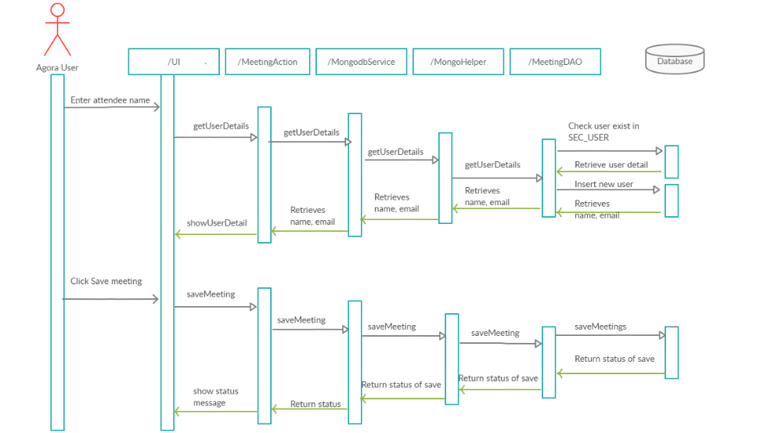

Once user saves meeting, it is stored in MEETINGS collection. List of attendee and agenda(s) are stored as array within MEETINGS collection. Email is sent to all attendees which has hyperlink to open scheduled meeting.

CREATE/VIEW/EDIT NOTE/DECISION/TASK

Attendee: The user can specify whether the attendee participated in the meeting or not. This updates attendeeIsPresent column value to Y or N in attendees Array. This section also allows adding new attendee who was not originally invited while scheduling meeting. New attendee details get inserted into attendees array with attendeeIsPresent column value to Y. Users can track Attendee activities (IN/OUT). These details will be stored in ATTENDEELOG collection

User can add note/decision/task

The system allows the user to add attachments for note, decision, and task.

The system allows the user to start/stop the timer of the agenda. This helps the user to track the actual effort spent by the user on a particular agenda. Timer extends alert will come before XXX minutes of agenda duration [XXX minutes is configured in ORGONTROL]

While saving the note, decision, and task it gets saved inside MINUTESATTRIBUTES collection.

The system allows the user to create private notes and tasks. The private note and task will be displayed for the person who created those notes and tasks.

Based on ORGONTROL value the user can edit others notes. This flag value configured based on the organization level. [This is configured in ORGONTROL collection parent code: NOTES_SETTINGS, control code: MOMEDIT]

Users can change the note to a decision, decision to note, note to a task, and decision to a task.

User can move note/decision/task from one agenda to another agenda

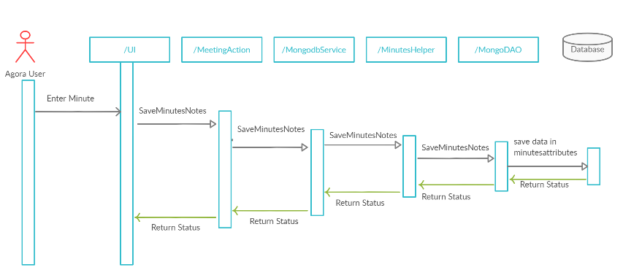

GENERATE MEETING MINUTES

The system allows the user to create minutes from notes, decisions, and tasks entered while the meeting is running or after the meeting completed.

In the MOM page, the left panel displays all notes, decisions, and tasks grouped by note owners/Agenda. The user can select notes, decisions, and tasks and move to the right text area.

Users can apply basic formats.

Minutes will be saved inside MOMDETAILS and MINUTES collection.

Users can create multiple minutes.

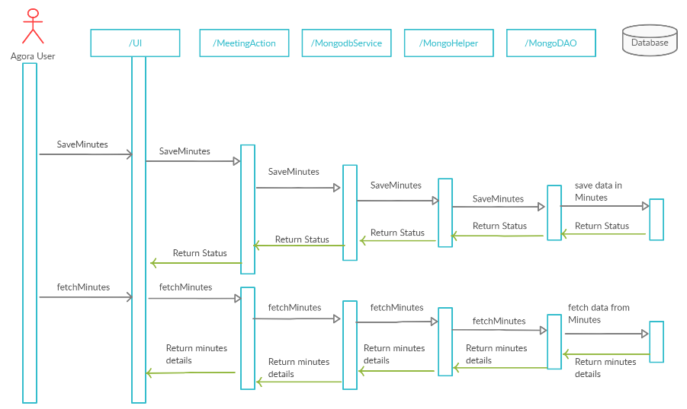

SENDING REMINDERS

The following notifications will be sent to the users.

Meeting Reminder – Reminder email will be sent to the attendees before meeting starts. Time is configured in ORGONTROL collection [parent code: EMAIL_SETTINGS, control code: MEETING_REM_DURATION]

Meeting Cancellation Notification – When a meeting is canceled notification will be sent to all attendees.

Daily Activity Email - User’s daily activity remainder (Will includes everyday meetings, tasks, and tasks to be completed on the next day). This is also configured in ORGCONTROL collection [parent code: EMAIL_SETTINGS, control code: DAILY_ACTIVITY_SEND]

Task Notification Email – Will be sent at the end of the day. This includes tasks created and assigned to them on that day and the due date is greater than today. If the due date is today then the system will send immediately after creating the task.

Action Item Update – Will be sent after the meeting completed (Ended). It will group all tasks creating in that meeting and send the notification to all task owners.

SEARCH

Global Search (Anywhere) – Allows the user to search from meetings and minutes. Entered text can be a meeting title or agenda description or note or decision or task tile.

Column Search – Allows the user based on meeting title, date, meeting type, status, facilitator, participants, and agenda

HIGH LEVEL ARCHITECTURE

The high-level architecture diagram and the business object model are added here for easy reference.

