PROJECT DOCUMENTATION

System Requirements Specification

For Project:
Aithent-Agora

Release No: 1.7-final
Oct-27-2014

Approvals:
Project Manager: _________________________ Date: __________

Revision History

Revision Number | Revision Date | Summary of Changes | Updated By | Reviewer | Changes marked

Table of Contents

1 Introduction 4
2 System Requirements 5

1 Introduction
This document defines system requirements specifications for the Aithent Meeting Management System.

SCOPE AND OBJECTIVE
This document will be used as baseline to assess the scope and size of AMMS project. The objective of this document is to meet the following system requirements in a manner that facilitates the creation of a AMMS application system design.

Abbreviation, Acronyms and Definitions
Term used | Definition
AMMS | Aithent Meeting Management System.
MOM | Minutes of Meeting.
SRS | System Requirement Specifications.
Note Taker | Person responsible for taking meeting minutes.
* | Items to be part of next iteration.

System Requirements

Login

Description
The user will login in to the system by entering her/his user id and password. The system will authenticate the user using eSecurity. In first iteration AMMS will only be accessible to the users registered with ADMS. AMMS will check for new users with ADMS on daily basis and will populate AMMS system accordingly. In next phase AMMS system will allow users to directly register themselves to access AMMS. *Any user changes such as password or role should also be captured from ADMS.

Layout
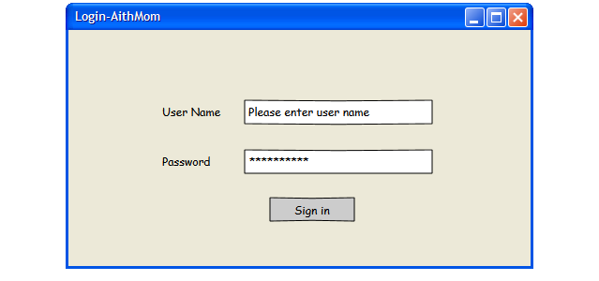

Page Validation
After the applicant enters his/her login information and selects the “Sign In” button, AMMS database will be read to validate the login information (registered username and password).

Navigation
“Sign In” will redirect the user to the AMMS home page.

Error Messages
If incorrect username or password is entered - Invalid Login Details. Please enter correct login Information.
*User should have option for “Forgot Password”.

Dashboard

Description
      - The page will be displayed after login and will display “Meetings”, “My Actions”, ”Other Action Items”. User should be able to filter the results for these three sections by status in the each section.

Dashboard

Description
      - The page will be displayed after login and will display “Meetings”, “My Actions”, ”Other Action Items”. User should be able to filter the results for these three sections by status in the each section.
      - *User should be able to filter each section based on available fields.
      - This page will also provide links to create a meeting, create a MOM and search.
      - Using “Create MOM” link user can create a meeting and MOM as one step process.

Meetings
      - Displays meetings that are scheduled and not yet completed for logged user.
      - Should have columns for Meeting Title, date, time, link for MOM.
      - Should be able to update Meeting status from this screen.
      - Displays meetings for which logged in user participated and are completed.
      - Provide a link to create new Meeting.
      - Open details for selected meeting.
      - If logged in user is a facilitator for a meeting, and listed meeting has corresponding MOM “Pending for Approval“, user will be able to review and update the MOM.
      - If logged in user is note taker for a meeting, s/he should be able to create MOM for that meeting.
      - System will notify facilitator about meetings for which MOMs are pending for approval. Once a MOM is approved system will email link to the MOM page to all attendees. Once approved MOM cannot be edited.
      - * System will email the MOM document as an attachment to all attendees.

My Action Items
      - Shows action items assigned to the logged in user for the meeting he or she was a participant. By default it will show pending items.
      - * Search will be provided to filter based on available fields.
      - User will be able to view/edit action items for which he or she is the owner. For any action item, facilitator will also be able to update the action item details as well as status.

Other Action Items
      - Shows action items assigned to other users for the meetings, logged in user participated in. By default it will show pending items.
      - Should display action item owner name(s).
      - *Search will be provided to filter based on available fields.
      - Action Items are displayed as hyperlink, on click it will open up corresponding Action item details, such as associated meeting, MOMs, original date of completion, actual date of completion, status change, associated description and notes. An action item may be associated with more than one MOM.
      - Action items should have meeting title, action item title, assigned date, due date and status change option.
      - *Attendees should be able to follow up with action item owner(s).

Layout

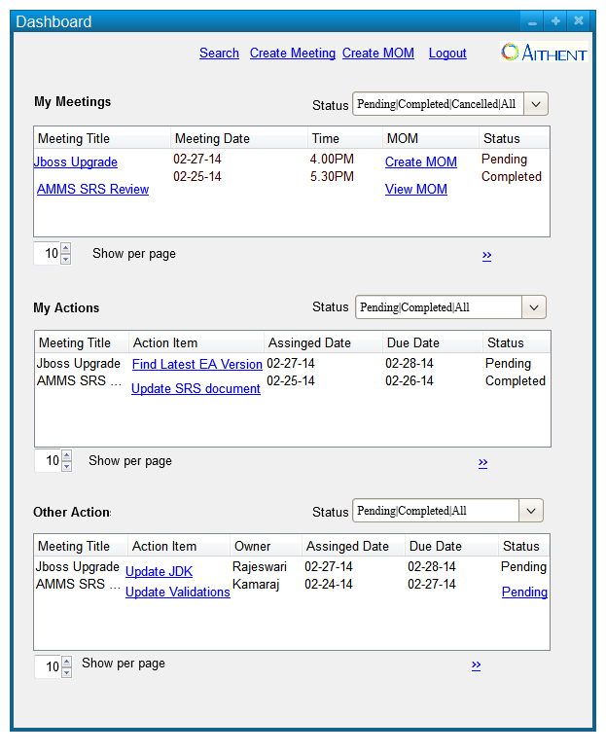

Search
User will be presented to this page when s/he clicks on the search link on dashboard page.

Description
      - User should be able to search meetings, participants, MOMs, agendas and action items.
      - User will be able to view existing meetings list and view/edit the selected meeting.
      - User will be able to create new meeting by clicking “Create New Meeting” link.
      - If user creates new meeting from this screen, user should be able to select agenda item(s), attendee(s) and action item(s) from the search result so that it becomes part of the new meeting.
      - If user creates new MOM from this screen, user should be able to select agenda item(s), attendee(s) and action item(s) from the search result so that it becomes part of the MOM for the corresponding meeting. It will be helpful if an agenda or action item is associated with more than one MOM.
      - User will be able to filter the search results based on available fields.
      - User will be able to define the expected output from the available attributes/fields.
      - User will be able to export search results into spreadsheet.
      - User will be able to print the search results.
      - User will be able to save the search criteria.
      - With saved search users can reuse existing search criteria.

Layout

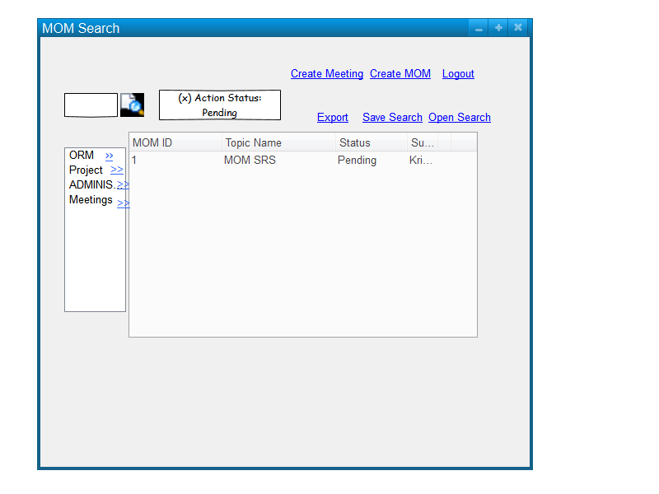

Navigation

      - When users click on “Create New Meeting”, user will be redirected to “New Meeting” page.
      - Meeting ID is a hyperlink in the search results, by clicking Meeting ID link user will be redirected to View/Edit page.
      - If user selects a meeting and clicks “Create MOM”, user will be directed to “Create MOM” page.

New/Edit Meeting

Description
      - User should be able to create or update a meeting.
      - A Meeting will have a title, description, list of agenda items, list of invited attendees, date, start time, end time, facilitator, meeting chairperson and Note Taker.
      - User will have option to specify role for each attendee, such as participant, facilitator, note taker, chairperson.
      - An attendee can have multiple roles, e.g. an attendee can be facilitator as well as chairperson.
      - User should be able to add an attachment for the meeting.
      - Email for scheduled meeting will have a link using which user can directly access the “Meeting” page. If user is not already logged in to AMMS then system will prompt user to login.
      - Once Approved, MOM can’t be edited.
      - *User should be able to send the meeting schedule as an email attachment to all attendees.
      - *User should be able to specify time zone for the meeting.

Layout
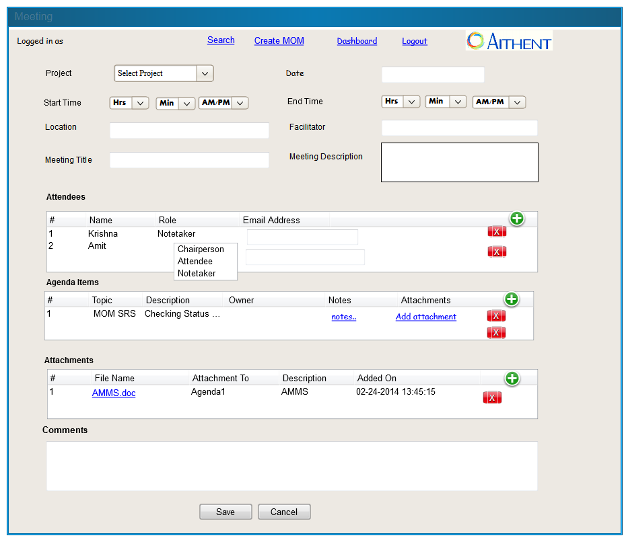

New/Edit MOM

Description

      - User can create/edit the MOM document.
      - There can be only one MOM for a meeting.
      - Project name will list all available projects along with “Others” options. If note taker is creating a MOM and meeting does not belong to any project then user can select “Others” and input a project name but inputting project name will be optional.
      - Each MOM should have a title.
      - Each MOM should have meeting date (MM/DD/YYYY) populated from corresponding meeting.
      - Each MOM should have start time and end time (HH:MM) populated from corresponding meeting.
      - Each MOM should specify the name of the note taker populated from corresponding meeting.
      - Agenda will have option to specify owner/s for each agenda item.
      - User should be able to add notes corresponding to the agenda.
      - User should be able to add attachment(s) corresponding to the agenda.
      - User should be able to sort by clicking column header in each section.
      - If required, note taker should be able to share the MOM in draft mode with all or specific attendees.
      - In draft mode email will be sent to all attendees with MOM hyperlink. Any attendee can review and change the notes. System will keep MOM in draft mode for one day (configurable). After that MOM will be send to facilitator for approval. Once facilitator is approved, then MOM can't be edited.
      - Facilitator can change the status of a MOM in draft mode to “approved” or “rejected” with comments. If rejected, system will notify “Note Taker” to update the MOM based on Facilitator’s comments.
      - Once MOM is approved, it will be emailed as an attachment to all attendees along with a link to MOM screen.
      - *User should be able to schedule a follow up meeting.
      - *Carry over items should be listed.
      - All the attachments related to MOM/meetings/Agenda/Actions will be displayed in the attachment section.

Layout

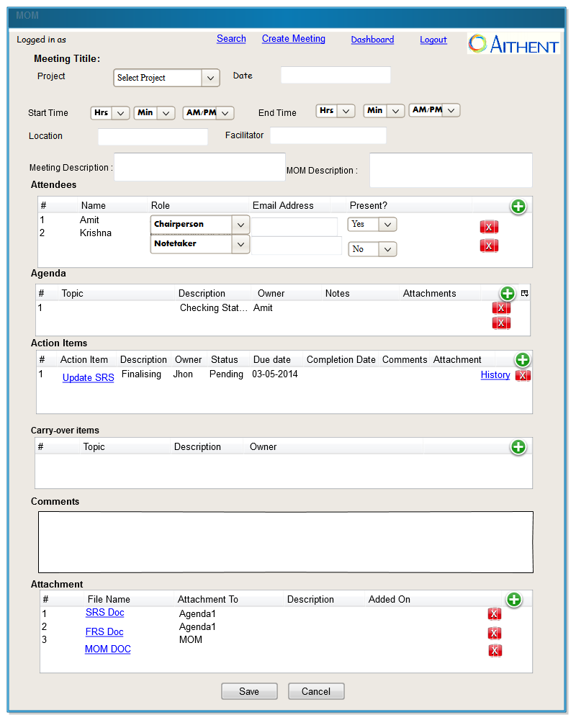

New/Edit Action Item

Description
      - User can add the action for selected agenda through link action cell from agenda section.
      - User can add actions those are not associated to agenda from action items section.
      - User can attach the files for selected action from attachment column in the attachment section. On clicking attachment icon pop page will be displayed which allow to attach files.
      - User can see the history from link view history in the action section.
      - User can update/edit action from dash board or MOM-action section.
      - By default the status for newly added action item will be pending.

      - All action items of a meeting should be versioned.
      - Action items should have associated agenda if any, title, description, owner(s), due date and actual completion date.
      - An action item may be assigned to one or more than one person.
      - If an action item is from a new meeting, it should be available to other meetings too.
      - An action item can only be deleted by the note taker, in “Create” stage of the MOM.
      - Owners should be able to indicate that the action item is completed. If one or more artifacts are associated with the action, the owner should be able to attach the artifacts to the action item.
      - Owners can also request additional time to complete an action item and should have a reason associated with that. When this is done, an email should be sent to the facilitator with copies to the attendees.
      - Once an action item is closed, it can’t be edited.

Layout
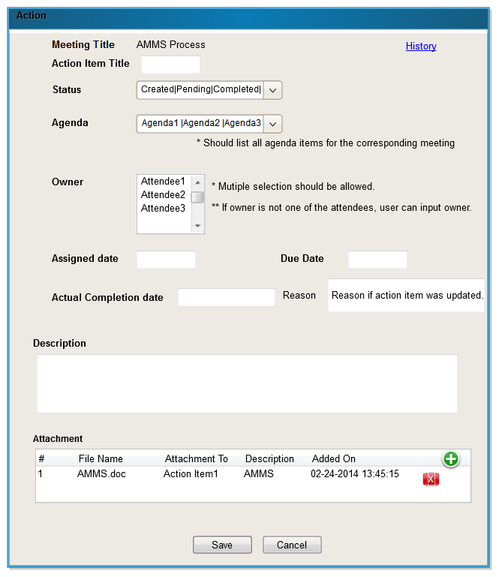

Notifications

Description
      - MOM system will send reminders for due/pending action items with configurable frequency to the action item owners.
      - Facilitator will be copied for all reminders.
      - If status of a MOM changes all meeting participants will be sent a notification along with updated MOM document as an attachment.

Master Maintenance
Project list, team members list and Status type will be maintained from backend.

Miscellaneous

Header
The Aithent logo should appear on every page. Once inside the application, each page will include the following navigational links in the upper right corner:
Home User will be returned to the MOM Home page.
Logged in as Username log off – User will be directed to Login page.

Footer
Aithent @2014 All Rights Reserved.

Browser
The applicant must be compatible with Firefox, Chrome, Safari and Internet Explorer.

