Signature Card – Mockup
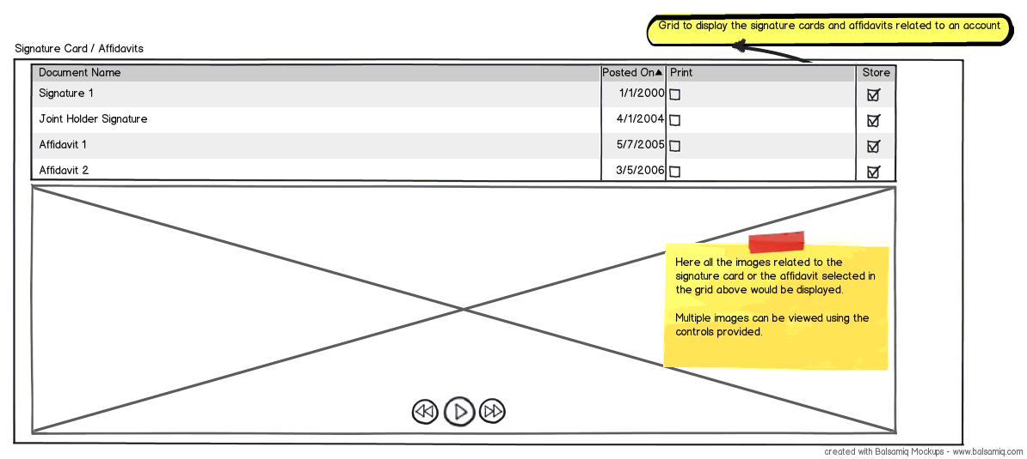
Here the grid would display all the Signature cards / Affidavits related to an account.
On the click of an item, the below image gallery would load that image and show that to the user. Below the image gallery, the page controls allow the user to move across multiple pages (if available) of the Affidavit.
Over the grid, the capabilities to print / store the Signature Card / Affidavit would be provided as buttons (not as check boxes as shown).
SWAMI: Are you suggesting that print and store to case will be a one item at a time capability instead of multiple as well? why?
Printing Option
Printing would actually render a document similar to the format shown below.
TBD: Refer Check Image Format.
User should be able to download it to their hard disk and fire a print from the document.
SWAMI: Print should be direct from the application. You are suggesting a two-step approach. Look at it from a user standpoint and how painful it would be.
Storing Option
On click of store button, a document similar to the print would be created and stored as an attachment to the case.

