Outward Facing LINX

Address Change

Licensee will login page to login. First page will be prsmain page for external user which Kala is building. On this page on the right hand side there will be a link/button ( Update Address), this button should be visible for Active/Inactive licensee only.

When the user click on this button, we will open up a wizard which will show
- Biographial page . In this page user should be able to only modify home state.
- Address Page – We will use this address page in (Address Change/Renewal/Relicensing/Original)
  - Residense Address Section: This page will show existing Residense Address and will allow the user to modify all the field
  - Mailing Address Section: This page will show existing Mailing Address and will allow the user to modify all the field
  - Business Address page: This page will show existing Business Address and will allow the user to modify all the field
- In each of the section there will be a drop down which will say Address same as
  - Business/Mailing/Residence – upon selection will copy the address from that section.
- Confirmation Page: Once the user confirm, we will validate all rules that we have currently and move the data over to LINX table from temporary table.

Producer Lookup

General public will reach to this page by clicking on a link (Producer Search) from the department website. Clicking on producer search will open up our search page, we will allow the user to search for following business type
- Individual
- Business Entity (Corporation, Limited Liability, Partnership)

Other search parameter will be
If business type individual is selected

- First Name
- Last Name
- License Number
- NPN Number

If business type Business Entity is selected
- Name
- License Number
- NPN Number

Something like below

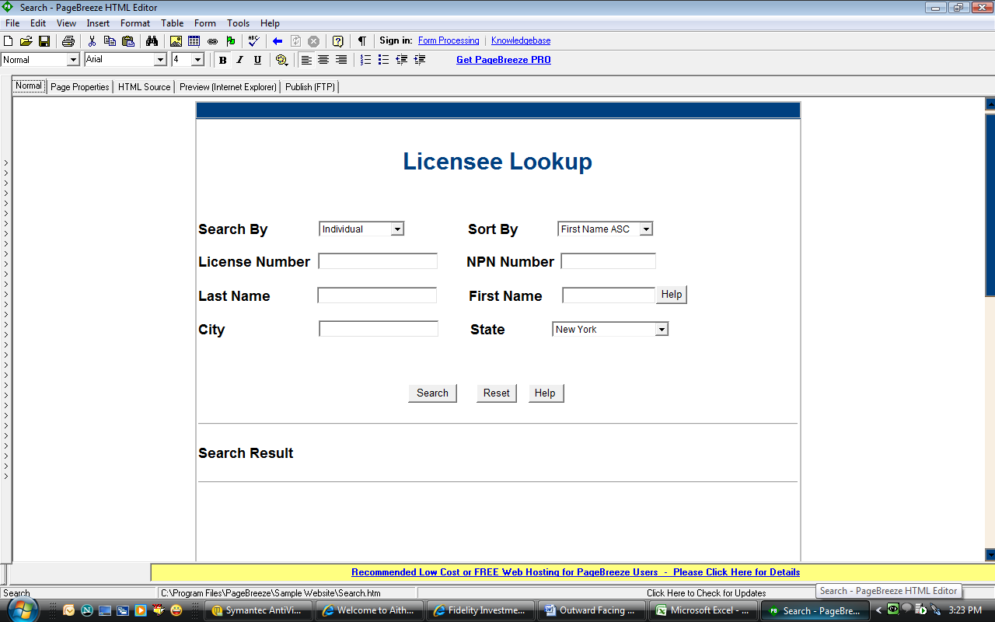

The top frame (where you are entering search criteria) will always remain on the top.

Search result will be in same format as what we have today. We will remove
- SSN field
On the Search Result when the user clicks on Name of the Licensee we will bring them to Prs main page. In this page we will only show the following section
- Top piece of current prs main page
- Address Section (we may remove some of the field). We wont allow the user to modify any address, meaning there should not be hyperlink nor add/modify buton
- Qualification Section (We will rename this as LOA). Say for example a licensee have LA and PC license and the user have selected PC, all of the section should say PC LOA or PC Address
- Active Company Appointment Section
- Terminated Company Appointment Section
- Agency Affiliation Section ( if the agent is a sublicensee of any agency then we will list all those agency) – whatever we have in our is sublicensee link from related info link on our search page
- Terminated Afiliation (we will show what we have under was sublicensee )

For f , and g since we will be showing the agency name/ agency license number/ affiliation effective date/ affiliation terminated date. Name should have a hyperlink. On click of this hyperlink it should open up prs main page for that agency as a popup.

At all time the search frame will always remain on the top. We should never bring in ssn even as a hidden field for any of the external app.
- If user is doing search for Business Entity then instead of f, and g, we should should show Affiliated Producer Section in place of (f) and Terminated Affiliation in place of (g).

