Check Image – Mockup
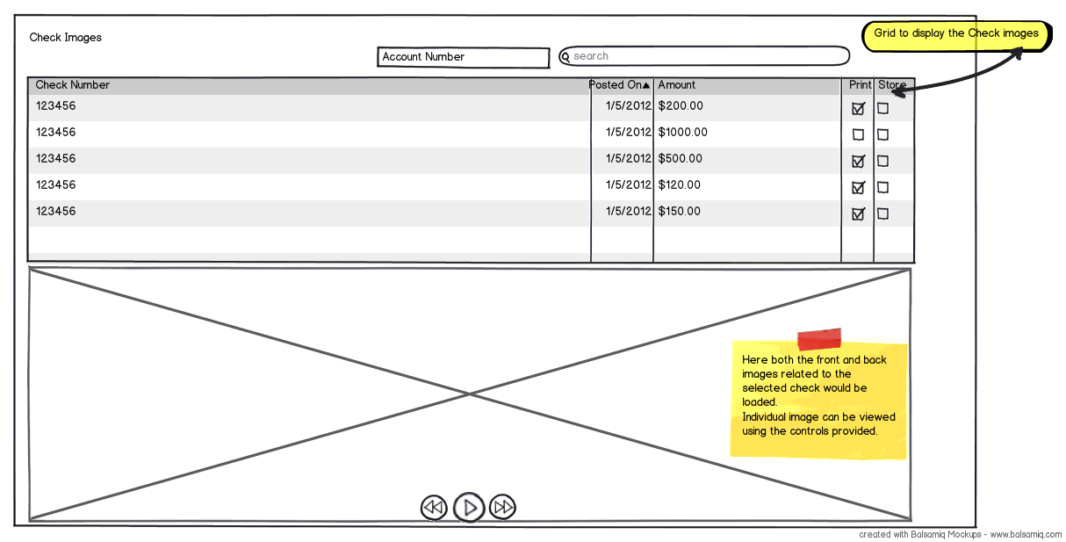
Here the grid would display all the checks based on the search criteria.
On the click of an item, the below image gallery would load both images of the check and show that to the user. Below the image gallery, the page controls allow the user to move between the front and back images of a check.
Over the grid, the capabilities to print / store the Check image would be provided as buttons (not as check boxes as shown).
SWAMI: Are you suggesting that print and store to case will be a one item at a time capability instead of multiple as well? why?
Re-search Option SWAMI: Research is one word
User could re-search by typing in new account number or other parameters and click on search button given at the top of the screen.
Printing Option
Printing would actually render a document similar to the format shown below.

Cheque Details American spelling is Check
Check A/c #: 886423078 Check Posted: 2011-02-12
Front Image

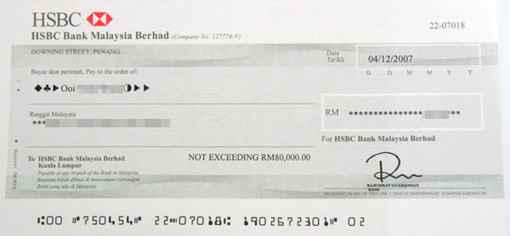
Back Image
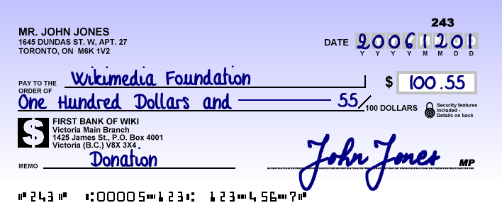

User should be able to download it to their hard disk and fire a print from the document.
SWAMI: Print should be direct from the application. You are suggesting a two-step approach. Look at it from a user standpoint and how painful it would be.
Storing Option
On click of store button, a document similar to the print would be created and stored as an attachment to the case.

