EX NIPR

Technical Design Document
Version: 1.0 Draft
Date of Release: 2-April-2012



This document contains proprietary information of Aithent and is tendered subject to the condition that the information be retained in confidence.
Document Information
Author(s) | : | Lakshmi kala. M
Document Status | : | Definitive
Compliance Status | :

Initial Release Information
 | Role | Date | Name | Sign
Reviewed By
Approved by
Released By

Document Control Information
Total Pages | : | 18
Review Period | : | As and when required
Distribution | : | Project Team, SQA

Revision History
Version No. | Release Date | Description of Change | Approved By
0.1 | 09/06/2005 | Original document

Table of Contents
1. Introduction 4
1.1 Purpose 4
1.2 Assumptions 4
1.3 Scope 4
2. Use Case driven Approach of NIPR EX Individual original/renewal process 4
2.1 Actors 4
2.2 Use Cases 4
2.3 Activity Diagram 5
3. Use Case flow implementation 8
i. Look up for NIPR application 8
Query to fetch all original application submitted by NIPR 8
Query for fetch all renewal application submitted by NIPR 8
ii. Validate application and Record transaction status 8
iii. RIRS/SAD validation 9
iv. Check whether BR license exists and is active 9
4. Show all unclean EX application as queue from LINX internal 9
4.1 Query to fetch EX NIPR records from LINX internal system 10
5. NIPR Flow for Original and Renewal for both Individual and Agency 13

Introduction

Purpose
The purpose of this document is to describe the data flow and object interactions between presentation, service, and persistence layers of the EX NIPR Individual original and renewal applications.

Assumptions
It is assumed that the reader is familiar with the ALiS concepts and architecture. This document is not intended to address the architecture of the ALiS. This document should be used by the developers of ALiS application during the construction phase of EX NIPR application.

Scope
The scope of this document is to discuss in detail about the various steps involved in processing of EX NIPR Individual Original and Renewal applications, their internal interactions with the ALiS application.

Use Case driven Approach of NIPR EX Individual original/renewal process
The below use case diagram illustrates the NIPR Ex Individual original and renewal process.

Actors
NIPR System: System which process NIPR applications
LINX Internal User: System which controls the activities of Companies, Licensees, Providers.

Use Cases
- Look for NIPR EX application
System shall check whether there is any EX Individual or renewal application submitted through NIPR gateway.
- Validate application and Record transaction status
Mark application as clean or unclean and record the transaction status, in LINX internal system.
- Show all unclean EX application as Queue
Show all EX pending and clean applications from NIPR.
- Process pending application
Validate the application status, and issue license, if all the business rules are satisfied.

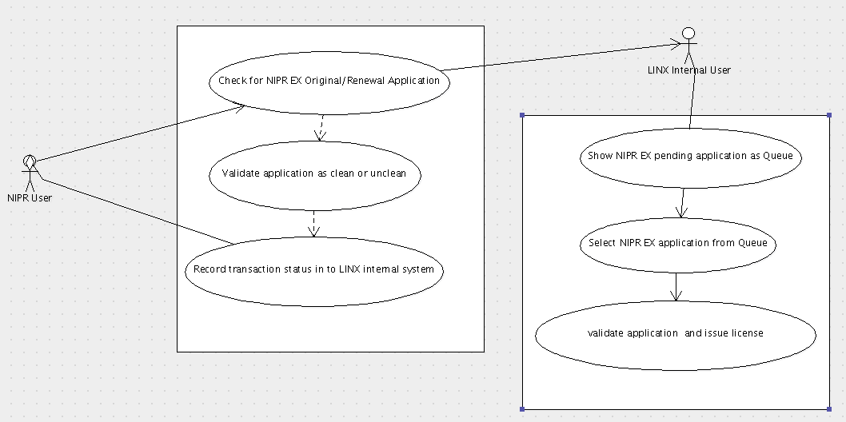
Activity Diagram
The below activity diagram describe the workflow behavior of the proposed EX NIPR application processing system. Activity diagram refer to the state of processing the application. The diagram describes the state of activities and also shows the sequence of activities performed. The idea is to use activity diagram to model the workflow behind the system being designed.
The following diagram illustrates the sequences of activities during the processing of EX NIPR Individual original and renewal applications.
LINX - Look up for NIPR EX original/renewal application
NIPR
Is Original?
Mark application as clean if:
BR active
No affirmative answer
No open BC
License Fee is correct
Record transaction into LINX internal application with the indication of license is not issued. This data will be processed from LINX Internal application.
Issue License. Record transaction into LINX internal application with the indication of license is issued.
Internal
Mark application as clean if:
BR active
No affirmative answer
No open BC
License Fee is correct
BR must be renewed
Is clean?

Application status will remain the same
Clean
Issue License
Internal
Show queued NIPR EX original/renewal application
Select EX NIPR application for Processing
Internal user can mark the application as clean and process the application, by validating the following:
1. BR is licensed and active
2. No Affirmative answer
3. License Fee

Internal user can mark the application as clean and process the application, by validating the following:
1. BR is licensed and active
2. BR already renewed
3. No affirmative answer
4. License Fee
Is Original?

Use Case flow implementation

Look up for NIPR application
NIPR will look for EX Original/Renewal Application from LWGNLIC_APPLOG table and validate the application as clean or not clean using the validation(s) defined in the validateNRLentity.xml. If application is valid, then issue license. Finally record the status (Pending/Issued) in the LINX database.

Query to fetch all original application submitted by NIPR
SELECT PK_APPLOG,FK_LICENSEE,FK_CLASS,RIRS,SAD,FK_APPLICATIONTYPE FROM LWGNLIC_APPLOG WHERE APPLOG_IMPORTDATE IS NOT NULL AND FK_APPLICATIONTYPE=(SELECT PK_CODELST FROM LWGNCODELST WHERE CODELST_PARENTCODE='APPTYPE' AND CODELST_CODE='ORG') AND FK_LICENSEE IS NOT NULL AND FK_CLASS IS NOT NULL AND APPLOG_STATSDATE IS NULL and FK_CODELST_APPSTATUS is null

Query for fetch all renewal application submitted by NIPR
SELECT PK_APPLOG,FK_LICENSEE,FK_CLASS,RIRS,SAD,FK_APPLICATIONTYPE FROM LWGNLIC_APPLOG WHERE APPLOG_IMPORTDATE IS NOT NULL AND FK_APPLICATIONTYPE=(SELECT PK_CODELST FROM LWGNCODELST WHERE CODELST_PARENTCODE='APPTYPE' AND CODELST_CODE='REN') AND FK_LICENSEE IS NOT NULL AND FK_CLASS IS NOT NULL AND APPLOG_STATSDATE IS NULL and FK_CODELST_APPSTATUS is null

Validate application and Record transaction status
SP_NIPR_VALIDATEFEE used to validate whether fee given by NIPR is valid. We don’t care about the fee amount like we have in our current implementation. Even if it is less application is accepted. The application is accepted and the relevant data updated in the APPRECEIVED table. User will see the “FEE” checkbox in the application processing queue. They will manually select the checkbox and save, if there is a fee amount mismatch (less than stipulated).

RIRS/SAD validation
RIRS, SAD fields in LWGNLIC_APPLOG table will be used to determine whether the licensee has any remarkable entries in those databases. If any of those columns has a value, greater than 0, then that licensee is blue carded.

Check whether BR license exists and is active
After validating all the business logic, update application table with Pending/Pending Issue Status. If status is Pending Issue then call SP_PRS_ISSUELICENSE to issue license.
If class is EX, then Call saveNIPRInfoToAppReceived() to save NIPR details into LWGNLIC_APPRECEIVED and LWGNLIC_APPFORCLASS tables.
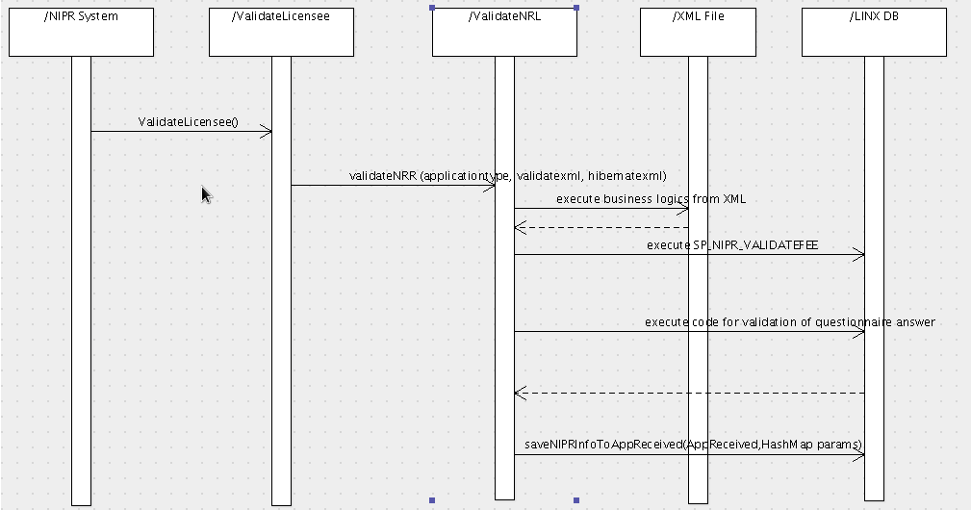
Fig. Sequence diagram representing processing of NIPR application

Show all unclean EX application as queue from LINX internal
LINX system will show the NIPR EX original/renewal application by using the V_APPRECEIVED view based in the source as 'NIPR' and application type with the indication of whether License is issued or not.
Add FK_LICCLASS, FK_CODELST_APPLICATIONTYPE fields in V_APPRECEIVED from LWGNLIC_APPFORCLASS.

Query to fetch EX NIPR records from LINX internal system
SELECT PARENT_FNAME,PARENT_MNAME,PARENT_LNAME,BTYPE,PARENT_SSN,PARENT_DOB,APPRECEIVED_IRREGDONE,APPRECEIVED_SUBDATE,SOURCEVAL,PK_APPRECEIVED,FK_LICENSEE,LICENSEE_LICENSENUM,FKBTYPE,APPRECEIVED_REFNUM,APPRECEIVED_SCHOOLCODE,APPRECEIVED_DOCREC,APPRECEIVED_NASDREC,APPRECEIVED_DOBFEE,trim(lower(APPFORCLASS_LISISSUE)),trim(lower(PENDINGFEE)),FK_PARENTENTITYID FROM V_APPRECEIVED WHERE SOURCEVAL='N' AND BTYPECODE in ('I','T') and fk_licclass=6('EX') and FK_CODELST_APPLICATIONTYPE='org/ren';

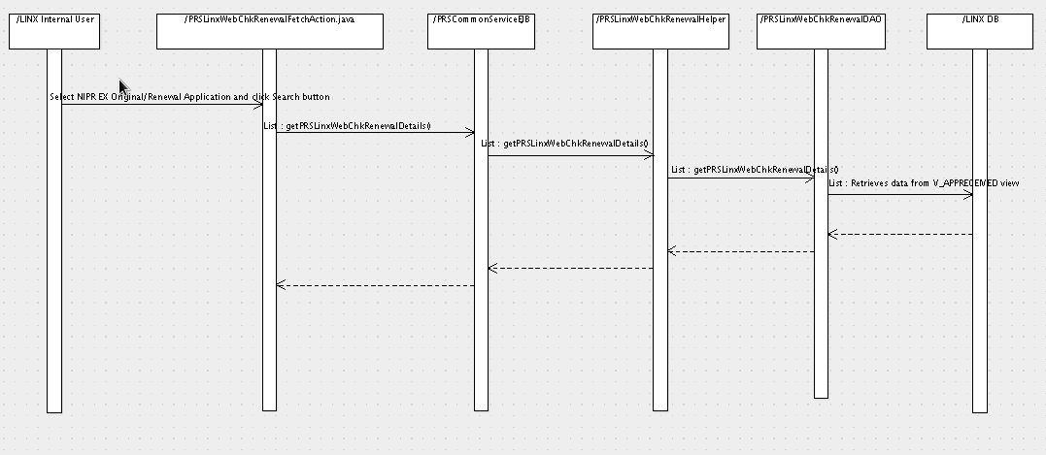
Fig. Sequence diagram for show all unclean EX application as Queue
Process pending application:
All unclean application is validated and processed. License is issued for all application once it is marked as clean, by an internal user.
Pending queue will have the below checkboxes:
- BR active
- Affirmative
- Fee
License will be issued only when all checkboxes have been checked and saved.
If BR class is not active, even if the user tries to by-pass this validation by clicking the checkbox, then the user will be prompted about this and license will not be issued.

Sequence diagram for processing NIPR application from LINX internal system
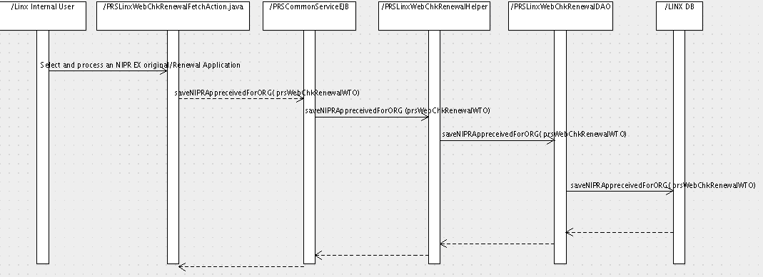
Fig. Sequence diagram representing the processing of an EX NIPR application by an internal user

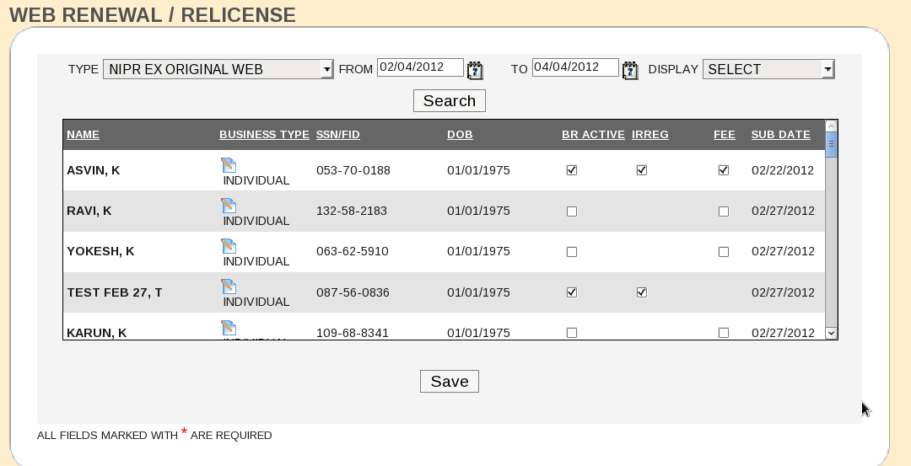

Fig. Prototype representing the screen, using which the internal user will process an EX NIPR unclean applications.
The display drop down will display options like “All, Pending, Issued”. When the status of the application is “Pending”, the application should be in LINX with the background question and Fee details.
Record will be there in the queue, even when the license is issued. Issued licenses can be searched with the “Display” option as “Issued”. The lower portion of the screen portraying the licensee information and the status will be available. APPFORCLASS table will still be used.

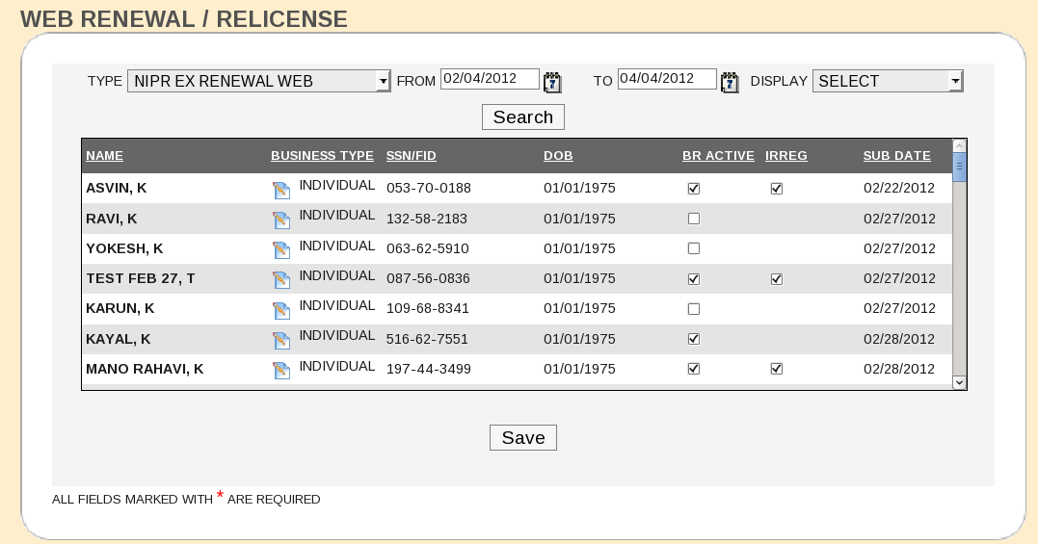
Fig. Prototype representing the screen, using which the internal user will process an EX NIPR unclean applications.

NIPR Flow for Original and Renewal for both Individual and Agency
From NIPR/java/ValidateLicensee.java we will call validateNRL(Java file). validateNRR method.
In validateNRR method the below process will be executed
1) Fetch application from LWGNLIC_APPLOG using below query
- For ORG
queryBuffer="SELECT PK_APPLOG,FK_LICENSEE,FK_CLASS,RIRS,SAD,FK_APPLICATIONTYPE FROM LWGNLIC_APPLOG WHERE APPLOG_IMPORTDATE IS NOT NULL AND FK_APPLICATIONTYPE=(SELECT PK_CODELST FROM LWGNCODELST WHERE CODELST_PARENTCODE='APPTYPE' AND CODELST_CODE='ORG') AND FK_LICENSEE IS NOT NULL AND FK_CLASS IS NOT NULL AND APPLOG_STATSDATE IS NULL and FK_CODELST_APPSTATUS is null";
- For REN
queryBuffer="SELECT PK_APPLOG,FK_LICENSEE,FK_CLASS,RIRS,SAD,FK_APPLICATIONTYPE FROM LWGNLIC_APPLOG WHERE APPLOG_IMPORTDATE IS NOT NULL AND FK_APPLICATIONTYPE=(SELECT PK_CODELST FROM LWGNCODELST WHERE CODELST_PARENTCODE='APPTYPE' AND CODELST_CODE='REN') AND FK_LICENSEE IS NOT NULL AND FK_CLASS IS NOT NULL AND APPLOG_STATSDATE IS NULL and FK_CODELST_APPSTATUS is null";
2) We are getting the userId from SEC_USER table as follows
- String usersql="select PK_USERID from SEC_USER where TRIM(USER_LOGINNAME) = TRIM('NRR') and deletedflag =0";
3) We iterate the following for all licensee fetch by the step 1.
4) The below procedure is used to update lwgnlic_application reneffdate,renexpdate(temp column values)
- SP_PRS_CALCULATEEXPIRYDATE(?,?,?,?,?,?)} procedure
5) Get the Licensee details(Submitted through NIPR) from LWGNLIC_LICENSEE table and LWGNLIC_APPLICATION table as follows
- For ORG below hibernate queries are used to fetch data from lwgnlic_licensee and lwgnlic_application table
queryBuffer="from Licensee where id="+applog[1] ;
queryBuffer="from PRSApplication where applicationIssuelicense=0 and fkLicclass="+applog[2].toString()+ " and applicationIsresident=0 and fkCodelstAppstatus not in ( select pkcodelst from CodeList where lower(trim(codelst_code)) not in('y','e','a','i') and trim(lower(codelst_parentcode))='appstatus' and deletedflag=0 ) and fkCodelstAppsource=(( select pkcodelst from CodeList where lower(trim(codelst_code))='n' and trim(lower(codelst_parentcode))='as' and deletedflag=0 ))";
- For Renewal
queryBuffer="from Licensee where id="+applog[1] ;
queryBuffer="from PRSApplication where fkLicclass="+applog[2].toString()+ " and applicationRenewalsent=1 and applicationIsresident=0 and APPLICATION_RENEWALISSUEDATE is null and fkCodelstAppstatus in ( select pkcodelst from CodeList where lower(trim(codelst_code)) in('a','i') and trim(lower(codelst_parentcode))='appstatus' and deletedflag=0 ) ";
- If there is no record from above query then we are updating the LWGNLIC_APPLOG table as follows
queryBuffer="UPDATE LWGNLIC_APPLOG SET APPLOG_COMMENTS='No Application toProcess',APPLOG_STATSDATE=SYSDATE,FK_CODELST_APPSTATUS='"+rejectedStatus+"' WHERE PK_APPLOG="+applog[0];
6) If record exist for processing then call the business logic written in validatenrlentity.xml for each licensee.
7) If business logic is success then we are validating the fee using call SP_NIPR_VALIDATEFEE(?,?) procedure
8) Finally we are calling the IssueLicense procedure as follows if the app satisfies the business logic and validfee and No Blue card and No Irrugularity
- update lwgnlic_application table niprid=null
queryBuffer="UPDATE LWGNLIC_APPLICATION SET niprid=null WHERE FK_LICENSEE="+ licensee.getId() + " AND FK_LICCLASS="+applog[2];
- update lwgnlic_application table status as pending issue using below query
queryBuffer="UPDATE LWGNLIC_APPLICATION SET FK_CODELST_ISSUELICSTATUS=(SELECT PK_CODELST FROM LWGNCODELST WHERE LOWER(TRIM(CODELST_CODE))='y' AND LOWER(TRIM(CODELST_PARENTCODE))='appstatus' AND DELETEDFLAG=0 ),APPLICATION_PROCESSDATE = sysdate,FK_CODELST_APPSOURCE=(select max(pk_codelst) from lwgncodelst where codelst_parentcode ='AS' and codelst_code ='N'),LASTMODIFIEDON=sysdate,LASTMODIFIEDBY="+userId +" WHERE FK_LICENSEE="+ licensee.getId() + " AND FK_LICCLASS="+applog[2];
- Update LWGNLIC_APPLOG table with status as 'Accepted' using below query
queryBuffer="UPDATE LWGNLIC_APPLOG SET APPLOG_COMMENTS=APPLOG_COMMENTS||"+"'"+temperrorMessage+"',APPLOG_STATSDATE=SYSDATE,FK_CODELST_APPSTATUS='"+acceptedStatus+"' WHERE PK_APPLOG="+applog[0];
- Call issue license procedure
SP_PRS_ISSUELICENSE(?,?,?,?) procedure
- Update LWNGLIC_LICENSEHISTORY using below query
queryBuffer="UPDATE LWGNLIC_LICENSEHISTORY SET LICENSEHIS_EXPIRYDATE=(SELECT APPLICATION_RENEWALEXPDATE FROM LWGNLIC_APPLICATION WHERE FK_LICENSEE = " +applog[1] + " and FK_LICCLASS = " +applog[2] + " and FK_CODELST_APPLICATIONTYPE = " + licensee.getApplicationType() +" ) WHERE PK_LICENSEHISTORY = (select max(PK_LICENSEHISTORY) from LWGNLIC_LICENSEHISTORY where FK_LICENSEE = "+ licensee.getId() + " AND FK_LICCLASS="+applog[2] + " and FK_CODELST_APPLICATIONTYPE = " + licensee.getApplicationType() +")";
9) If the business logic fails then the steps are
- update lwgnlic_application table status as pending using below query
queryBuffer="UPDATE LWGNLIC_APPLICATION SET FK_CODELST_ISSUELICSTATUS=(SELECT PK_CODELST FROM LWGNCODELST WHERE LOWER(TRIM(CODELST_CODE))='p' AND LOWER(TRIM(CODELST_PARENTCODE))='appstatus' AND DELETEDFLAG=0 ) WHERE FK_LICENSEE="+licensee.getId() +" AND FK_LICCLASS="+applog[2];
- Update LWGNLIC_APPLOG table with status as 'Rejected' using below query
queryBuffer="UPDATE LWGNLIC_APPLOG SET APPLOG_COMMENTS='"+temperrorMessage+"',APPLOG_STATSDATE=SYSDATE,FK_CODELST_APPSTATUS='"+rejectedStatus+"' WHERE PK_APPLOG="+applog[0];
- Update LWNGLIC_LICENSEHISTORY using below query
queryBuffer="UPDATE LWGNLIC_LICENSEHISTORY SET FK_CODELST_STATUS=(SELECT PK_CODELST FROM LWGNCODELST WHERE LOWER(TRIM(CODELST_CODE))='p' AND LOWER(TRIM(CODELST_PARENTCODE))='appstatus' AND DELETEDFLAG=0 ) WHERE PK_LICENSEHISTORY = (select max(PK_LICENSEHISTORY) from LWGNLIC_LICENSEHISTORY where FK_LICENSEE = "+ licensee.getId() + " AND FK_LICCLASS="+applog[2] + " and FK_CODELST_APPLICATIONTYPE = " + licensee.getApplicationType() +")";
10) Call SP_NIPR_FINALUPDATE(?,?,?,?) procedure.
APPENDIX - REVIEW COMMENTS
Queries | Comments | Date
When we say the application is pending, background question / fee should be in LINX. | Need discussion. | 04/10/2012

