EX NIPR

Technical Design Document
Version: 1.2 Draft
Date of Release: 14-June-2012


This document contains proprietary information of Aithent and is tendered subject to the condition that the information be retained in confidence.
Document Information
Author(s) | : | Lakshmi kala. M
Document Status | : | Definitive
Compliance Status | :

Initial Release Information
 | Role | Date | Name | Sign
Reviewed By
Approved by
Released By

Document Control Information
Total Pages | : | 15
Review Period | : | As and when required
Distribution | : | Project Team, SQA

Revision History
Version No. | Release Date | Description of Change | Approved By

Table of Contents
1. Introduction 1
1.1 Purpose 1
1.2 Assumptions 1
1.3 Scope 1
2. Use Case driven Approach of NIPR EX agency renewal process 1
2.1 Actors 1
2.2 Use Cases: 1
2.3 Activity Diagram 2
3. Use Case flow implementation 5
i. Look up for NIPR application 5
ii. Validate application and Record transaction status 6
iii. RIRS/SAD validation 6
iv. Check whether BR license exists and is active 6
4. Submit sublicensee background questions through LINX external 8
5. Show all unclean EX application as queue from LINX internal 9
5.1 Query to fetch EX NIPR records from LINX internal system 9

Refer Excess Line App from NIPR_v_1 3

Introduction

Purpose
The purpose of this document is to describe the data flow and object interactions between presentation, service, and persistence layers of the EX NIPR Agency original and renewal applications.

Assumptions
It is assumed that the reader is familiar with the ALiS concepts and architecture. This document is not intended to address the architecture of the ALiS. This document should be used by the developers of ALiS application during the construction phase of EX NIPR application.

Scope
The scope of this document is to discuss in detail about the various steps involved in processing of EX NIPR Agency Original and Renewal applications, their internal interactions with the ALiS application.

Use Case driven Approach of NIPR EX agency renewal process
The below use case diagram illustrates the NIPR Ex Agency original and renewal process.

Actors
NIPR System: System which process NIPR applications
LINX Internal User: System which controls the activities of Companies, Licensees, Providers.
LINX External User: System which process Agency's member original/renewal applications online.

Use Cases:
- Look for NIPR EX application
System shall check whether there is any EX Agency renewal application submitted through NIPR gateway.
- Validate application and Record transaction status
Mark application as clean or unclean and record the transaction status, in LINX internal system.
- Submit sub-licensee background questions through LINX external
Process member’s renewal applications and record the transaction status in LINX internal system for completed Agencies.
- Show all unclean EX application as Queue
Show all EX pending and clean applications from NIPR.
- Process completed Agency applications through LINX internal
Validate completed agency applications and issue license for clean applications.

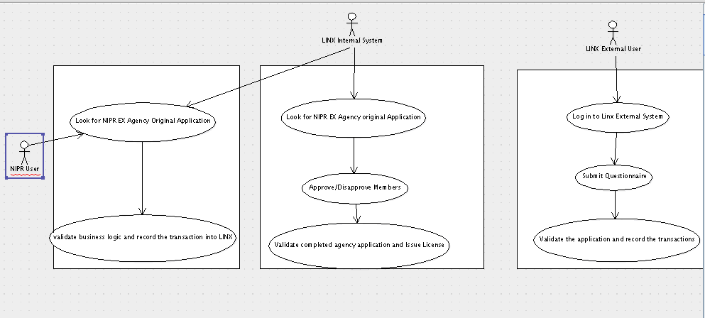

Activity Diagram
The below activity diagram describe the work flow behavior of the proposed EX NIPR application processing system. Activity diagram refer to the state of processing the application. The diagram describes the state of activities and also shows the sequence of activities performed. The idea is to use activity diagram to model the work flow behind the system being designed.
The following diagram illustrates the sequences of activities during the processing of EX NIPR Agency renewal applications.

NIPR System

Look for NIPR Agency Renewal Application

Insert agency status into LWGNLIC_APPRECEIVED table for internal process
Check BR is active and renewed. Check all sublicensees are active in BR.
Fee and Blue card values.

LINX internal system

Yes
No
Yes
No
Look for Agency Renewal Application
Is Clean Application?
1. BR Active
2. Fee

3.
3.No Blue card
4.One Member should be Approved
Is Completed Agency Application?
Process the Member application
1. Status Approved
2. No Irregularity.
3. BR Active and Renewed
Issue License
Remains in Queue

LINX external system

LINX External User – Log in
Submit Background questions
Record transaction into LINX with Irreg and BR Active flags

Load Instructions page
Confirmation Page with list of completed and pending sublicensee

Use Case flow implementation

Look up for NIPR application
NIPR will look for EX Renewal Application from LWGNLIC_APPLOG table and validate the application as clean or not clean using the validation(s) defined in the validateNRLentity.xml. If application is valid, then issue license. Finally record the status (Pending/Issued) in the LINX database.
Query to fetch all renewal application submitted by NIPR

SELECT PK_APPLOG,FK_LICENSEE,FK_CLASS,RIRS,SAD,FK_APPLICATIONTYPE FROM LWGNLIC_APPLOG,LWGNLIC_LICENSEE WHERE APPLOG_IMPORTDATE IS NOT NULL AND FK_APPLICATIONTYPE=(SELECT PK_CODELST FROM LWGNCODELST WHERE CODELST_PARENTCODE='APPTYPE' AND CODELST_CODE='REN') AND FK_LICENSEE IS NOT NULL AND FK_CLASS IS NOT NULL AND APPLOG_STATSDATE IS NULL and FK_CODELST_APPSTATUS is null AND LWGNLIC_APPLOG.FK_LICENSEE=LWGNLIC_LICENSEE.PK_LICENSEE AND FK_CODLEST_BUSINESSTYPE =(SELECT PK_CODELST FROM LWGNCODELST WHERE CODELST_PARENTCODE='BT' AND CODELST_CODE IN('C','L','P'))

Validate application and Record transaction status
SP_NIPR_VALIDATEFEE used to validate whether fee given by NIPR is valid. We don’t care about the fee amount like we have in our current implementation. Even if it is less application is accepted

RIRS/SAD validation
RIRS, SAD fields in LWGNLIC_APPLOG table will be used to determine whether the licensee has any remarkable entries in those databases. If any of those columns has a value, greater than 0, then that licensee is blue carded.

Check whether BR license exists and is active
In internal system check whether BR license is active and renewed before EX renewal
Validate the following business logic from renewalicense.xml.
HasSSN
hasSSNFIDReleaseFlag
licenseehasDOB
hasPOADate
hasFPRCnumber
hasValidHomeState
classHasLine
hasAddrofRecord
hasBusinessAddress
hasResidenceAddress
hasValidFeeAmount
isFirstRenewal
isCERequiredForClassLine
isRenewal
hasValidMembers
hasValidQualificationCompanyAppointment
memberHasLine
hasValidMemberrrenewal

Update application table with Pending/Pending Issue Status. If status is Pending Issue then call SP_PRS_ISSUELICENSE to issue license.
If class is EX, then Call saveNIPRInfoToAppReceived() to save NIPR details into LWGNLIC_APPRECEIVED and LWGNLIC_APPFORCLASS tables.

From NRL Member table and NRL member address, process each member, check the member already exists in LINX DB. If exists then insert record for member into LWGNLIC_APPRECEIVED and LWGNLIC_APPFORCLASS.
If member does not exist in LINX then insert record in LWGNPARENTENTITY, LWGNLIC_LICENSEE,LWGNLIC_ADDRESS, LWGNLIC_APPRECEIVED and LWGNLIC_APPFORCLASS.

Fig. Sequence diagram representing processing of NIPR application
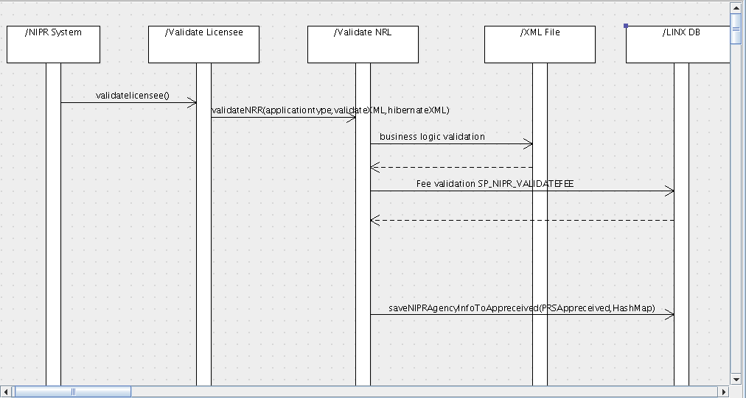

Submit sublicensee background questions through LINX external
Login Process
Login LINX external application using agency license number and sublicensee last 4 digits of SSN and DOB. Verify agency application source, if it is NIPR then validate sublicensee DOB and SSN from AITH_NRLMEMBER table instead of LWGNPARENTENTITY table.
Verify the given SSN is already exist is LINX system as LICENSEEE or LICENSEE MEMBER or UNLICENSED ENTITY.
If exist move LWGNPARENTENTITY, LWGNLIC_LICENSEE, LWGNLIC_ADDRESS, LWGNLIC_CONTACTMODE details from LINX system to tempdb. Create new record in LWGNLIC_MEMBER for this agency.
If it is not exist in LINX create new record in LWGNPARENTENTITY, LWGNLIC_LICENSEE, LWGNLIC_ADDRESS, LWGNLIC_CONTACTMODE (From AITH_NRLMEMADDRESS) and LWGNLIC_MEMBER tables.
Submit Questionnaire
Show NIPR questionnaire and get the response from sublicensee. Insert sublicensee responses in corresponding questionnaire tables.
Update NRLMEMBER_ISCOMPLETE flag as 1 in AITH_NRLMEMBER table.
Move temp data to LINX internal DB
Once the sublicensee completes the app, the app will be available to the internal user to process and sublicensee questionnaire will come into LINX. Internal user can Approve/Disapprove or Select the status of Review for the member. On click of save from the queue screen record will move from tempdb to main db.
Internal user will not be able to process the app unless all the sublicensee has completed the app. But if the internal user set the status of the sublicensee to Disapprove then we don’t need to worry whether that sublicensee completed the app.

Show all unclean EX application as queue from LINX internal
LINX system will show the NIPR EX original/renewal application by using the V_APPRECEIVED view based in the source as 'NIPR' and application type with the indication of whether License is issued or not.
Add FK_LICCLASS, FK_CODELST_APPLICATIONTYPE fields in V_APPRECEIVED from LWGNLIC_APPFORCLASS.

Query to fetch EX NIPR records from LINX internal system
SELECT PARENT_FNAME,PARENT_MNAME,PARENT_LNAME,BTYPE,PARENT_SSN,PARENT_DOB,APPRECEIVED_IRREGDONE,APPRECEIVED_SUBDATE,SOURCEVAL,PK_APPRECEIVED,FK_LICENSEE,LICENSEE_LICENSENUM,FKBTYPE,APPRECEIVED_REFNUM,APPRECEIVED_SCHOOLCODE,APPRECEIVED_DOCREC,APPRECEIVED_NASDREC,APPRECEIVED_DOBFEE,trim(lower(APPFORCLASS_LISISSUE)),trim(lower(PENDINGFEE)),FK_PARENTENTITYID FROM V_APPRECEIVED WHERE SOURCEVAL='N' AND BTYPECODE in ('C','L','P') and fk_licclass=6('EX') and FK_CODELST_APPLICATIONTYPE='REN';

Fig. Sequence diagram for show all unclean EX application as Queue
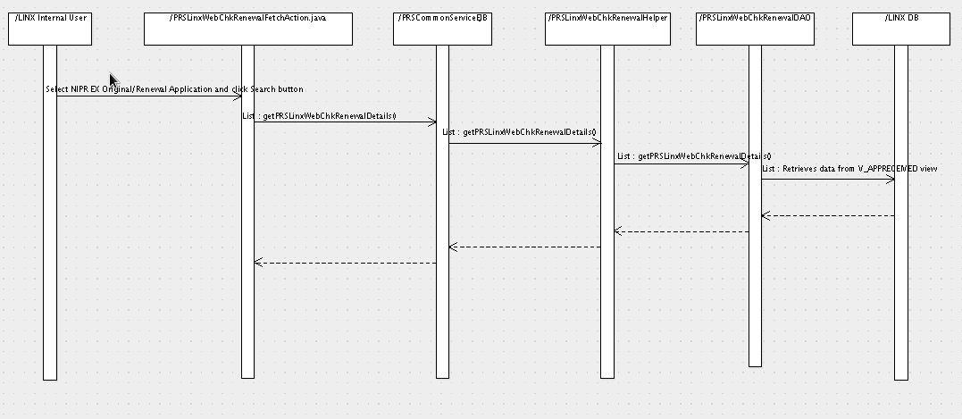
Process pending application:
All unclean application is validated and processed. License is issued for all application once it is marked as clean, by an internal user.
Pending queue will have APPROVAL link to approve/disapprove members. Member detail page will have below checkboxes
- Affirmative check box
- Link for quals to view/add the LOA
- Status (default to pending)
- Exist in BR
- Is Completed Flag (Checkbox which show whether sublicensee completed this questionnaire through LINX external application?)
- Will also show whether the sublicensee completed the app. If he sublicensee didn’t complete the app then it cannot be approved or pended or put under Review status. Though it can be put under disapprove status

After processing all member details, license will be issued only when below checkboxes are checked for an agency
- BR Active and renewed
- Fee
- Blue Card validation

If BR class is not active and renewed, even if the user tries to by-pass this validation by clicking the checkbox, then the user will be prompted about this and license will not be issued.

Sequence diagram for processing NIPR application from LINX internal system
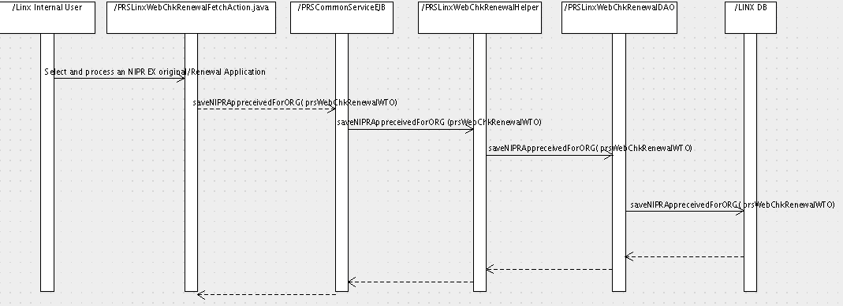
Fig. Sequence diagram representing the processing of an EX NIPR application by an internal user

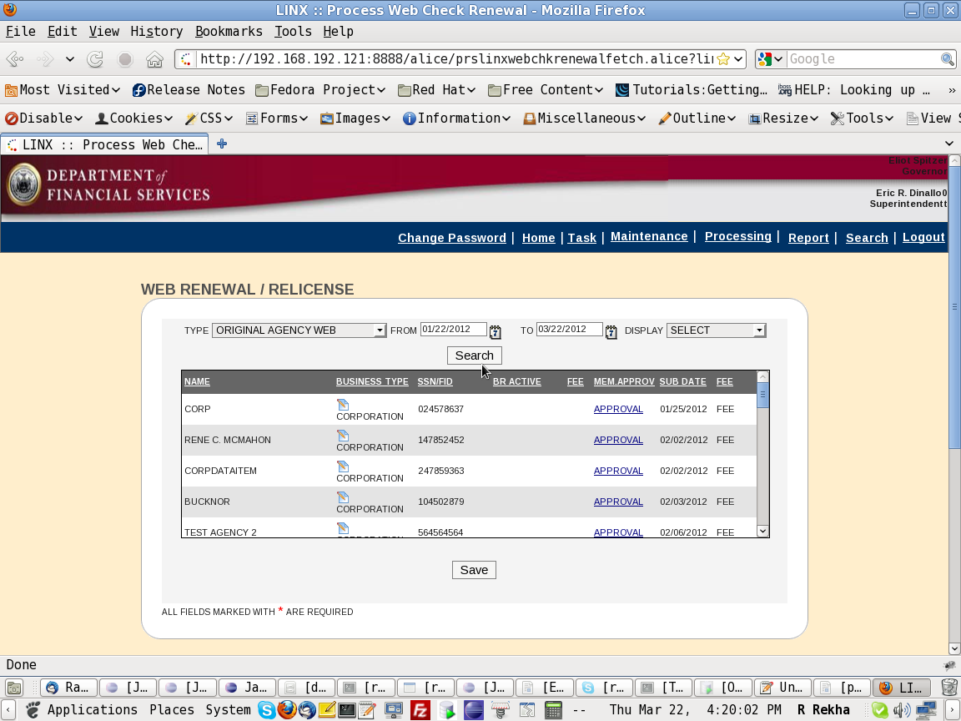
Fig. Prototype representing the screen, using which the internal user will process an EX NIPR unclean applications.

Approval link will be in RED if there is any member still pending.
The display drop down will display options like “All, Pending, Issued”.
Record will be there in the queue, even when the license is issued. Issued licenses can be searched with the “Display” option as “Issued”. The lower portion of the screen portraying the licensee information and the status will be available. APPFORCLASS table will still be used. Search criteria will include SSN/FID also.

End of document

