Aithent Meeting Management System

Technical Design Document
Version: 2.0 Draft
Date of Release: 21-Mar-2014



This document contains proprietary information of Aithent and is tendered subject to the condition that the information be retained in confidence.
Document Information
Author(s) | : | M. Lakshmi Kala
Document Status | : | Definitive
Compliance Status | :

Initial Release Information
 | Name | Date
Reviewed By | Amit Singh | 03/21/2014
Approved by
Released By

Document Control Information
Total Pages | : | 20
Review Period | : | As and when required
Distribution | : | Project Team, SQA

Introduction
Aithent meeting management system will be used to
- Schedule a meeting
- Take notes while the meeting is on-going or post meeting
- Generate meeting minutes
- Managing and tracking action items
- Send notifications
- Provide search for meetings, minutes of meeting, action items, attendees and agenda

Abbreviation, Acronyms and Definitions
Term used | Definition
AMMS | Aithent Meeting Management System.
MOM | Minutes of Meeting.
SRS | System Requirement Specifications.
Note Taker | Person responsible for taking meeting minutes.
* | Items to be part of next iteration.
Present Tense | Solr based full-text search engine.
Solr | open source enterprise search platform.
PTSC | Present Tense Setup and Configuration

Use Case Driven Approach of AMMS

Actors
- Meeting facilitator– Person who organizes the meeting. Define list of attendees and agenda's.
- Chairperson – Person who controls the meeting.
- Note taker – Person who takes the meeting notes and creates MOM.
- Attendee - Person who participates in the meeting.
- AMMS – System which sends MOM, action item reminders and status to all attendees.

Use Cases
- Login validation - Validates the authentication of the user logging in.
- Create/View/Edit Meeting (Schedule Meeting) – Explains about scheduling new meeting and update existing meeting.
- Create/View/Edit Minutes of Meeting – Explains about capturing Minutes of Meeting while meeting is in place or once meeting is completed.
- Create/View /Edit Action Items – Explains about defining, viewing and managing history of an Action Item.
- Sending reminders about Action items – Explains about sending reminders about pending or overdue action items.
- Search – Explains about search for action items, meetings, MOM etc.

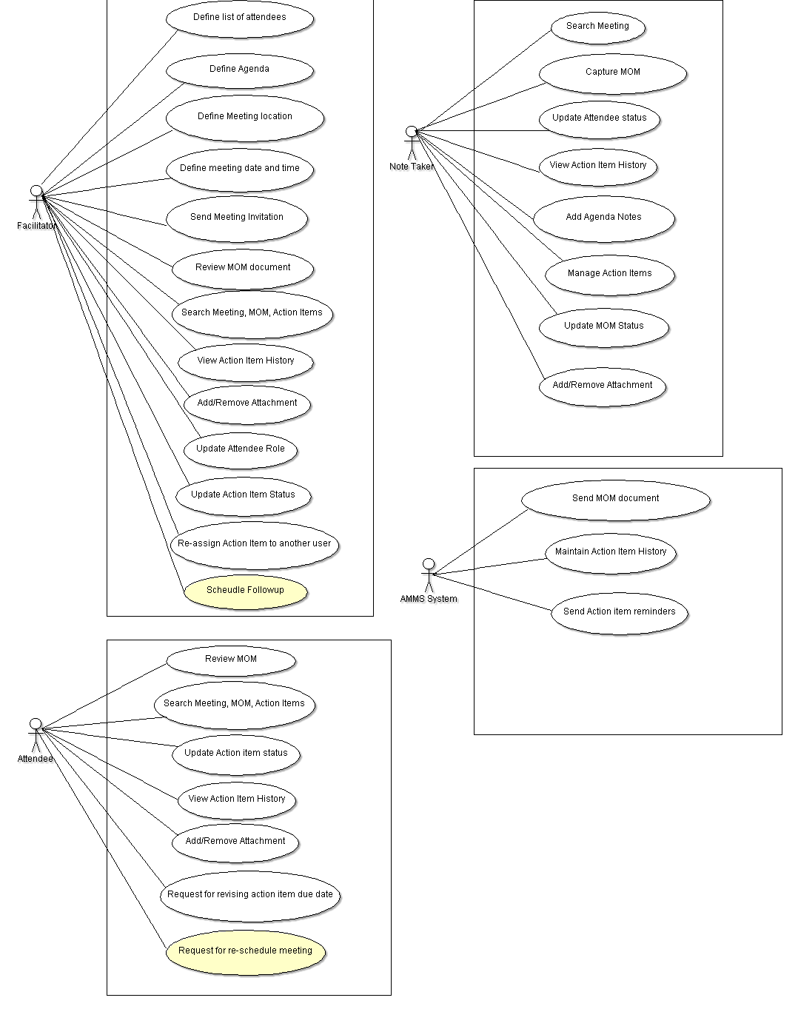

Fig. 1.0 Use Case Diagram
Note: Items highlighted in yellow to be part of next iteration.

System details

4.1 com.aithent.amms.service
This package contains all services that the System exposes to external clients (front-end or web service). It consists 1 sub-package that contains the service implementation
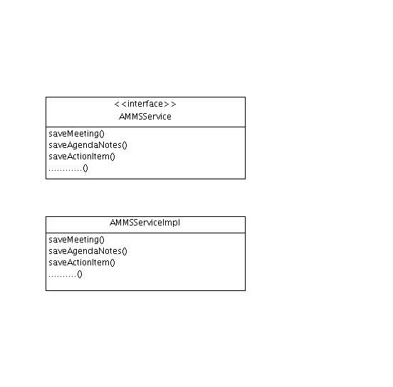
AMMSService - Interface exposing required methods to clients
AMMSServiceImpl - Implementing the interfaces declared in the interface.

4.2 Com.aithent.amms.helper
This package contains all helper objects. Helper class contains business logic validations.
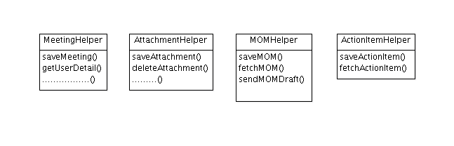

MeetingHelper – Contains methods related to create and edit meetings.
AttachmentHelper – Contains methods related to saving and fetching attachments.
MOMHelper – Contains methods related to MOM.

4.3 com.aithent.amms.dao
This package contains all DAO objects. These classes are responsible for interacting with the database.
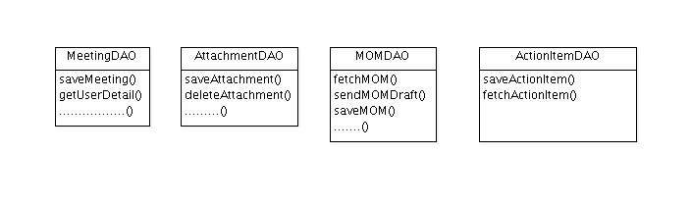

MeetingDAO – Contains methods related to create and edit meetings.
AttachmentDAO – Contains methods related to saving and fetching attachments.
MOMDAO – Contains method related to MOM.

4.4 Com.aithent.amms.domain
This package contains hibernate persistent objects. These classes represent table in a database
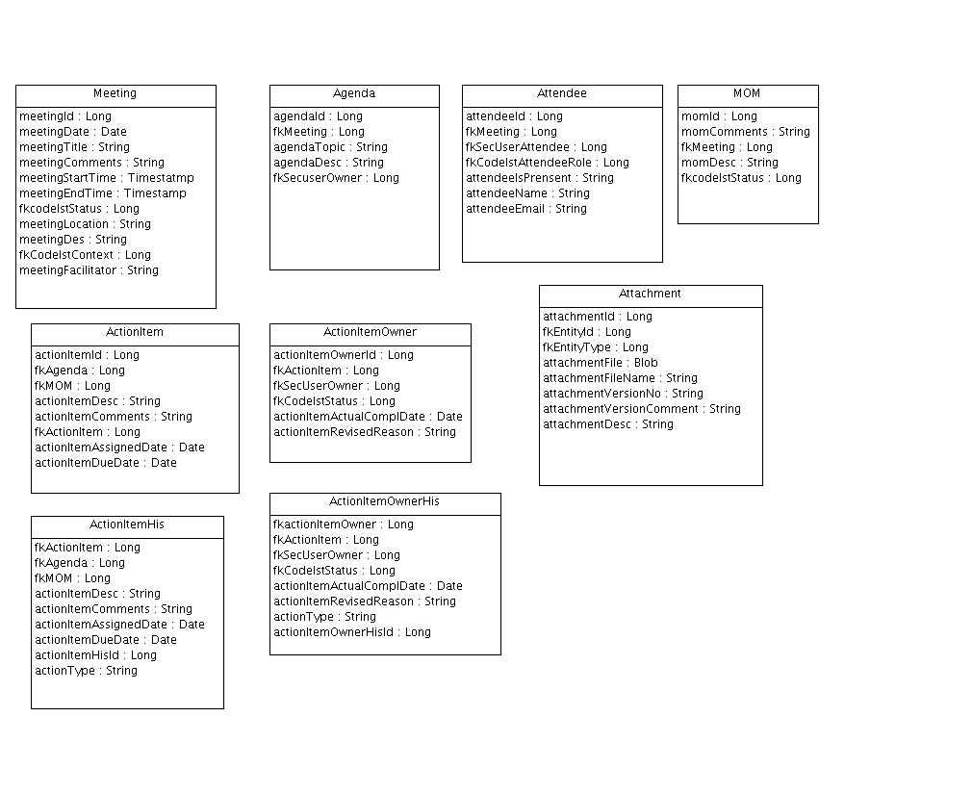
.

Meeting – Mapped with AMMS_MEETING table.
Agenda – Mapped with AMMS_AGENDA table.
Attendee – Mapped with AMMS_ATTENDEE table
MOMDetail – Mapped with AMMS_MOMDetail table
ActionItem – Mapped with AMMS_ACTIONITEM table.
Attachment – Mapped with AMMS_ATTACHMENT table.

4.5 Com.aithent.amms.pojoobjects
This package contains the model objects used as containers of request and response information passed between web-tier and the System.
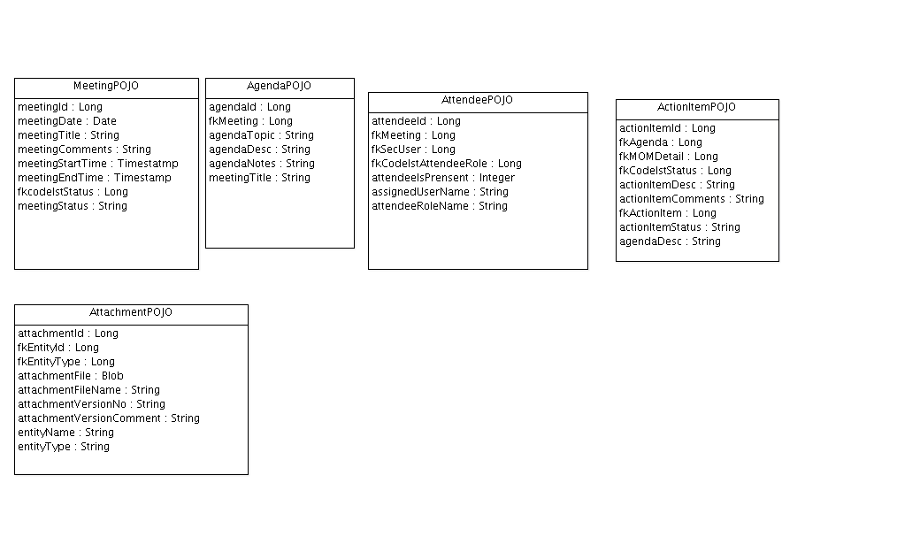

MeetingPOJO – Mapped with Meeting domain object
AgendaPOJO – Mapped with Agenda domain object
AttendeePOJO – Mapped with Attendee domain object
ActionItemPOJO – Mapped with ActionItem domain object
AttachmentPOJO – Mapped with Attachment domain object

4.6 Com.aithent.amms.exception
This package contains common exception classes.
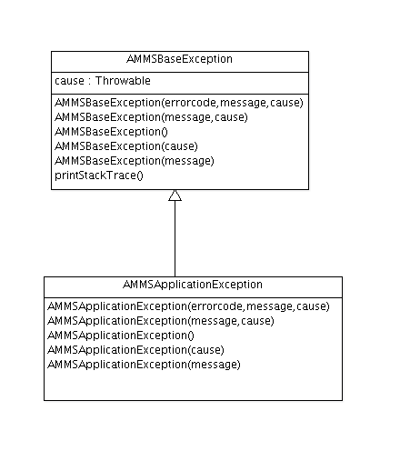
AMMSApplicationException - will throw this exception if any known application related exception happens in the underlying services.

Analysis of Use Cases

Login validation
Here the system validates whether the user logging in is a valid user or not. In case of Invalid user, the system displays an error message “Invalid user”. On successful validation, user logs in and the system displays the dashboard containing Meetings, My Action Items and Other Action Items.

Create/Edit Meeting (Schedule Meeting)
Logged in user can create/edit meetings. A meeting has a context (optional project information), title, description, list of agenda items, list of invited attendees, date, start time, end time facilitator, chairperson and note taker.
- Attendee: Meeting organizer defines list of attendees. This section contains attendee name, email address, role of the attendee. Attendee can be a facilitator, note taker, Chairperson or regular a participant. This section also provides field to specify presence of attendee in the meeting which can be updated once meeting is completed. If user tries to enter name of the attendee, it will display matching names using autocomplete and fetch name and email address from sec_user table. If attendee is guest or new user, then it is inserted in AMMS_ATTENDEENAME field in AMMS_ATTENDEE table. Attendee’s information gets stored in AMMS_ATTENDEE table.
- Agenda:This section allows user to provide agenda topic, description, owner, notes and attachments. Notes are updated once meeting is completed. Owners list is populated from sec_user table using autocomplete. Agenda details are stored in AMMS_AGENDA table.
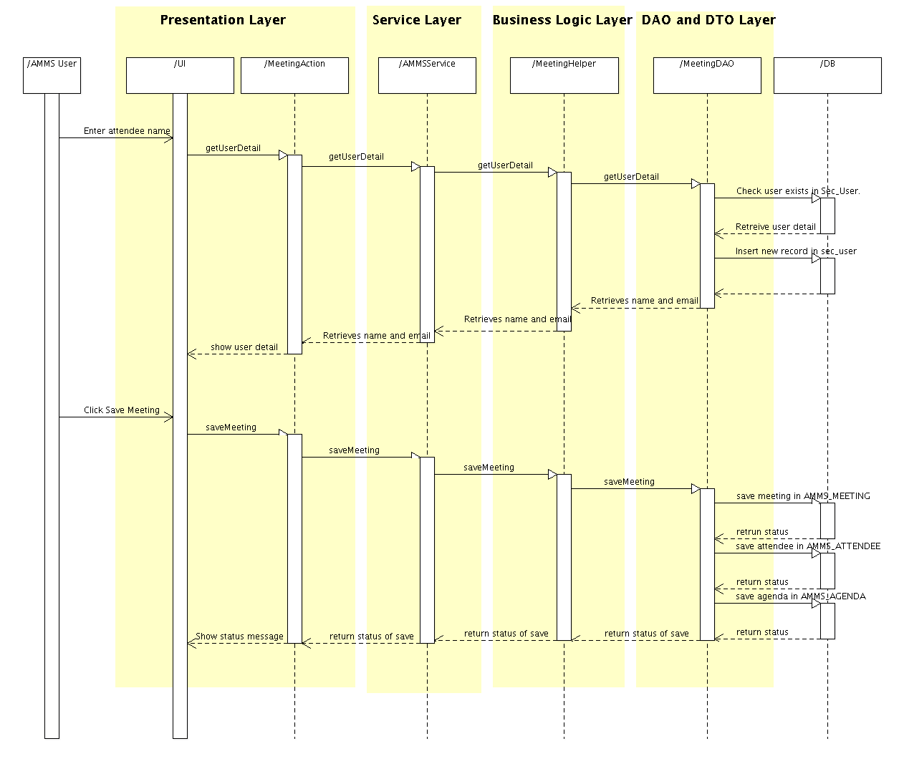
Fig. 1.1 Sequence diagram for Schedule Meeting

Once user saves meeting, it is stored in AMMS_MEETING table. List of attendee and agenda's are stored in AMMS_ATTENDEE, AMMS_AGENDA table respectively with foreign key reference as AMMS_MEETING. Email is sent to all attendees which has hyperlink to open scheduled meeting.
- Attachments: This section lists attachments related to agenda, action items or meeting. User can add new attachments and delete existing attachments. Attachments get stored as BLOB in FILE field of AMMS_ATTACHMENT table.
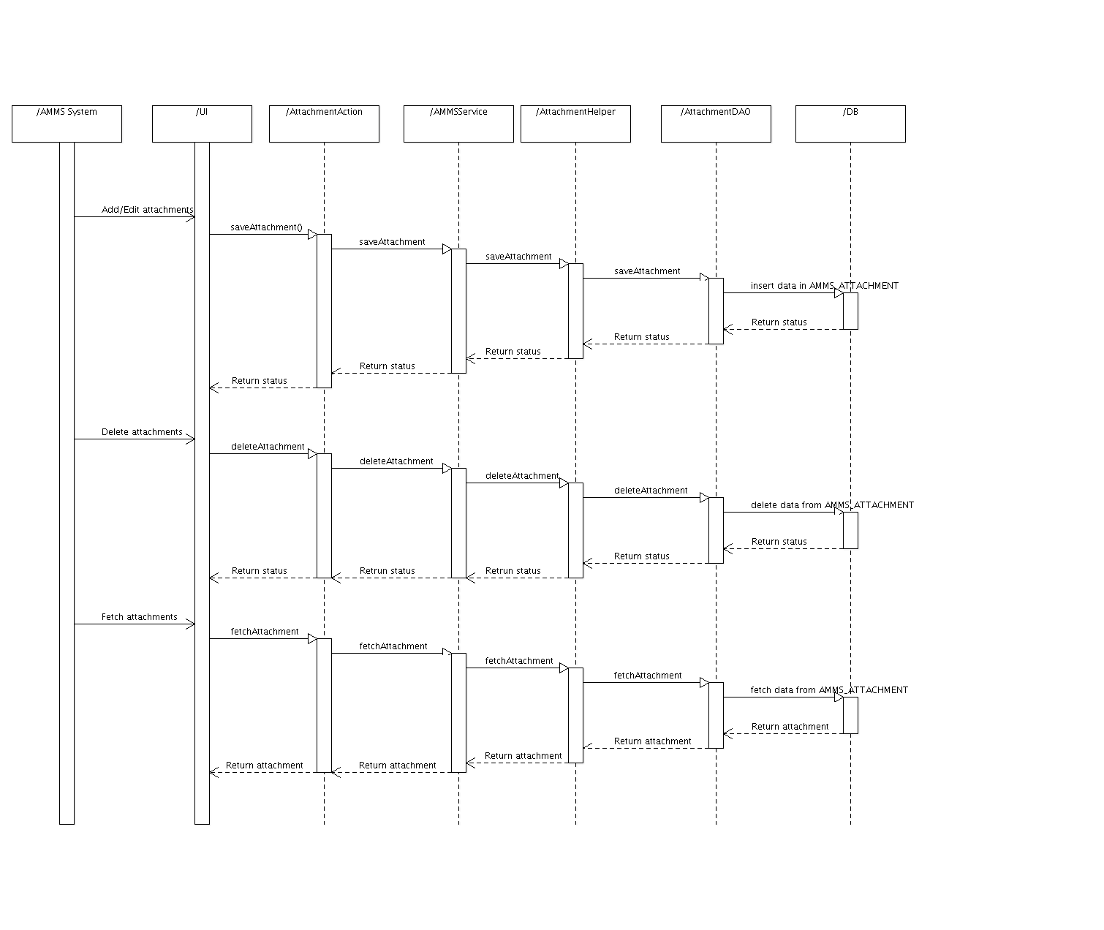
Fig. 1.2 Sequence diagram for Attachments

Create/Edit Minutes of Meeting
If logged in user is a note taker, s/he can create/edit Minutes of Meeting. MOM has meeting title, date, start time, end time, facilitator and other information. These are populated from Meeting. Each meeting contains only one MOM.
- Attendee: User can specify whether the attendee participated in the meeting or not. This updates ATTENDEE_ISPRESENT column value to Y or N in AMMS_ATTENDEE table. This section also allows adding new attendee who was not originally invited while scheduling meeting. New attendee details get inserted into AMMS_ATTENDEE table with ATTENDEE_ISPRESENT column value to Y.
- Agenda: User can add notes and attachments to the agenda defined while scheduling the meeting. Notes get updated in AGENDA_NOTES field in AMMS_AGENDA table. Attachments get stored in AMMS_ATTACHMENTS table.
- Action Items: User can add action items based on agenda or meeting. This includes action item title, agenda, owner and assigned date and due date. Attachments can also be added to action items if necessary. Action items get stored in AMMS_ACTIONITEM table.
- Changing status of an Action item: Action item status can be modified by owner or facilitator. This gets updated in AMMS_ACTIONITEM table and history table. Change in the status is notified to all attendees. New record gets inserted in AMMS_NOTIFICATION table to send an email. AMMS will also keep audit trail and provide history for the actions items.
- Requesting additional time for an Action item: Action item owner may request additional time to complete the task. To do this, owner has to change the status to “Revised”, which asks for new revised date and reason for changes. Also notification is sent to facilitator. Revised date and reason gets updated in AMMS_ACTIONITEM table and new record gets inserted in history table. To send email, new record is inserted in AMMS_NOTIFICATION table. Once MOM is approved MOM template is created and is updated in AMMS_MOMDETAIL table as blob.
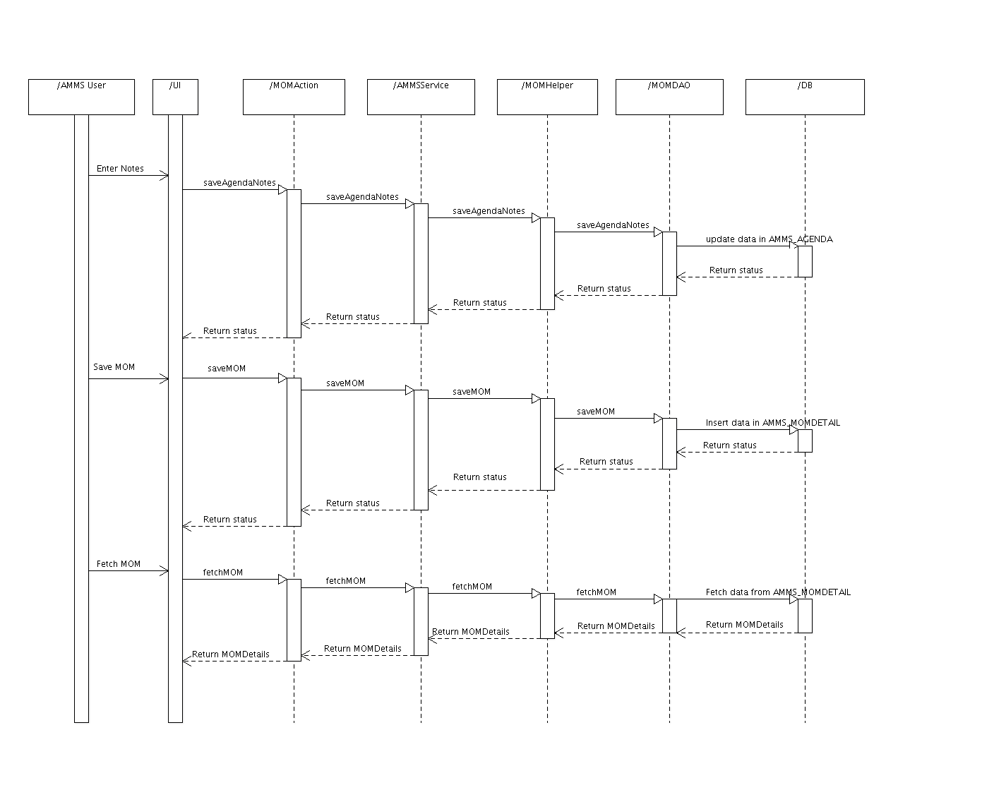
Fig. 1.3.Sequence diagram of MOM

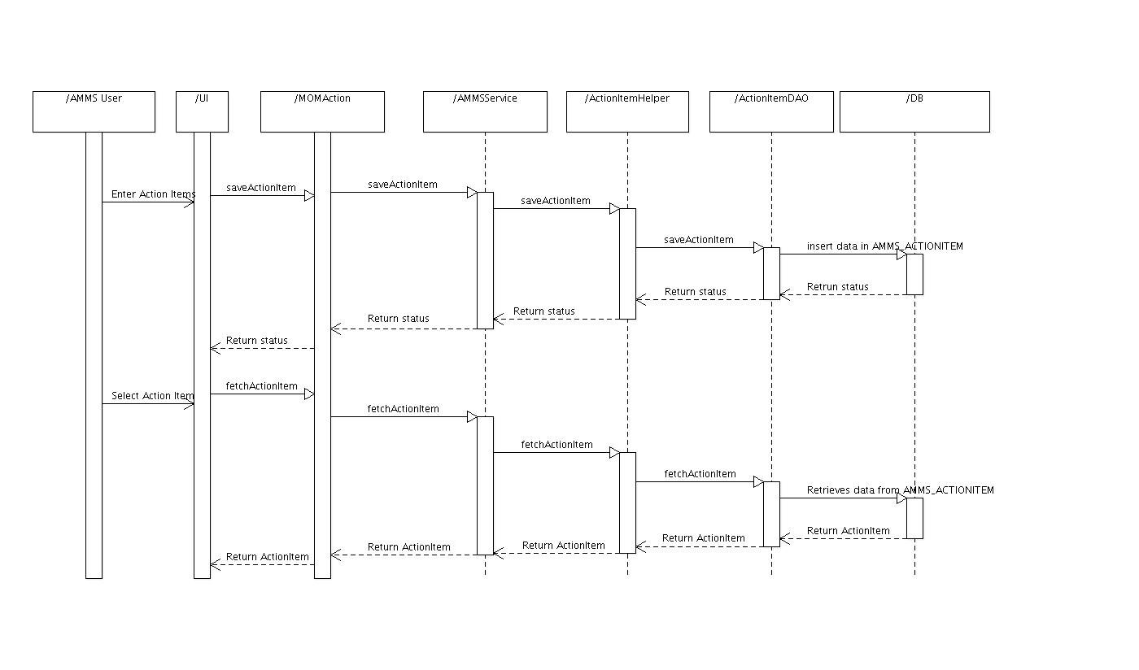

Fig 1.4 Action Items Sequence diagram

Dashboard:
Through Dashboard user can view scheduled Meetings, My Action Items and Other Action Items.
- Meetings: Shows Meeting title, Meeting date and time and Meeting Status along with hyperlink to create/view Minutes of meeting.
Query to fetch Meetings
Select MEETING_TOPICNAME, MEETING_DATE, MEETING_STARTTIME, MEETING_ENDTIME, FK_CODELST_STATUS from AMMS_MEETINGwhere pk_meeting in(select fk_meeting from AMMS_attendee where fk_user=(logged in user) and fk_codelst_attendeerole in('A','F','N','AO'));
- My Action Items: By default shows pending action items of the logged in user .User can view/edit action items for which s/he the owner.
Query to fetch Action Items
Select (select MEETING_TOPICNAME from AMMS_MEETING WHERE PK_MEETING=(SELECT FK_MEETING FROM AMMS_MOMDETAIL WHERE PK_MOMDETAIL=FK_MOMDETAIL) AS MEETINGTITLE,ACTIONITEM_DESCRIPTION,ACTIONITEM_ASSIGNEDDATE,ACTIONITEM_DUEDATE,FK_CODELST_ACTIONSTATUS from AMMS_ACTIONITEM where ACTIONITEM_ASSIGNEDTO in(logged in user) AND FK_CODELST_ACTIONSTATUS='Pending';

- Other Action Items: By default shows pending action items of the other attendees who are part of that particular meeting. The user can only view this but cannot modify, however, if logged in users is facilitator for corresponding meeting, user can update the action item details as well as status.
Query to fetch Action Items
Select (select MEETING_TOPICNAME from AMMS_MEETING WHERE PK_MEETING=(SELECT FK_MEETING FROM AMMS_MOMDETAIL WHERE PK_MOMDETAIL=FK_MOMDETAIL) AS MEETINGTITLE,ACTIONITEM_DESCRIPTION,ACTIONITEM_ASSIGNEDDATE,ACTIONITEM_DUEDATE,FK_CODELST_ACTIONSTATUS from AMMS_ACTIONITEM where ACTIONITEM_ASSIGNEDTO not in(logged in user) AND FK_CODELST_ACTIONSTATUS='Pending';

Sending reminders about Action items
On daily basis, AMMS will compare action item due date with current date and send an e-mail notification to the action item owner based on the number of days configured in the control code AIRD. For example if number of days is configured as ‘1’ and if due date is one day prior to current date, it inserts record in AMMS_NOTIFICATION table and an email is sent to owner of action item.

Search
To do search, full-text search engine called Present Tense will be used. It provides the following features:
- Full Text search
- Field search
- Number & Date Search
- Facet
- Highlighting
- Spelling suggestions
- Search by value ranges
- Response formats (xml, json etc.)

Present Tense configuration:

- Solr Configuration
- Index AMMS data
- GUI – HTML/JSP & JavaScript changes

PTSC helps us to setup our SQL and create server and client war files. We have to deploy those war files in our web server post that we have to index data.
Present Tense creates XML file which helps to create GUI, and html file to display data. If we want to generate XML at run time, then we need to insert records in configuration table where visibility, sequence, field type, maximum length and hyperlink details of each field is maintained.

5. High Level Architecture:

Controller
(Struts2)
GUI
(Jsp, JQuery
,Html5)
Validation
Data Mapping

Helper
DAO
(Hibernate)
Database
Service

