AGORA

User Registration Email Format

Version: 1.0
Date of Release: Jan 22, 2019



This document contains proprietary information of Aithent and is tendered subject to the condition that the information be retained in confidence.
Document Information
Author(s) | : | Lakshmi Kala M
Document Status | : | Draft
Compliance Status | : | Mandatory

Document Control Information
Total Pages | : | 8
Review Period | : | As and when required per scope of project.
Distribution | : | PL, TL and team members

Revision History
Version No. | Release Date | Description of Change | Approved By
1.0 | Jan 22, 2019 | Initial Release

Purpose
The purpose of the document is to review the registration email format from different competitors.

Agora:
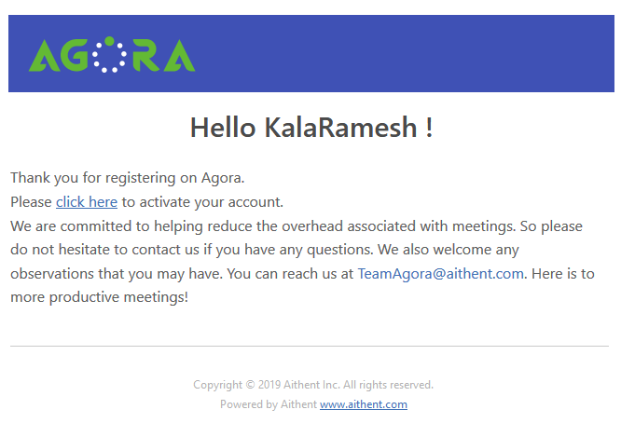

MeetingKing:

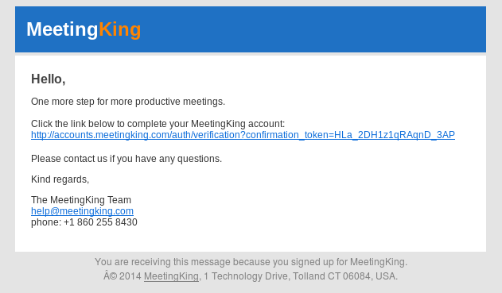

Lucid:
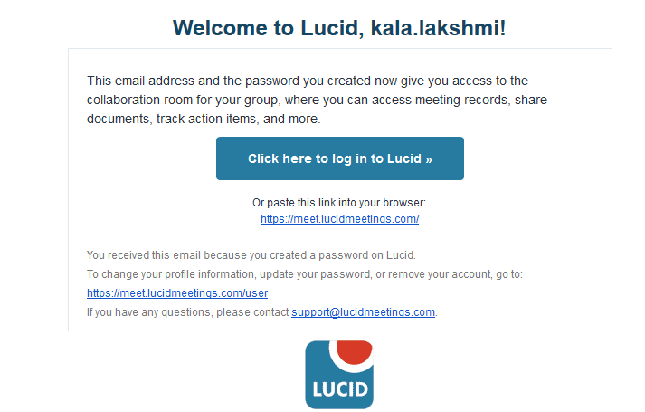

Beenote:

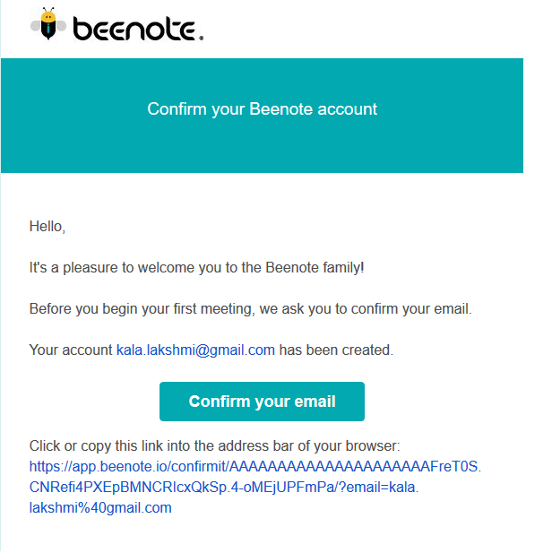

MeetingBooster:

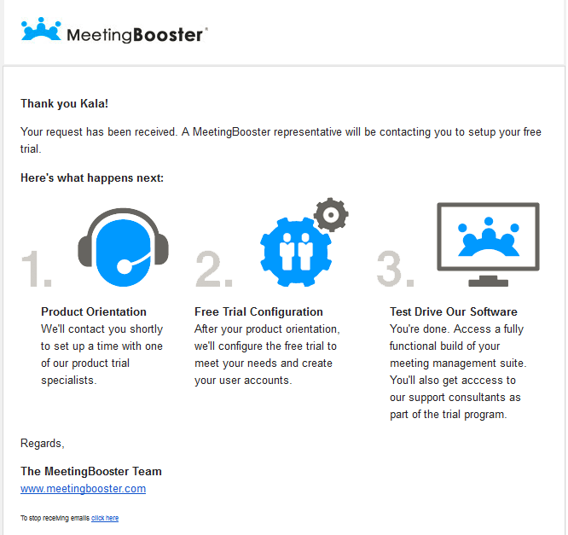

Zoom:

