LINX - NY-External

Software Requirement Specification

Individual Licensee Web Renewal

Reference Number: AITHENT-LINX-SRS-D

Version: 2.0

Date of Release: 27 / 03 /2012



This document contains proprietary information of Aithent and is tendered subject to the condition that the information be retained in confidence.

Document Information

Author(s) | :
Document Status | : | Definitive
Compliance Status | : | Mandatory

Initial Release Information

 | Role | Date | Name | Sign
Reviewed By | PL
Approved by | PM |  | Pradeep Prasad
Released By | PL

Document Control Information

Total Pages | : | 33
Review Period | : | As and when required
Distribution | : | Project Team

Revision History

Version No. | Release Date | Description of Change | Approved By
1.0 |  | System Requirement document
1.1
1.2

Table of Contents
1. Introduction 5
1.1 Purpose 5
1.2 Overview 5
2. Functional requirements 5
2.1 Individual / TBA licensee login 5
2.2 Business rules to calculate classes due renewal/ relicensing 6
2.3 Class Summary section 7
2.4 Renewal Entry 8
2.4.1 Instructions and Computation of total fee 8
2.5 Biographical 12
2.6 Submitter Info 16
2.7 Address 17
2.8 Questionnaire 20
2.9 CE detail 22
2.9.1 Attestation Page 27
2.9.2 License Fee 27
2.9.3 Invoice Page 32
2.10 Pay by check process in LINX 33
2.11 Processed On Web 34
2.12 Reports 34
2.13 Other Process 35
2.14 BR EX Process 35
3. Relicensing 38
3.1 Process flow of LINX External Relicensing 39
4. History Section 40
4.1.1 License history before processing in external 40
4.1.2 CE History 43
4.1.3 Address History 46
4.1.4 Cash History 49
4.1.5 Before processing through check 52
4.1.6 AFTER PROCESSING CHECK 54
5. Processing check through Internal Linx 57
5.1.1 License Fee 59

Introduction
This document defines various functionalities of LINX individual/TBA license web renewal process.

Purpose
The purpose of this document is to collect, analyze and define the user needs and functionalities of the features, which need to be configured.

Overview
The Department of Financial Services (DFS) will request licensee to submit their Renewal application and pay their licensing fees through the web. The web pages for each such application type shall be determined dynamically based on data stored in ALiS database tables. This will allow the Licensing Bureau to easily a) change their Web application pages for each application type, b) change the questions text on the Web application page, c) append other Web enabled license applications without creating another Web page, and d) perform entire tasks without much of technical staff participation. During this Web enabled license submission process the licensee must be able to view all the pages, which accesses common directory containing the code with business and validation rules. Due to this updating of multiple pieces of code can be eliminated when a single business or validation rule is modified.

Functional requirements

Individual / TBA licensee login
This page will authenticate the licensee. Authenticated user will be taken to the Licensee home page. The business rules used to authenticate a Licensee are:-
The User id for an individual will be the license no. The password for an individual will be the combination of the last four-digits of their social security number and their date of birth (I.e. XXXXMMDDYYYY where XXXX = the last four digit of their SSN, MM = two-digit month of birth, DD = two-digit day of birth and YYYY = four-digit year of birth; for example SSN is 123-45-6789 and DOB is 02/03/1945 then the password would be 678902031945).
After authenticating the licensee, the licensee and class summary page will be displayed along with renewal button option for corresponding class those due for renewal.
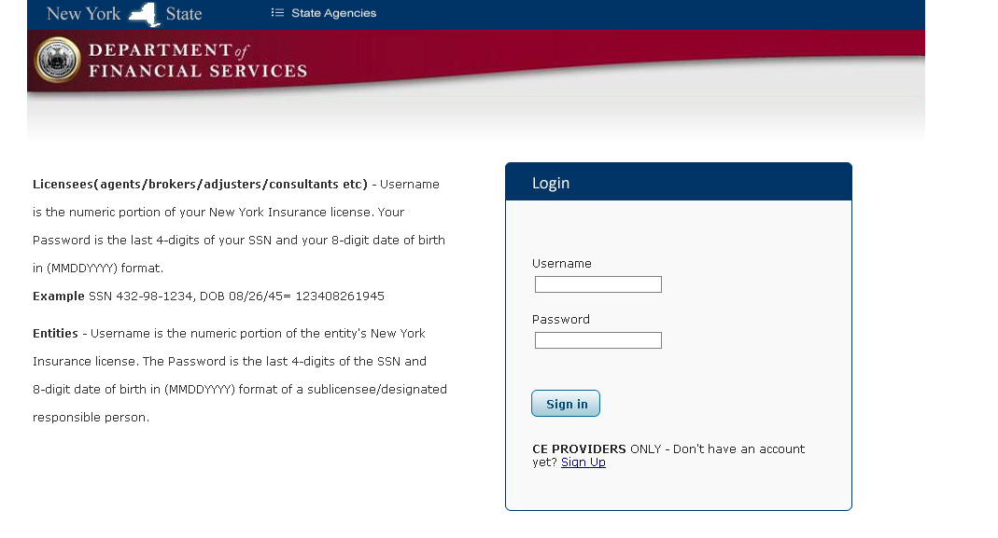

Business rules to calculate classes due renewal/ relicensing
The renewal button should be displayed according to following Business rules:

- The class maintenance flag to accept Web application submissions is ‘YES’.
The classes which have the “APP ON WEB” permission maintained as per the Class Line maintenance only will have the “Renewal” button displayed in the Class Summary page.
- The application has not been previously processed through LINX or the Web for current renewal/ relicensing.
If the application is processed through the LINX internal application, the renewal button will not show up for that class in the Class summary. Renewal is not considered as “Processed” unless the final confirmation is done and payment is processed. Till final confirmation is done, “Renewal” button should be enabled.
- In case of renewal Licensee class status should be ‘Active’ or ‘Inactive ‘. In case of relicensing License class status should be “Expired”.
- In case of renewal the expiration date should be greater than or equal to sys date. In case of relicensing the expiration date should be less than sys date after the 2 years expiration period.
- The licensee renewal document sent flag should be ‘YES’.
- In case of renewed payment through the “Pay by Check” or “Pay by Credit Card” option, once the user confirms the renewal, then it is considered as “Processed” for that renewal cycle. So, the “Renewal” button will not show up for such user. Renewal button should not show up if the renewal was ever processed.
- Renewal is considered as “Processed”, once the payment is made, irrespective of the payment mode. Therefore, irrespective of the mode of payment (check or credit card) users should not be allowed to process renewal again. However, user should be allowed to process the application for next renewal.

Class Summary section
In the Class Summary screen, the following information about the licensee has to be displayed:
- Class
- Status
- Effective date
- Expiry date
- CE Required (Y/N)

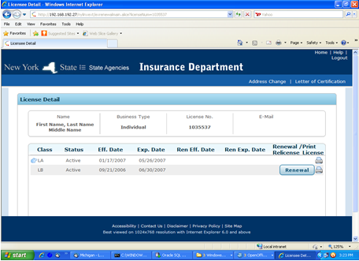

On clicking the renewal button for selected class on home page, system displays following wizard pages.
  - Instructions page
  - Biographical Page
  - Submitter page
  - Address
  - Questionnaire
  - CE Detail
  - Attestation page
  - License Fee
  - Payment
  - Success page with Invoice details
The above said wizard pages should display the next license period i.e. renewal effective date and renewal expiry date for renewal process.

Renewal Entry

Instructions and Computation of total fee
This page will display renewal instructions to the licensee. The screen shot of instructions page is displayed below. Clicking on Next button will redirect to Biographical page.
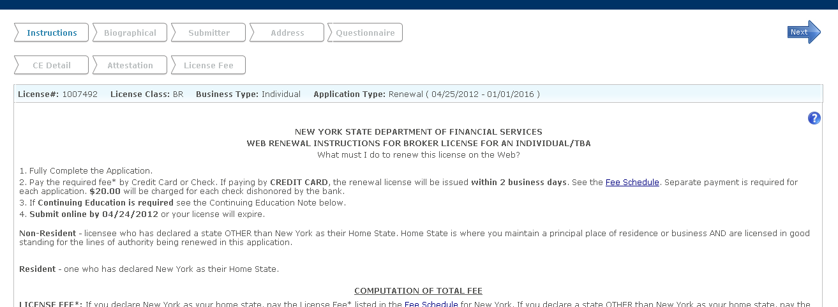
The four-digit year contained in of all dates referenced in the instructions will be dynamically determined based on the renewal year. In the page below the text Submit online before expiry date– The date here is License Expiry date for the class being renewed.
VA FEE
VA Fee column will appear on the fee instruction page if the class is LA or LB. Otherwise it will display Full Fee as “License Fee”. Fee rule is already in place for LINX and the same will be used here. VA Fee will be taken care by the user as per the instructions. Always fee for the licensee, which in this case would be VA Corp fee.
Check dishonor fee
Check dishonor fee displayed in the instructions is a static fee.
Instruction page

NEW YORK STATE INSURANCE DEPARTMENT
WEB RENEWAL INSTRUCTIONS FOR LIFE/ACCIDENT AND HEALTH AGENT LICENSE FOR AN INDIVIDUAL/TBA
What must I do to renew this license on the Web?
- Fully Complete the Application.
- Pay the required fee* by Credit Card or Check. If paying by CREDIT CARD, the renewal license will be issued within 2 business days. See the Fee Schedule. Separate payment is required for each application. $20.00 will be charged for each check dishonored by the bank.
- If Continuing Education is required see the Continuing Education Note below.
- Submit online before expiry date or your license will expire.
Non-Resident - licensee who has declared a state OTHER than New York as their Home State. Home State is where you maintain a principal place of residence or business AND are licensed in good standing for the lines of authority being renewed in this application.
Resident - one who has declared New York as their Home State
**NOTE -- DUE TO A CHANGE IN LEGISLATION YOUR RENEWED LICENSE WILL BE ISSUED WITH AN EXPIRATION DATE DETERMINED BY YOUR DATE OF BIRTH:
- If you were born in an even numbered year, your license shall expire on your birthday in an even numbered year.
- If you were born in an odd numbered year, your license shall expire on your birthday in an odd numbered year.
Your renewed license will be issued for a period of 2 to 4 years. Licensing Fees are based on a 2 year period; you will be charged for each year or fraction of a year beyond the 2 year period. The online application will automatically calculate the licensing fee.
COMPUTATION OF TOTAL FEE
LICENSE FEE*: If you declare New York as your home state, pay the License Fee* listed in the Fee Schedule for New York. If you declare a state OTHER than New York as your home state, pay the License Fee* listed in the Fee Schedule for the declared home state.
CONTINUING EDUCATION FILING FEE: Add $10.00 if your application indicates that CE is required.
STATUTORY LATE FILING FEE: Add $10.00 if this Renewal Application is processed less than 60 days prior to expiration of current license. (Applies to licenses with prefix of LA, LB, PC, BR.)
TOTAL FEE: Add Continuing Education Filing Fee (if applicable) and Late Fee (if applicable) to License Fee* listed in the Fee Schedule. If license includes VARIABLE ANNUITIES, add additional VA fee to calculate total License Fee* if your home state charges extra for Variable Annuities.
*Licensing Fee and additional Variable Annuities Fee on the Fee Schedule are based on a 2 year licensing period.
CONTINUING EDUCATION NOTE
2012 Renewal: Required credit hours of Continuing Education are obtained from the class line maintenance table if the application indicates "CE REQUIRED." Do NOT submit Continuing Education documentation. Credits must be accumulated during the biennial licensing period and before submitting this application.
Non-residents who have met the Continuing Education requirements of their Home State need not take New York Continuing Education Courses.
When the user clicks on the “Fee Schedule” link, it should show the following fee details page.
Also, VA fee will appear for LA and LB class in a separate column. The date you are seeing below on the header is the expiry year of the licensee.
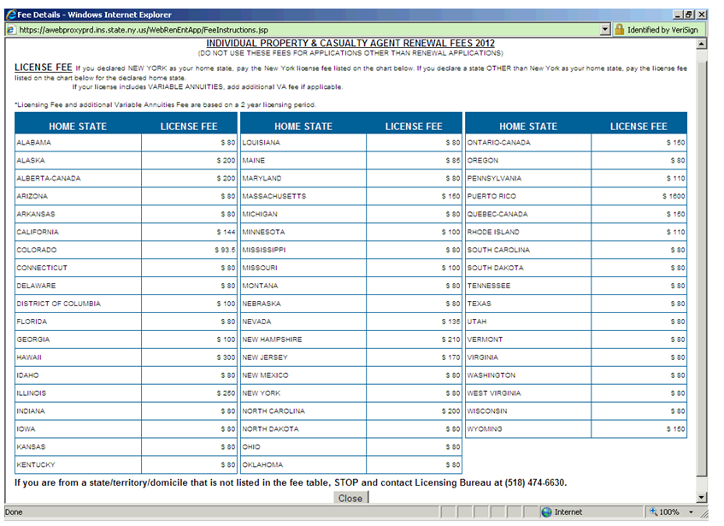
A hyperlink to the Fee Schedule will reside on the screen. The fee schedule will be dynamically created from the LINX database lwgnlic fee table. It will display all fees excluding those for NY State. Home State and counties will be listed together in alphabetical order.

Biographical
Biographical page displays the biographical details. The screen shot of Biographical page is displayed below.
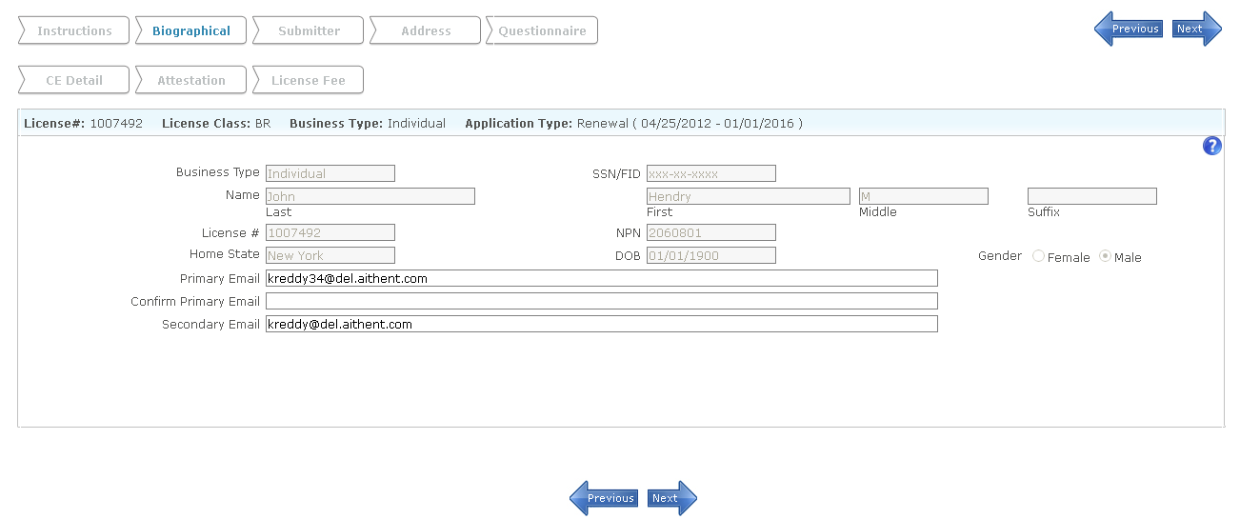
The following fields are editable.
- Primary email
- Confirm primary email
- Secondary email

General Rules
- In case of an individual, the name will be displayed on top of the screen. The licensee cannot modify his/her name.
- In case of TBA, both individual and TBA name will be displayed on the screen. The name of the licensee is non-editable always.
- SSN and DOB cannot be modified by the Licensee and will be masked on the Web page with an ‘*’. No SSN validations are required for the SSN.
Field Name | Field Type | Description | Mandatory | Default Value | Max. Length | Comments
License#:  License Class  Business Type :  Process : | Read Only | Licensee information | Yes | Fetch and display the existing data from db.
Business Type | Read Only | Business type (Individual) | Yes | Fetch from the existing data from db. |  | Business type can be Individual or TBA depending on who is renewing.
SSN/FID | Read Only | Social Security Number  should be masked. | Yes | Fetch from the existing data from db. |  | User should not be able to remove the value in this field.
Name 1) Last 2) First 3) Middle 4) Suffix | Text Boxes | Licensee can update Last/First/Middle/Suffix | Yes | Fetch from the existing data from db. |  | Licensee name not modifiable.
License # | Read Only | License Number | Yes
NPN | Read Only | National Producer Number
Home State | Read Only | Licensee home state | Yes
Primary Email | Text | System displays the Email addr1. Prompt the user if this field is NULL  “No email address has been provided. Providing an email address will enable you to receive Department of Financial Services updates, including early notice of online renewals & material quickly and electronically. Do you wish to continue with no email address?” – This will be just an alert with OK and Cancel button |  |  | 50 | User should be allowed to change email address.
Confirm primary email | Text | Email address | If primary email is changed, confirm primary email is mandatory. |  | 50 | User should be allowed to change email address.
Secondary email | Text | Email address |  |  | 50 | User should be allowed to change email address.
DOB | Read Only | Date of Birth
Gender | Read Only | Gender
Next | Button | On clicking this button system will validate the Biographical information, saves the data in the temp db and successful message will be displayed and move the next page in the wizard.

Submitter Info
The purpose of this page is to capture the submitter of the application, if the application is submitted by non-applicant. Below will be the data element on this page. None of the below fields are mandatory:
“Please enter below information if you are not an applicant:”
- Name
- Company
- Telephone number
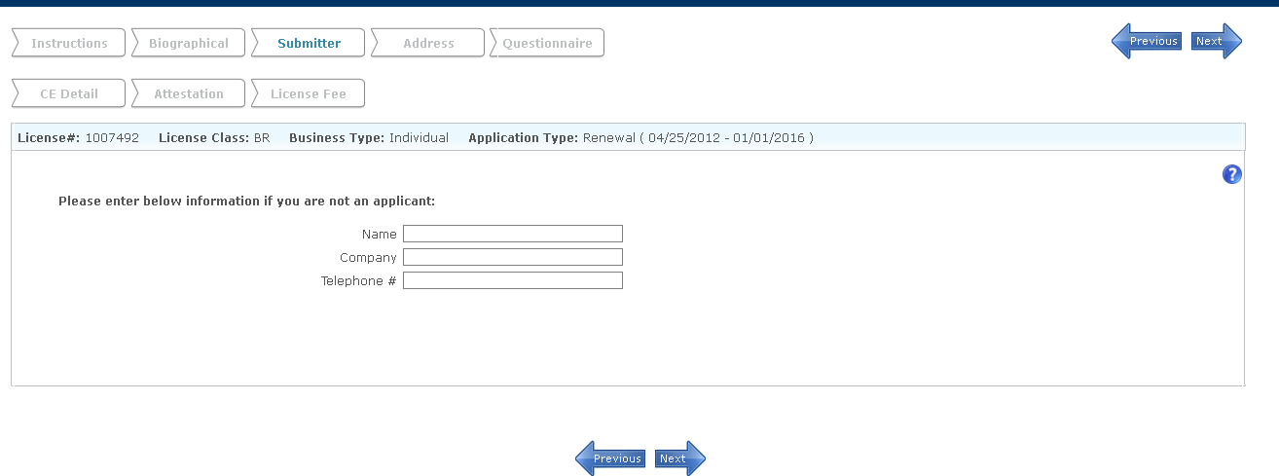

Address
Address wizard page will display the address details of the selected class and allow updating the address details during renewal process. The screenshot of address window is displayed as shown below.

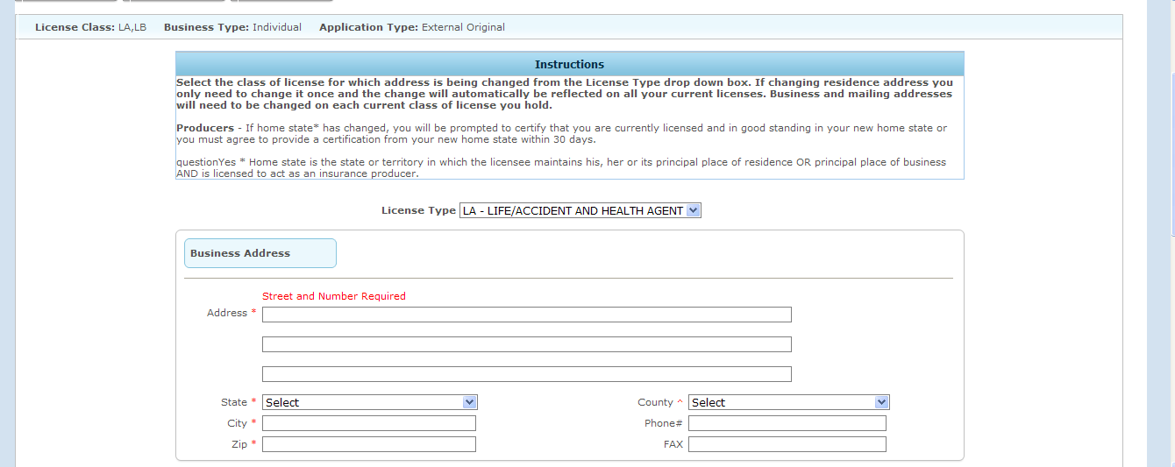
Table below shows the fields available on this form – This page will be what we have in address change today but only for one class.
Field Name | Field Type | Description | Mandatory | Default Value | Max. Length | Comments
Address | Text Box | System displays address1/address2/address3 of a class and allows to edit. | Address1 is Yes |  | 50
State | Drop Down | System displays state and allows to update. | Yes
County | Drop Down | System displays County value and allows updating. | Yes (Needed If the State is New York) |  |  | Drop down box will be displayed only when the state = NY.  If a Licensee changes their state from NY to non-NY, the system will blank out the county field and the Licensee will be unable to edit it. County will be saved to database only if the state is NY.
City | Text box | System displays City value and allows to edit. | Yes |  | 10
Zip | Text Box | System displays Zip value and allows to edit.(Accepts only digits in the format #####-#### or #####) | Yes |  | Should allow either 5 or 9 digits
Phone | Text Box | System displays phone value and allows to edit accepting in the format (###) ###-####. | No |  | 12
Fax | Text Box | System displays Fax value and allows to edit accepting in the format (###) ###-####. | No |  | 12
Same As | Drop down | Allows to copy address in to MLG from Bus /Res. | No |  |  | Displays only in the mailing address section.
Home State | Drop down | System displays the home state of the agent and allows user to change home state. The value will change according to home state rule applicable in ACH process. Only possible states should be shown based on home state rule already defined in LINX. |  |  |  | Home state can be either resident address or any of the business address. It is editable and will be same as address change. User can change this.
Next | Button | On clicking Next button the licensee is navigated to CE Detail wizard page.
Previous | Button | On clicking Next button the agent is navigated to previous page i.e. Biographical wizard page.

When the home state= Non NY, then add a section at the bottom of this page which will read like this (This is called certification question)
I CERTIFY THAT I AM CURRENTLY LICENSED AND IN GOOD STANDING IN MY STATE OF DOMICILE FOR THE LICENSE APPLIED FOR IN THIS APPLICATION.
The question will be followed by a ‘Yes’/’No’ radio button. The above field will be required field on the page, user cannot move forward without filling this question for Non-NY.
When the Licensee answers ‘No’ to the above question, they will immediately receive a message asking them to verify that is what they meant to select. The text of the message will read “You have indicated that you are not currently licensed and in good standing in your Declared Home State. Is this correct?” Two buttons will display below the text of the message. The “Cancel” button will return the licensee to this question on the application entry screen. The “Ok” button will link to a second message that indicates that processing of the application cannot continue. The text of the message will read "Since you have indicated that you are not currently licensed and in good standing in your state of domicile, you are not eligible to renew this license.”

Questionnaire
Below is the sample of the screen which we have in our current app. As you can see, if the main question is answered ‘No’ then user should not be able to respond to sub question and all sub question should be expanded by default.

Business Logic for BR/EX class:The Question response used for BR class will be used for EX class by clicking “Start EX application” button from invoice page. 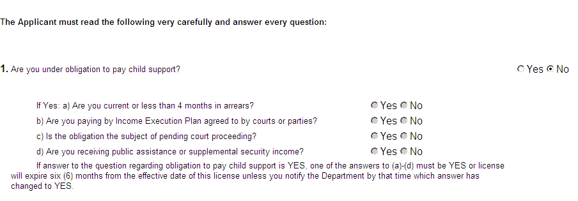
Field Name |  | Field Type | Description | Mandatory | Default Value | Max. Length | Comments
Questionnaire | Text box/Radio buttons |  | System displays questions with corresponding radio button / text box according to configuration for the class maintenance. | Yes
NEXT | Button |  | On clicking Next button validates and saves the Questionnaire information and the agent is allowed to navigate to the CE Detail section of the wizard.
PREVIOUS | Button |  | On clicking Next button the agent is navigated to previous page i.e. CE details page.

CE detail
This section will show only valid CE. Same rule that we have in LINX now will be applicable here for the CE validity and consumption. CE consumption logic and validation logic has to be narrated here:
This page will be visible only if CE is required. External user won’t be able to modify/delete course being fetched from LINX. In home page if CE detail is No then we are not showing EX if EX is immediately renewed after BR. CE wizard required for licensee will be displayed The screen will look like it is pasted here under.
Approval number has to be prefixed by NY.
Below is how screen should look like. If the user responds as Yes to Question (A) then he should be able to add new courses in the screen provided. When a licensee selects “No” to both questions A and B and CE is required, they will immediately receive a message asking them to verify that is what they meant to select. The text of the message will read “You have indicated that you have not complied with the continuing education requirements in either NY or your state of domicile. Is this correct?” Two buttons will display below the text of the message. The “No” button will return the licensee to this question on the application entry screen. The “Yes” button will link to a second message screen that indicates that processing of the application cannot continue. The text of the message will read "Since you have not complied with the continuing education requirements, you are not eligible to renew this license."
If the licensee answers ‘Yes’ to question (B), they must select a home state, this selection should be stored in the database.
“I HEREBY CERTIFY THAT I HAVE MET MY STATE OF DOMICILES CONTINUING EDUCATION CRITERIA. MY STATE IS: “(include a non-resident state drop down box; it should not include New York).

CONTINUE EDUCATION PAGE

15 credit hours of Continuing Education are required. Do not submit Continuing Education Documents. Credits must be accumulated during the biennial licensing period.
If New York has been your declared home state for the period shown on your current license, New York approved Continuing Education courses must have been completed in order to renew this license.
/* Development Note: The credit hours shown in bold text in the above paragraph have to come from Class Line maintenance.*/
If you are a non-resident, you must have met the Continuing Education requirements of your home state. Section A OR Section B must be completed. You will be charged an additional $10.00 to renew this license.
(A) | New York Approved Continuing Education.
 | I ATTEST THAT I HAVE COMPLETED STATUTORY CONTINUING EDUCATION AS INDICATED BELOW AND MAINTAIN CERTIFICATES EVIDENCING THIS |  | Yes | No
It will be necessary for you to enter the details below for the continuing education courses that you have taken for this renewal.
YOU WILL NOT RECEIVE CONTINUING EDUCATION COURSE CREDIT FOR COURSES TAKEN MORE THAN ONCE. ANY COURSE REPORTED ON THIS APPLICATION WILL NOT BE ACCEPTED ON SUBSEQUENT APPLICATIONS FOR THIS LICENSE.
The logic behind the consumption of CE is already in place in use in LINX today. The same will be applied here too. All Course type in LINX has to be listed. The possible values in this drop down are: CL, CR, CS, CS/L, and CX drop-down is for Course Type. Approval number will be entered in the next field before credits.

B) | Non-Resident Continuing Education Certification Attestation:
 | I HEREBY CERTIFY THAT I HAVE MET THE CONTINUING EDUCATION CRITERIA OF MY HOME STATE.
  Yes | No
 | MY STATE IS:

Field Name | Field Type | Description | Mandatory | Default Value | Max. Length | Comments
Approval# | Text box | Actor can add the CE information by entering valid course approval# | Yes
Completion Date | Date | System populates the Completion Date of corresponding Approval# from LINX.  If the course is new then licensee has to enter completion date. | Yes |  |  | Application verifies whether course is active or not in this completion date. If not active this date cannot be taken.
Credits | Text filed | System populates the Credits of corresponding Approval#.
Optional Exam Credits | Check box | If Exam credits are there for approval number then check box gets displayed on the screen. If licensee checks this box then exam credits will be added to total credits. If there is a data in Optional Exam credit then show a check box which should read as Exam Credit and if the user checks that then  add the optional exam credit to the regular credit, For the below course by default the credit will be 8 but once the user checks Exam Credit box the credit will be 9. | No
NEW | Button | System allows adding new course details.
DELETE | Button | System allows deleting selected CE information.
NEXT | Button | On clicking Next button validates, saves the CE information and the agent is navigated to Questionnaire wizard page.
PREVIOUS | Button | On clicking previous button the agent is navigated to previous page i.e. address page.

Courses are fetched for licensee based on the following conditions:
  - Course consumption (used flag) = ‘N’
  - Course end date of the courses being fetched should be greater than Current Date.
  - Delete flag should be ‘0’ (zero)
  - Course Completion date entered by the user through the application should be greater than or equal to License Effective Date.
  - Course Completion date entered by the user through the application should be lesser than or equal to Current Date.
If the licensee meets the CE required hours for a class with sufficient credits obtained by undergoing one or more courses, they are considered to be “CE MET” and allow submitting and processing their renewal application successfully.

Attestation Page
The Attestation content of this page will be table driven, in order to facilitate any change by the department as deemed necessary. This page displays the agreement between Licensee and NYDFS. The text of the agreement will change based upon the status of the Licensee (resident or non-resident). Processing of the application will continue only if the Licensee selects "I AGREE " If the Licensee selects "I DECLINE", a message will be displayed to the Licensee asking them “Are you sure want to decline it?” Below the text of the message, two buttons will be displayed. If the Licensee selects “OK”, the licensee will be returned to the Department’s Home Page. If the licensee selects “Cancel” the application remains in the same page. The screen shot of attestation page is displayed as shown below.
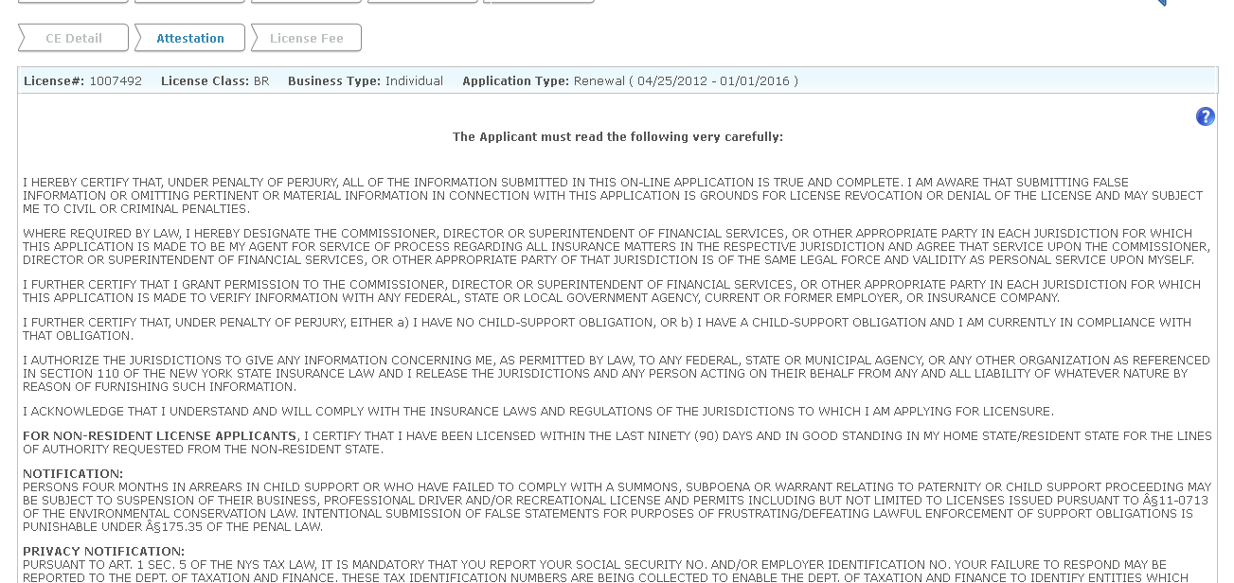

License Fee
This is the sample from our current application. As you can see all fee types are displayed separately. No Partial payment is allowed. User can pay by check or by credit card. While paying by check we do not collect check information. Check comes in separately by mail. Renewal is not processed till check is not received, but other information like changes to address and new CE Data, residency change gets updated. Renewal gets processed only when the department receives check.
Before displaying this page we are checking whether application temp data is updated correctly or not. If not updated as per application then system will forward to error page instead of fee page.

If the class is EX and licensee is resident then fee will be calculated based on County whatever licensee selected in address page .It fetches the fee from control table till the values are maintained.

In Internal, License History details will be:
Before processing check
Effective Date=Null, Expiry Date=Null, Status=Pending, Serial No=Null, Amount=$0.00, Issue Date=Null, User= Electronic Renewal and Pending Fee=Fee pending Date.
After Processing Check the system displays
Effective Date=Renewal Effective Date, Expiry Date= Renewal Expiry Date, Status=Active, Serial No=Check Invoice No, Amount=Total amount paid, Issue Date=License Issued date, User=Administrator and Pending Fee=Null.
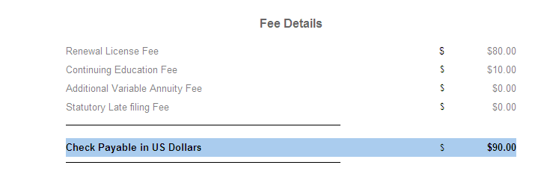
Check bounce information, if any, is keyed into LINX always manually.
In situation, where we have to collect no goods check – display it as outstanding fee as shown in the following figure:
BR – Original License Fee
LA – Original License Fee
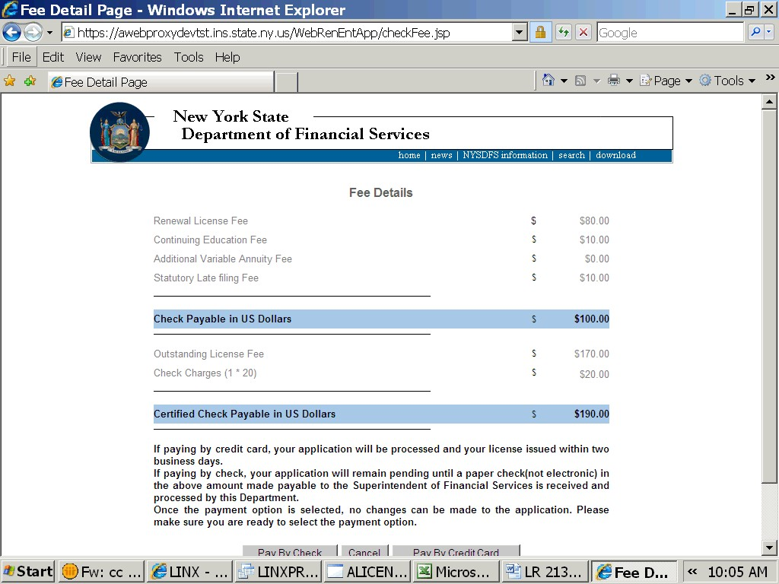
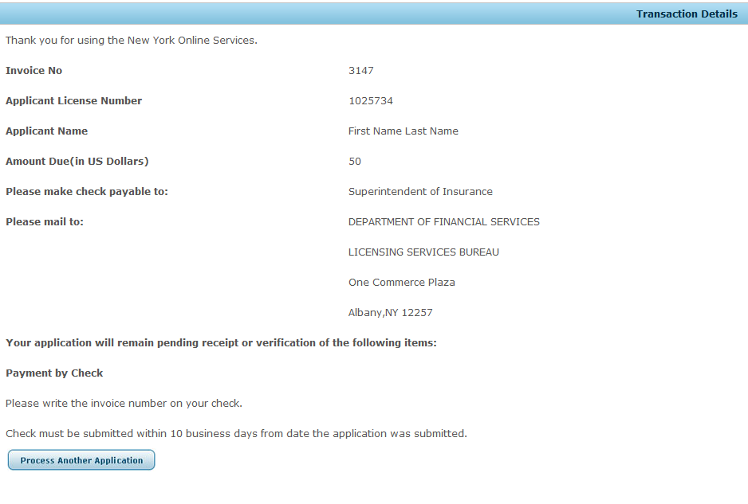
Field Name | Field Type | Description | Mandatory | Default Value | Max. Length |  | Comments
Fee details | Read only | CE fee /renewal /relicense\ing fee/NG fee will be displayed based on licensee class selected for renewal |  |  |  | This entire fee should display in a separate line as shown in the figure attached.
Pay by Credit Card | Button | System allows to pay through credit card through Authotized.net process. |  |  |  | On successful payment the temp data will be moved to Main DB and deleted the temp data. In case of relicensing the license will not issue if any Open BC or affirmative question and the questionnaire data will move to maindb and fee details will be inserted in the cash sheet and fee table.
Pay by Check | Button | It allows to pay fee through Check screen. |  |  |  | User won’t enter check information.  On click of this button LINX will accept the application and insert a record in license history with no eff dt/exp dt. This record will be a duplicate copy of the previous record but with no effdt/exp dt. Pending fee column in license history will have submission date. The questionnaire data will move to maindb and fee details will be inserted in the cash sheet and fee table.

Invoice Page
a) Invoice page will be displayed once user pays fee through the Authorize.net process and redirected to NY external renewal web application.
b) We will show the invoice details as per renewal old invoice page wizard for renewal including Next and Print button.
Below is the invoice page from current application. Please include all information we have in our current application. Check information should appear if the payment type is check. Application need have to do anything about a payment being made within the 10 days as mentioned in the Invoice text. No business rules are to be implemented in this regard. “Process another application” will be displayed in this screen. Instead of this option, this screen will display “Start Excess Line Application” only for BR with EX, after BR processing. Process Another Application will always remain here and if the user clicks on it will take the user to our Home page. No need to display the “Home” option in this page.
If the user clicks on “Start Excess Line Application” in invoice page then application will be redirected to instruction, biographical, submitter, Address and to attestation pages. This EX class uses BR Class Questionnaire data. If the user does not click “Start Excess Line application” then the application works in normal way.
The moment the credit card is charged, we show the invoice page and insert data into main table. We do not want user to click on confirm and then move data. Instead, this should happen when the check is accepted in LINX from the current screen in LINX.

Pay by check process in LINX
Any application where payment was made by check should be available in LINX under this page. Functionality will remain the same as it is now.. We would still use the same screen from LINX to process renewal web check from LINX external system. The internal user will still have option for updating/processing application submitted in Sybase world. Once we provide check number in the fee page then the licensee is eligible for issuing the license.

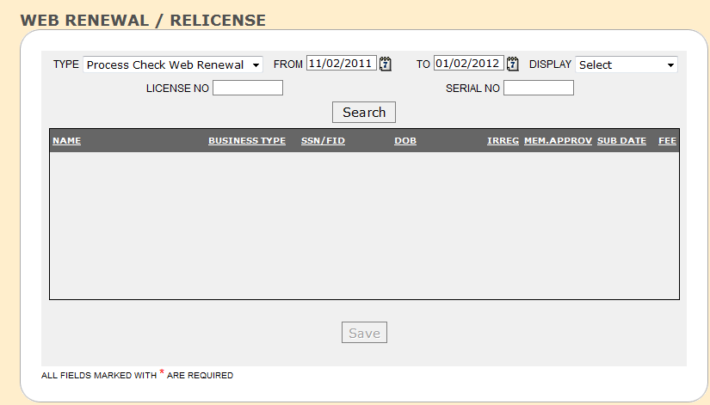

Processed On Web

If any licensee is submitted by pay by check from external and if any licensee status is pending which was processed from external then “Processed on web “will be displayed in Linx main page. This means all these records are processed from external application and cannot be processed again from Linx and only licensee can be issued. Reports
For legal purposes, the Department will need the ability to view and recreate the application submitted in the exact format as the applicant submitted it. This report is similar to what you have for recreate application in LINX. You can see this when you select original app from the drop down. I need all information which was a part of renewal application. You can separate it out in section.
In order to facilitate the recreation of the hardcopy application, the data will remain in the
If a renewal was processed for a licensee who had an open BC then LINX will generate a report
- OPEN BC report –
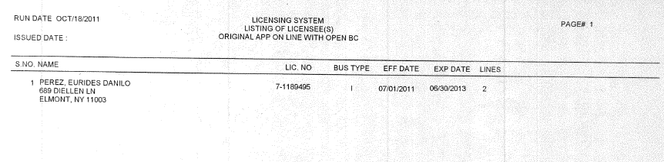
b) Irregularity Report – This report will have to be generated, for all application which had an affirmative answer.
c) Generate report for all licensee where money was collected for No Good check. 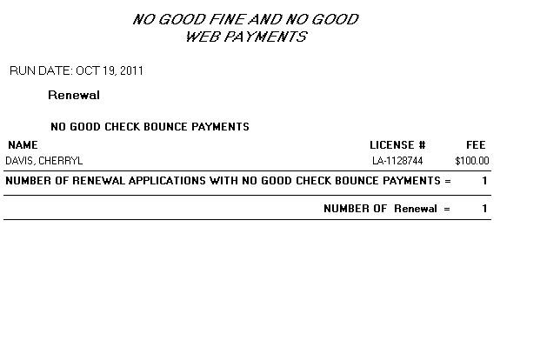
Number of renewal represents the number of renewal records with “No Good” payment. Based on the application type, this has to be the count of relicensing or renewal.

Other Process
If a renewal was processed by check and no check was received then expiration run will expire those licensee, terminated company etc. This is already working now. When the check is received for this renewal then everything will roll back, this is also working now.
But if relicense is done then LINX should not allow check to be processed for the above renewal.

BR EX Process
If the licensee holds an EX license then EX can be renewed only if BR has been already renewed. There is no late fee for EX.
If BR was processed by check then licensee can process EX either by
- check any time or
- By credit card only when the BR checks has been processed.
This option to pay by check has to be enabled /disabled based on the above rule.

‘YOUR PREVIOUS PAYMENT WAS BY CHECK SO THIS PAYMENT MUST BE BY CHECK’ – This language should appear above the button and Pay by Credit card should be disabled. – This is for BR - EX

Once the broker application is completed, then on the invoice page as shown below there should be a wording to renew EX license – There should be a button to process EX license.

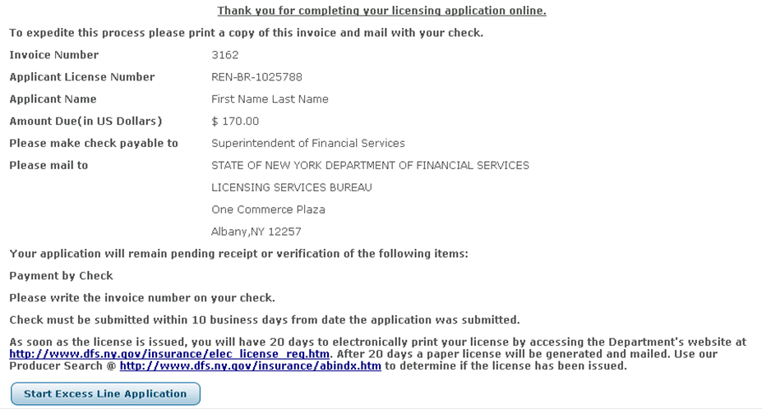

If the applicant wishes to process EX in this fashion then take the user to the biographic page.

- if the applicant‘s home state is New York the following question will appear and must be answered: Include this question on Address page only for EX.

“1. Name of the largest county in New York State in which you maintain an office or in which risks are located upon with you propose to place insurance as an excess line broker:

County Name (Drop box of County names)”

Once the applicant answers this question then take the applicant to the fee page.

The fee calculation will be based on the county selected. LINX will have to maintain the county data along with population in some table.
The fee will be $400.00 the county selected has a population of greater than 100,000. If the county is a county with a population of less than 100,000 the fee is $50.00. We will have to create a separate table to store this information.

The excess line renewal fee for ALL Non-Residents is $400.00. Nonresidents should not be prompted for County info.

Only the business and mailing addresses can be changed if the renewal is being processed in this fashion.
Residence address and Home State will be disabled. They cannot be changed. The information displayed will be what was entered on the broker application.
NO IRREGULARITIES QUESTION WILL APPEAR WHEN THE EXCESS LINE APPLICATION IS PROCESSED in this fashion. Background Question will not appear for the user while processing EX. But, the same set of questions will get tied to this user for EX also, when the data is moved to LINX main table.
NOTE: if an affirmative answer is given on broker application – it will be considered an affirmative answer for the excess line as well and 2 online irregularities reports will be printed – one for BR and one for EX. But while processing the EX application, user will not be presented with the Questionnaire. Whatever they answered for BR will still hold for EX. Whenever there is an affirmative answer, such question has to be printed in the Irregularity report format in current LINX format.
If home state is NOT New York = then Non-resident Certification question will need to be answered and Excess line County question will not appear. This nonresident question will appear on the address page and will be editable if the Home state is not NY.
Test of this question is “I CERTIFY THAT I AM CURRENTLY LICENSED AND IN GOOD STANDING IN MY STATE OF DOMICILE FOR THE LICENSE APPLIED FOR IN THIS APPLICATION” – just below this question we should have (Non – resident must complete this question in lieu of submitting a hardcopy home state certification). The above will be there for all class of license.
Once Certification question is answered and “NEXT” is selected, attestation, fee page and payment option will follow and then invoice page will appear. If check option was selected from BROKER – check option ONLY will be available for Excess line.

Relicensing
Once, licensee logs in, the Class summary page will show licensee detail page of the applicant.
Relicense button will appear against those classes based on following rule:
- If the licensee is resident and home state is NY.
- License is not expired for 2 years or more
Once user click on Relicense button, LINX will take the user to instruction page / biographic page then to Address page / Address confirmation page / Background confirmation / attestation page /fee page/ Invoice page. All these pages will be same as renewal. If the payment is processed by check then the check will be processed from LINX and record will be updated upon check process, the current rule of LINX for processing check will remain.
If paid by check, license history will have one entry for app type of REL, application process date – date on which application was submitted, pending fee should have the date.
If the record was processed by credit card then it will be processed immediately. License issuance rule will be same as what we have in LINX.

Process flow of LINX External Relicensing
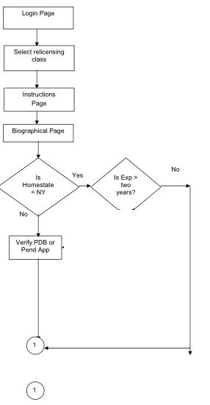
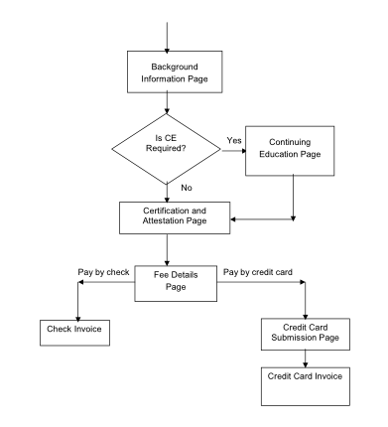
1

History Section
History section describes the history details of web renewal and relicensing. The various types of history items in web renewal and relicensing include:
- Address History.
- Cash History.
- CE History.
- License History.
The screen shot of various history details are displayed below.

License history before processing in external

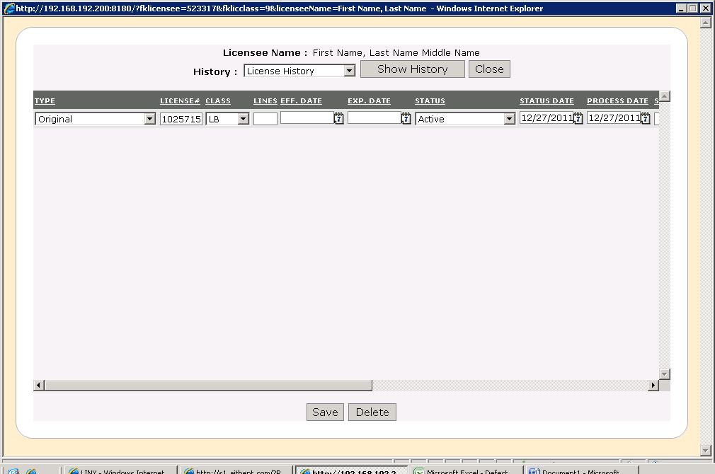
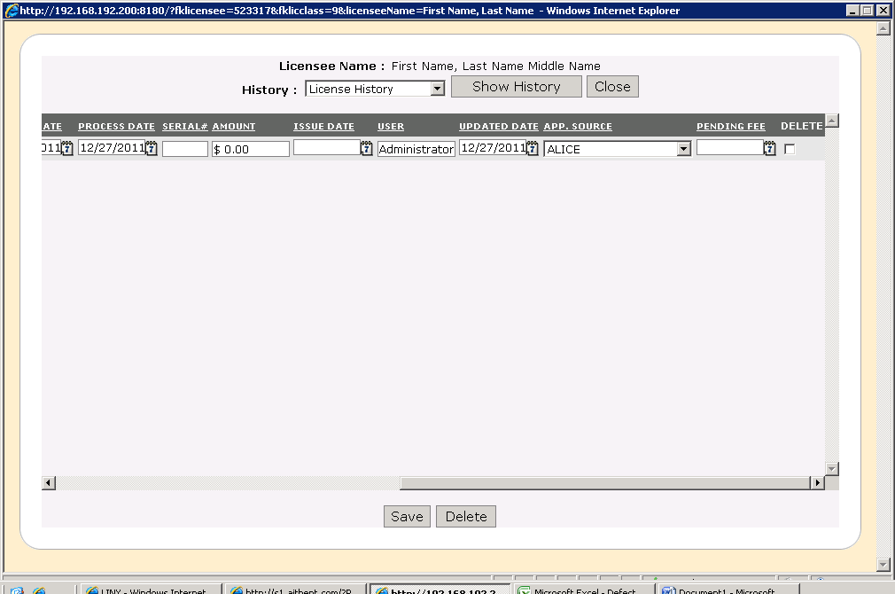
The above screenshot describes about the License History before processing in external.
Field Name |  | Field Type | Description | Mandatory | Default Value | Max. Length
Show History | Button |  | Displays the history details of License history.
Close | Button |  | On clicking Close button the license history details are closed.
Type | Drop down |  | Displays the type of license history.
Save | Button |  | Saves the license history details.
Delete | Button |  | Deletes the license history details.

CE History
The below screen shot displays CE History details.
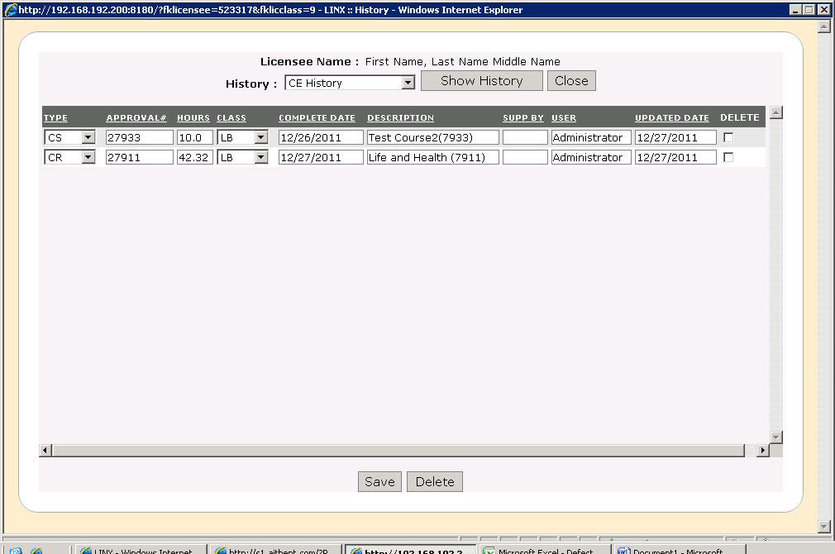

Field Name |  | Field Type | Description | Mandatory | Default Value | Max. Length
Show History | Button |  | Displays the history details of License history.
Close | Button |  | On clicking Close button the license history details are closed.
Type | Drop down |  | Displays the type of CE history.
Approval# | Dropdown box |  | Displays the approval number.
Hours | Text field |  | Displays the number of hours in CE history.
Complete Date | Text field |  | Displays the complete date of CE History.
Description | Text field |  | Displays the details of CE History.
Updated date | Text field |  | Displays the updated date of CE History.
Delete | Check box |  | Deletes the license history details.

Address History
Address history displays the address details of web renewal or relicense. The below screen shot displays the address history.
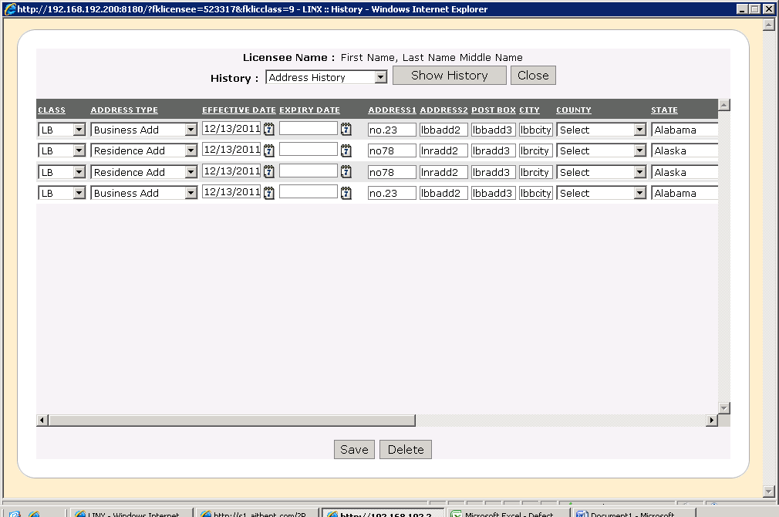

Field Name |  | Field Type | Description | Mandatory | Default Value | Max. Length
Class | Drop down |  | Displays the license class.
Address type | Drop down |  | Displays the type of address of address history.
Effective date | Drop down |  | Displays the effective date of address history.
Expiry date | Dropdown box |  | Displays the expiry date of address history.
Address | Text field |  | Displays the address of address history.
Post box | Text field |  | Displays the post box of address History.
City | Text field |  | Displays the name of city of address history.
County | Drop down |  | Displays the county name of address history.
State | Text field |  | Displays the name of the state.

Cash History
The below screen shot displays the cash history.
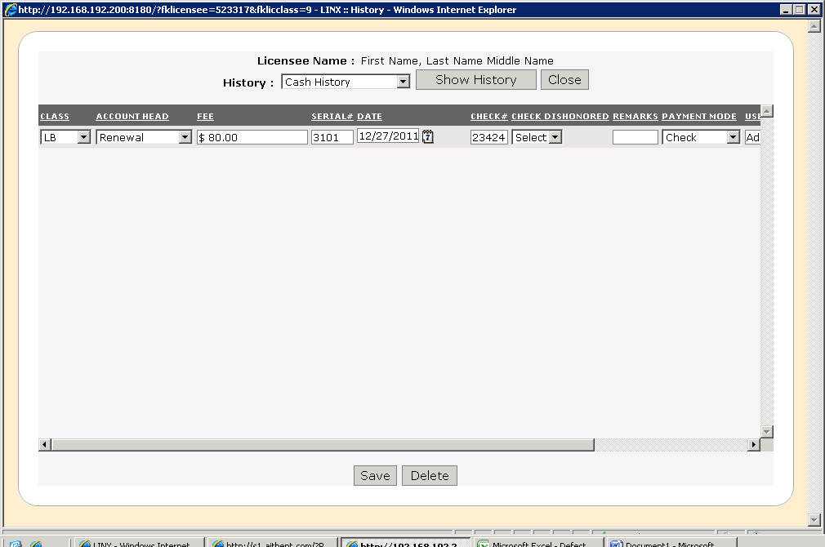

Field Name |  | Field Type | Description | Mandatory | Default Value | Max. Length
Class | Drop down |  | Displays the license class.
Account Head | Drop down |  | Displays the account head of cash history.
Fee | Text box |  | Displays the fee details.
Serial# | Text box |  | Displays the serial number.
Check# | Text field |  | Displays the check number.
Check Dishonored | Drop down |  | Displays whether check is dishonored.
Payment mode | Dropdown |  | Displays the payment mode through check.
Save | Button |  | Saves the cash history details.
Delete | Text field |  | Deletes the cash history details.

Before processing through check
The below screen shot displays before processing through check. In Before processing through check the user is electronic renewal and after processing through check the user is administrator.
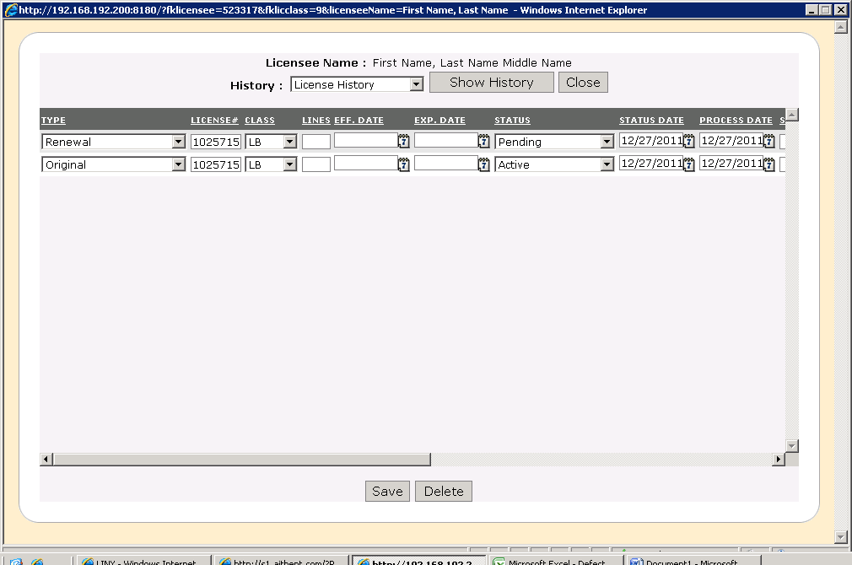

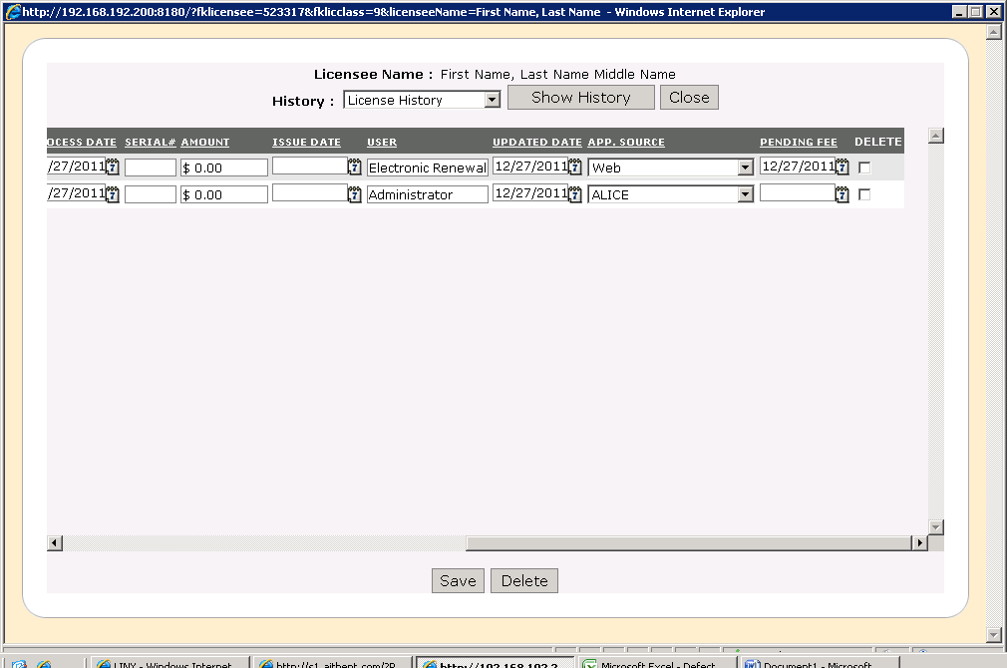

AFTER PROCESSING CHECK
The below screen shot displays after processing check. In After processing check the user name changes to administrator.
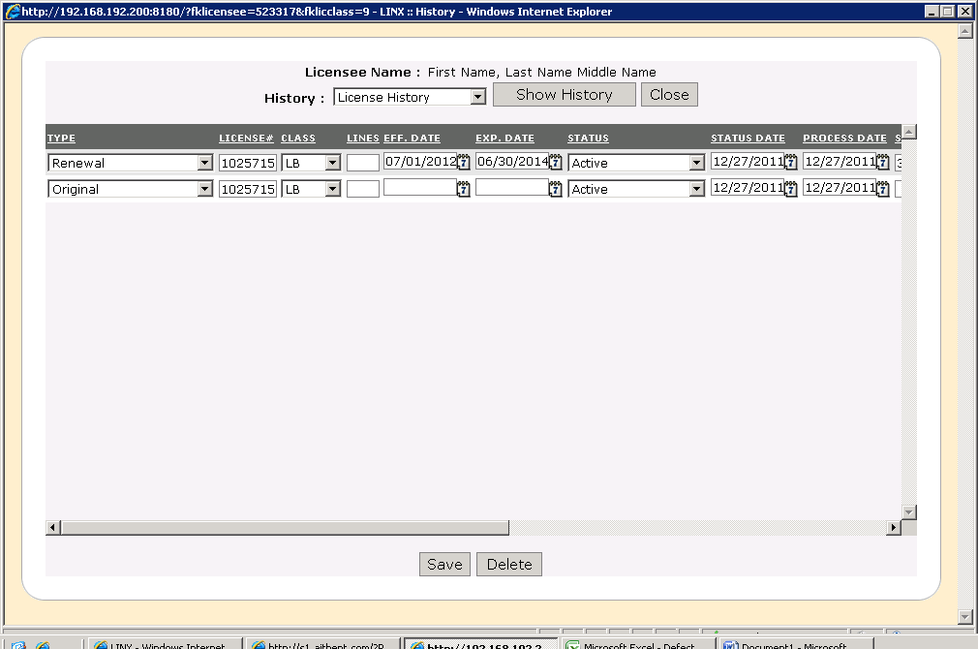
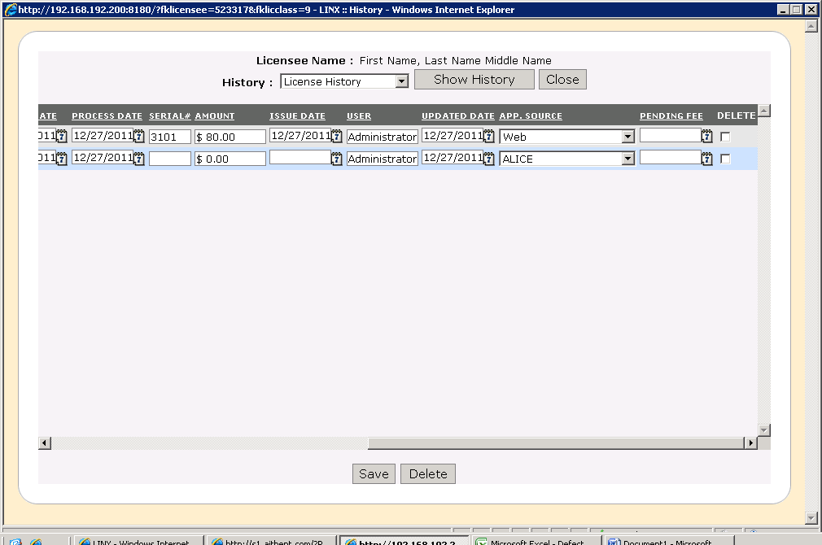

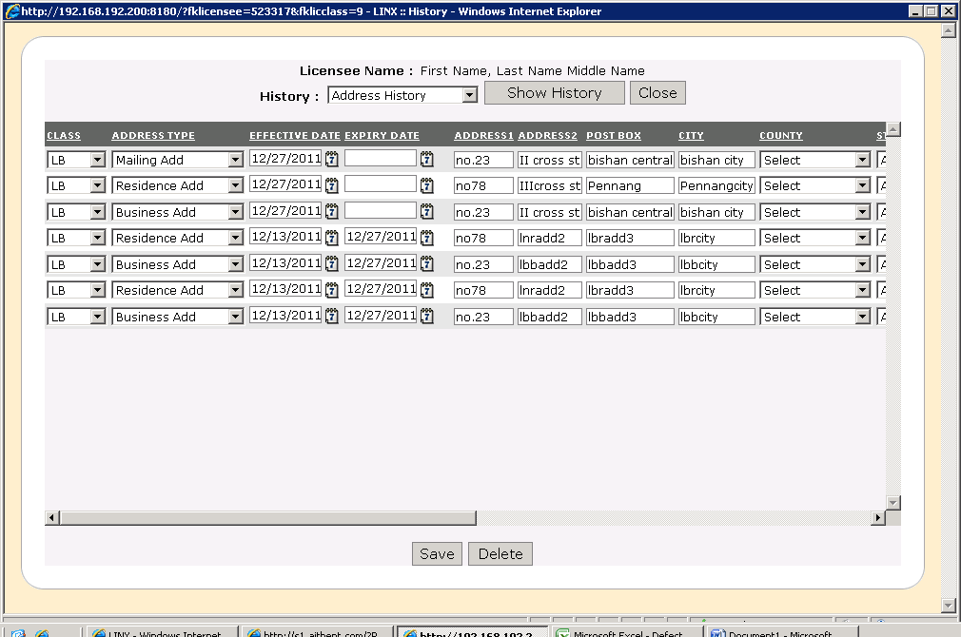

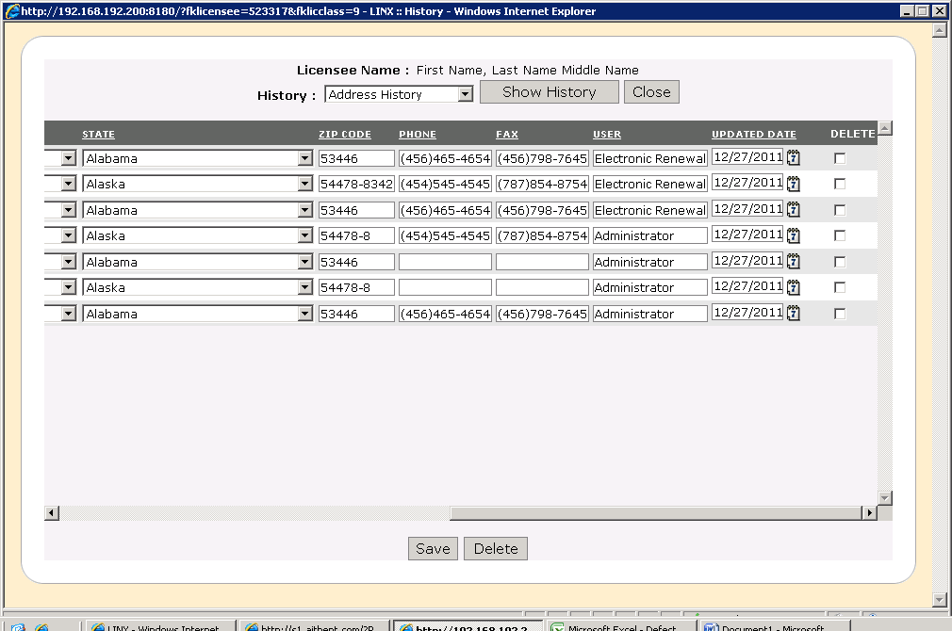

Processing check through Internal Linx
The internal web renewal/ relicense is displayed by clicking processing tab and selecting LINX web renewal/ relicense. The below screen shot shows the internal web renewal/ relicense.
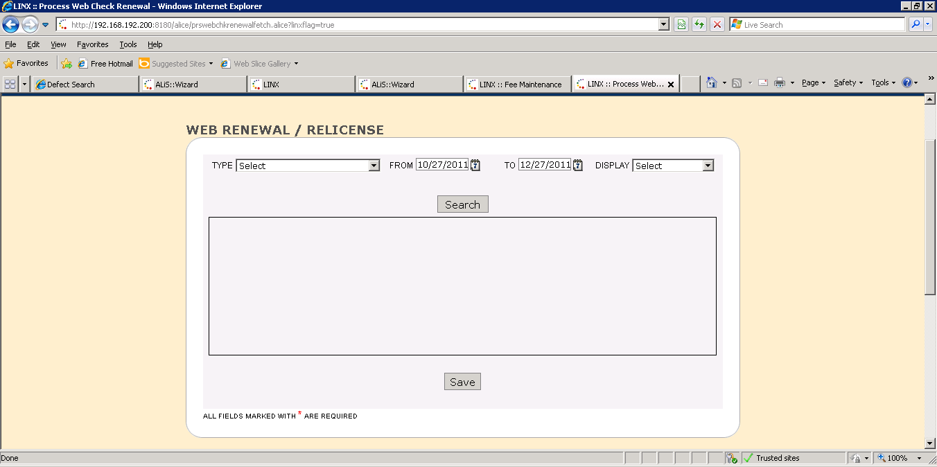
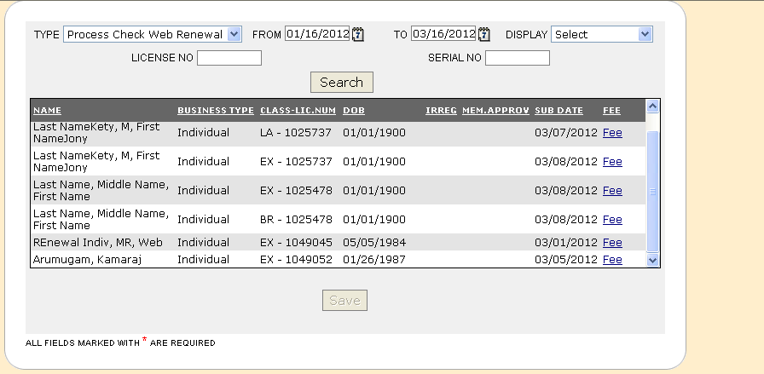

In the type select process check web renewal and click search button. The search results are displayed. The save button allows to save the details of web renewal/ relicense. Click on fee link and license fee window is displayed.

License Fee
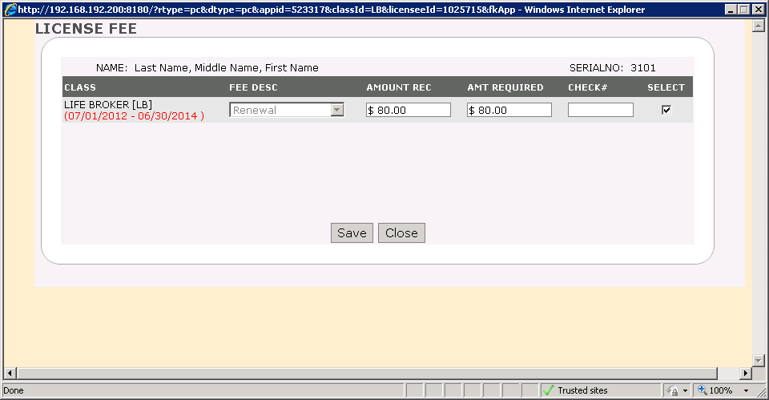

Field Name |  | Field Type | Description | Mandatory | Default Value | Max. Length
Class | Drop down |  | Displays the license class.
Fee Desc | Drop down |  | Displays the fee description details.
Amount Required | Text box |  | Displays the amount required.
Check# | Text box |  | Displays the check number.
Save | Button |  | Saves the License fee details.
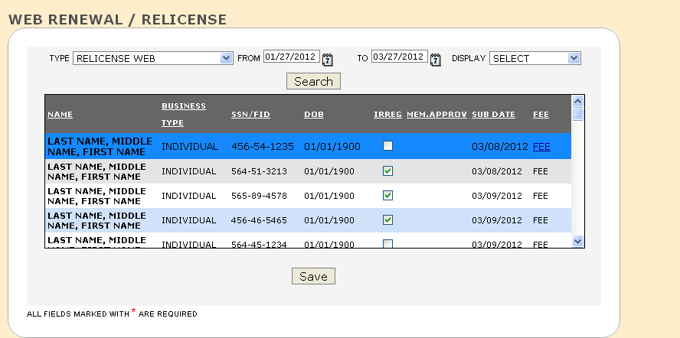
In the type dropdown box select Relicense web and the search results for web renewal/ relicense is displayed. On clicking save button the license will be issued in case of no affirmative question and no open BC. If the user clicks on relicense web and if irregularity is checked the fee process is completed. Click on Fee link and the license fee window is displayed as shown below.
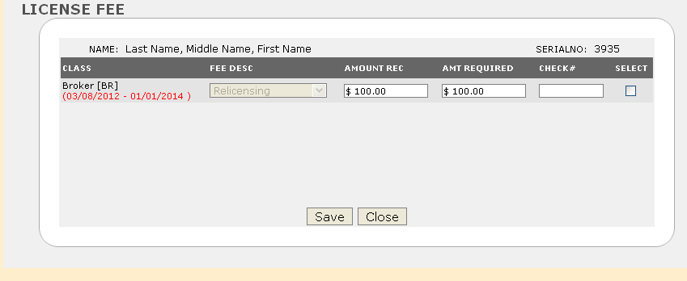
Field Name |  | Field Type | Description | Mandatory | Default Value | Max. Length
Class | Drop down |  | Displays the license class.
Fee Desc | Drop down |  | Displays the fee description details.
Amount Required | Text box |  | Displays the amount required.
Check# | Text box |  | Displays the check number.
Save | Button |  | Saves the License fee details.

This process explains about how an external user processing an application affects the internal LINX and status changes that affect the LINX internal system.

