PHASE AND GROUP VELOCITY DERIVATION AND PROBLEM

Introduction
In the study of electromagnetic waves, optics, transmission lines, waveguides, and quantum mechanics, two important wave propagation parameters—phase velocity and group velocity—play a fundamental role in describing how waves travel through different media. Every real-world signal, whether electrical, optical, acoustic, or electromagnetic, is not a single sinusoid but a superposition of many frequencies. Because of this, it becomes essential to distinguish between the speed of an individual phase of the wave and the speed at which the overall information or signal travels. The concepts of phase and group velocity help engineers and physicists understand phenomena like signal delay, pulse distortion, data transmission, dispersion in optical fibers, radar operation, and wave propagation in dispersive mediums.
Phase velocity refers to the rate at which a single-frequency wavefront travels, while group velocity represents the speed at which the envelope of multiple waves—or the “group” of waves—propagates. In most practical communication systems, information travels at the group velocity, not phase velocity. This report provides a detailed mathematical derivation of both velocities, along with example problems and their practical applications in engineering and physical systems.
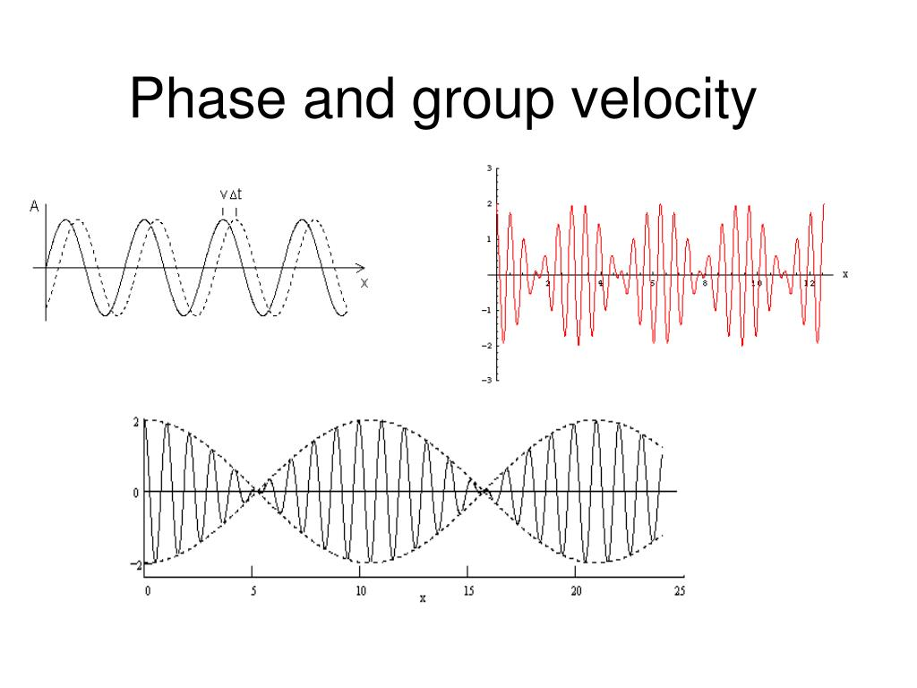

Basic Wave Theory
A general sinusoidal wave traveling in the +x direction is expressed as:
$$E(x,t)=Acos⁡(kx-ωt)$$
Where:
- $A$= Amplitude
- $k$= Wave number = $\frac{2π}{λ}$
- $ω$= Angular frequency = $2πf$
- $f$= Frequency
- $λ$= Wavelength
A physical wave is usually a combination or superposition of several such sinusoidal waves. When the medium is non-dispersive (e.g., vacuum), all frequencies travel at the same speed. But in dispersive media (optical fibers, waveguides, plasmas), each component frequency travels at a different speed, causing distortion and delay. To characterize these effects, engineers compute phase velocity and group velocity.
Before deriving these quantities, remember that the propagation constant is:
$$β=k=\frac{ω}{v_{p}}$$
and it describes how quickly the phase changes along space.

Derivation of Phase Velocity
Phase velocity is defined as the speed at which a constant phase point of a sinusoidal wave travels.
Take a constant-phase condition:
$$kx-ωt=\text{constant}$$
Differentiate with respect to time:
$$k\frac{dx}{dt}-ω=0 \\ \frac{dx}{dt}=\frac{ω}{k}$$
Thus,
Phase Velocity
$$v_{p}=\frac{ω}{k}$$
Expanding using $k=\frac{2π}{λ}$and $ω=2πf$:
v_p = \frac{\lambda f}
This means phase velocity is simply the product of frequency and wavelength.
Important Notes About Phase Velocity
- May exceed the speed of light ($c$)—this does not violate relativity because phase velocity does not carry information.
- In dispersive media, different frequencies have different phase velocities.

Derivation of Group Velocity
Consider two waves of slightly different frequencies and wave numbers:
$$E_{1}=Acos⁡(k_{1}x-ω_{1}t) \\ E_{2}=Acos⁡(k_{2}x-ω_{2}t)$$
Their sum forms a beat (group):
$$E=E_{1}+E_{2}$$
Using trigonometric identities:
$$E=2Acos⁡(\frac{Δk⋅x-Δω⋅t}{2})cos⁡(kx-ωt)$$
Where:
$$k=\frac{k_{1}+k_{2}}{2},ω=\frac{ω_{1}+ω_{2}}{2} \\ Δk=k_{2}-k_{1},Δω=ω_{2}-ω_{1}$$
The envelope is represented by:
$$E_{group}=2Acos⁡(\frac{Δk⋅x-Δω⋅t}{2})$$
Setting the phase of the envelope constant:
$$\frac{Δk}{2}x-\frac{Δω}{2}t=\text{constant}$$
Differentiating:
$$\frac{dx}{dt}=\frac{Δω}{Δk}$$
Taking the limit as $Δk→0$:
Group Velocity
$$v_{g}=\frac{dω}{dk}$$
This is the speed at which the information or energy in a wave packet travels.

Physical Meaning of Phase and Group Velocity
Phase Velocity Meaning
- Represents the velocity of a sinusoidal wavefront.
- Does NOT carry energy or information.
- Can be faster than light in media (not a violation of physics).
Example: The peaks inside a laser beam travel at phase velocity.

Group Velocity Meaning
- Represents the speed of the envelope, which carries modulation/information.
- Actual data transmission happens at group velocity.
- In optical fibers and waveguides, dispersion changes the group velocity.
Example: Internet data sent through fiber travels at group velocity, not phase velocity.

Relationship Between Phase and Group Velocity
In a medium with refractive index $n(ω)$:
$$v_{p}=\frac{c}{n} \\ v_{g}=\frac{c}{n+ω\frac{dn}{dω}}$$
General relationship:
$$v_{g}=v_{p}-λ\frac{dv_{p}}{dλ}$$
For non-dispersive media:
$$v_{p}=v_{g}=c$$
For dispersive media:
$$v_{g}≠v_{p}$$
In waveguides (rectangular/circular):
$$v_{p}>c,v_{g}<c,v_{p}v_{g}=c^{2}$$
This is a very important engineering result.

Numerical Problems
Problem 1: Compute Phase Velocity
A wave has
- frequency $f=10 \text{GHz}$
- wavelength $λ=2.5 \text{cm}$
Solution:
$$v_{p}=fλ=10×{10}^{9}×0.025=2.5×{10}^{8} \text{m/s}$$

Problem 2: Compute Group Velocity from dispersion relation
Given a dispersion relation:
$$ω=ak^{2}$$
Find group velocity.
Solution:
$$v_{g}=\frac{dω}{dk}=2ak$$
If $a=4$and $k=3$:
$$v_{g}=2⋅4⋅3=24 \text{m/s}$$

Problem 3: Waveguide Phase and Group Velocities
In a rectangular waveguide:
Operating frequency: $f=10 \text{GHz}$
Cutoff frequency: $f_{c}=6 \text{GHz}$
Solution:
$$v_{p}=\frac{c}{\sqrt{1-{(\frac{f_{c}}{f})}^{2}}} \\ v_{g}=c\sqrt{1-{(\frac{f_{c}}{f})}^{2}}$$
Compute:
$${(\frac{6}{10})}^{2}=0.36 \\ v_{p}=\frac{c}{0.8}=1.25c \\ v_{g}=0.8c$$
As expected:
$$v_{p}v_{g}=(1.25c)(0.8c)=c^{2}$$

Real-Life Practical Applications of Phase & Group Velocity
1. Optical Fiber Communication
- Internet signals travel as wave packets → group velocity controls data speed.
- Dispersion affects group velocity causing pulse broadening.
- Engineers design dispersion-compensating fibers using group velocity equations.

2. RF and Microwave Waveguides
- TE and TM modes have different phase and group velocities.
- Radar systems and aircraft communication use precise group velocity calculations.
- Waveguide size and cutoff frequencies are designed using these relations.

3. Transmission Lines
- Coaxial cables and microstrip lines have dispersive behavior.
- Phase velocity determines wavelength on the line.
- Group velocity determines signal and information speed.

4. Seismology (Earthquake Waves)
- Earthquake P-waves and S-waves propagate with different velocities.
- Group velocity helps locate epicenters.

5. Quantum Mechanics
- De Broglie matter waves have phase velocity > c.
- But particle information travels at group velocity.
- Important in electron microscopy and particle accelerators.

Application in Everyday Life
1. Mobile Communication 4G/5G
Radio signals travel through air → dispersive medium.
Group velocity affects latency in mobile networks.

2. Music and Audio Systems
Different sound frequencies travel at different speeds in air or instruments.
This causes beats and resonance effects.

3. Wi-Fi Routers
Microwave frequencies propagate inside rooms and walls as dispersive waves.
Proper antenna design uses group velocity to minimize distortion.

4. Medical Ultrasound
Pulse waves rely on group velocity for accurate imaging.

5. Fiber Internet Speed Perception
Even though light travels at $3×{10}^{8}$, actual data speed depends on group velocity, which is slower (~2×10^8).

Conclusion
Phase and group velocity are fundamental concepts for understanding how waves propagate through different media. While phase velocity describes the movement of individual wavefronts, group velocity describes the movement of the wave envelope that carries information. These concepts are vital for designing communication systems, waveguides, optical fibers, radar equipment, seismological instruments, and many modern technologies. The difference between phase and group velocities forms the basis of dispersion, which affects the performance of all real-world signal systems. Accurate calculation and understanding allow engineers to optimize bandwidth, minimize signal distortion, and ensure high-quality data transmission.

