SIMATS ENGINEERING
ASSESSMENT TOOL 1: Experiments

COURSE NAME: | Cloud Computing and Big Data Analytics | COURSE CODE: | CSA1515

COURSE OUTCOME COVERED
CO3: Implement cloud-based solutions using cloud storage, web APIs, and platform services for real-world applications. (BL3)
Assessment Tool Weightage: 40%

Dave's Taxonomy: Precision (Level 3)  Question Count: 5 | Total Marks: 40
Duration : 60 Minutes
Code of Conduct
I VIGNESHWAR.D 192524415 (Name / Reg No) certify that this submission is my original work and that I have adhered to the guidelines specified for this assessment.
I understand that any violation of academic integrity rules will result in disciplinary action.

Signature of the student: ____________________

Experiment 1: Create a simple cloud software application for Library book reservation system for SIMATS library using any Cloud Service Provider to demonstrate SaaS include the necessary fields such as Title of the book, author, publications, Year, edition, no of copies, Rack no, status (taken/returned) etc.

IMAGES:

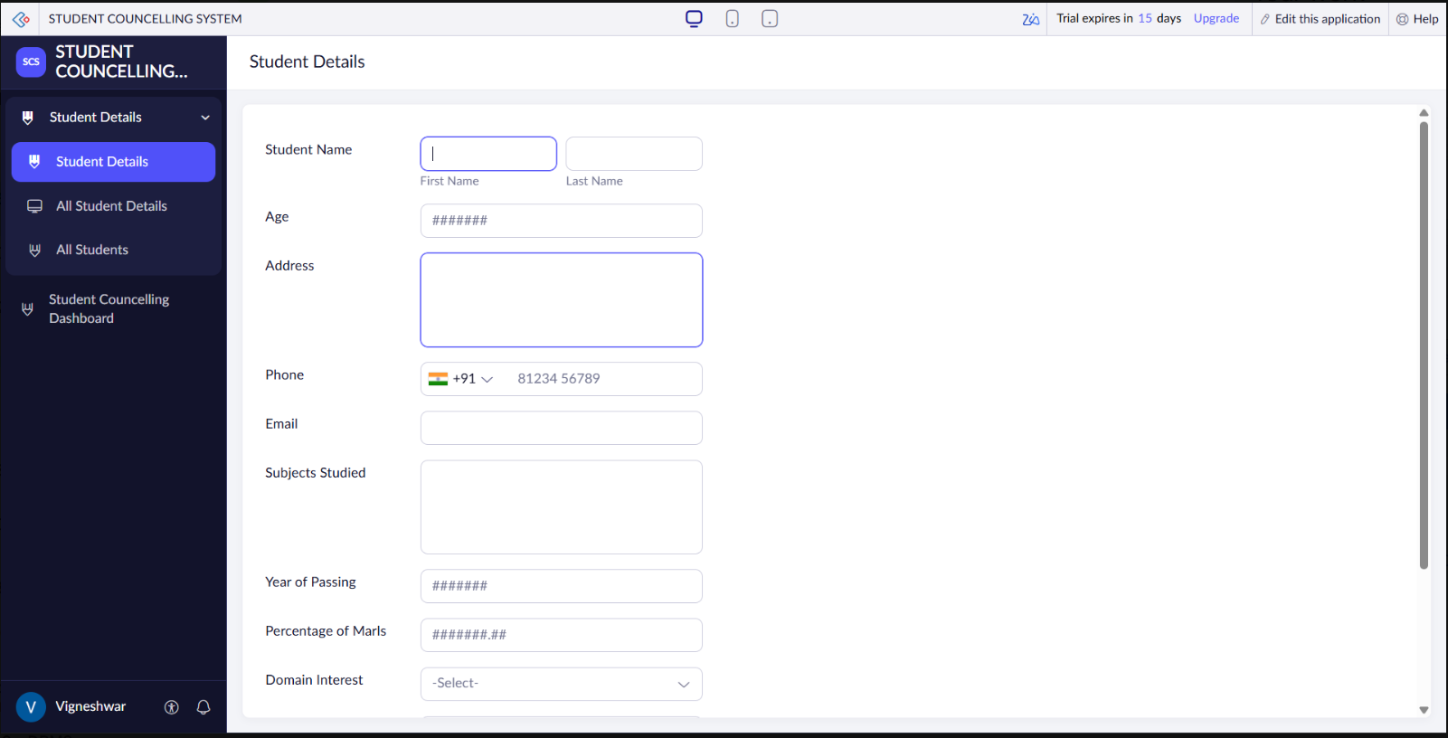

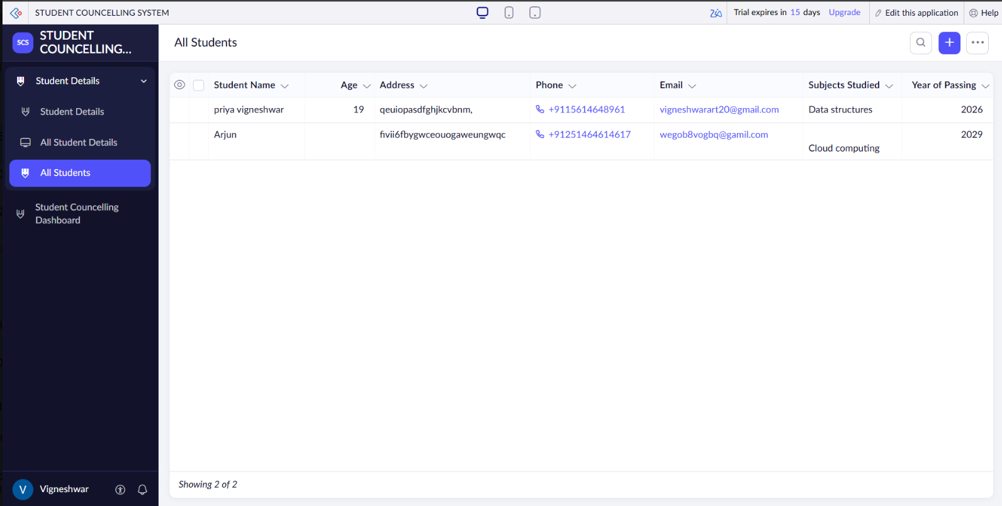

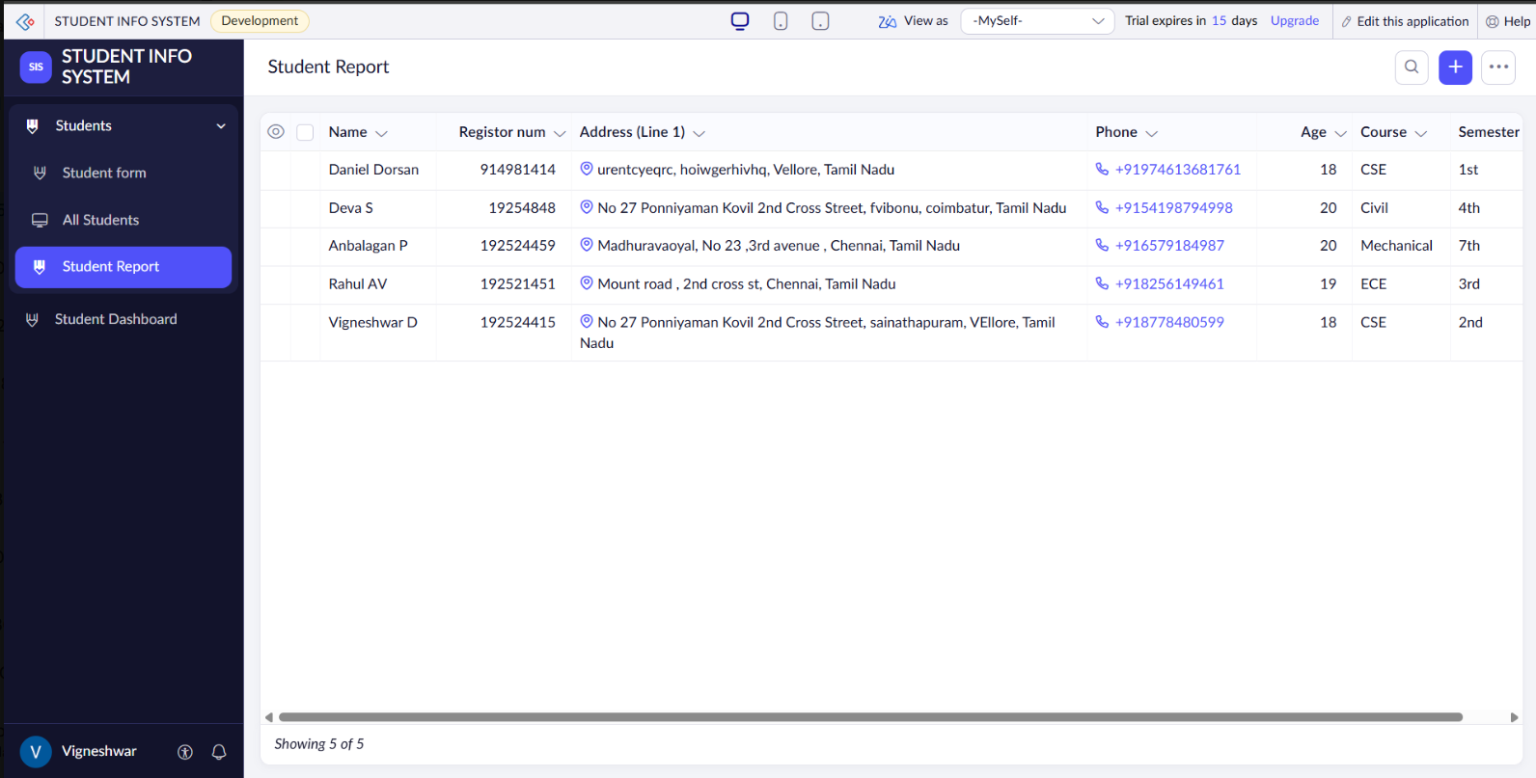

Experiment 2: Create a simple cloud software application for Property Buying & Rental process (In Chennai city) using any Cloud Service Provider to demonstrate SaaS include the necessary fields such as Buy, Rent, commercial, Rental Agreement , Rental Agreement, Area, place, Range, property value etc.

IMAGES:

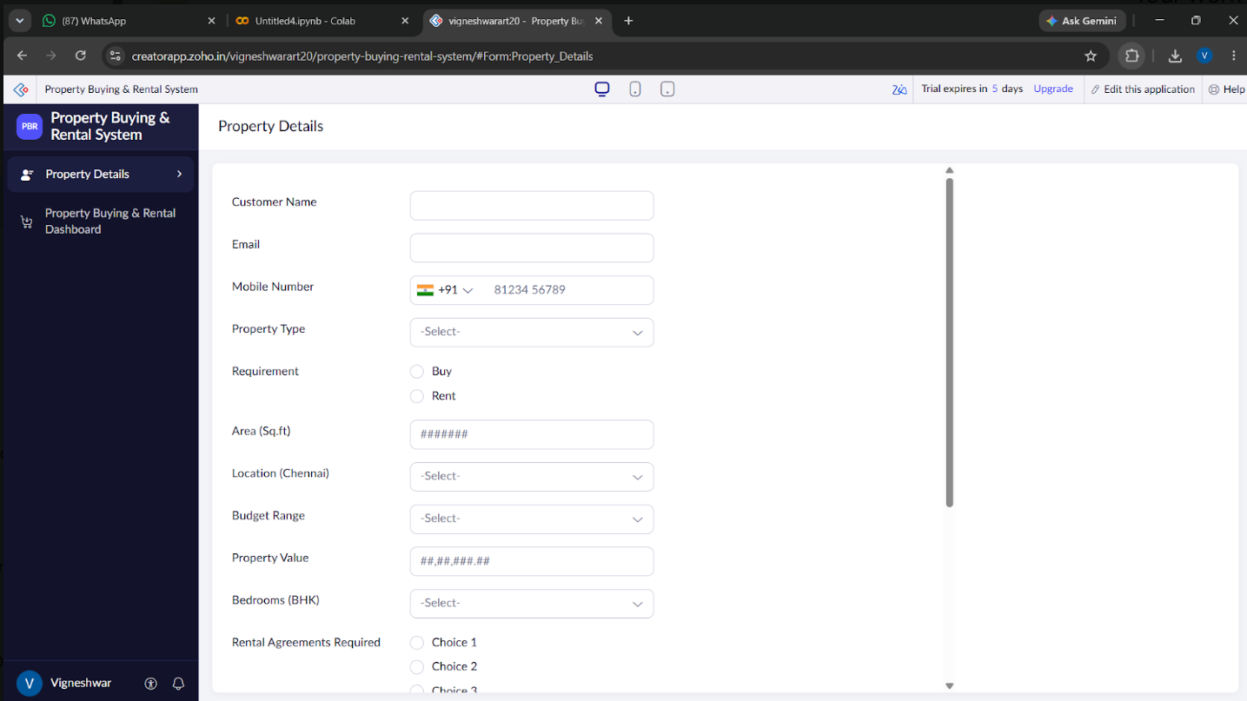

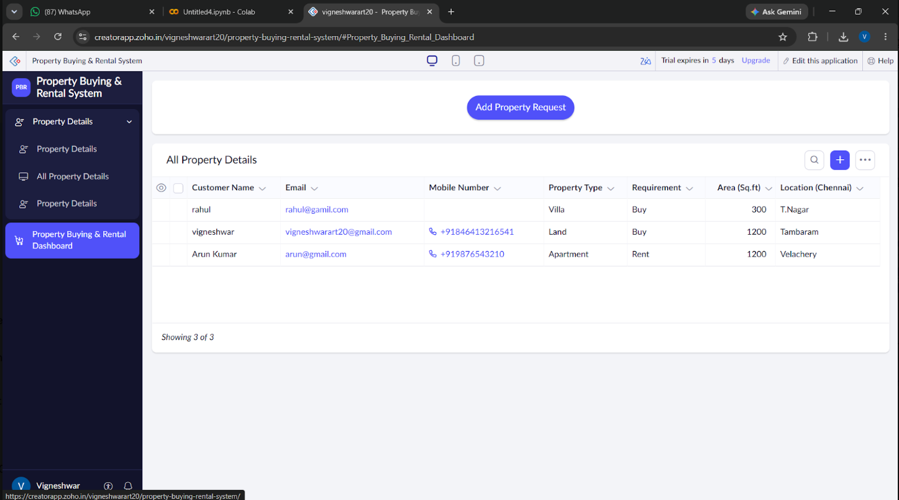

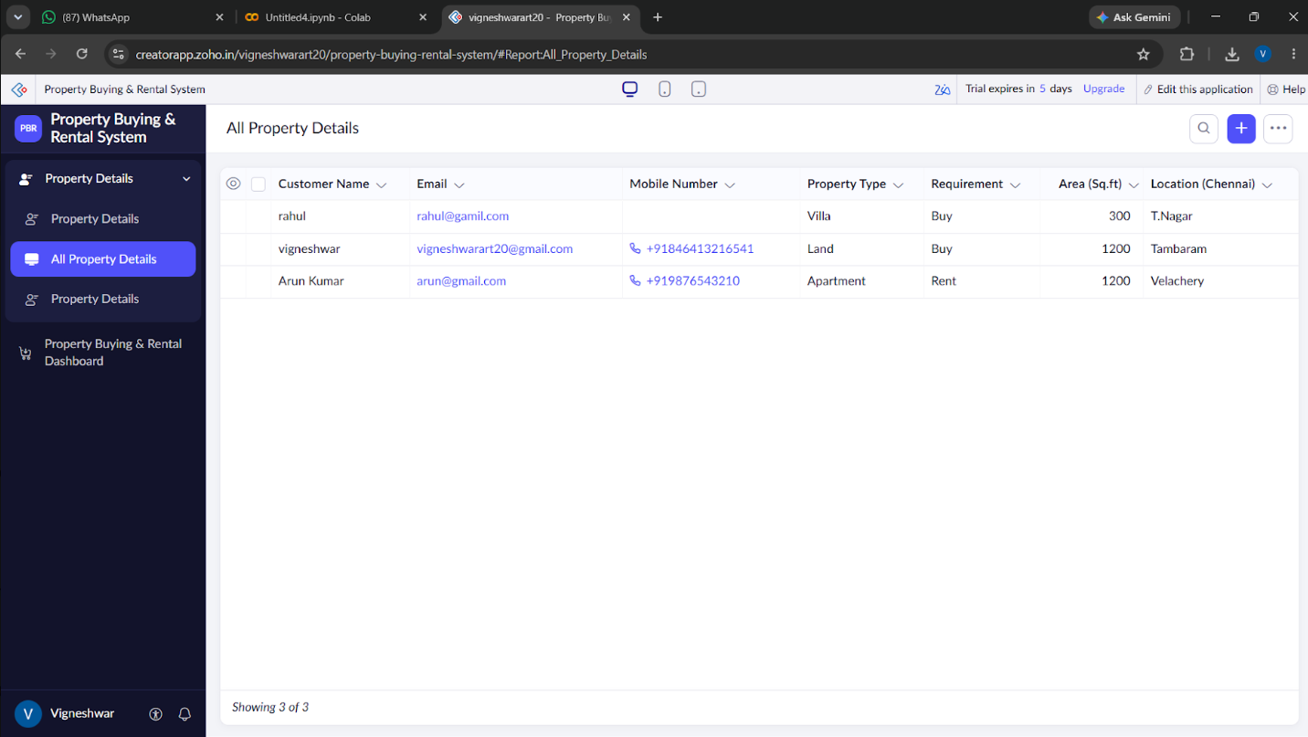

Experiment 3: Demonstrate virtualization by Installing Type-2 Hypervisor in your device, create and configure VM image with a Host Operating system (Either Windows/Linux). Create a Virtual Machine with 5 CPU, 12 GB RAM and 8 GB storage disk using a Type 2 Virtualization Software.

IMAGE:

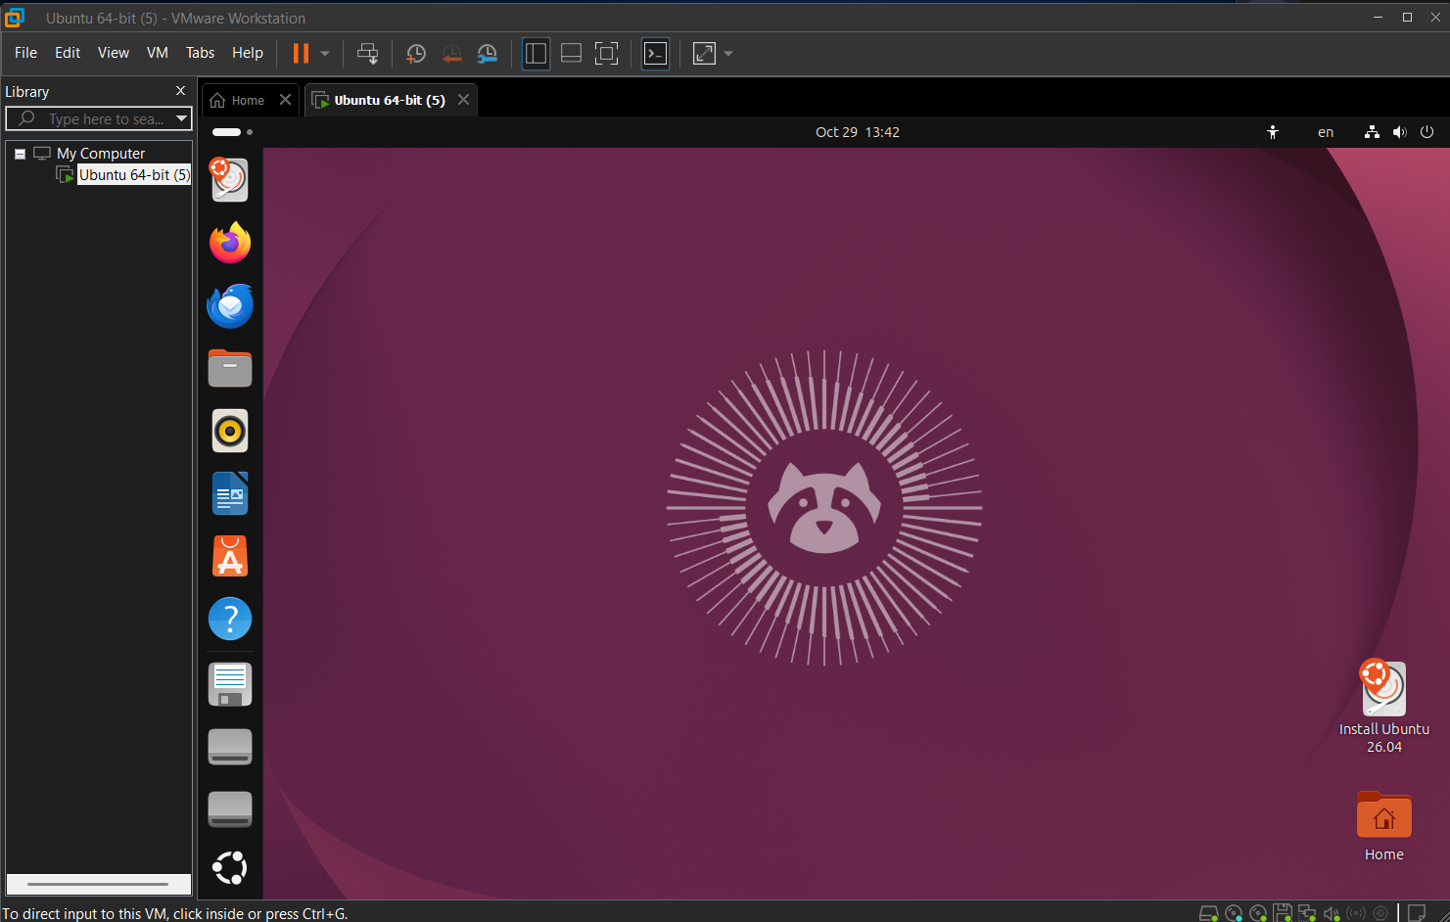

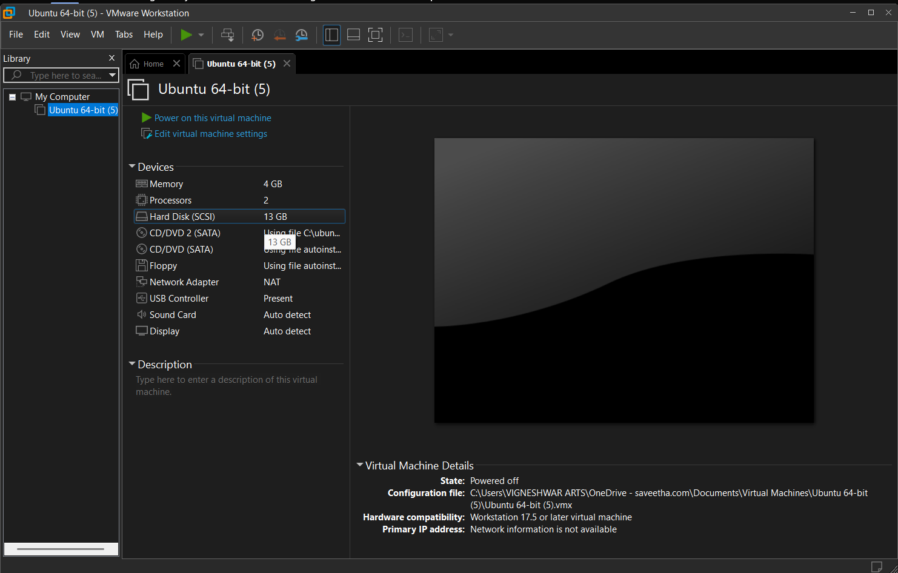

Experiment 4: Demonstrate virtualization by Installing Type-2 Hypervisor in your device, create and configure VM image with a Host Operating system (Either Windows/Linux). Create a Snapshot of a VM and Test it by loading the Previous Version/Cloned VM.

IMAGE:
Before Snapshot:
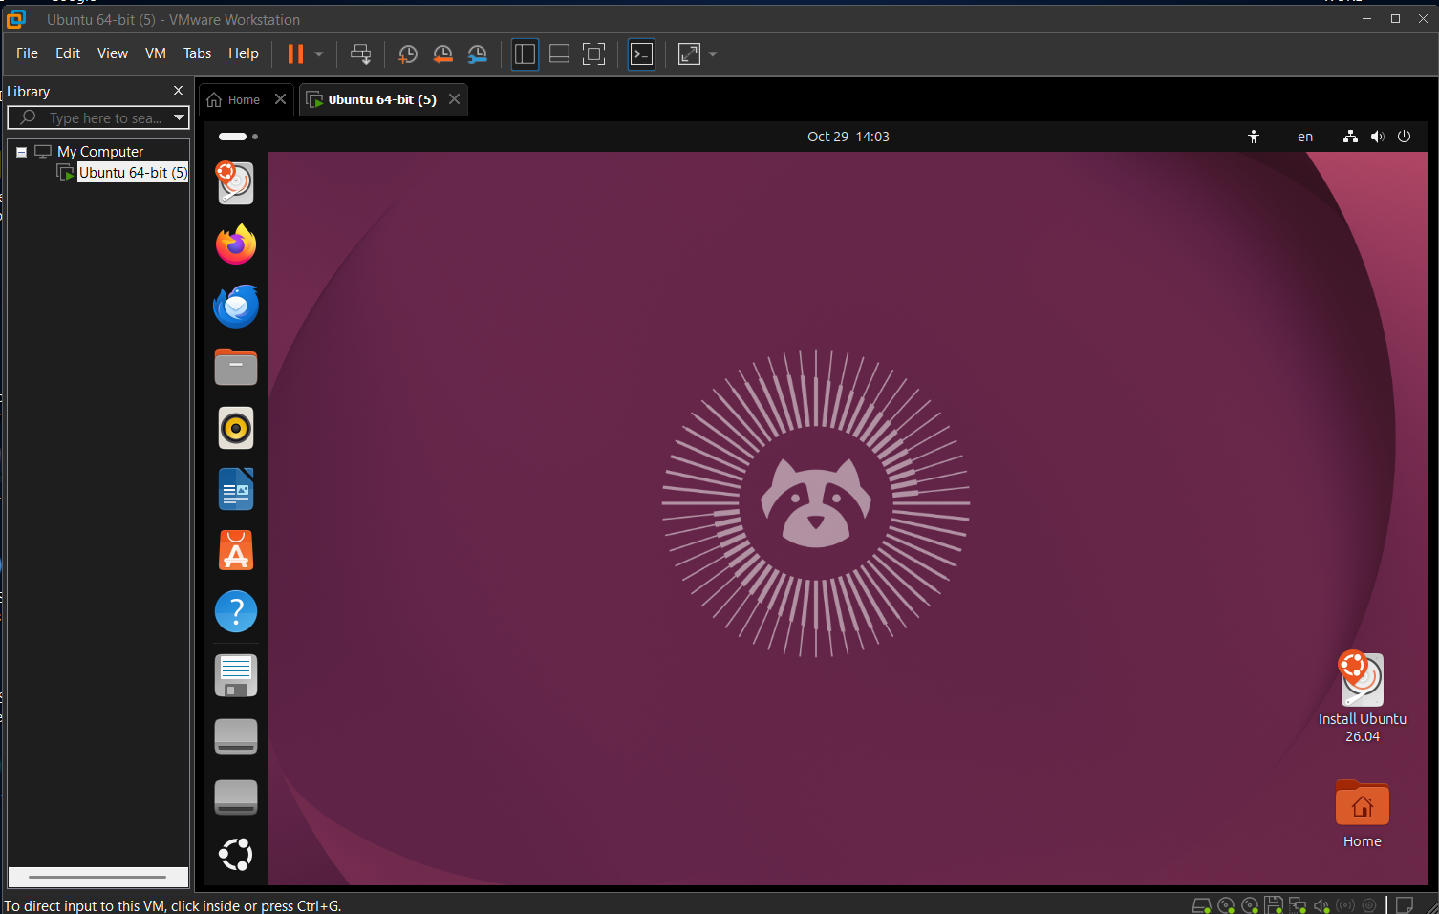

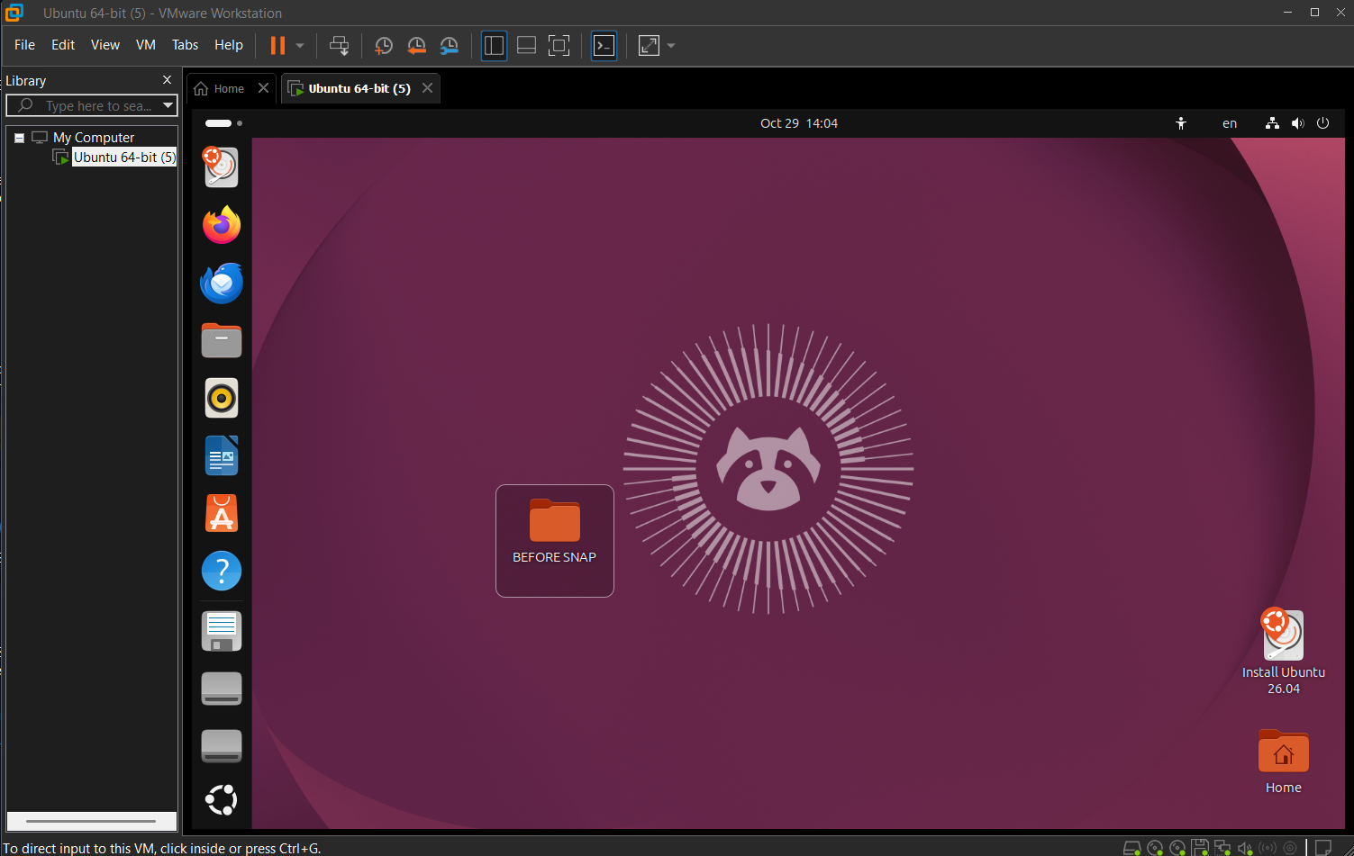

Experiments Rubric
Criteria | Weightage | Level 4 - Exemplary | Level 3 - Proficient | Level 2 - Developing | Level 1 - Beginning
Experimental Design | 25% | Design is systematic and technically strong | Mostly correct design | Basic design with gaps | Poorly designed activity
Use of Tools / Platforms | 20% | Appropriate and effective use of cloud tools | Good tool usage with minor issues | Limited tool usage | Incorrect or missing tool usage
Application of Concepts | 20% | Concepts are applied accurately to practical tasks | Mostly accurate application | Partial application | Weak application
Analysis and Output | 20% | Strong analysis and meaningful outcome interpretation | Good analysis with minor gaps | Basic analysis | Little or no analysis
Documentation | 15% | Clear, structured, and complete documentation | Mostly complete documentation | Partially complete | Poor documentation

Total Marks Awarded:

Assessment Tasks-III

Experiment 1: Create a simple cloud software application for Mark Sheet Processing System using any Cloud Service Provider to demonstrate SaaS include the necessary fields such as name of the student, Reg no of the student , Subjects , Marks, Average, percentage, rank, overall performance etc.

Experiment 4: Demonstrate virtualization by Installing Type-2 Hypervisor in your device, create and configure VM image with a Host Operating system (Either Windows/Linux). Create a Snapshot of a VM and Test it by loading the Previous Version/Cloned VM.

