School Management System

Project Overview

School Management system to manage students, subjects, exams, and marks while analyzing academic performance using MySQL.

E - R Diagram

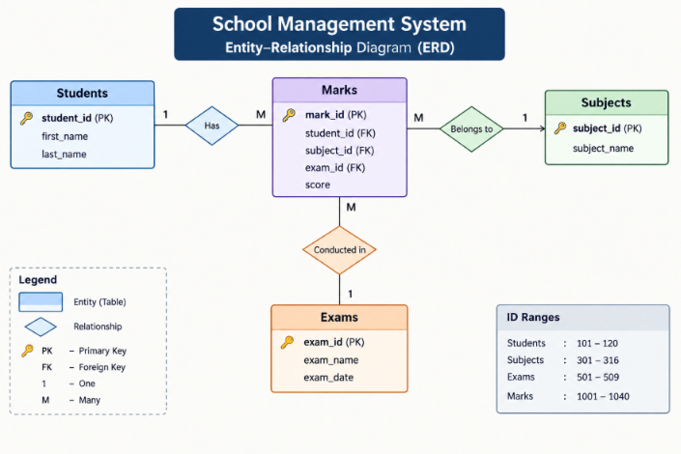

Database Design

create database school_managementDB;

Tables:

1 .Students Table :

create table students(
student_id int primary key,
first_name varchar(50),
last_name varchar(50)
);

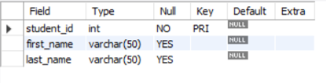

2 .Subjects Table :

create table subjects(
subject_id int primary key,
subject_name varchar(30)
);

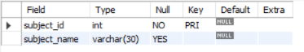

3 .Exams Table :

create table exams(
exam_id int primary key,
exam_name varchar(30)
);

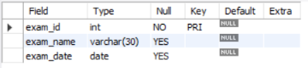

4 .Marks Table :

create table marks(
mark_id int primary key,
student_id int,
subject_id int,
exam_id int,
score int,
foreign key (student_id) references students(student_id),
foreign key (subject_id) references subjects(subject_id),
foreign key (exam_id) references exams(exam_id)
);

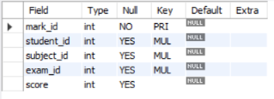

Test Data

Students :  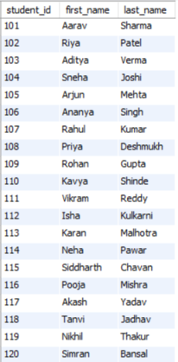 | Subjects :  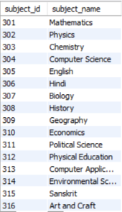
Exams :

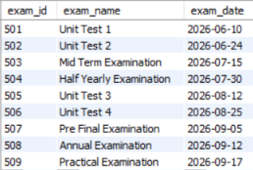

Marks :  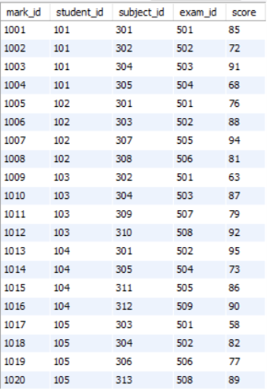 | 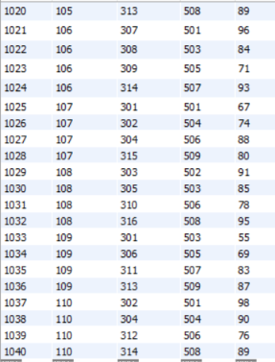

SQL Queries and Implementation

Query 1 :

Retrieve all students: List the first name and last name of every student.

select first_name,last_name from students;

Output:

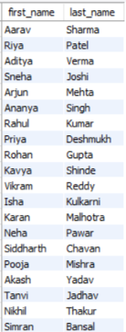

Query 2 :

Filter by Score:

Find all entries in the Marks table where the score is greater than 80.

select * from marks where score > 80;

Output:
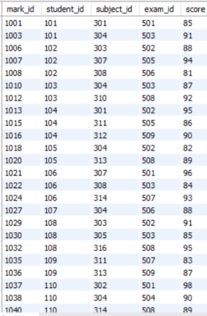

Query 3 :

Sort Data:

List all exams sorted by their date, starting with the most recent.

select * from exams order by exam_date desc;

Output:

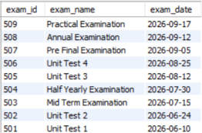

Query 4 :

Student Marks:

List the First Name, Subject Name, and Score for every mark recorded.

SELECT s.first_name, sub.subject_name, m.score
FROM students s
JOIN marks m
ON s.student_id = m.student_id
JOIN subjects sub
ON m.subject_id = sub.subject_id;

Output:

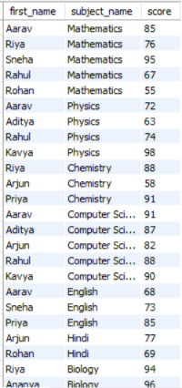



Query 5 :

Subject Averages:
Calculate the average score for each subject. Display the Subject Name and the Average Score.

SELECT s.subject_name, AVG(m.score) AS average_score
FROM subjects s
JOIN marks m
ON s.subject_id = m.subject_id
GROUP BY s.subject_id, s.subject_name;

Output:
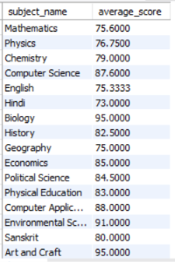

Query 6 :

Count Exams: How many marks have been recorded specifically for "Aarav Sharma"?
SELECT COUNT(*) AS total_marks
FROM students s
JOIN marks m
ON s.student_id = m.student_id
WHERE s.first_name = 'Aarav'
AND s.last_name = 'Sharma';

Output:
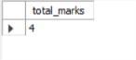

Query 7:

Top Performer: Find the student (First Name, Last Name) who has the highest single score in any exam.

SELECT s.first_name, s.last_name, m.score
FROM students s
JOIN marks m
ON s.student_id = m.student_id
WHERE m.score = (SELECT MAX(score) FROM marks);

Output:



Query 8:
Scores by Exam: Display the Exam Name and the total sum of scores for that exam, but only for exams where the total sum is greater than 250.
SELECT e.exam_name, SUM(m.score) AS total_score
FROM exams e
JOIN marks m
ON e.exam_id = m.exam_id
GROUP BY e.exam_id, e.exam_name
HAVING SUM(m.score) > 250;

Output:
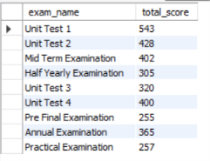

Query 9:
Pass/Fail Label: Create a report showing the Student Name, Subject, Score, and a status column that says "Pass" if the score is 70 or above, and "Fail" if below.

SELECT
CONCAT(s.first_name, ' ', s.last_name) AS student_name,
sub.subject_name,
m.score,
CASE
WHEN m.score >= 70 THEN 'Pass'
ELSE 'Fail'
END AS status
FROM students s
JOIN marks m
ON s.student_id = m.student_id
JOIN subjects sub
ON m.subject_id = sub.subject_id;

Output:
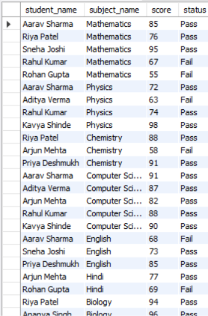


Prepared by Lam Vigneswar

