[http://awards.aggie100.com/HonoreeDashboard/BackgroundInformation](http://awards.aggie100.com/Admin/DashBoard)

* Light button outline – means didn’t get
* Outline the buttons lightly

[http://awards.aggie100.com/HonoreeDashboard/companyLogoPhoto](http://awards.aggie100.com/HonoreeDashboard/SpeakingInfo)

* Update the preview so that the logo is not distorted
* Allow them to download the file and click to view it in a browser to verify that the file is the correct one.
* Update (no) border to match drop down  
  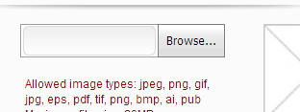

<http://awards.aggie100.com/HonoreeDashboard/BackgroundInformation>

* Add a Dashboard link before Company Information
* 