* Allow users to update their username to something that is not an email address.
  + Allow people to enter their email address for username recovery.
    - Then enter username for password recovery.
  + When nominating, how do we allow them to use one email address for multiple nominations? Enter a username or create a username automatically when nominating? [taseer@ztwealth.com1](http://awards.aggie100.com/Admin/Export/SponsorStudentLunche), [taseer@ztwealth.com2](http://awards.aggie100.com/Admin/Export/TableIndividualTickets), [taseer@ztwealth.com3](http://awards.aggie100.com/HonoreeDashboard/SpeakingInfo)? Or should there be a landing page when they log in with that email and be able to select which company they’re working on for that session.
    - Example issue – TaseerBadar (has 11 companies) – Filter not working
  + At a minimum, the administrator needs to be able to update the username for someone.
  + By default, for usernames, we could create it based off of the first 4 letters of the company name and then the GUID (5 characters), so 9 total.
    - This way they can have multiple usernames with a single email address.

Please explain what to do exactly, for username we can add one more text box for that, not auto generated because it hard to remember, also if multiple username bind with single email address than not possible to username and password recovery from email address.

You can just add another box for username.

What about password recovery from username? We should still have email address as an option. If someone has more than 1 account under the same email it can show them a message to recover their password using their individual usernames.

[http://awards.aggie100.com/HonoreeDashboard](http://awards.aggie100.com/Admin/EmailTemplates)

* Speaking Opportunities – Change “No information available” to a status “You are not currently scheduled for (what?)Required more detail what to do exactly?
* This page isn’t pulling up for me now. We need to have “No Information Available” changed to “You are not currently scheduled for (whatever is available to schedule).”

<http://awards.aggie100.com/HonoreeDashboard/BackgroundInformation>

* Strip out Nugget of Wisdom to its own page. Between “Speaking Opportunities” and “Company Logo/Photos” sections.

Exports

* RSVP: Breakfast with Dean
  + Separate out the list of “Users” from the current “Guest1 – College1, Guest2 – College2” to four separate columns instead: Guest1 | College1 | Guest2 | College2

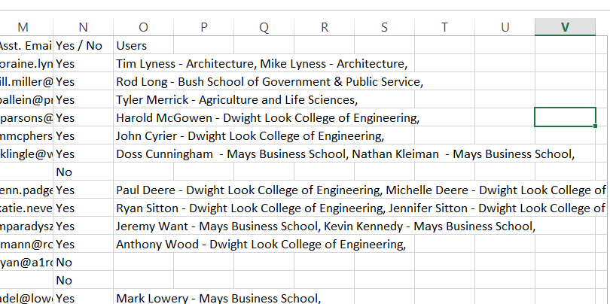

* Export > Invoicing

# **For next year? – This part is not do right now, its for next year or complete right now?**

No we need this to be done this year. We have a few months to finish stuff up so it shouldn’t be an issue.

[http://awards.aggie100.com/HonoreeDashboard/MainEvent](http://awards.aggie100.com/HonoreeDashboard/companyLogoPhoto)

* Take out the attendees text area and have that as its own section between Events and Speaking Engagements.
* Show an Attendees section on the Dashboard and show red if they’re not either all filled in, or they
  + They could have a later date for Attendee name entries “Attendee Name Deadline”
* Leave the Guest 1 and Guest 2 on the MainEvent page but also carry it over to the first two lines of the Attendees page if they have purchased additional spots.
* Include a Verify Information page for them to review the details (similar to the company information area).
  + List in the Dashboard and show RED|GREEN status

Menu

* Company Information
  + Background Information
  + Representatives Information
  + Verify Information
* Events
  + Event Information
  + Program Awards Luncheon
  + Attendees
  + Verify Information
* Speaking Opportunities
* Nugget of Wisdom
* Company Logo/Photos