**002: MySql**

**Having the follow table structures: tbl_user: user_id, user_full_name, tbl_role:**

**role_id, role_name and tbl_user_role: user_id, role_id.**

***-Create the mysql code to create these tables.***

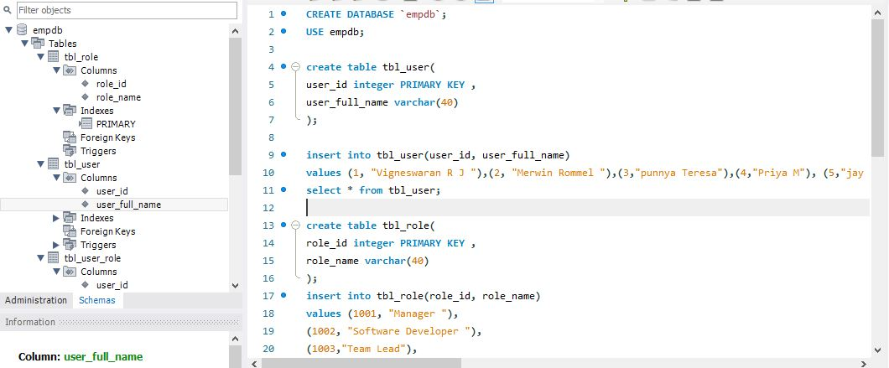

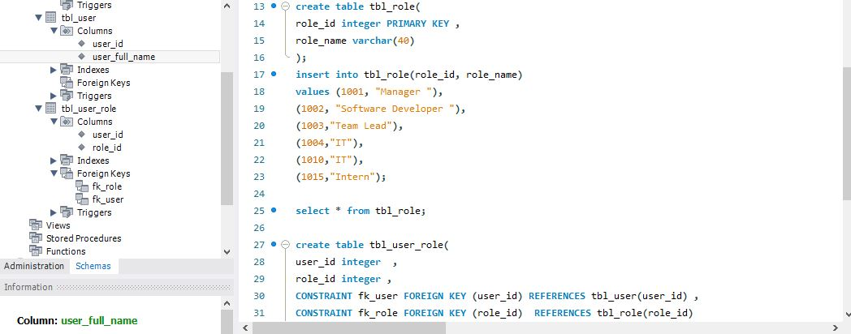

***- Write a query that will give you all users that belong to the role_name IT***

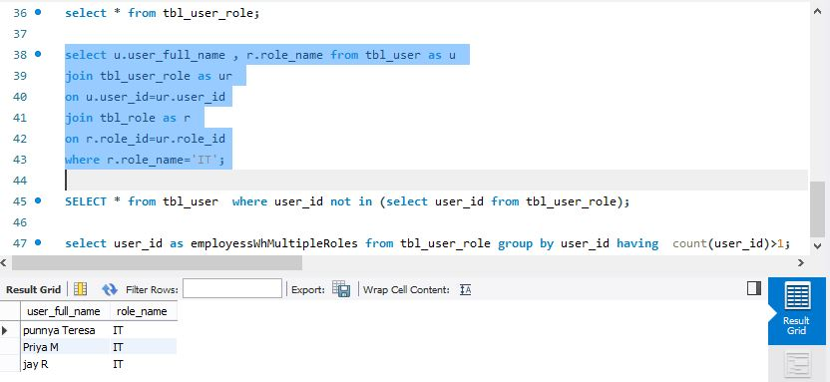

***- Write a query that will give you a list of users with no roles***

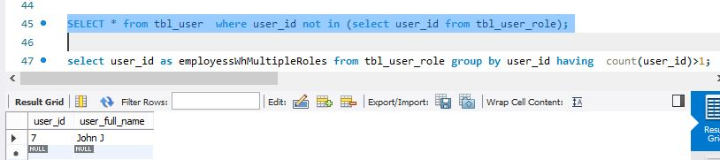

***- (Bonus) Write a query that will find the users with duplicate roles.***

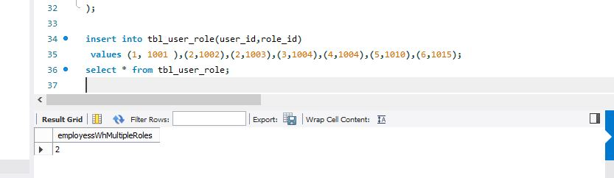

**Code:**

**CREATE DATABASE `empdb`;**

**USE empdb;**

**create table tbl_user(**

**user_id integer PRIMARY KEY ,**

**user_full_name varchar(40)**

**);**

**insert into tbl_user(user_id, user_full_name)**

**values (1, "Vigneswaran R J "),(2, "Merwin Rommel "),(3,"punnya Teresa"),(4,"Priya M"), (5,"jay R"), (6,"Brijith J"), (7, "John J");**

**select * from tbl_user;**

**create table tbl_role(**

**role_id integer PRIMARY KEY ,**

**role_name varchar(40)**

**);**

**insert into tbl_role(role_id, role_name)**

**values (1001, "Manager "),**

**(1002, "Software Developer "),**

**(1003,"Team Lead"),**

**(1004,"IT"),**

**(1010,"IT"),**

**(1015,"Intern");**

**select * from tbl_role;**

**create table tbl_user_role(**

**user_id integer ,**

**role_id integer ,**

**CONSTRAINT fk_user FOREIGN KEY (user_id) REFERENCES tbl_user(user_id) ,**

**CONSTRAINT fk_role FOREIGN KEY (role_id) REFERENCES tbl_role(role_id)**

**);**

**insert into tbl_user_role(user_id,role_id)**

**values (1, 1001 ),(2,1002),(2,1003),(3,1004),(4,1004),(5,1010),(6,1015);**

**select * from tbl_user_role;**

**select u.user_full_name , r.role_name from tbl_user as u**

**join tbl_user_role as ur**

**on u.user_id=ur.user_id**

**join tbl_role as r**

**on r.role_id=ur.role_id**

**where r.role_name='IT';**

**SELECT * from tbl_user where user_id not in (select user_id from tbl_user_role);**

**select user_id as employessWhMultipleRoles from tbl_user_role group by user_id having count(user_id)>1;**