Human-robot handshake
qb SoftHand
july, 5th
Dear all, the last time we talked about an open loop experiment where the softhand is set to a fixed position for a fixed amount of time, the human hand is in the handshaking position, and the FSR sensors are on and in their fixed position. Having this situation we want to record the behaviour of the human and correlate it with the softhand movements. Here my setup.
The following picture shows the time(seconds) vs. position (pseudo random)
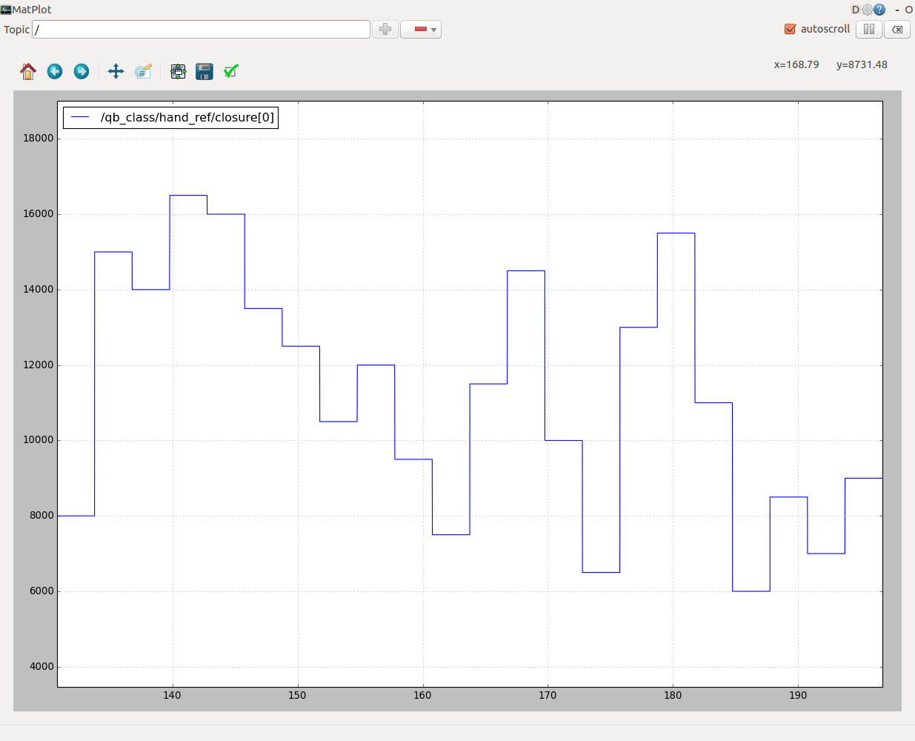Illustration 1: Referenced Position
The softhand is receiving 22 different positions from [6000 to 17000] with a step of 500. each position appears only once and lasts 3 seconds. The frequency rate is 100Hz so the whole experiment lasts 66 seconds.
The vector in which i'm storing the 22 values is shuffled using a fixed seed in order to have a pseudorandom order.
Here's a snippet of the code
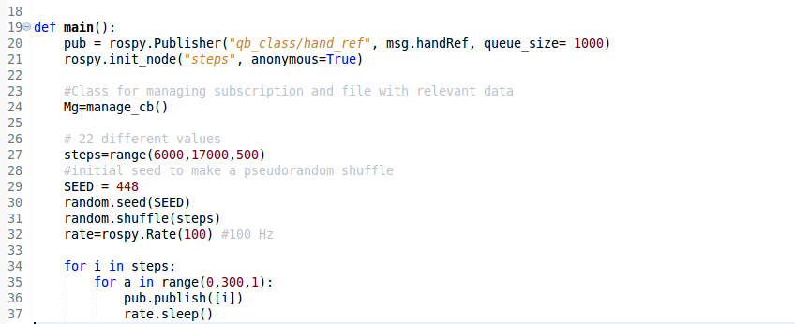
The seed value of 448 is chosen randomly but is fixed between experiments with different humans.
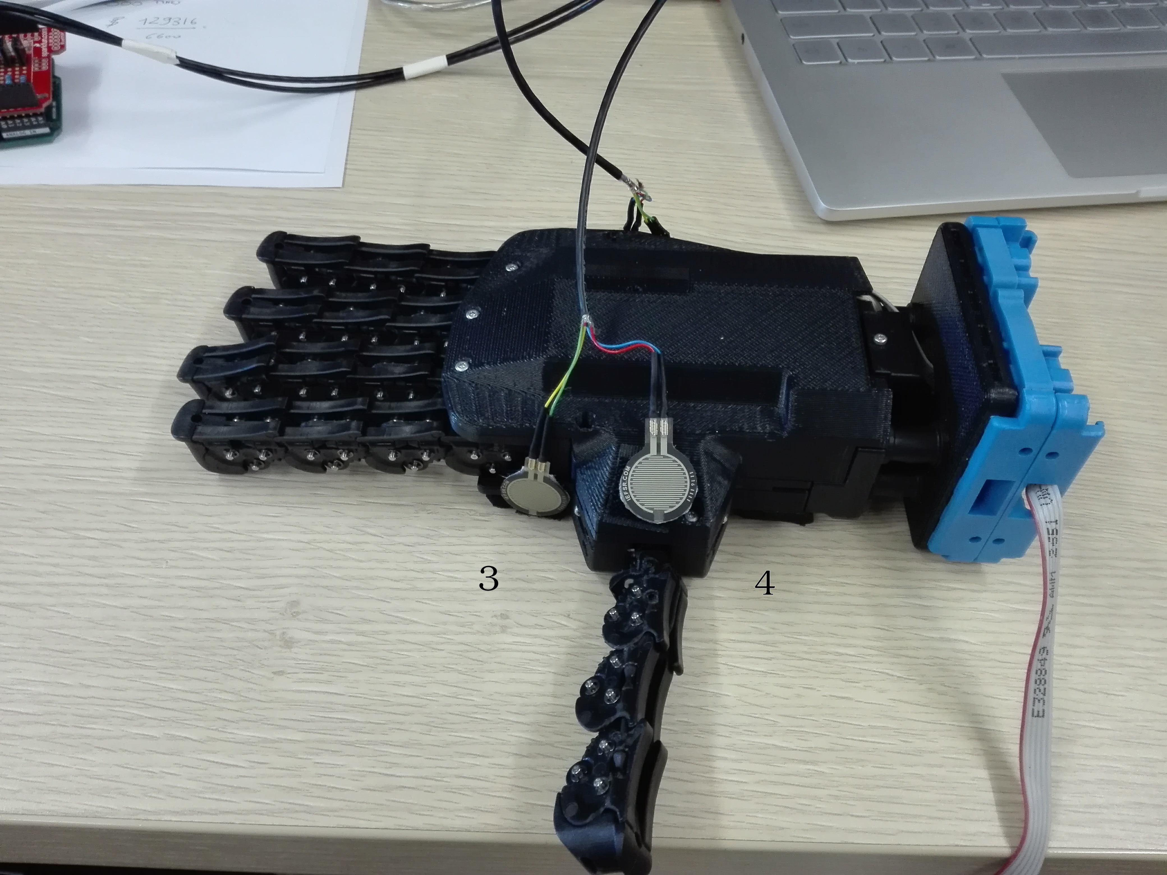
The physical position of the sensors and their id on the softhand is the following:
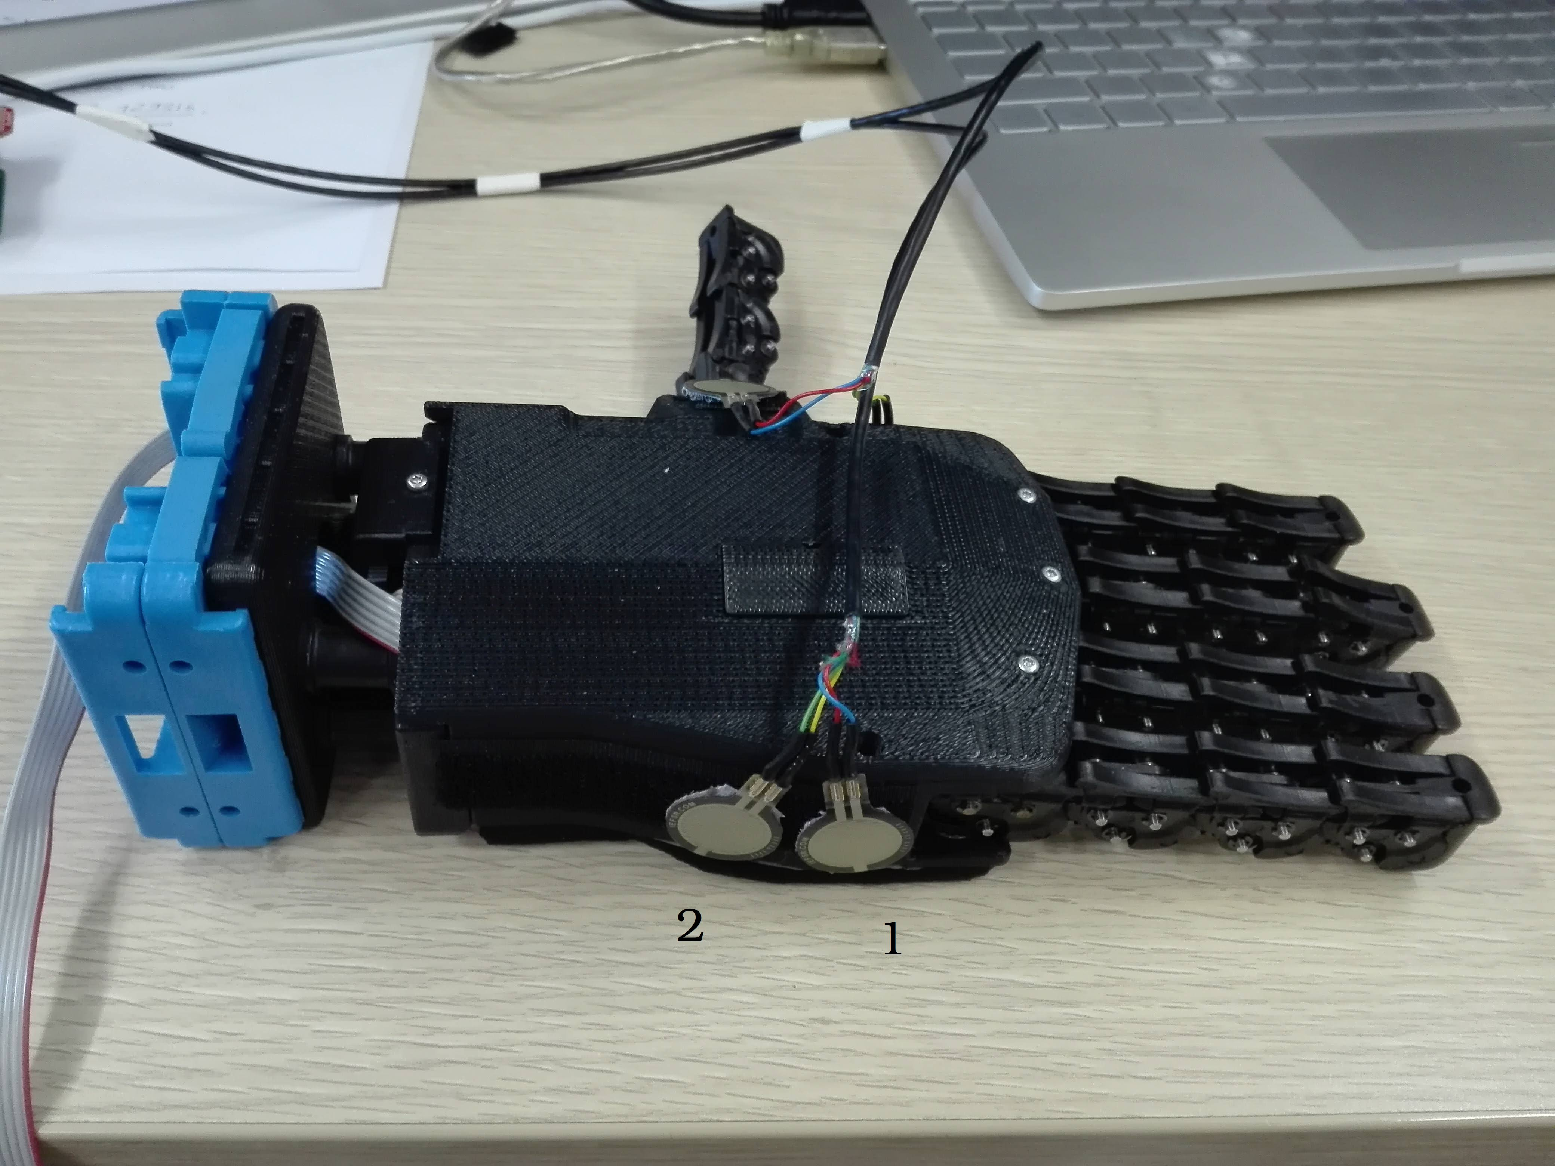

The value of the sensors during the experiment is the following:
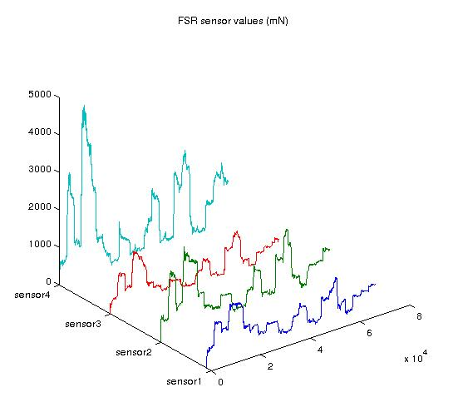

From this approach we can clearly notice that the sensor4 is the most relevant one, in its physical position is the only one which is reflecting the behaviour of the human thumb. If we compare the shapes of these curves with with referenced position in the Illustration 1: Referenced Position, we can appreciate a correlation at first sight. Analytical tools should now be used in order to evaluate the correlation.
The Picture below shows the Current absorbed by the softhand during the experiment, the Referenced position and the real position measured by the softhand.
The real position is trying to follow the referenced position but in this experiment we used a low stiffness (0.1), low proportional gain. If we increase the proportional gain to (f.i 0.7) the error between the positions tends to decrease.

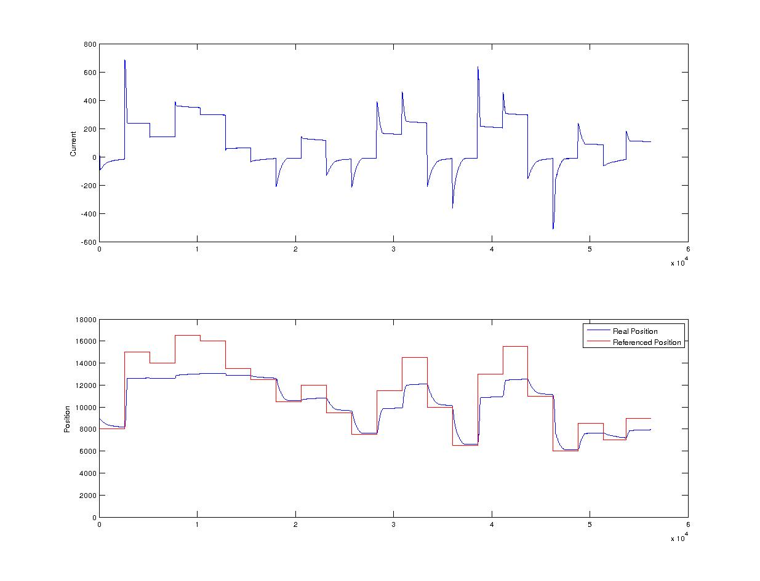Illustration 2: stiffness = 0.1
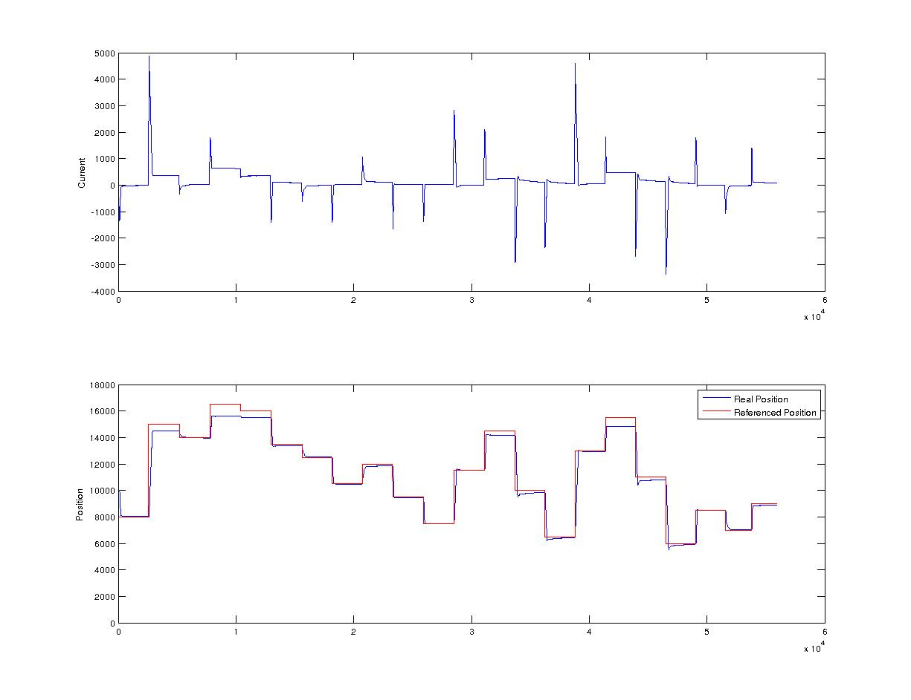Illustration 3: stiffness = 0.7
Increasing the stiffness is resulting in a less smooth current but more trusty position. Is interesting to notice the x axis of the previous plots. Both the experiments last 66seconds. The small difference in the x axis scale is due to the way i'm using to write the file. Each time a topic is publishing a value, a row is written to the file, this means that the faster topic will write more rows in the file.
The problem raised notice that the topic named '/qb_class/hand_measurement' which is the topic published by the softhand with its current and real position, has a frequency rate which is not fixed. Its frequency takes values aprox. from 300Hz to 600Hz this is not ensuring a fixed length of the file.
In order to compare different experiments (different files) we want these to have the same amount of data.
In order to solve this issue I decided to write a row in the file each time a Referenced position is sent to the softhand, in this way i'm sampling all the topics at a predefined frequency 100Hz.
The previous experiments(stiffness = 0.1 and stiffness = 0.7) are now repeated with this solution for data sampling.

