Human-robot handshake
qb SoftHand
The proposed State Machine, works as follows, compute the full closure twice. The first time without the human hand in handshaking position and the second time we are expecting a human hand to be in the position. Both times we are saving the position value sent to the softhand and the corresponding current absorbed by the dc motor [q,i]. This method is safe since the proportional gain(stiffness parameter) is kept at 0,1.
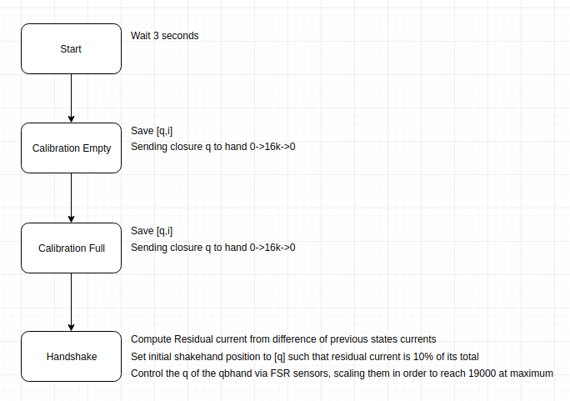

After the 'Calibration Full' state, two vectors with the couples [q,i] are available. Due to the physical presence of the human hand in the second state, the dc motor had to absorb more current but the respective [q] column are identical. Now in order to obtain the residual current which we assume to be proportional to the grasping force, we simply subtract the above mentioned columns [i].
The graph below shows the two current obtained with this configuration, its clear that a physical obstacle in the finger movements is affecting the way current is absorbed.
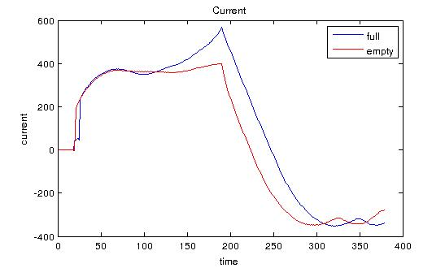

The last state 'Handshake' is executing the handshake in the following way:
1- Sending the 'first touching position' which is the position in which the residual current is at relatively low value (10% of its total).
2- Scaling the value read from the FSR sensors in order to span the full range of the current handshaking.
3- Setting as maximum closure position, a position in which the residual current obtained after the state 'Calibration Full' is at a relatively high value (80%).

The future work will be to find ways to optimize this Low Threshold and High Threshold.
Currently we have a linear controller with respect to the FSR sensors for the range spanned by the thresholds.
The maximum position that the hand is receiving is 19000 (where the hand is fully closed), that means that we never want the controller to send values up to 19000 in the 'handshake' state.
The range of position which we want to send must vary with respect to the hand size f.i. a small hand will have a starting closing position high. (the qbhand must close itself more in order to touch a small hand). On the other side a big hand will have a low starting closing position, which enables the controller to play more with the ranges. In case of a small hand, as closer the starting position is to the upper threshold 19000 as less effective the controller can be.
27/06
Next experiments. Try the current configuration with more subjects and make them evaluate the handshake. How to evaluate the response? If we want to have teleoperated handshake with no information about the other side (human or robot) how can we set up experiments?
Salve files from State machine with calibration empty and calibration full and after a
Skypecall:
create more handshake algorithm
Questions to make to the people:
1- how good do you feel this handshake?
2- which one do you prefer and why?
3- google form
4- is it too strong or too weak?
5- too slow or too fast?
Give a statement and then put a scale to make people give a discrete value.
Does it seams reasonable?? second order controller / include social influenction
look how the human adapt to the robot handshake. → open loop, robot is closing and human is responding. Record values from sensors.
NO Ask to imitate the robot
YES aks to shake hand as normal as possible
20 trials. 4 different strenght level. Randomize the order of the levels. Random order everytime. Want to be able to say that there's no effect of the time in the experiments. Make sure that the strongest level is not too painfull(decrease upper value and insert emergency stop).
## 03/07/18
slow experiments
constant steps
different step levels
not time related / simplest first experiment
-1 FIRST EXPERIMENT
run one state → step long enough to cut transient → save into files
-2 SECOND EXPERIMENT
change closure value during time to see if human is following with sensors.
Save into file:
sensors | qbhand current | qbhand published position | qbhand real position
take pict before experiment / not continuously, send steps directly/

## 12/07
plot Reference pos vs. sum of sensors
normalize ranges sensors and add them up for closure
FSR position ok
fix the stiffness to a high one ok
what is the hand position when it makes contact, with different participants so we know when is the softhand touching the human one
try with highest stiffness that conserves stability to the hand and low the maximum
without moving the softhand ask the user to double the grasping force.
Remove ears and eyes!! blind and deaf!

