Procedure for Boot Loading AT328 Chip

Loading Arduino ISP Sketch:
- Connect the Boot Sheild to Arduino and place the new AT328 IC to Jig base as shown below.
Arduino with BootSheild
- Open Arduino ISP Skectch by, selecting File->Examples->11.ArduinoISP-> ArduinoISP and upload the sketch to arduino.
Opening Arduino ISP Sketch
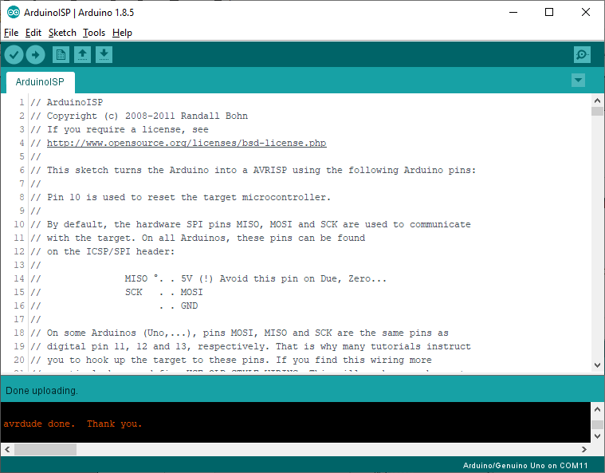
Uploading to Arduino

Identifing COM Port:
- Press “Win+R” to open Run, and type devmgmt.msc command to open Device Manager.
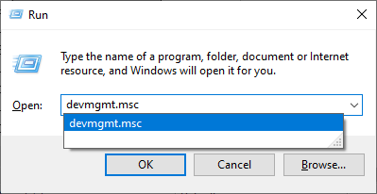
Run
Device manager
- Note down the Serial Port to which arduino is connected. (In the above screen shot it is COM3).

Edit the Script File:
- To edit the script file, right click on the file (Load-BL-AT328-xVyz.bat), and select edit and a notepad will open as shown below.
Right Click Menu
Changing COM Port

- Now change the COM port number to the port to which Arduino is connected (ie Previous Step) and save and close the file.

Loading BootLoader:
- Go to the folder where the “Load-BL-AT328-xVyz.bat” file is present, and type cmd in the address bar and press enter to open command prompt.
Boot Loader Script Folder
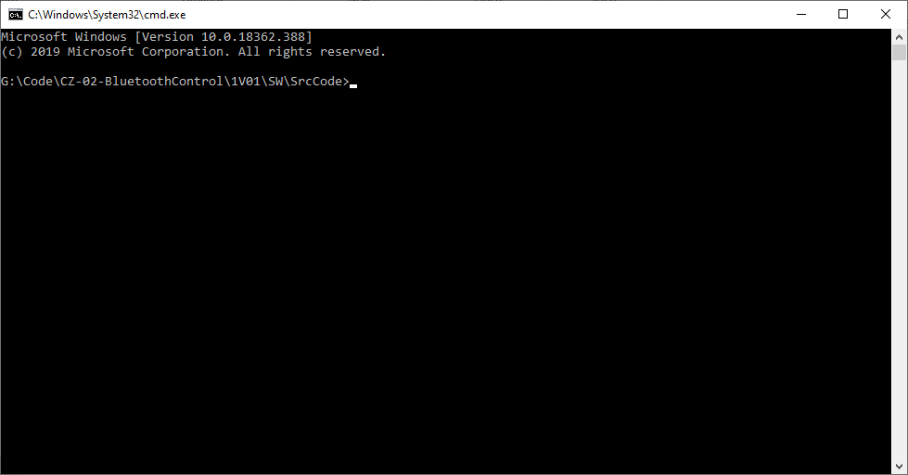
Command Prompt
- In Command Prompt, type Load-BL-AT328-1V00.bat and press enter to load the boot loader. Refer the below screen shot

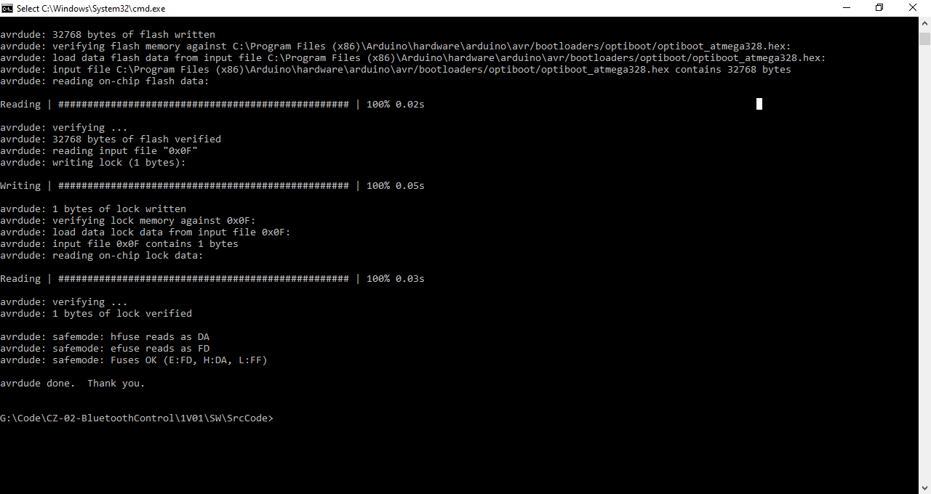
Script Output

