Procedure for Configuring HC-05 Bluetooth Module

Switching to AT Mode:
- Remove the fuse from the Relay Module.
- Upload the HC-05_AT_mode.ino sketch to arduino and remove the controller (AT328p) from arduino and place the IC into the Relay modlue.
- Connect the HC-05 module to the Relay Module as per schematic.
- Connect the jumper end of USB to serial converter to the Relay Module (ie to the Debug Connector) and USB end to the PC.
- Connect the Power cable to the Relay Module as per schematic.
- Press and hold the Mode switch button on the HC-05 modlue and simultaneously insert the fuse to power on the Relay module.
- Now the LED in the HC-05 modlue will blink every 2 seconds indicating it is in AT mode.
- Note: If HC-05 is in data mode, the LED blinks every 500 milliseconds.

Opening Serial Monitor:
- In Arduino IDE, go to Tools -> Serial Monitor to open the serial monitor.

- Change the serial monitor Settings as below,
Speed: 9600
Line Endings: Both CR & LF

Changing Device Name:
- Type AT+NAME=BYDEV to change the name to BYDEV, and HC-05 will respond with OK.

- Verify the name change by typing AT+NAME?
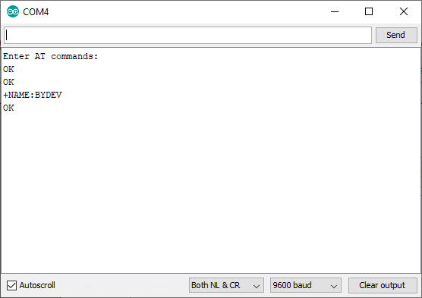

Changing Password:
- Type AT+PSWD="XXXX" to change the password to XXXX, and HC-05 will respond with OK.
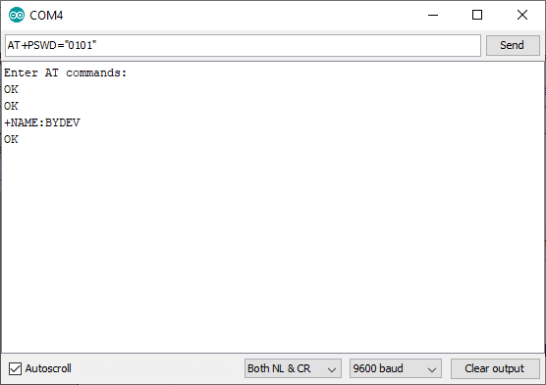
- Verify the password change by typing AT+PSWD?.
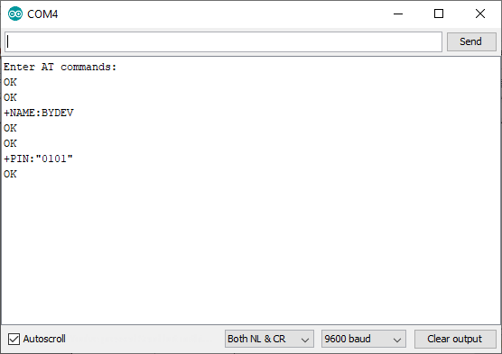

Relay Module Pictures

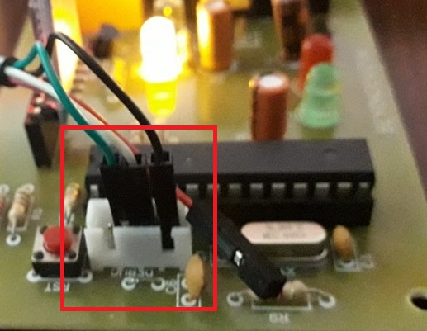
Debug Port Connection

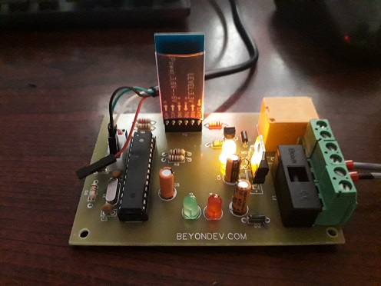
Bluetooth Module orientation

