# Voxblox算法实现文档

参考博客：<https://www.guyuehome.com/15664>

## 一、computeDistance

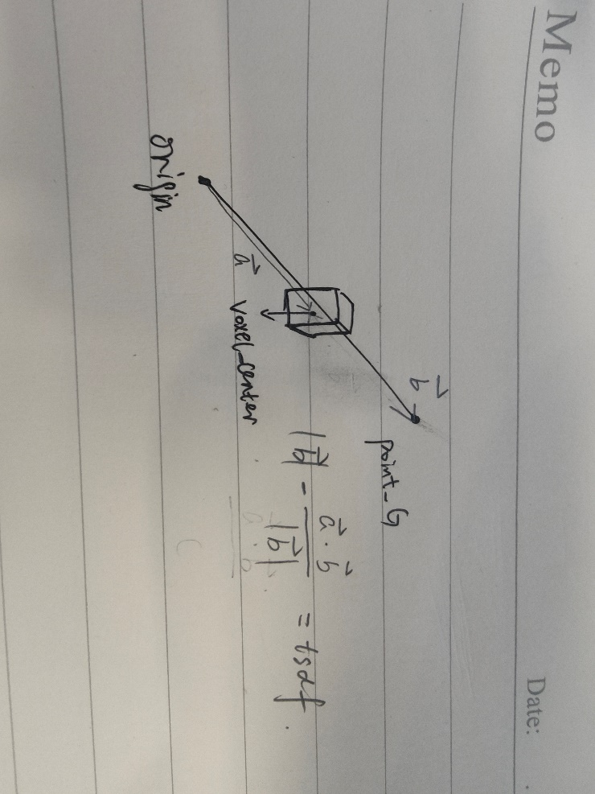

## 二、marching cube

参考博客：<https://www.bilibili.com/video/BV1Ev411r7vx/?spm_id_from=333.337.search-card.all.click&vd_source=984a70561ab2b42249f5eeff92b8d9f1>

<https://paulbourke.net/geometry/polygonise/>

<https://www.youtube.com/watch?v=M3iI2l0ltbE&t=58s&ab_channel=SebastianLague>

## 三、