Definition:

Deep learning: Deep learning is a set of automatic learning methods attempting to model with an elevated level of abstraction of data through articulated architectures of different nonlinear transformations.

Machine learning (2): Machine learning is a type of artificial intelligence (AI) that allows software applications to become more accurate in predicting outcomes without being explicitly programmed.

Artificial intelligence (3): Artificial intelligence (AI, also machine intelligence, MI) is intelligent behavior by machines, rather than the natural intelligence (NI) of humans and other animals.

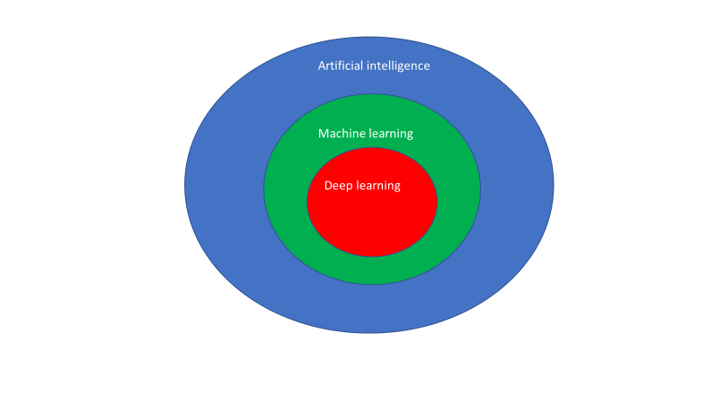

Neuron Network: a neuron network is an organized architecture of neurons.

Neuron (6): A formal neuron, or neuron, is a nonlinear and bounded algebraic function whose value depends on parameters called coefficients or weights

Loss function (7): Sometimes referred to as the cost function or error function the loss function is a function that maps values of one or more variables onto a real number intuitively representing some "cost" associated with those values. For backpropagation, the loss function calculates the difference between the network output and its expected output, after a case propagates through the network.

Activation function: mathematical function applied on the output signal of a node.

First analysis:

Artificial intelligence is used in numerous fields (1)like: formal calculation, behavior simulation, natural language processing, problem solving, speech recognition, text recognition, image recognition, robotic. Considering our project, we will focus on image recognition and especially on handwritten digit recognition. This choice is motivated by the fact that this problem started in the 90s with Yann Le Cun(4) so the problem is well known. In addition to that there are opensource training and testing data to validate our algorithm (5) which should be hard to build alone. Finally, training time is limited which is important given our computing power.

Standard of mnist problem

To validate our algorithm, we will try to recognize handwritten digit (28*28 pixels image). We get 50 000 training pictures and 10 000 testing pictures.

Choice of the activation function:

<https://www.youtube.com/watch?v=-7scQpJT7uo>

<https://fr.coursera.org/learn/deep-neural-network/lecture/HRy7y/softmax-regression>

#TODO

Library to use for machine learning and deep learning

Since the explosion of machine learning algorithm utilization many libraries have been created in different language. We are looking for a library in Python or/and C++ because we do not want to code extra-algorithm. However, one of the most important (11) library is written for python and C++: Scikit-learn (10).

Scikit-learn logo.png

Scikit has been created in 2007 and is still developed. Its length of service is its most important strength (12). Nevertheless, Scikit does not get any module for deep learning approach.

To support deep learning approach, we need to use another library. Two high-level libraries exist: Lasagne (8) and Keras (9) but, because they are high-level libraries, they are not speed enough (13) compared to other libraries. Speed is the aim of our project, that’s why we cannot use them.



Caffe (14) is the most veteran framework for deep learning approach. Nevertheless, it gets a poor documentation and the syntax to use is not clear (13).



Theano is a low-level library which can be used in python. The main problem to use Theano is the impossibility to perform parallel computing thanks to GPU.



The solution which seems the best one is TensorFlow (16). It is a low-level library which can be used in C and Python. Contrary to Theano, TensorFlow can use parallel computing thanks to Cuda (17) extension which is a language developed by Nvidia to use their GPU. That’s why TensorFlow should be our best option (13) in terms of speed if we do not want to input parts of the algorithm on FPGA device.



Image classification architectures :

CNN :

<https://www.youtube.com/watch?v=FTr3n7uBIuE>

<https://ujjwalkarn.me/2016/08/11/intuitive-explanation-convnets/>

<http://ufldl.stanford.edu/tutorial/supervised/ConvolutionalNeuralNetwork/>

Capsule networks :

<https://www.youtube.com/watch?v=VKoLGnq15RM>

<https://openreview.net/pdf?id=HJWLfGWRb> (to read)

Fully connected network:

<http://andrew.gibiansky.com/blog/machine-learning/fully-connected-neural-networks/>

<http://forums.fast.ai/t/dense-vs-convolutional-vs-fully-connected-layers/191>

Bibliography

1

[http://www.intelligenceartificielle.fr/domaines_IA.php](http://www.intelligenceartificielle.fr/domaines_IA.php 2)

[2](http://www.intelligenceartificielle.fr/domaines_IA.php 2) <http://whatis.techtarget.com/definition/machine-learning>

3

[https://en.wikipedia.org/wiki/Artificial_intelligence](https://en.wikipedia.org/wiki/Artificial_intelligence 4)

[4](https://en.wikipedia.org/wiki/Artificial_intelligence 4)

[http://yann.lecun.com/exdb/publis/pdf/lecun-90c.pdf](http://yann.lecun.com/exdb/publis/pdf/lecun-90c.pdf 5)

[5](http://yann.lecun.com/exdb/publis/pdf/lecun-90c.pdf 5) <http://yann.lecun.com/exdb/mnist/>

6 <https://www.universalis.fr/encyclopedie/reseaux-de-neurones-formels/2-quelques-definitions/>

7 <https://en.wikipedia.org/wiki/Backpropagation#Loss_function>

8 <https://lasagne.readthedocs.io/en/latest/>

9 <https://keras.io/>

10 <http://scikit-learn.org/stable/>

11 <https://www.youtube.com/watch?v=MDP9FfsNx60>

12 <http://makemeanalyst.com/5-popular-python-libraries-machine-learning-deep-learning-2017>

13 <https://buzzrobot.com/deep-learning-frameworks-a-review-before-finishing-2016-5b3ab4010b06>

14 <http://caffe.berkeleyvision.org/>

15 <http://deeplearning.net/software/theano/tutorial/>

16 <https://www.tensorflow.org/>

17 <http://www.nvidia.fr/object/cuda-parallel-computing-fr.html>