**First Inference**

In this inference we are finding the number of arrest recorded by police in 2014 and 2016 and categorised based on Adult and Juvenile and checks whether arrests are increased or decreased.

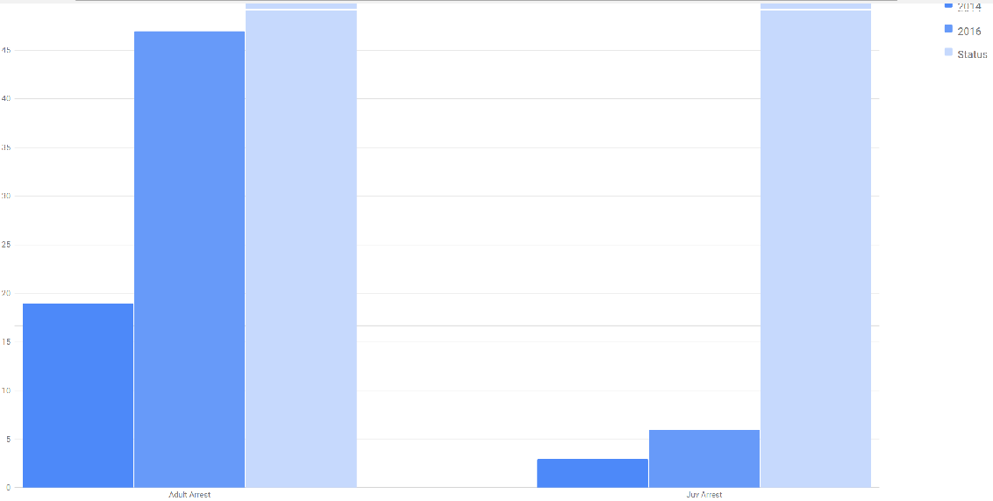

**Second Inference**

In this inference we are finding number of crimes in different areas of LA in 2014 and 2016 and finding whether the crimes per area is increased or decreased.

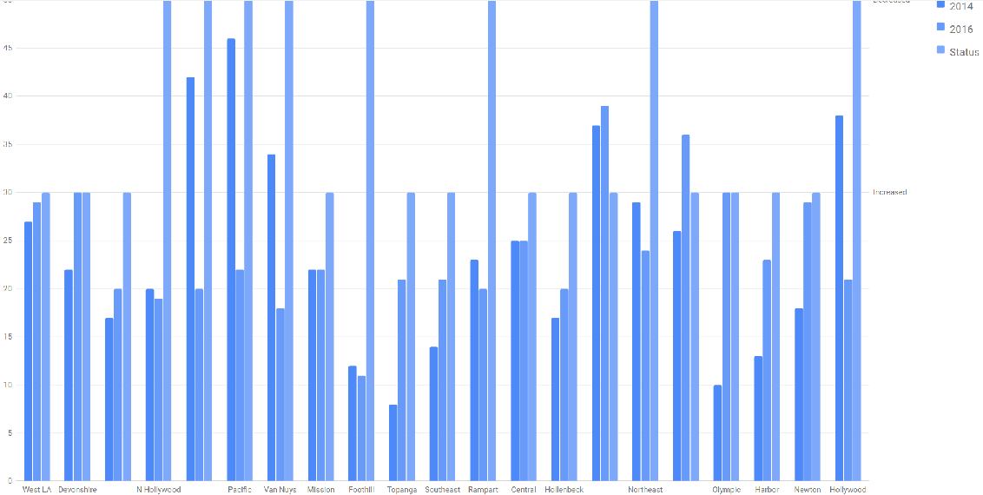

**Third Inference**

In this inference, we are finding the count of different types of crimes in 2014 and 2016

