**DAILY ONLINE ACTIVITIES SUMMARY**

|  |  |  |  |  |  |  |  |  |
| --- | --- | --- | --- | --- | --- | --- | --- | --- |
| **Date:** | **19/02/2020** | | | | | **Name:** | **Viha B Raju** | |
| **Sem & Sec** | **6th sem** | | | | | **USN:** | **4al17cs108** | |
| **Online Test Summary** | | | | | | | | |
| **Subject** | | **CGV** | | | | | | |
| **Max. Marks** | | **60** | | **Score** | | | **47** | |
| **Certification Course Summary** | | | | | | | | |
| **Course** | **Python for machine learning** | | | | | | | |
| **Certificate Provider** | | | **IBM** | | **Duration** | | | **12 hours** |
| **Coding Challenges** | | | | | | | | |
| **Problem Statement: Give an array of distinct integers. The task is to count all the triplets**  **Such that sum of two elements equal to the third element.** | | | | | | | | |
| **Status:done** | | | | | | | | |
| **Uploaded the report in Github** | | | | | **yes** | | | |
| **If yes Repository name** | | | | | https://github.com/Viha/coding | | | |
| **Uploaded the report in slack** | | | | | **yes** | | | |

Online Test Details: (Attach the snapshot and briefly write the report for the same)

Certification Course Details: (Attach the snapshot and briefly write the report for the same)

Coding Challenges Details: (Attach the snapshot and briefly write the report for the same)

Online Test Details:

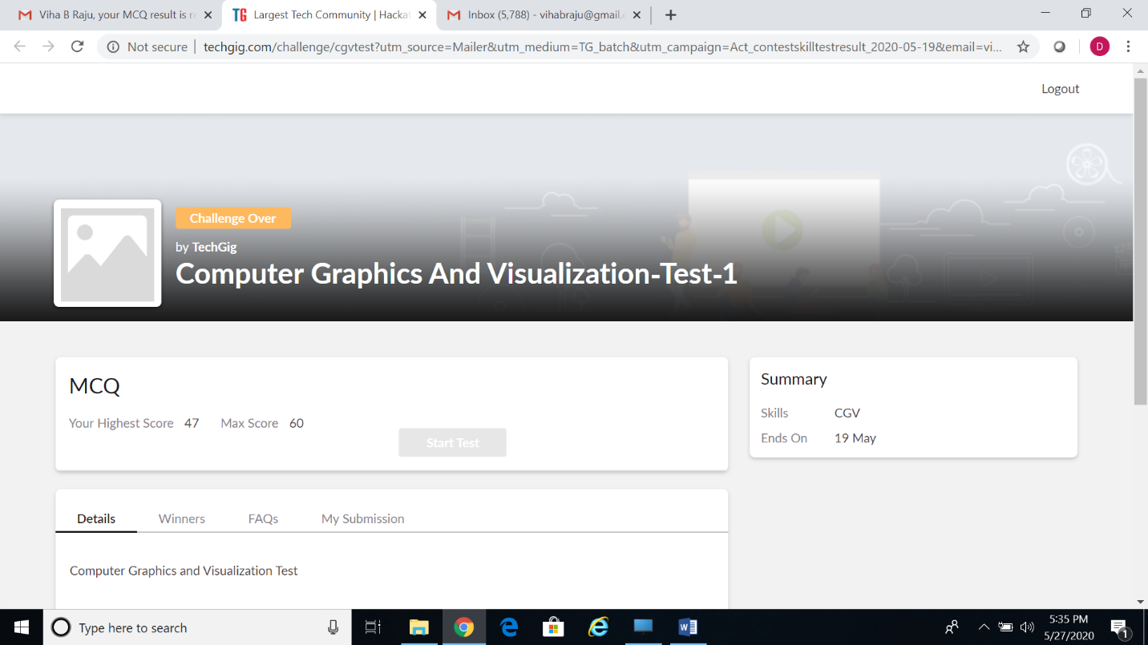

Certification Course Details:



Coding:

