**MIS:112315139**

**GROUP-4**

**NAME: VIHAAN**

**Q1)**

**Code:**

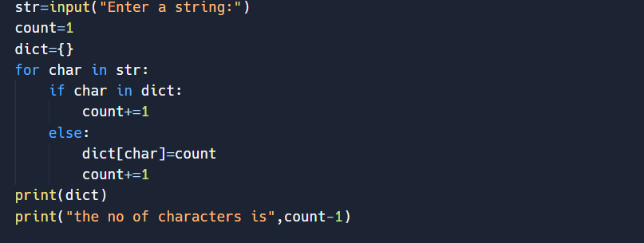

**Output:  
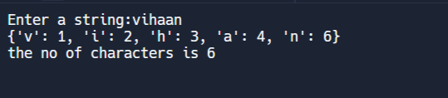**

**Q2)**

**Code:**

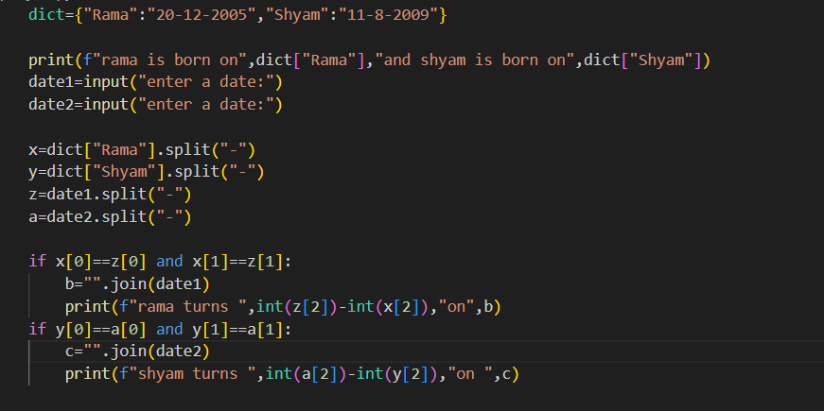

**Output:**

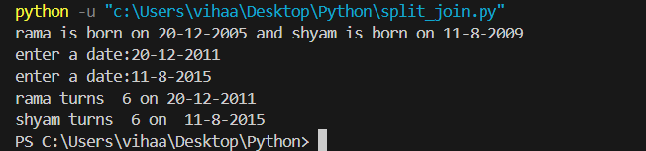

**Q3)**

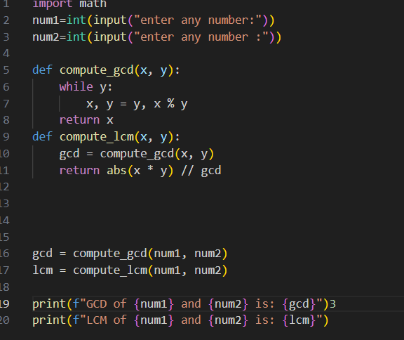

**Output:**

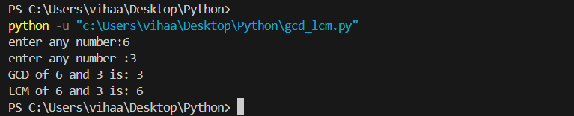

**Q4)**

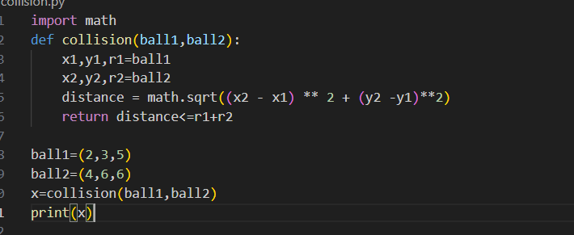

**Output:**

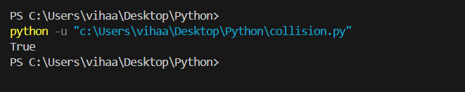

**Q5)** 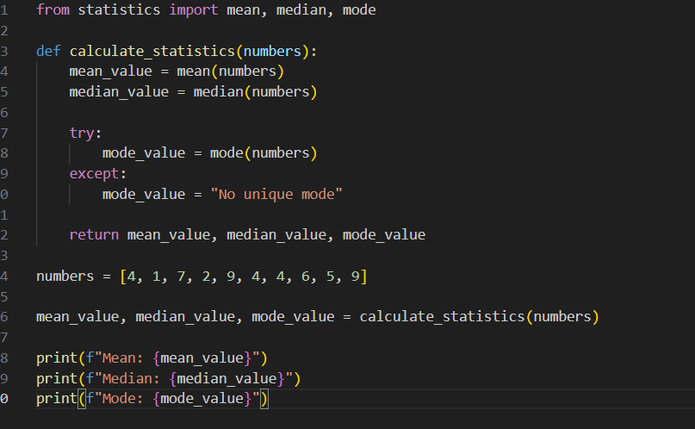

Output:

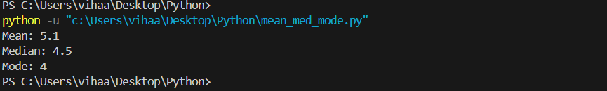

**Q6)**

**def bubble_sort(arr):**

**n = len(arr)**

**for i in range(n):**

**for j in range(0, n-i-1):**

**if arr[j] > arr[j+1]:**

**arr[j], arr[j+1] = arr[j+1], arr[j]**

**def merge_sort(arr):**

**if len(arr) > 1:**

**mid = len(arr) // 2**

**left_half = arr[:mid]**

**right_half = arr[mid:]**

**merge_sort(left_half)**

**merge_sort(right_half)**

**i = j = k = 0**

**while i < len(left_half) and j < len(right_half):**

**if left_half[i] < right_half[j]:**

**arr[k] = left_half[i]**

**i += 1**

**else:**

**arr[k] = right_half[j]**

**j += 1**

**k += 1**

**while i < len(left_half):**

**arr[k] = left_half[i]**

**i += 1**

**k += 1**

**while j < len(right_half):**

**arr[k] = right_half[j]**

**j += 1**

**k += 1**

**def selection_sort(arr):**

**n = len(arr)**

**for i in range(n):**

**min_idx = i**

**for j in range(i+1, n):**

**if arr[j] < arr[min_idx]:**

**min_idx = j**

**arr[i], arr[min_idx] = arr[min_idx], arr[i]**

**def insertion_sort(arr):**

**for i in range(1, len(arr)):**

**key = arr[i]**

**j = i - 1**

**while j >= 0 and key < arr[j]:**

**arr[j + 1] = arr[j]**

**j -= 1**

**arr[j + 1] = key**

**def switch_case(sort_type, arr):**

**if sort_type == 1:**

**print("Performing Bubble Sort...")**

**bubble_sort(arr)**

**elif sort_type == 2:**

**print("Performing Merge Sort...")**

**merge_sort(arr)**

**elif sort_type == 3:**

**print("Performing Selection Sort...")**

**selection_sort(arr)**

**elif sort_type == 4:**

**print("Performing Insertion Sort...")**

**insertion_sort(arr)**

**else:**

**print("Invalid choice")**

**print("Sorted array is:", arr)**

**if __name__ == "__main__":**

**arr = [64, 34, 25, 12, 22, 11, 90]**

**print("Choose the sorting algorithm:")**

**print("1. Bubble Sort")**

**print("2. Merge Sort")**

**print("3. Selection Sort")**

**print("4. Insertion Sort")**

**choice = int(input("Enter your choice (1-4): "))**

**switch_case(choice, arr)**

**output:**

