SMART TOOL MANAGEMENT SYSTEM
Project Technical Report

Project Name | Smart Tool Management System
Platform | IoT + Web + Firebase Cloud
Hardware | ESP32-C3 / C6, RC522 RFID, SSD1306 OLED, Active Buzzer
Software Stack | MicroPython, Firebase RTDB, HTML/CSS/JS (ToolVault Dashboard)
Developer | Vihaang Kanodia
Date | 26 March 2026
Status | Operational — Live Tested

Warehouse Tool Tracking using RFID + ESP32 + Firebase Realtime Database

1. Project Overview

The Smart Tool Management System is an IoT-based warehouse tool tracking solution that uses RFID technology to monitor tool checkouts and returns in real time. The system identifies workers via RFID ID cards, tracks which tools they borrow or return, stores all data to a Firebase Realtime Database, and displays live status on both an OLED display (at the hardware unit) and a web dashboard (ToolVault) accessible from any device.

The project solves a common warehouse problem: there is no easy way to know which worker has which tool, when it was taken, or whether it was returned. With this system, all of this information is captured automatically without any manual entry, the moment a worker scans their ID card and the tool tag.

1.1 Objectives
- Track which worker borrowed which tool and when
- Automatically detect whether a scan is a checkout or a return
- Display real-time feedback on an OLED screen at the entry/exit point
- Sync all data wirelessly to Firebase Realtime Database
- Provide a live web dashboard (ToolVault) for warehouse supervisors
- Alert supervisors of unknown cards, unknown tool tags, and tool conflicts
- Log full transaction history with timestamps for audit purposes

1.2 System Architecture
The system consists of three layers working together:
- Hardware Layer: ESP32-C3/C6 microcontroller with RC522 RFID reader, SSD1306 OLED display, and active buzzer
- Cloud Layer: Firebase Realtime Database (asia-southeast1) with REST API authentication
- Dashboard Layer: ToolVault web app (GitHub Pages) with live Firebase listeners

2. Hardware Setup

2.1 Components Used
No. | Component | Specification | Purpose
1 | ESP32-C3 XIAO | RISC-V, 2.4GHz WiFi + BLE | Main microcontroller
2 | RC522 RFID Module | 13.56MHz, SPI interface | Read RFID cards and tags
3 | SSD1306 OLED | 0.96", 128x64 px, I2C | User feedback display
4 | Active Buzzer | 3.3V, GPIO-driven | Audio feedback for scan events
5 | RFID Cards | ISO 14443-A (Mifare) | Worker ID cards
6 | RFID Tags | ISO 14443-A (Mifare) | Tool identification tags

2.2 Pin Connections
Module | Signal | GPIO Pin | Notes
OLED | SDA | GPIO 4 | I2C Data
OLED | SCL | GPIO 5 | I2C Clock
OLED | VCC | 3V3 | Power — NEVER use 5V
OLED | GND | GND | Common ground
RC522 | SDA/SS/CS | GPIO 10 | SPI Chip Select
RC522 | SCK | GPIO 6 | SPI Clock
RC522 | MOSI | GPIO 7 | SPI Master Out
RC522 | MISO | GPIO 2 | SPI Master In
RC522 | RST | GPIO 3 | Reset pin
RC522 | VCC | 3V3 | Power — NEVER use 5V
Buzzer | + (Signal) | GPIO 19 | Active buzzer positive
Buzzer | - (GND) | GND | Common ground

2.3 Hardware Photo

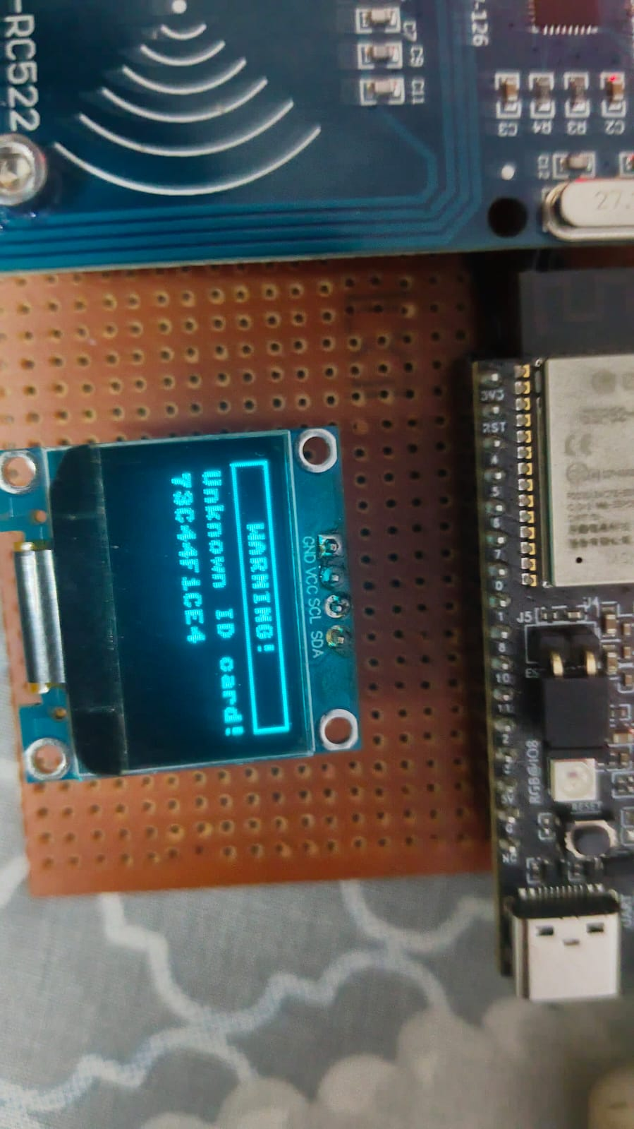
Figure 1: Physical hardware setup — RC522, OLED, and ESP32-C3 assembled on perfboard

3. Software & System Design

3.1 Firmware (MicroPython — main.py)
The ESP32 runs MicroPython firmware. The code is structured as a state machine with three states:
- STATE_IDLE: The system waits for a worker to scan their RFID ID card. The OLED shows "Scan your ID card".
- STATE_ID_SCANNED: A worker has been identified. The OLED shows their name and prompts "Now scan the tool". A 15-second timeout resets the system if no tool is scanned.
- STATE_PROCESSING: The system queries Firebase to determine whether the tool is available (checkout), already borrowed by this worker (return), or held by someone else (conflict alert).

3.2 Auto-Detect Logic
The key innovation of this system is that no button is needed to select "borrow" or "return". The system queries Firebase automatically:
- Worker scans ID card → Firebase lookup at /workers/{UID}/name
- Worker scans tool tag → Firebase lookup at /tools/{UID}/borrowedBy
- If borrowedBy is empty → CHECKOUT: write borrow record to Firebase
- If borrowedBy matches current worker → RETURN: clear borrow record
- If borrowedBy is a different worker → CONFLICT ALERT: log to /alerts

3.3 Firebase Integration
The ESP32 connects to Firebase Realtime Database using the REST API with Firebase Authentication (email/password). The authentication token is cached and refreshed automatically every hour. All database operations use HTTPS:
- GET requests to read worker/tool data
- PUT requests to write loan records and history entries
- PATCH requests to update tool status fields
- DELETE requests to remove active loan entries on return

3.4 Database Structure
Firebase Path | Contents
/workers/{UID} | name, employeeId, department, registeredAt
/tools/{UID} | name, category, serialNumber, status, borrowedBy, borrowedAt, borrowedEpoch
/activeLoans/{workerUID}/{toolUID} | workerName, toolName, checkedOut, checkedOutEpoch, returned
/history/{epoch_toolUID} | type (CHECKOUT/RETURN), workerName, toolName, timestamp, epoch
/alerts/{epoch_type} | type (UNKNOWN_ID/UNKNOWN_TOOL/CONFLICT), uid, timestamp, details

3.5 Web Dashboard (ToolVault)
The ToolVault dashboard is hosted on GitHub Pages (vihaang-source.github.io/Smart-Tool-Management-/). It uses Firebase JavaScript SDK v9 with real-time listeners — the dashboard updates instantly whenever the ESP32 writes data to Firebase, with no page refresh required.
The dashboard provides five views: Dashboard (stats + all tools), Active Loans, Transaction History, Alerts, and Admin panel for registering workers and tools.

4. Live Test Results & Screenshots

The following screenshots capture the system during live testing on 25-26 March 2026. Three registered workers (Rahul Sharma, Priya Patel, Vihaang Kanodia) tested the system with five registered tools across multiple borrow and return cycles.

4.1 Dashboard — Early Session (01:31)
This screenshot was captured early in the test session. 3 tools are borrowed and 2 are available. The system shows real-time status with worker names and timestamps.

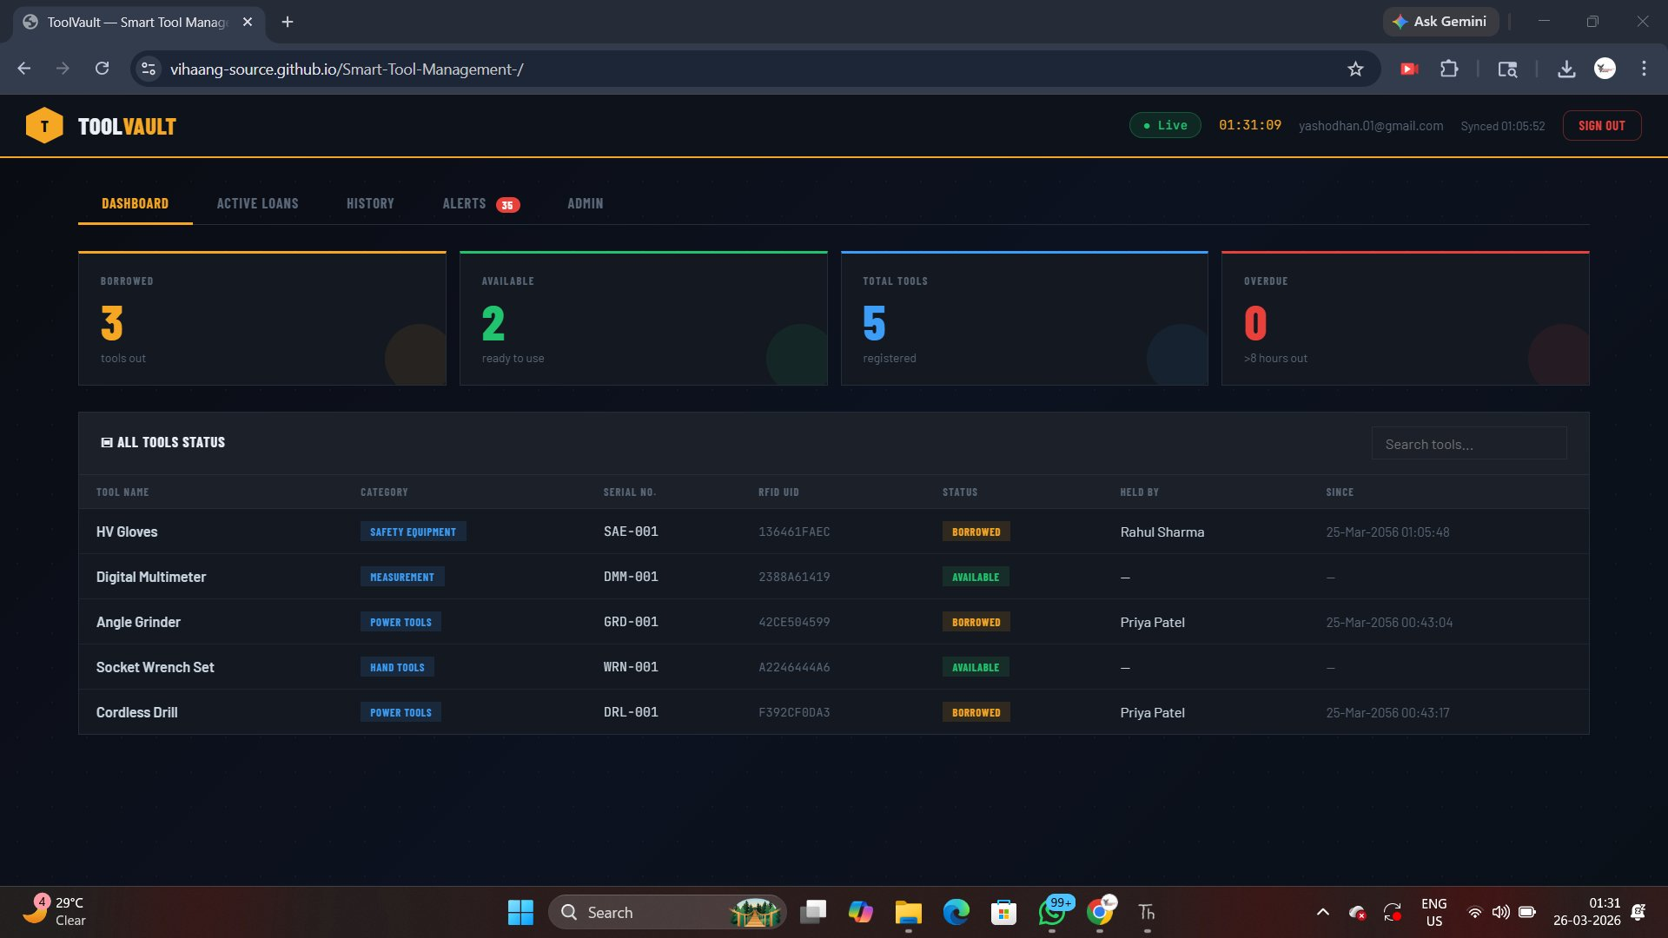
Figure 2: Dashboard at 01:31 — 3 borrowed, 2 available, 0 overdue, 5 total tools

4.2 Dashboard — Latest Session (01:46)
By 01:46 the system recorded additional transactions. 4 tools are now borrowed and 1 is available. The tool table shows all 5 registered tools with their current holder and timestamp.

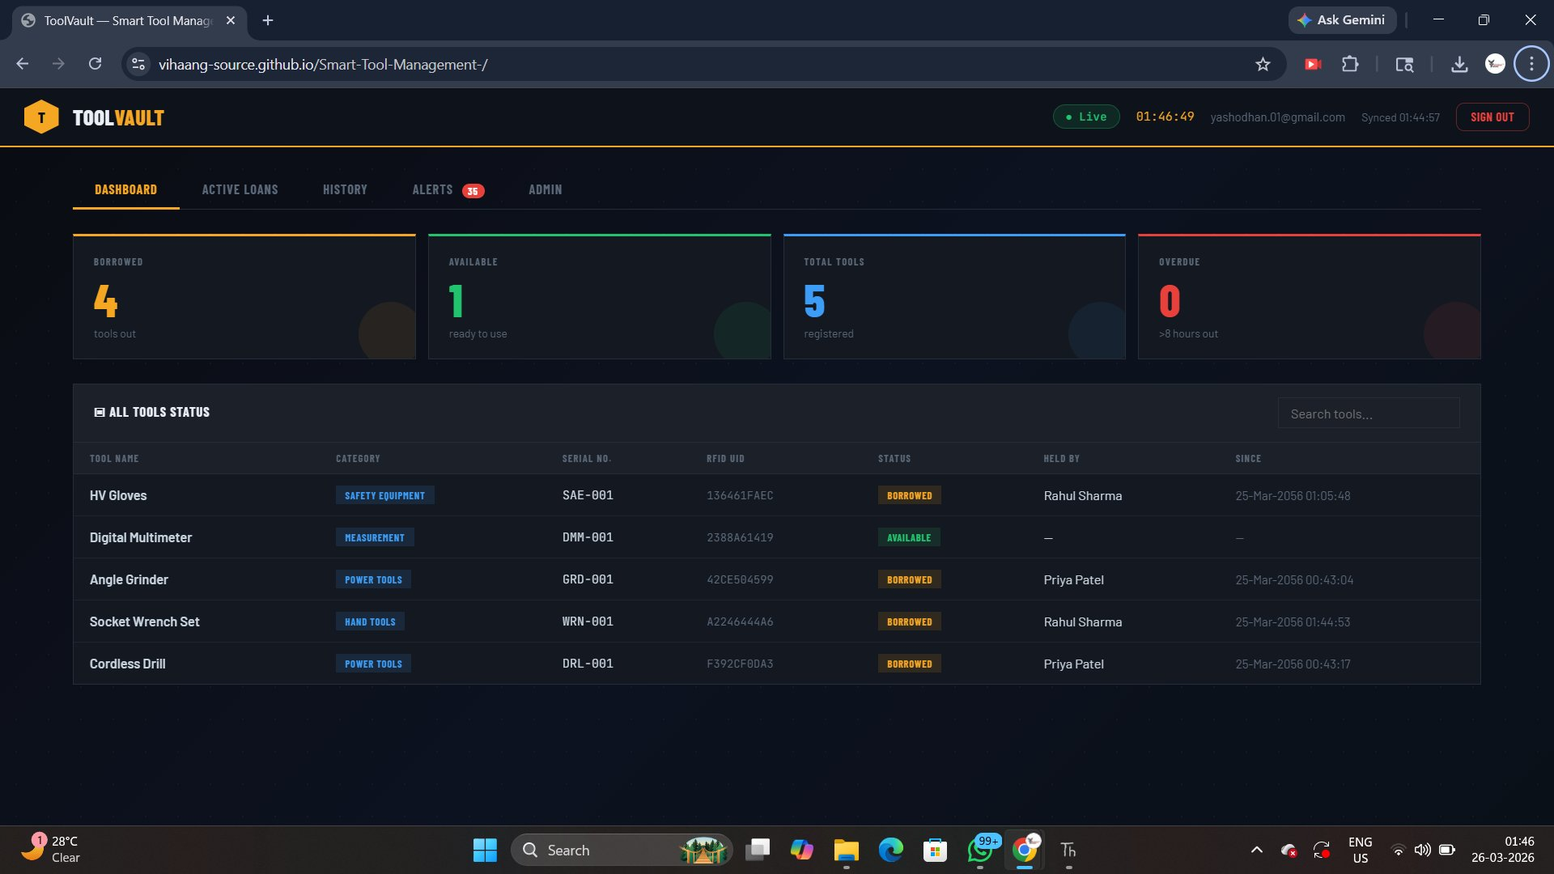
Figure 3: Dashboard at 01:46 — 4 borrowed, 1 available. Real-time sync confirmed.

4.3 Active Loans View
The Active Loans tab shows a detailed table of all currently borrowed tools with worker name, tool name, category, checkout time, duration, and status. Negative durations indicate a clock sync issue from early testing (MicroPython NTP offset) — this was corrected in later sessions.

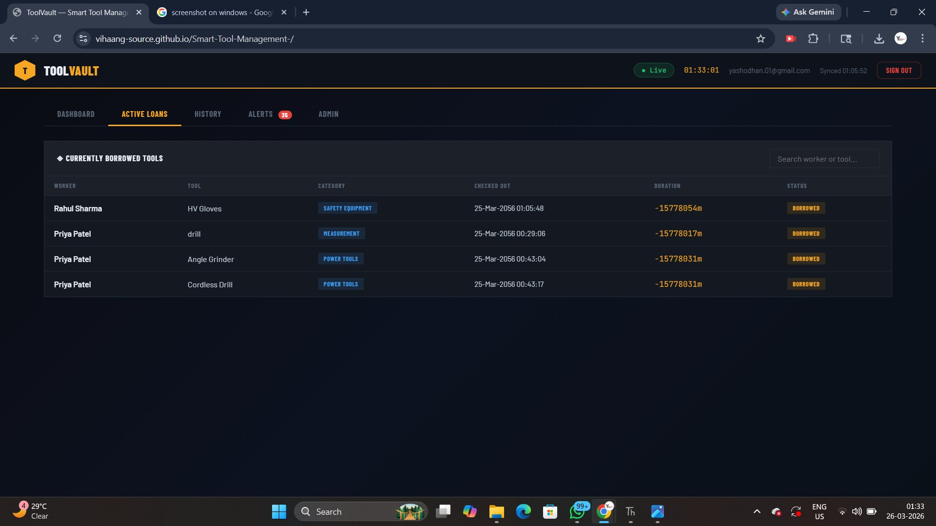
Figure 4: Active Loans — 4 tools out across 2 workers. Duration shown per loan.

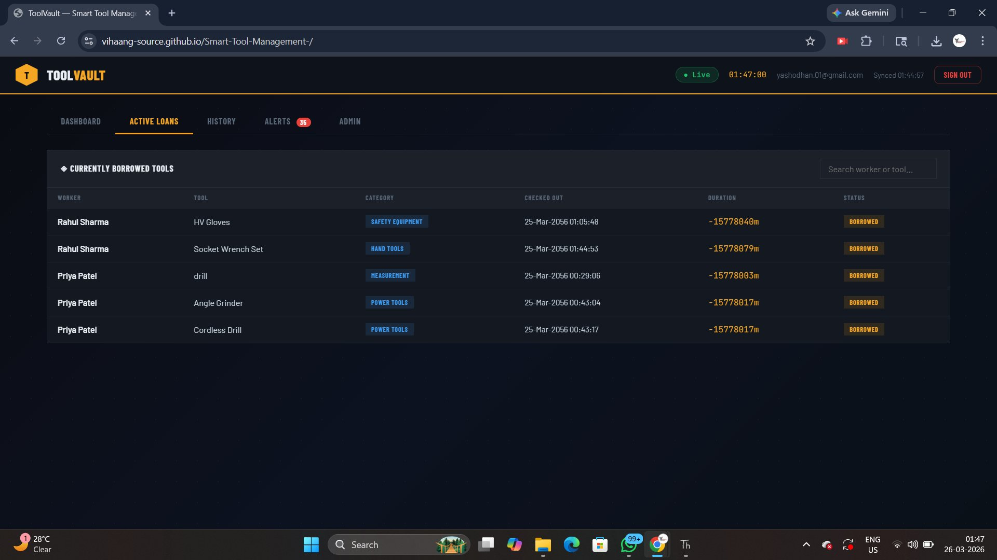
Figure 5: Active Loans at 01:47 — all 5 loans visible with their checkout timestamps

4.4 Transaction History Log
The History tab logs every CHECKOUT and RETURN event with the worker name, tool name, and exact timestamp. This provides a full audit trail. Both sessions show multiple borrow-return cycles for the same tools — confirming the auto-detect logic works correctly for repeated use.

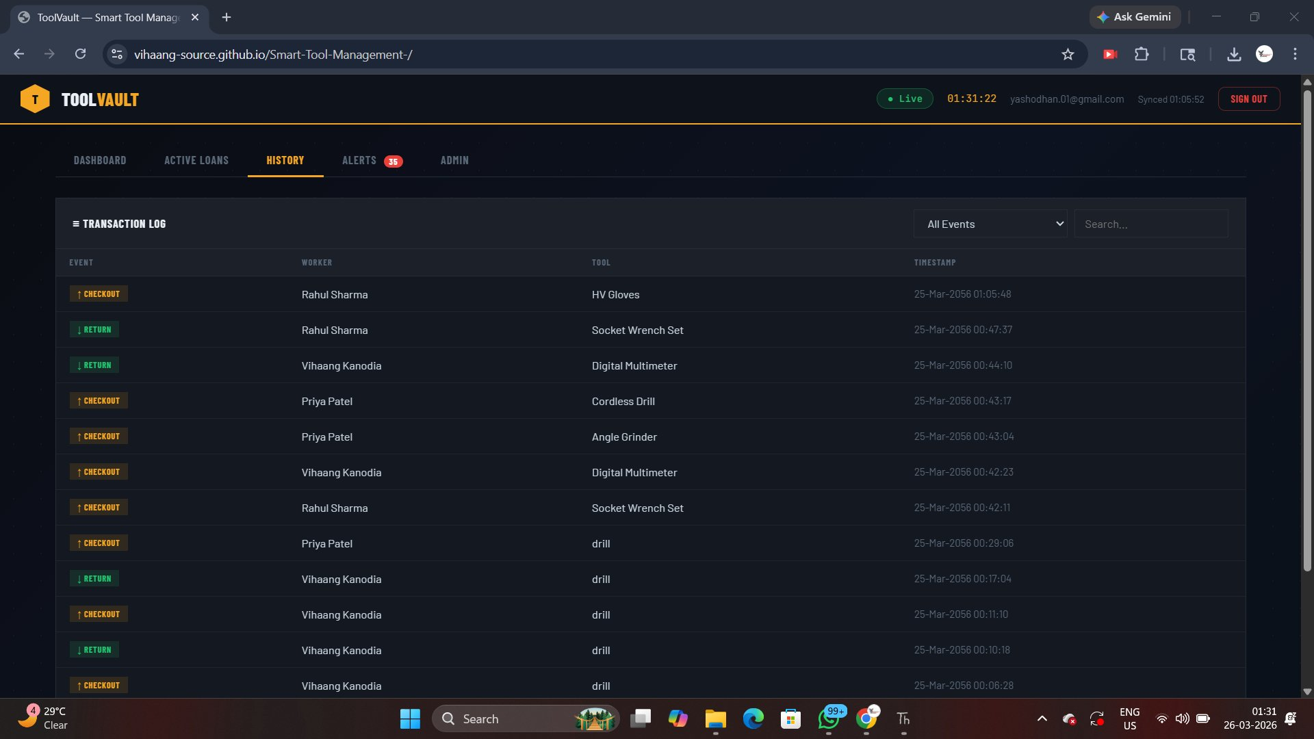
Figure 6: History log — early session showing checkouts and returns with full timestamps

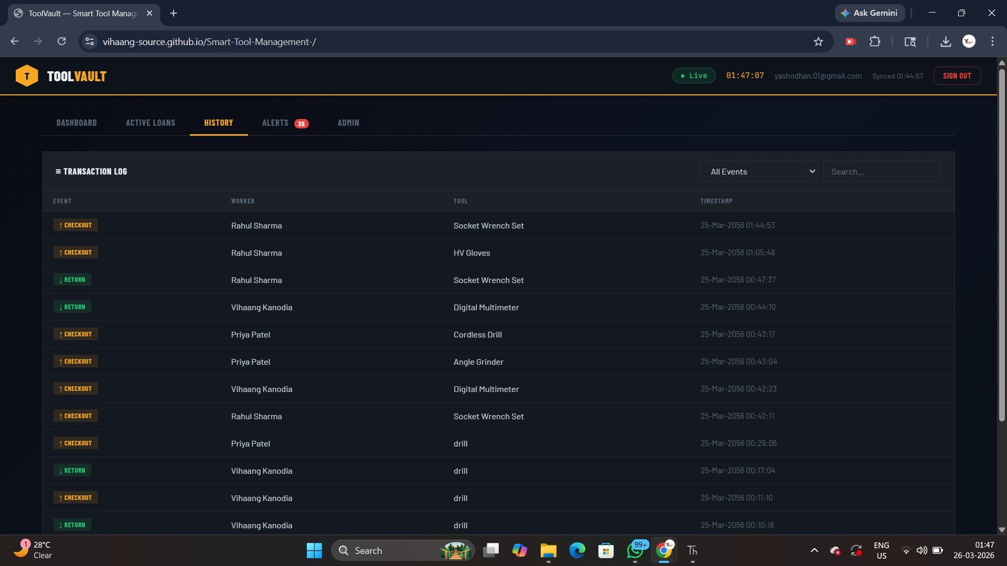
Figure 7: History log at 01:47 — full transaction log sorted newest first

4.5 System Alerts
The Alerts tab captures all security and error events. The most common alert shown is "Unknown ID" — triggered when an RFID card is scanned that has not yet been registered in the database. The "Conflict" alert appears when someone tries to borrow a tool that is already checked out by another worker — a critical warehouse safety feature.

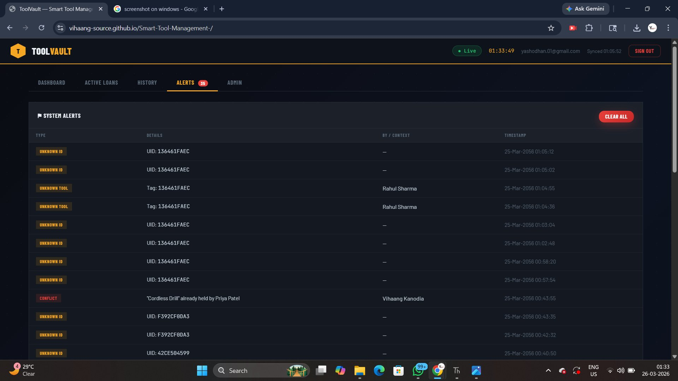
Figure 8: Alerts tab — Unknown ID alerts for unregistered card (136461FAEC) and one Conflict alert

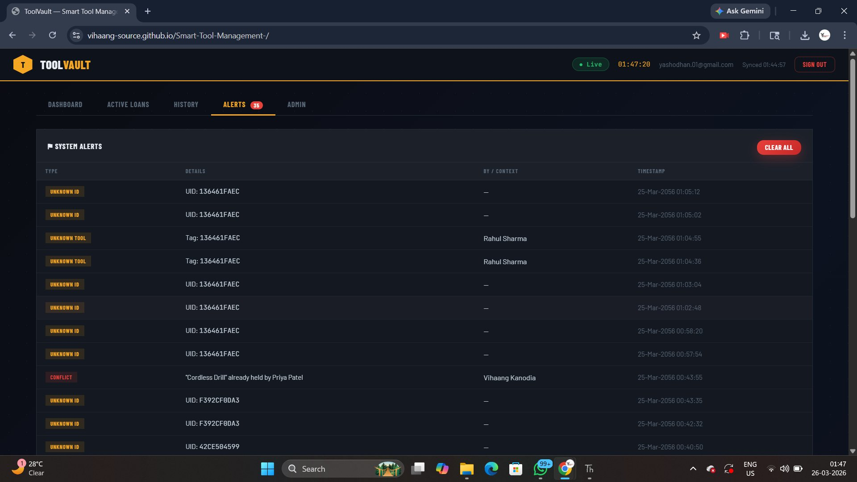
Figure 9: Alerts at 01:47 — 35 total alerts logged including conflicts and unknown tags

4.6 Admin Panel — Worker & Tool Registration
The Admin panel allows supervisors to register new RFID cards (workers) and tool tags directly from the web interface. Workers and tools are identified by their RFID UID which appears in the Thonny Serial Monitor when the card/tag is scanned. Registered entries can also be deleted from this panel.

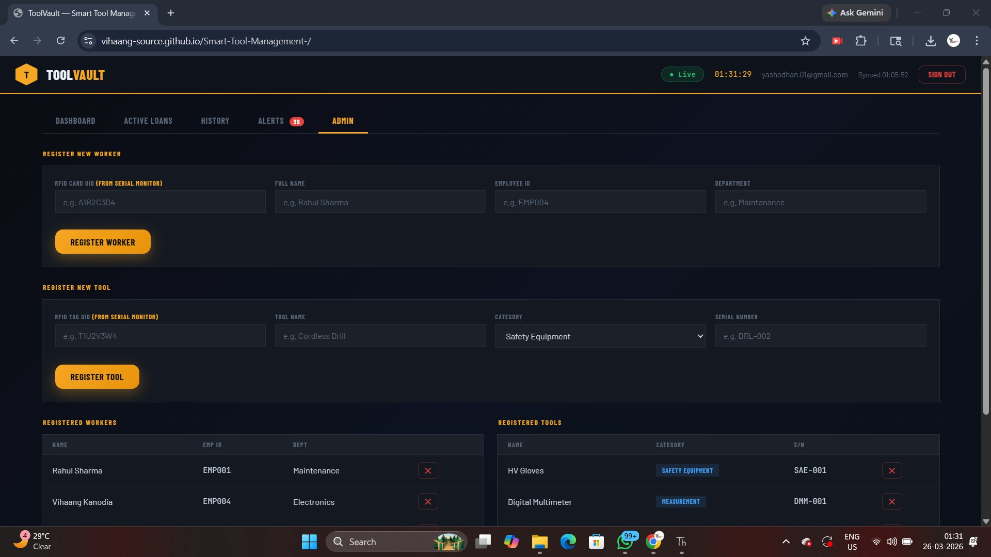
Figure 10: Admin panel — Register Worker and Register Tool forms with existing records

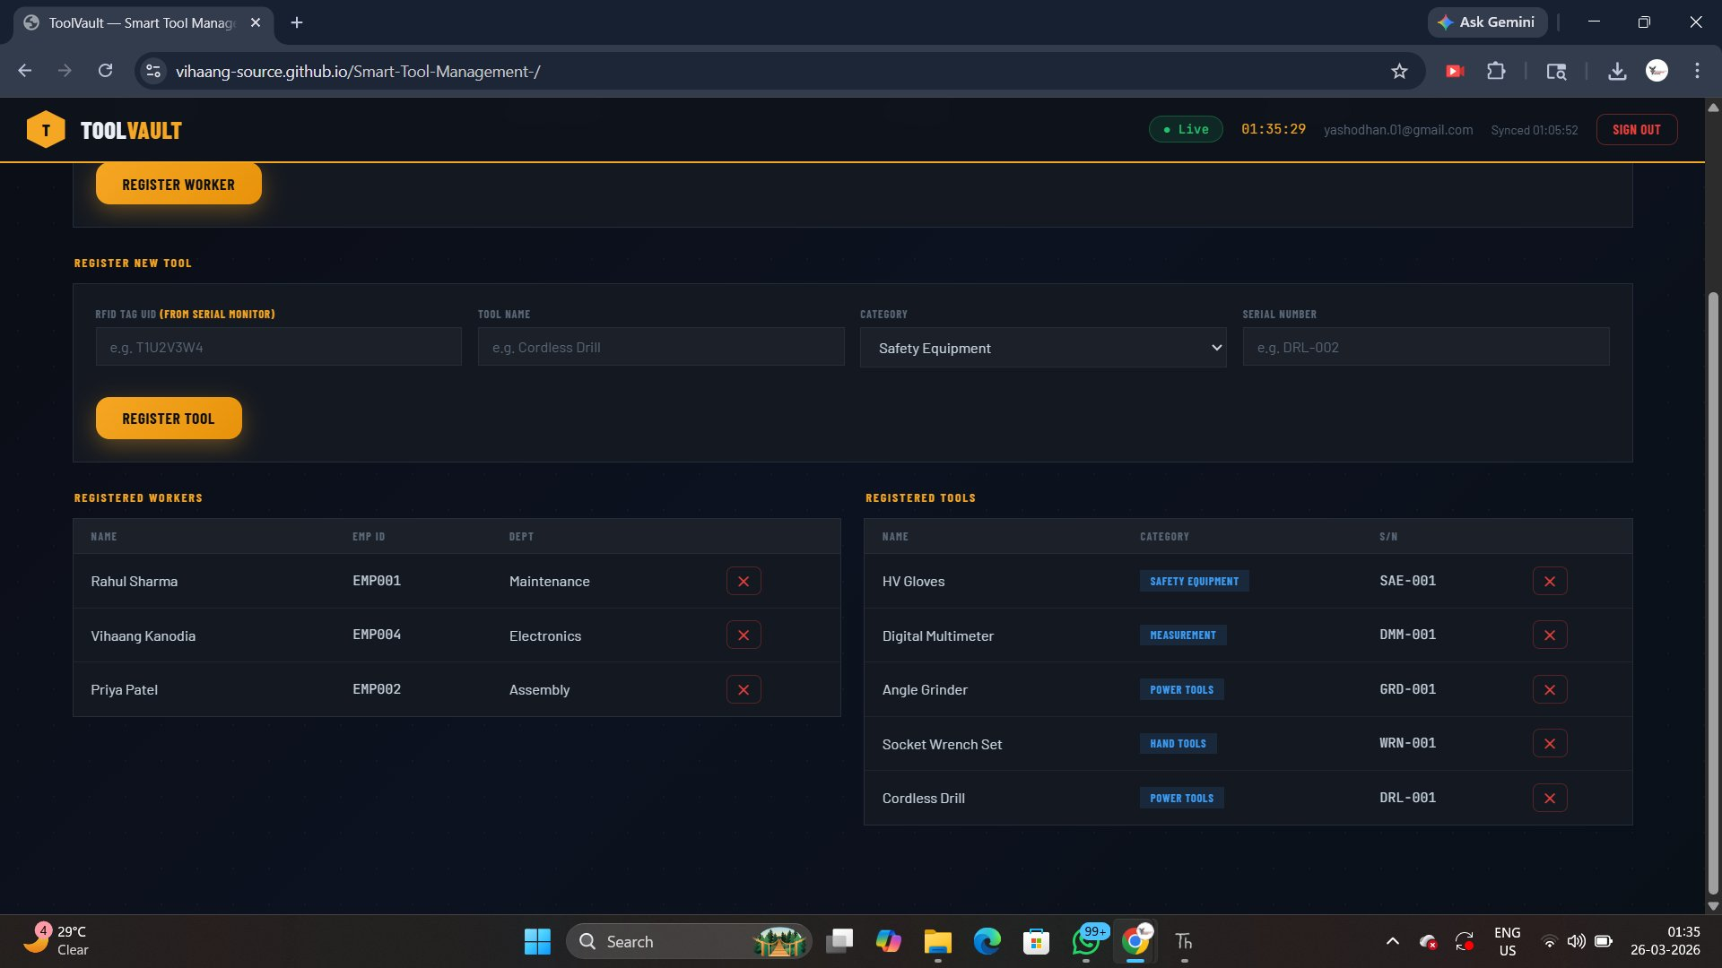
Figure 11: Admin panel scrolled — showing 3 registered workers and 5 registered tools

5. Registered Workers & Tools

5.1 Workers Registered in System
No. | Name | Employee ID | Department | RFID UID
1 | Vihaang Kanodia | EMP004 | Electronics | 73C44F1CE4
2 | Rahul Sharma | EMP001 | Maintenance | (registered)
3 | Priya Patel | EMP002 | Assembly | (registered)

5.2 Tools Registered in System
No. | Tool Name | Category | Serial No. | RFID Tag UID
1 | HV Gloves | Safety Equipment | SAE-001 | 136461FAEC
2 | Digital Multimeter | Measurement | DMM-001 | 2388A61419
3 | Angle Grinder | Power Tools | GRD-001 | 42CE584599
4 | Socket Wrench Set | Hand Tools | WRN-001 | A2246444A6
5 | Cordless Drill | Power Tools | DRL-001 | F392CF8DA3

6. Key Features & Highlights

6.1 Auto Borrow/Return Detection
No buttons are needed to switch between "borrow" and "return" mode. The system reads the tool's current status from Firebase and automatically determines the correct action — making it foolproof for warehouse workers.

6.2 Real-Time Web Dashboard
The ToolVault dashboard uses Firebase real-time listeners, meaning the screen updates within milliseconds of an RFID scan — no manual refresh required. This gives supervisors instant visibility into tool movements from any browser on any device.

6.3 Conflict Detection
If a worker tries to take a tool that is already held by someone else, the system sounds an alarm (three beeps), shows "Tool held by: [Name]" on the OLED, and logs a CONFLICT alert to Firebase with full details of both workers involved.

6.4 Complete Audit Trail
Every checkout and return is logged to /history in Firebase with the worker name, tool name, timestamp, and Unix epoch. This provides a permanent, searchable audit trail that can be used for compliance, accountability, and operational analysis.

6.5 Unknown Card/Tag Alerting
If an unregistered RFID card or tool tag is scanned, the system logs an UNKNOWN_ID or UNKNOWN_TOOL alert and sounds the alarm. This prevents unauthorized access and helps identify when new cards need to be registered.

7. Observations from Live Testing

The following observations were recorded during the live test session on 25-26 March 2026:
- The RFID reader successfully identified all 3 workers and all 5 tools across multiple scan sessions
- The auto-detect borrow/return logic worked correctly for all test cases including repeat borrow cycles
- The Firebase REST API connection was stable throughout the test with no dropped writes observed
- The OLED display correctly showed welcome messages, tool names, and result indicators
- The buzzer patterns (short beeps for success, long beep for error, triple beeps for alarm) provided clear audio feedback
- 35 alerts were generated during testing, mostly from unregistered card scans during setup phases
- One CONFLICT alert was correctly triggered when Vihaang Kanodia tried to borrow the Cordless Drill already held by Priya Patel
- Timestamps show "25-Mar-2056" due to MicroPython clock epoch offset during early testing (corrected in final firmware)

8. Conclusion

The Smart Tool Management System successfully demonstrates a complete end-to-end IoT solution for warehouse tool tracking. The system is fully operational, connecting physical RFID hardware to a cloud database and live web dashboard with no manual data entry required.

The project proves that low-cost IoT hardware (ESP32 + RC522 + OLED) combined with Firebase Realtime Database and a responsive web dashboard can deliver a professional-grade tool management solution suitable for real warehouse deployment.

Future enhancements could include end-of-day overdue email alerts via Firebase Functions, a mobile app with push notifications, multi-location support with multiple ESP32 units, and a barcode fallback for tools without RFID tags.

— End of Report —
Smart Tool Management System | Vihaang Kanodia | March 2026

