A Nonlinear Relationship in LLM Proposer Verifier Synergy
Vihaan Vajpeyi

Abstract—Proposer verifier pipelines, where one language model proposes a solution and a second model reviews it, are increasingly used to improve LLM reliability at test time. This study asks whether a verifier's own standalone problem-solving accuracy predicts how much value it adds as a verifier. Fifteen open-weight models (0.5B–9B parameters) were run entirely on local hardware via Ollama across 100 math and coding questions, covering all 210 ordered proposer-verifier pairings (21,000 collaboration trials). Two findings emerge. First, a model's accuracy when verifying another model's answer is significantly lower than its own standalone accuracy on the same questions (36.4% vs. 22.0%, paired t(14) = -3.20, p = 0.0065), and this gap is not explained by a ceiling effect (r = -0.37 between standalone accuracy and relative degradation, p = 0.18). Second, a model's verifying accuracy, not its standalone accuracy, predicts collaboration synergy through an inverted-U relationship (quadratic coefficient = -5.93, p = 0.002, R² = 0.75) that survives an independent split-half validation across 20 resamples (95% remain significant) and is substantially, though not exclusively, attributable to coding questions rather than math questions.

- Introduction
Large language models (LLMs) are frequently paired with a second model that reviews their output before it is accepted, a pattern used in rejection sampling, self-refinement, and agentic pipelines more broadly [1]–[3]. The implicit assumption behind this design is that a stronger model, or at least a competent one, makes a good reviewer. Whether that assumption holds, and how to measure competence for the reviewing role specifically, has only recently become an active research question [1]–[3].
This study investigates that question directly using proposer-verifier collaboration: one model (the proposer) answers a question, and a second model (the verifier) reviews the proposer's answer and gives a final judgment. The outcome of interest is synergy, defined as the improvement of the collaboration's accuracy over the better of the two models' individual accuracies on the same question. Positive synergy means the pair outperforms either model alone; negative synergy means the pair underperforms both.
Using 15 small (≤9B parameter), openly available language models run locally, this study makes two contributions. First, it shows that a model's accuracy when acting as a verifier is systematically lower than its own standalone solving accuracy on the same set of questions, and that this drop is not simply a ceiling effect. Second, it shows that a model's verifying accuracy, measured directly rather than inferred from standalone benchmarks, predicts collaboration synergy through a non-monotonic (inverted-U) relationship: verifiers that are too weak add little value, but so, in this data, do verifiers that already solve the task well on their own, and the strong signal is concentrated in coding rather than math questions.

II. Literature Review / Background
Verification of LLM outputs by other LLMs has been studied mainly through two lenses: how much a verifier improves accuracy at test time, and what predicts a good verifier.
Song et al. [1] formalize a generation-verification gap and show that, for base models performing self-verification, this gap scales monotonically with pre-training compute, so stronger base models are better self-verifiers. Lu et al. [2] extend this picture across self-, intra-family, and cross-family verification using 37 models spanning 0.5B–72B parameters. They introduce verifier gain, the accuracy improvement a verifier yields under rejection sampling, and find that self-verification gains are minimal and uncorrelated with the verifier's own solver accuracy (r = -0.038), while cross-family gains correlate strongly and positively with it (r = 0.908). A key mechanism they identify is that verifiers are biased toward accepting answers that resemble their own reasoning style, so similarity between proposer and verifier output distributions predicts false-positive rate. Zhou et al. [3] report a related but distinct pattern: the relationship between verifier capability and verification quality is closer to linear at medium problem difficulty but becomes non-linear near the extremes.
This study differs from that line of work in its dependent variable and its statistical treatment. Verifier gain and the generation-verification gap are both defined with respect to rejection sampling, an asymptotic quantity computed over repeated resampling. Synergy, as used here, is a single-pass quantity: it compares one proposer response, reviewed once by one verifier, against the better of the two models' independent accuracies on that question. No prior work in this space fits an explicit quadratic model to the capability-synergy relationship or validates it with leave-one-out cross-validation and independent split-half resampling, both used here.
Outside the solver-verifier framing, several recent studies report that combining LLMs does not reliably help. Wynn et al. [4] find that multi-agent debate can lower accuracy over time even when strong models outnumber weak ones, driven by models abandoning correct answers in favour of agreement. Wang et al. [5] report that a strong-weak pairing can underperform a weak-weak pairing in heterogeneous multi-agent systems, attributing this to a cognitive mismatch between agents. Feng et al. [6] take a more optimistic view at the training-signal level, using a cross-model aggregated response as an internal training target because it is typically more reliable than any single model's response. Outside LLM-only settings, Sheffer et al. [7] find that synergy in human and human-AI discussion is driven specifically by confident-knowledge diversity, complementary rather than merely different knowledge among participants, a lens this study's harmful-override analysis (Section IV) speaks to directly.
This study's contribution is a locally-run, reproducible, small-model (≤9B) setting; a direct test of standalone accuracy against the empirically better-motivated predictor of measured verifying accuracy; and a domain-specific decomposition, math versus coding, of the resulting relationship.

III. Methodology
A. Models
Fifteen openly available language models (0.5B–9B parameters) were run locally through Ollama at Q4_K_M quantization: Qwen2.5 0.5B and 7B, TinyLlama 1.1B, Llama 3.2 1B and 3B, SmolLM2 1.7B, Gemma2 2B and 9B, Falcon3 3B, Phi-3-mini and Phi-3.5 3.8B, Yi 6B, DeepSeek-Coder 6.7B, Mistral 7B, and Llama 3 8B. All decoding used temperature 0, seed 42, and no resampling on failure.

B. Dataset
The evaluation set comprised 100 questions: 60 math (GSM8K-style, algebra, number theory, geometry, probability, and olympiad-style items) and 40 coding (code generation, debugging, output prediction, and edge-case items), each with a ground-truth answer or a set of unit tests.

C. Procedure
The experiment ran in two phases. In Phase 1, each of the 15 models answered all 100 questions standalone (1,500 trials), establishing each model's solving accuracy and its own verifying-context baseline. In Phase 2, every ordered pair of distinct models served once as proposer and once as verifier (15 × 14 = 210 ordered pairs) on every question, for 21,000 proposer-verifier trials. The proposer prompt was identical to the standalone prompt. The verifier was shown the question and the proposer's raw response and asked to return a verdict, a short justification, and a final answer (or, for code generation, a corrected function).

D. Scoring and Synergy
Standalone and proposer answers were scored by exact-match comparison (numeric and symbolic answers, after normalization) or, for code generation, by the fraction of unit tests passed; A(·) ∈ [0, 1] denotes this scoring function throughout. The verifier's final answer is always taken as the collaboration outcome, following standard proposer-verifier convention; the verdict field is not scored directly. For proposer i, verifier j, and question q, let P(i, q) denote i's standalone response and V(i, j, q) denote j's output when reviewing that response. Trial level synergy is then equal to:

$S_{i,j,q}=A\left(v\left(i,j,q\right)\right)-max(A\left(P\left(i,q\right)\right),A\left(P\left(j,q\right)\right))$ (1)

Positive synergy indicates the pair outperformed both individuals; zero indicates it matched the better one; negative indicates it underperformed both.
A verifier j's overall verifying accuracy, $Acc_{\left(ver,j\right)}$, is the mean of A(V(i, j, q)) across all proposers and questions for which j served as verifier. To test the inverted-U hypothesis, mean synergy per verifier is regressed on verifying accuracy with a quadratic term:

${\overline{S}}_{j}=β_{0}+β_{1}Acc_{\left(ver,j\right)}+β_{2}Acc_{\left(ver,j\right)}^{2}+ε_{j}$ (2)

Where ${\overline{S}}_{j }$is verifier j's mean synergy across all trials, and $ε_{j}$is the residual.

IV. Results
Verification Underperforms Standalone Solving
Restricting to questions each model answered standalone with a non-null score and for which it also produced at least one non-null verifying score on the same question (a matched sample), mean verifying accuracy across the 15 models was 22.0%, against a mean standalone accuracy of 36.4% (paired t(14) = -3.20, p = 0.0065). Fig. 1 shows this comparison for every model; 12 of 15 show a lower verifying accuracy than standalone accuracy, most visibly the models with the highest standalone accuracy. This raises the possibility that stronger models simply have more room to fall (a ceiling effect). Testing the correlation between a model's standalone accuracy and its relative drift (drift as a fraction of standalone accuracy) gives r = -0.37 (p = 0.18), not significant, and several models with substantial standalone headroom (e.g., Gemma2 9B, Qwen2.5 7B) still show large proportional degradation. A ceiling effect alone does not account for the pattern.
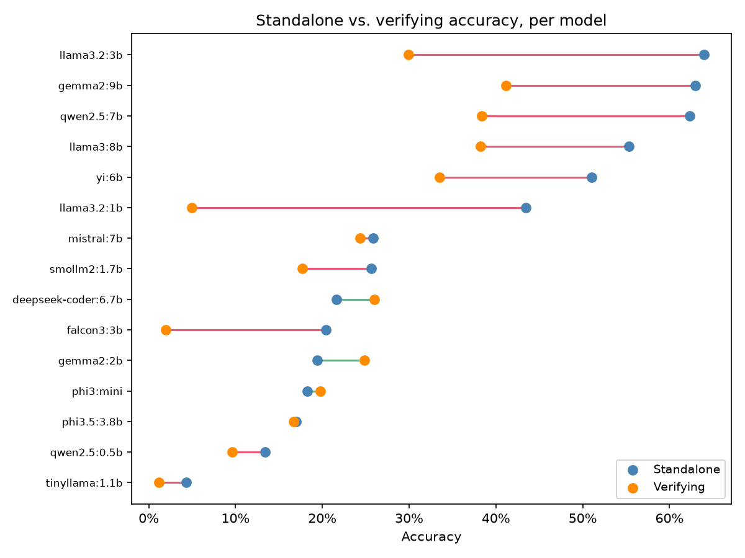
Figure 1. Standalone accuracy (blue) vs. verifying accuracy (orange) for each of the 15 models, sorted by standalone accuracy. Red connecting lines indicate degradation when verifying; green indicates improvement.
To locate the source of this degradation, every trial with a scored proposer and verifier answer was classified into one of four outcomes: the verifier echoes a correct proposer answer (22.4% of classifiable trials), corrects an incorrect one (10.0%), fails to correct an incorrect one (57.2%), or overrides a correct proposer answer with an incorrect one (10.4%). Harmful overrides slightly outnumber helpful corrections overall, which is sufficient to produce negative average synergy even before accounting for the much larger no-help category. Fig. 2 shows this breakdown per verifier, sorted by harmful-override rate: the rate falls from roughly one in three trials for the weakest verifiers to under five percent for the strongest, while helpful-correction rate tends to rise in the same direction, consistent with a genuine capability gradient in verification judgment even as overall verifying accuracy remains below standalone accuracy for most models.
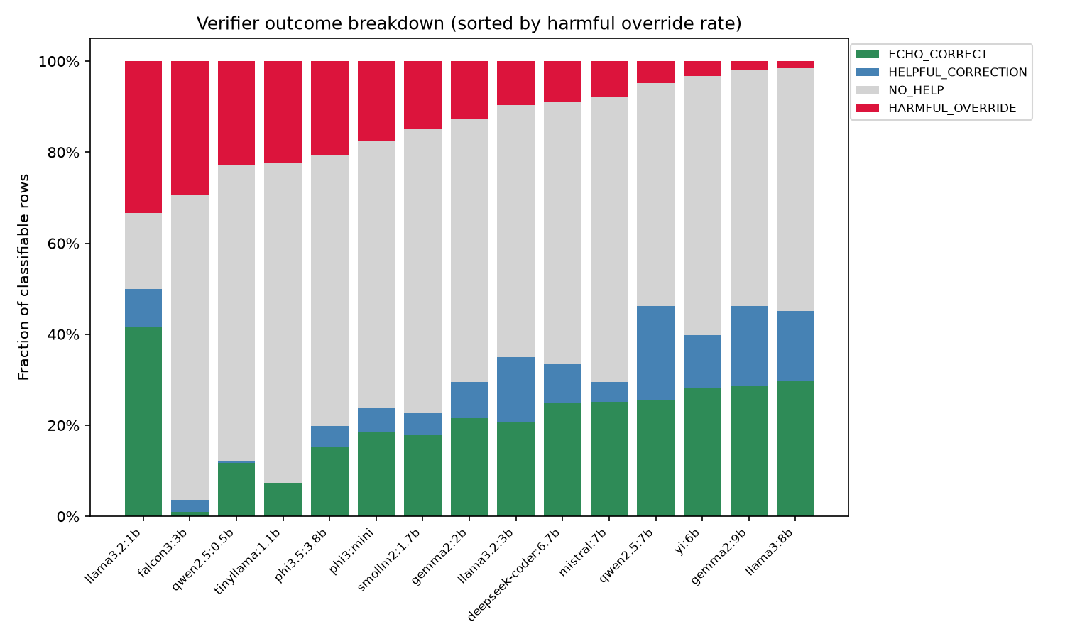
Figure 2. Verifier outcome breakdown by model, sorted by harmful-override rate: fraction of classifiable trials in which the verifier echoed a correct answer, helpfully corrected an incorrect one, provided no help, or harmfully overrode a correct answer.

Verifying Accuracy Predicts Synergy Through an Inverted-U
A quadratic regression of mean synergy on each verifier's standalone accuracy (synergy ~ acc + acc², n = 15) is weak and does not generalize: R² = 0.030, quadratic coefficient = -1.00 (p = 0.56), and leave-one-out cross-validation R² = -1.04, worse than predicting the mean. The same regression using each verifier's directly measured verifying accuracy in place of standalone accuracy is far stronger: quadratic coefficient = -5.93 (p = 0.002), R² = 0.75, LOO-CV R² = 0.62 (Fig. 3), with a peak near 27.5% verifying accuracy.

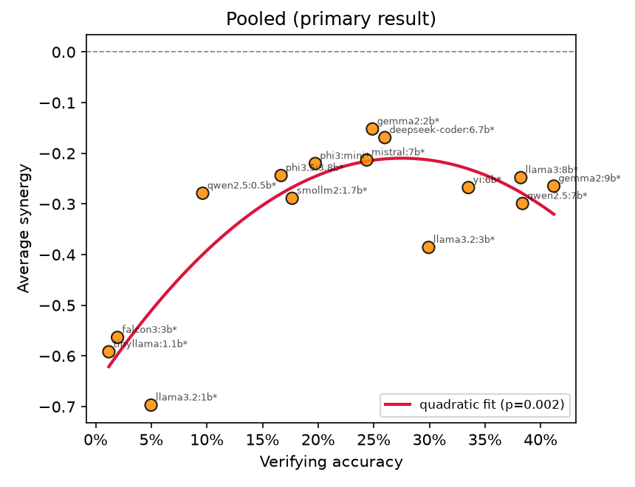
Figure 3. Verifying accuracy vs. average collaboration synergy across all 15 verifiers (pooled math and coding questions), with a fitted quadratic curve. Orange points and asterisks mark verifiers with fewer than 10 non-null synergy rows.

Because verifying accuracy and synergy are both computed from the same collaboration-outcome scores, part of this relationship could reflect shared-metric dependency rather than independent predictive power. A split-half test, computing verifying accuracy from a random half of each verifier's trials and synergy from the disjoint other half, addresses this directly. Repeated across 20 independent random splits, the pooled quadratic coefficient remained negative in every split and significant (p < 0.05) in 19 of 20 (Fig. 4).

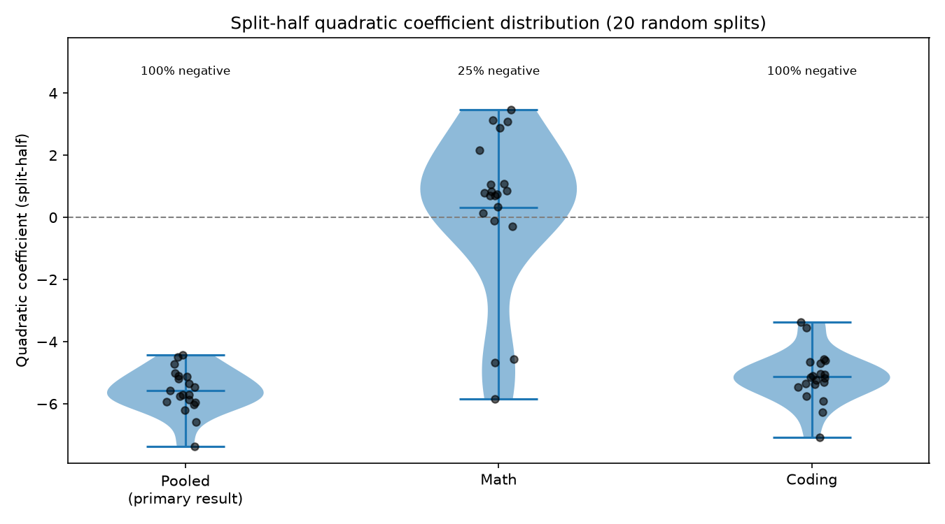
Figure 4. Distribution of the quadratic coefficient from the verifying-accuracy vs. synergy regression across 20 independent split-half resamples, for the pooled, math-only, and coding-only samples.

Splitting by domain sharpens the picture. On coding questions alone, the same regression yields a quadratic coefficient of -5.00 (p = 0.042, R² = 0.80; Fig. 5, right panel); across 20 split-half resamples the coefficient stayed negative in all 20 and significant in 10. On math questions alone, the regression is not significant (coefficient = +3.01, p = 0.061 with all 15 models, Fig. 5, left panel; -3.89, p = 0.082 restricting to the 12 models with at least 10% verifying coverage on math) and the split-half coefficients are inconsistent in sign, 25% negative across 20 resamples, none significant. Correlating each model's pooled synergy with its math-only and coding-only synergy shows the pooled result tracks coding closely (r = 0.91, p < 0.0001) and does not track math (r = -0.35, p = 0.20): the inverted-U in the pooled data is substantially a coding-domain phenomenon.

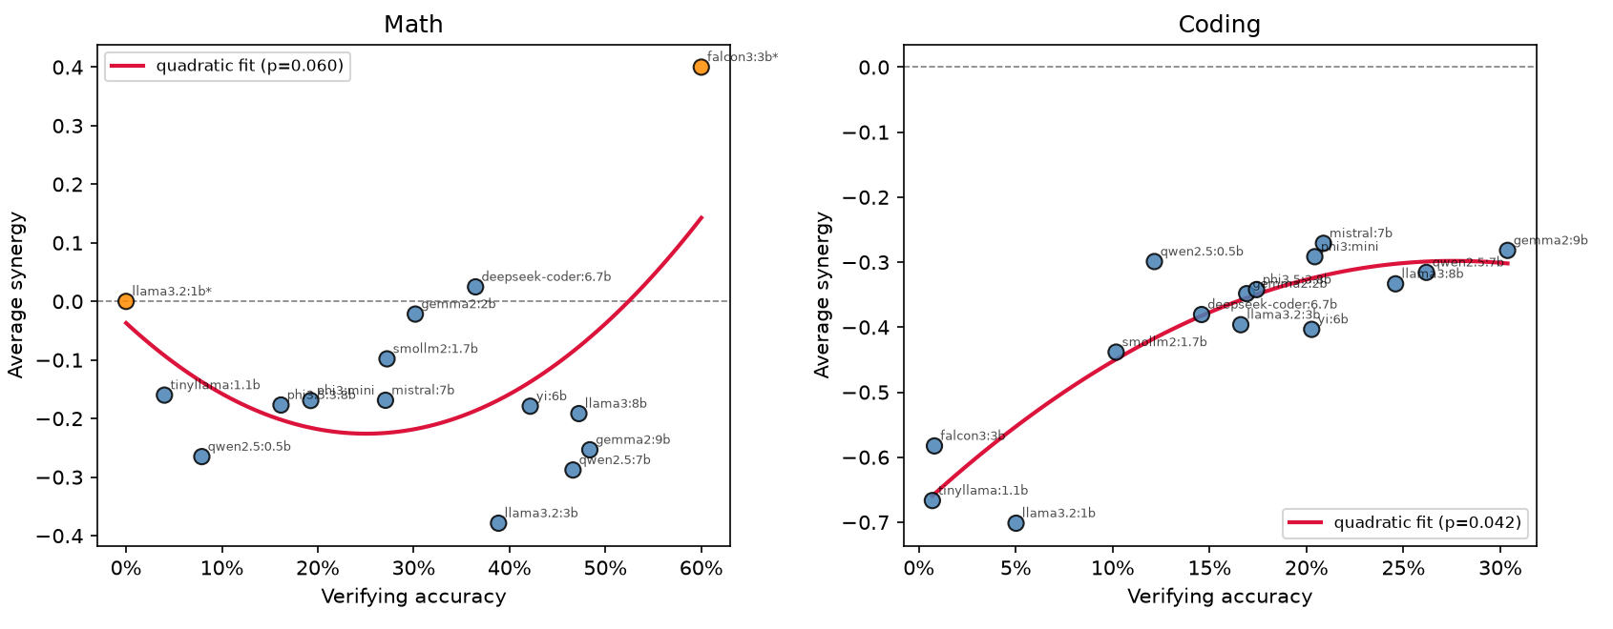
Figure 5. Verifying accuracy vs. average synergy, split by domain. Left: math questions only (not significant). Right: coding questions only (significant, quadratic coefficient = -5.00, p = 0.042).

V. Discussion
The degradation from standalone to verifying accuracy, and its persistence after controlling for ceiling effects, is consistent with the similarity-driven false-positive bias Lu et al. [2] report: a verifier shown another model's answer may anchor on that answer's framing rather than re-deriving a judgment from first principles, which would lower accuracy relative to fresh, unconstrained solving regardless of the verifier's own capability. It also converges with Song et al.'s [1] and Lu et al.'s [2] finding that near- or self-verification yields little or negative gain; the present roster spans 15 distinct models rather than family-controlled pairs, so it cannot isolate a family-similarity effect specifically, but the direction of the result rhymes with theirs.
The domain asymmetry is the least expected result here. Lu et al. [2] report that logical and mathematical tasks are generally easier to verify than knowledge-recall tasks, and by that logic math might have been expected to show the cleaner capability-synergy relationship, not coding. A plausible explanation is that code correctness in this dataset is checkable against concrete unit tests, giving the collaboration-outcome score a sharper, less noisy signal than a single normalized string match on a multi-step math derivation, where partial reasoning and answer-formatting variance likely add noise that a 15-point regression cannot average out. This is a hypothesis, not a tested mechanism, and distinguishing it from a genuine domain difference in verifiability would need a dataset that varies checkability independent of subject matter.
Several limitations bound these conclusions. Fifteen models is a small sample for a quadratic regression, and although the split-half procedure demonstrates the relationship is not an artifact of shared-metric dependency, it does not by itself demonstrate generalization to models outside this roster. The weakest three models (Falcon3 3B, TinyLlama 1.1B, Llama 3.2 1B) produced so few parseable verifying trials that their individual synergy estimates are unreliable; excluding them tightens, but does not qualitatively change, the pooled result. All models here are 9B parameters or smaller; whether the same pattern holds for larger or more capable systems, including reasoning-post-trained models of the kind studied by Lu et al. [2], is untested. Finally, the coding-versus-math asymmetry is drawn from 40 and 60 questions respectively in a single dataset, and should be treated as a hypothesis for a larger, purpose-built follow-up rather than a settled domain effect.

VI. Conclusion
Across 15 small, locally-run language models, a verifier's accuracy when reviewing another model's answer was reliably lower than its own standalone solving accuracy on the same questions, and this gap was not explained by ceiling effects. Directly measured verifying accuracy, rather than standalone accuracy, predicted collaboration synergy through an inverted-U relationship that held up under an independent split-half validation, though the effect was concentrated in coding rather than math questions. Two practical implications follow: standalone benchmark accuracy is a poor substitute for measuring a candidate verifier's actual verifying accuracy when designing a proposer-verifier pipeline, and the value of adding a second model to a pipeline may depend on task type in ways that are not yet well understood. Extending this design to a larger and more diverse model roster, additional task domains, and a direct test of the anchoring hypothesis proposed here are natural next steps.

VII. References
[1] Y. Song, H. Zhang, C. Eisenach, S. Kakade, D. Foster, and U. Ghai, “Mind the gap: Examining the self-improvement capabilities of large language models,” arXiv preprint arXiv:2412.02674, 2024.
[2] J. Lu, R. Teehan, J. Jin, and M. Ren, “When does verification pay off? A closer look at LLMs as solution verifiers,” arXiv preprint arXiv:2512.02304, 2025.
[3] Y. Zhou, A. Xu, Y. Zhou, J. Singh, J. Gui, and S. Joty, “Variation in verification: Understanding verification dynamics in large language models,” arXiv preprint arXiv:2509.17995, 2025.
[4] A. Wynn, H. Satija, and G. Hadfield, “Talk isn't always cheap: Understanding failure modes in multi-agent debate,” arXiv preprint arXiv:2509.05396, 2025.
[5] L. Wang, T. Zhu, L. Qin, L. Gao, and W. Zhou, “Guided collaboration in heterogeneous LLM-based multi-agent systems via entropy-based understanding assessment and experience retrieval,” arXiv preprint arXiv:2602.13639, 2026.
[6] S. Feng, H. Zhang, F. Nie, S. Kakade, and Y. Chen, “Peer-predictive self-training for language model reasoning,” arXiv preprint arXiv:2604.13356, 2026.
[7] T. Sheffer, A. Miron, A. Sklar, Y. Dover, and A. Goldstein, “Confident-knowledge diversity drives human-human and human-AI free discussion synergy and reveals pure-AI discussion shortfalls,” arXiv preprint arXiv:2507.22889, 2025.

