HTML(Hyper Text Manipulating Language)
Ptojects: Life Calculator
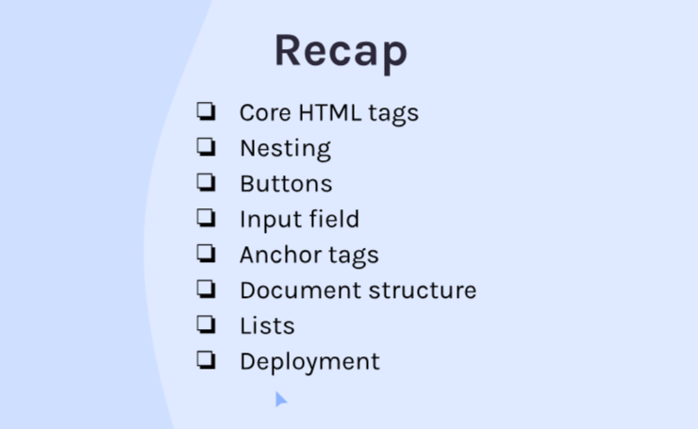

- HTML tags
Ex:- <h1></h1>
- Image tags
  - Ex:- <img/> : <img src=”link” width:100%>

- Nesting(div:Container)
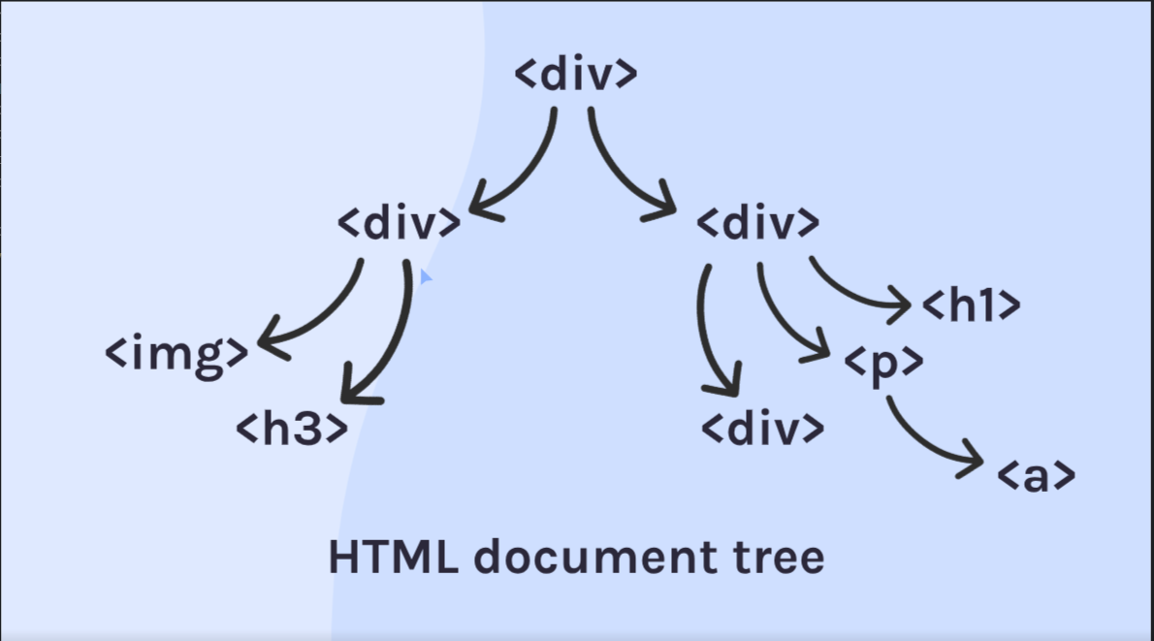
img

- Interactive elements
  - <button></button>
  - <input> tag
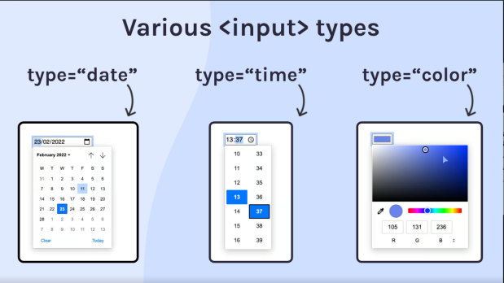
    - <input type=”” placeholder=””>

Input file
<input type=”file”
Id=”img” name=”img”
accept=".img”
/
- Anchor tag<a>
  - Ex:- <a href=”” taget=”_blank”>About</a>
- Structure of HTML
  - DOC
    - <DOCTYPE>
    - <html>
    - <head>
    - </head>
    - <body>
    - </body>
    - </html>

- Aside : List
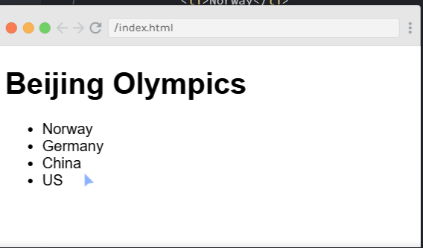

- <ol>
<li>Vihandu<li>
<li>Thisari<li>
</ol>
Output:
- Vihandu
- Thisari
- <ul>
<li>Vihandu<li>
<li>Thisari<li>
</ul>
Output:
- Vihandu
- Thisari
Deployment

CSS

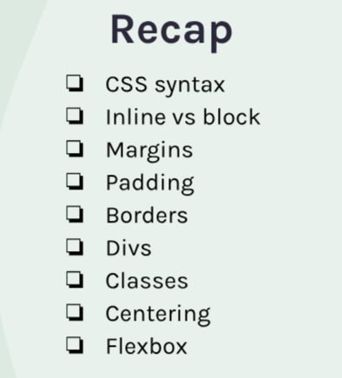

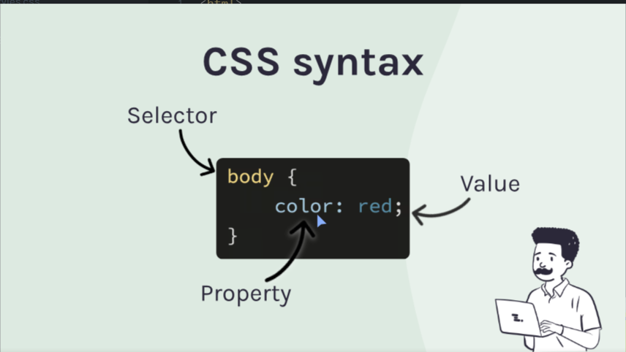
x
Link to html
<link rel=”stylesheet” href=”styles.css”>
Inline vs Block elements
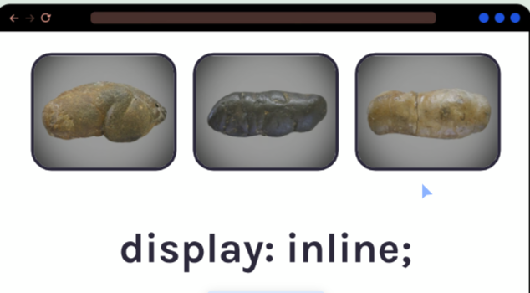
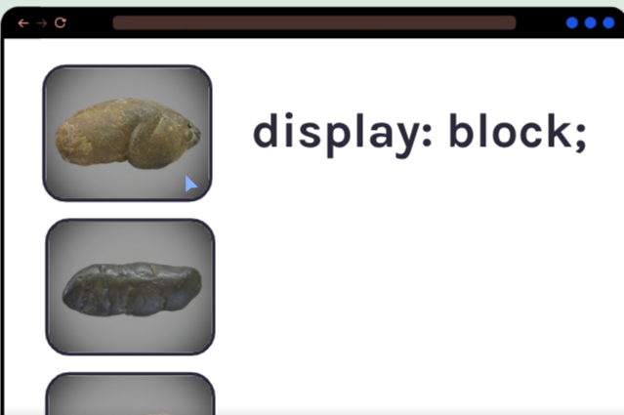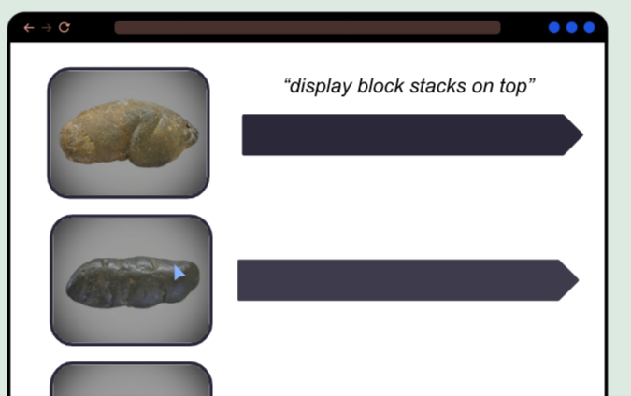The whole line is filled,No entry

- Div with classes
<div class=”name” >
Calling-> .name{}

- Margins
Add space between elements
Be center a img

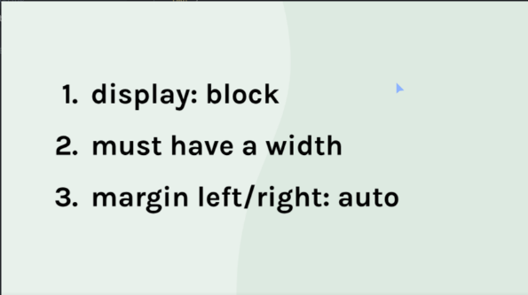
.
- Padding
- Border and border-radius
  - border: 2px solid red;
  - border-radius : 50px
- 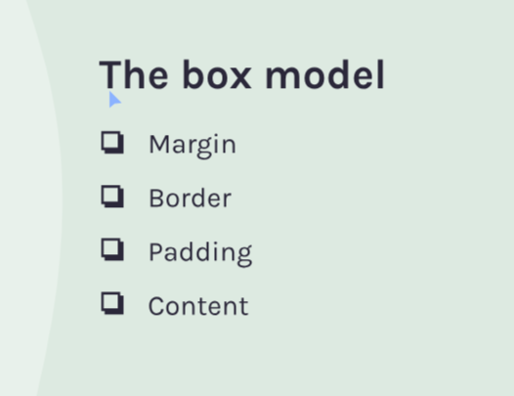
Lne height
FlexBox
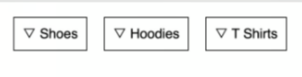Display : felx;
Only effect to direct elements not flexing child containers’s elements

Image File Path Fixed: 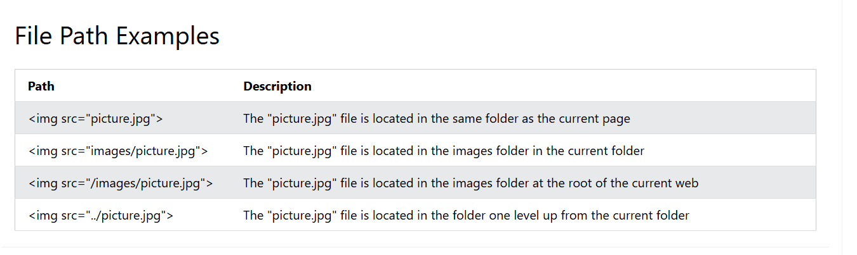

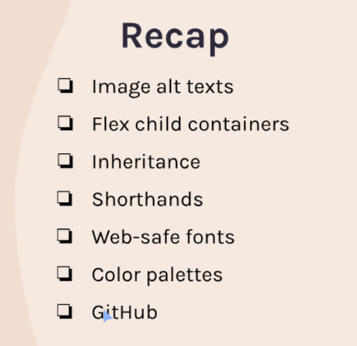
alt
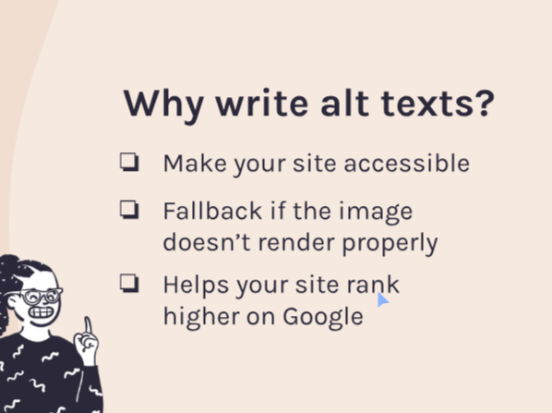
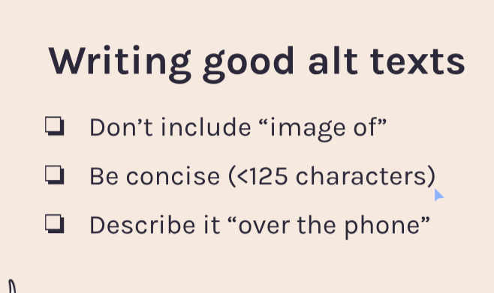
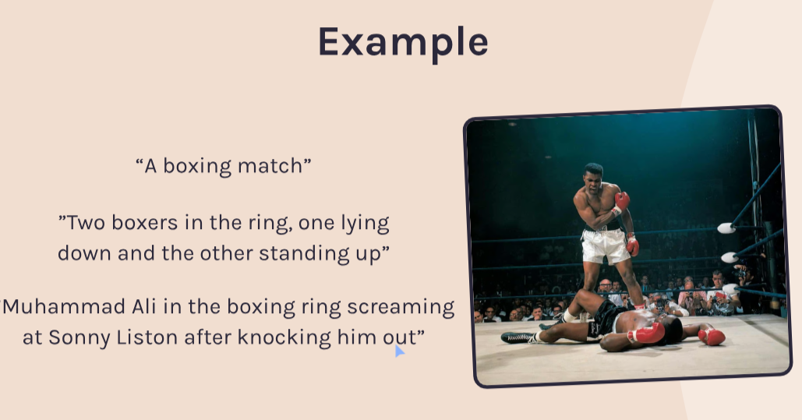

Make image smaller
Using width and height
Utility class

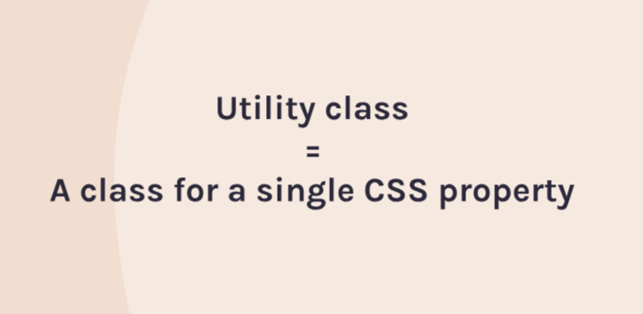


FONS


ShortCut
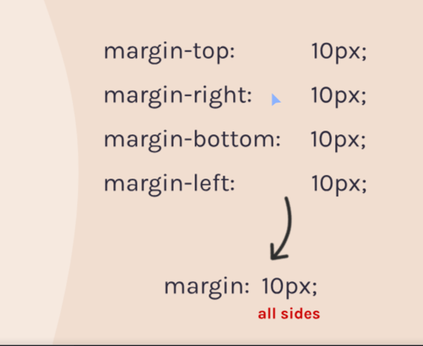
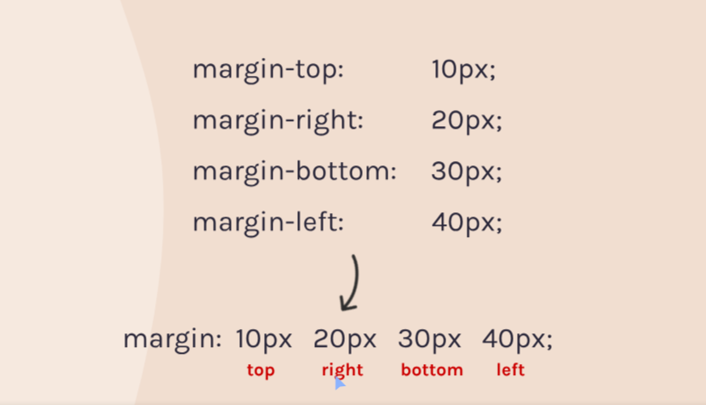
Clock time
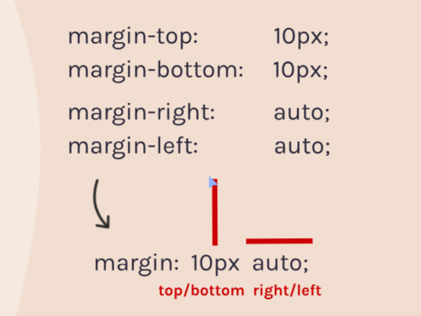


Background image: apply in css
- Background-image:url(“link”);
Get fonts from Google fonts
@fontFace
- Download the file
- Apply it to the css
- @font-face {
- src: url("Corleone.ttf");
- font-family: Corleone;
- }

- h1 {
- font-family: Corleone;
- }

- Spans
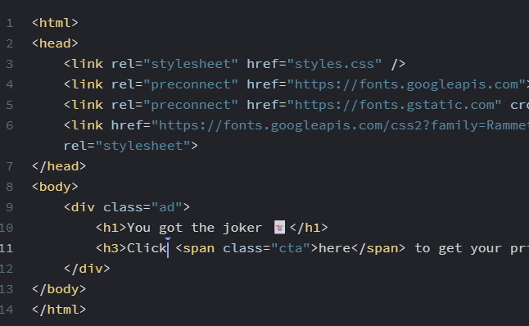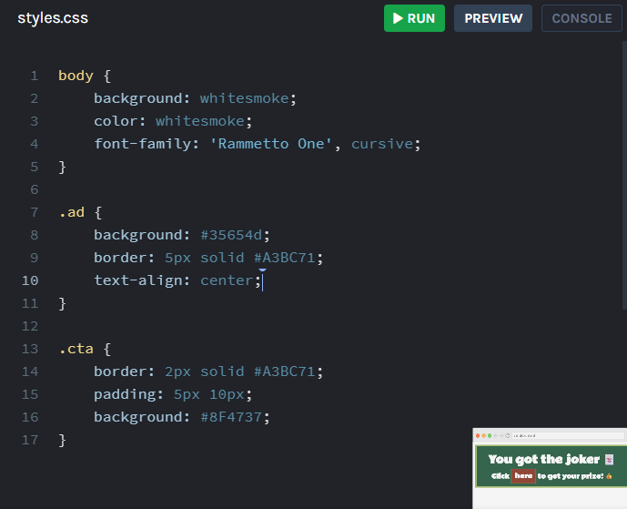

Add an underline using a span
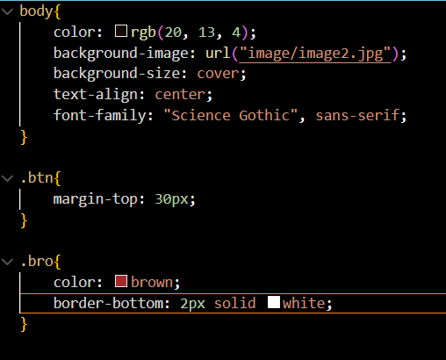

ID vs Class
Id: can’t use multiple times
Class : can use multiple times
?
Id=”idname”;
#idname(css){}

Color plate from image


Text-Shadow
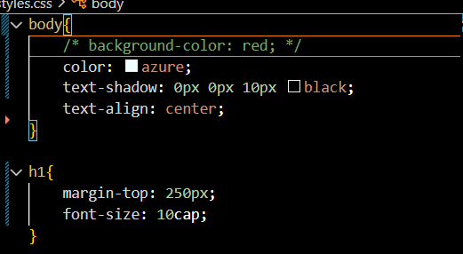


Flex :


Align-items
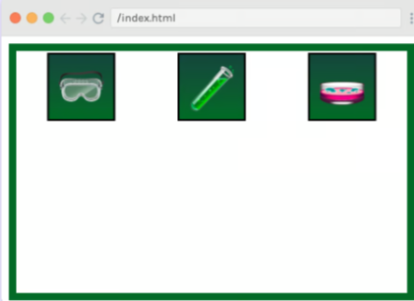
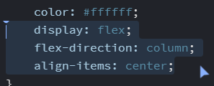

Flex-direction
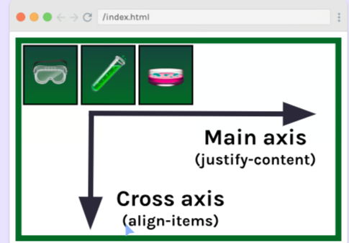
After adding flex direction
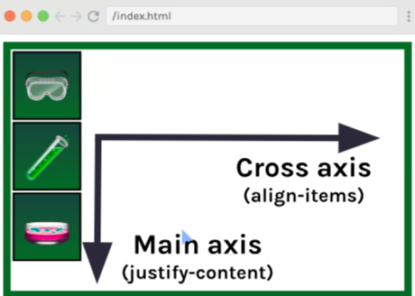

Replacing the image with the div
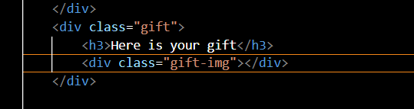

Hover
div:hover {
background-image: url("eyes.jpg");
}
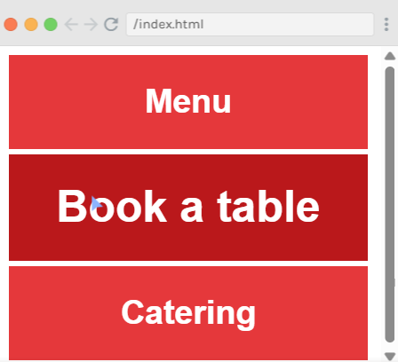
Hover with id

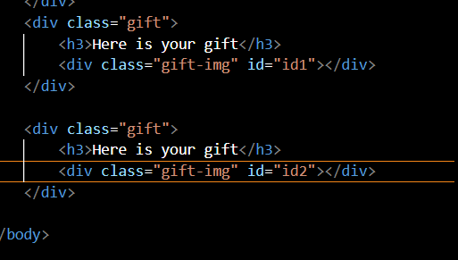

40px:top /auto:left/right / 20px:bottom

