1. Write a pseudocode and draw a flow chart to find roots of a quadratic equation. If quadratic equation is ax2 + bc + C = 0 then

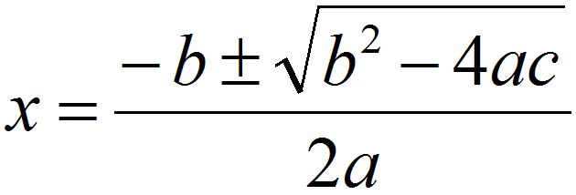 (P 28)

1. Convert a given integer into its reverse
2. Write a pseudocode and draw a flow chart to sum up all numbers which the user entered thru the keyboard. Stop when a negative number is encountered. (41)
3. Write a pseudocode and draw a flow chart to display following: (49)

\*

\* \*

\* \* \*

\* \* \* \*

\* \* \* \* \*

1. Write a pseudocode and draw a flow chart to produce the multiplication table.
2. Write a pseudocode and draw a flow chart for following scenario.

It displays two numbers and asks the sum of those two numbers from the user. The computer must tell the user whether the answer is right or wrong. (51)

1. Write a pseudocode and draw a flow chart for following scenario. The computer must convert either feet to meters or meters to feet depending upon the request of the user (52)
2. Write a pseudocode and draw a flow chart to find whether a given year is a leap year or not. (53)