|  |
| --- |
| Experiment No. 1 |
| Truth table of various logic gates using ICs. |
| Name: Vishwatej sarang |
| Roll Number: 51 |
| Date of Performance: |
| Date of Submission: |

**Aim -** To verify the truth table of various logic gates using ICs.

**Objective -**

1. Understand how to use the breadboard to patch up, test your logic design and debug it.
2. The principal objective of this experiment is to fully understand the function and use of logic gates.
3. Understand how to implement simple circuits based on a schematic diagram using logic gates.

**Components required -**

1. IC’s 7408, 7432, 7404

2. Bread Board.

3. Connecting wires.

**Theory -**

In digital electronics, a gate is logic circuits with one output and one or more inputs. Logic gates are available as integrated circuits.

**AND gate** :

AND gate performs logical multiplication, more commonly known as AND operation. The AND gate output will be in high state only when all the inputs are in high state.7408 is a Quad 2 input AND gate.

**OR gate:**

It performs logical addition. Its output become high if any of the inputs is in logic high. 7432 is a Quad 2 input OR gate.

**NOT gate:**

It performs basic logic function for inversion or complementation. The purpose of the inverter is to change one logic level to the opposite level. IC 7404 is a Hex inverter.

**Circuit Diagram, Truth Table -**

**AND Gate -**

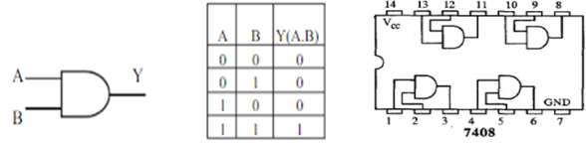

**OR Gate -**

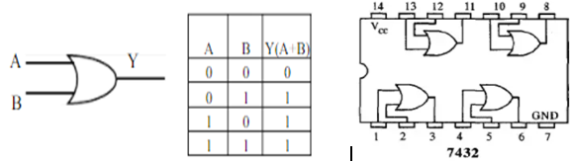

**NOT Gate -**

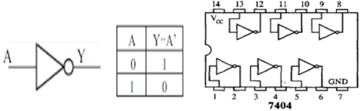

**Procedure:**

1.Test all the components in the Ic packages using a digital IC tester. Also assure whether all the connecting wires are in good condition by testing for the continuity using a Multimeter or a trainer kit.

2.Verify the dual in line package (DIP) inout of the IC before feeding the inputs.

3.Set up the circuits and observe the outputs.

**Output:**

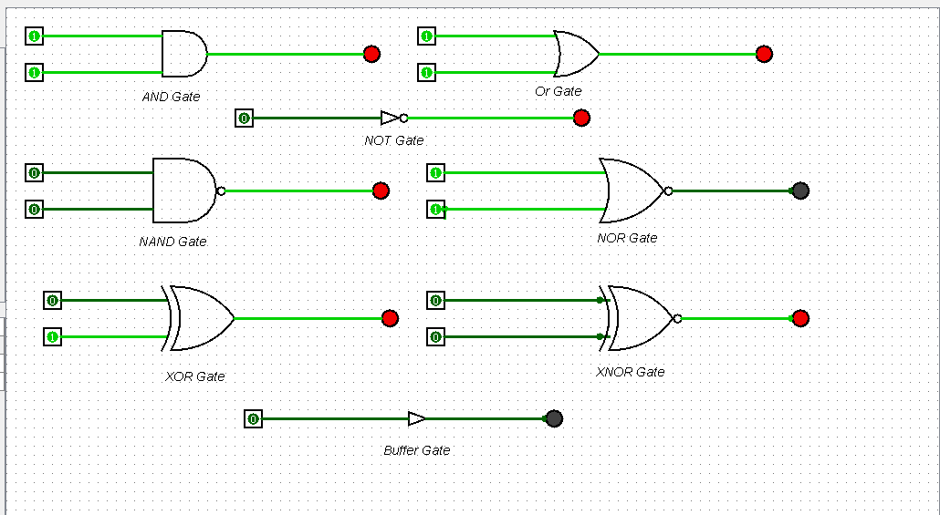

**Conclusion –**

I have learned some basic gates like “and” “or” “nand” “nor” “not” “xor” “xnor”.Hence the above experiment is verified and performed.