

| **Name:** | Vishwatej Sarang |
| --- | --- |
| **Roll No:** | 51 |
| **Class/Sem:** | SE/IV |
| **Experiment No.:** | 3 |
| **Title:** | Program for drawing square using Assembly Language. |
| **Date of Performance:** |  |
| **Date of Submission:** |  |
| **Marks:** |  |
| **Sign of Faculty:** |  |

**Aim:** Program for drawing square using Assembly Language.

**Theory:** INT 10h is a video service bios interrupt. It includes services like setting the video mode, character and string output and reading and writing pixels in graphics mode. To use the BIOS interrupt load ah with the desired sub-function. Load other required parameters in other registers and make a call to INT 10h.

INT 10h/AH = 0ch -Write graphics pixel.

**Input:**

AL = pixel colour

CX = column

DX = row

**Algorithm:**

1. Start

2. Initialize ax to 0013h for graphics mode.

3. Set the Counter bx to 60 h.

4. Initialize the co-ordinates cx and dx to 60h.

5. Set the Color.

6. Set Display Mode function by making ah = 0ch.

7. Increment cx and Decrement bx.

8. Repeat step 7 until bx = 0.

9. Initialize the counter by making bx = 60h.

10. Set the color.

11. Set Display Mode function by making ah = 0ch.

12. Increment dx & Decrement bx.

13. Repeat step 12 until bx = 0.

14. Initialize the counter by making bx = 60h.

15. Set the Color.

16. Set Display Mode function by making ah = 0ch.

17. Decrement cx and Decrement bx.

18. Repeat step 17 until bx = 0.

19. Initialize the counter by making bx = 60h.

20. Set the color.

21. Set Display Mede function by making ah = 0ch.

22. Decrement dx & Decrement bx.

23. Repeat step 22 until bx = 0.

24. To end the program use DOS interrupt:

1) Load ah = 4ch.

2) Call int 21h.

25. Stop.

**Assembly Code:**

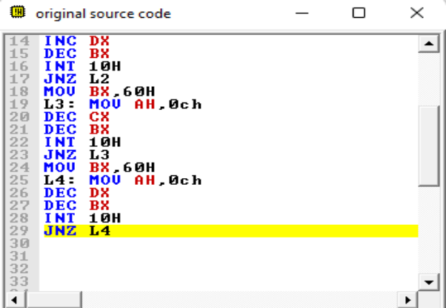

**Output:**

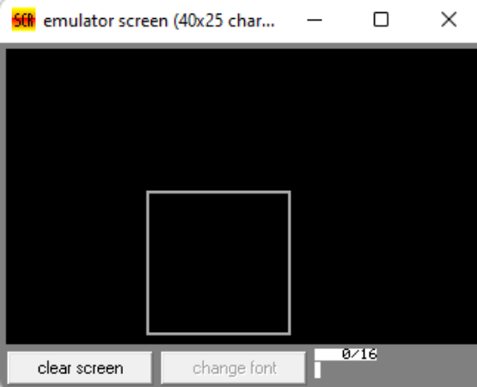

**Conclusion:**

1. Explain the use of int 10.

Ans. The `INT 10h` instruction is a software interrupt in x86 assembly language that serves as a gateway to BIOS video services. It’s commonly used for controlling video display output on IBM-compatible PCs. Here’s how it’s used:

1. Video Mode Setting: One primary use of `INT 10h` is to set the video mode, which determines the resolution and color depth of the display. Different modes offer various configurations suitable for text mode, graphics mode, or specific display resolutions.
2. Cursor Control: `INT 10h` allows for manipulation of the cursor position and its appearance on the screen. This includes setting the cursor’s position, hiding or showing the cursor, and changing its shape.
3. Character and String Output: `INT 10h` facilitates the output of characters and strings to the screen. This includes writing characters directly to specific locations on the screen or printing strings of characters.
4. Color and Attribute Control: It enables setting the foreground and background colors of characters displayed on the screen, as well as controlling attributes like blinking and brightness.
5. Scrolling: `INT 10h` allows for scrolling the contents of the screen both vertically and horizontally.
6. Palette Control (in some cases): In certain video modes, `INT 10h` provides functionality for manipulating the color palette used for graphics display.

In summary, `INT 10h` is a versatile instruction that provides access to a wide range of video-related functions, making it essential for controlling display output in DOS and BIOS-based systems.

1. Explain hardware interrupts.

Ans. Hardware interrupts are signals generated by hardware components to request attention from the CPU. Here’s an explanation of hardware interrupts:

1. Purpose: Hardware interrupts are used by peripherals like keyboards, mice, disks, and network adapters to notify the CPU that they require servicing.
2. Types: There are several types of hardware interrupts, including:

- Maskable Interrupts: Can be disabled or enabled by the CPU.

- Non-Maskable Interrupts (NMI): Cannot be disabled and usually signify critical system errors.

- External Interrupts: Generated by external devices connected to the CPU.

- Internal Interrupts: Generated by internal CPU events like divide-by-zero errors or page faults.

1. Handling: When a hardware interrupt occurs, the CPU interrupts its current execution, saves the context, and jumps to an interrupt service routine (ISR) associated with the interrupt. The ISR then services the interrupt, which may involve reading data from or writing data to the device, acknowledging the interrupt, and restoring the CPU’s previous context to resume execution of the interrupted program.
2. Priority: Interrupts may have different priority levels, and the CPU typically services higher priority interrupts before lower priority ones to ensure timely response to critical events.
3. IRQs: In PC architecture, hardware interrupts are often managed through interrupt request lines (IRQs), with each device connected to a specific IRQ line. The CPU communicates with devices through these lines to determine which device is requesting service.

Hardware interrupts are essential for real-time processing and efficient utilization of system resources in modern computer systems.

