**Practical 3**

**AIM:** Practical of Data collection, Data curation and management for Large-scale Data system (such as MongoDB)

**1. Create Database in MongoDB.**

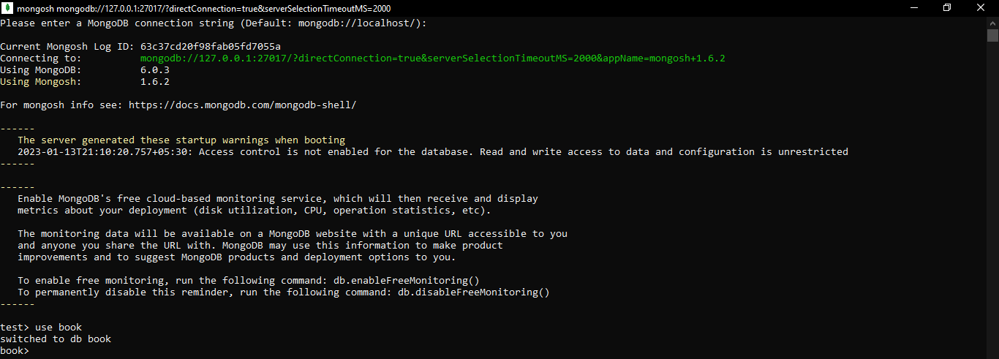

**2. List down all the databases.**

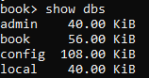

**3. Create collection with options before inserting the documents.**



**4. List down the created collections.**



**5. Create the collection in MongoDB on the fly.**

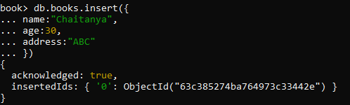

**6. Show all the documents in the given collection.**

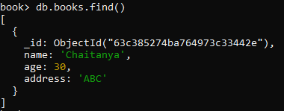

**7. Drop Database in MongoDB.**

To drop “student” database, switch to student and then drop it as follows:

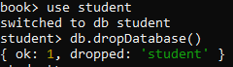

**8. Drop Collection in MongoDB.**

To drop “students” collection present in book database, switch to book and then drop the collection as follows:

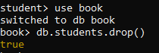

**9. Insert Multiple Documents in Collection.**

For inserting Multiple Documents, first switch to “book” database and then create a new collection. Then with the help of variable insert Multiple Documents in that Collection.

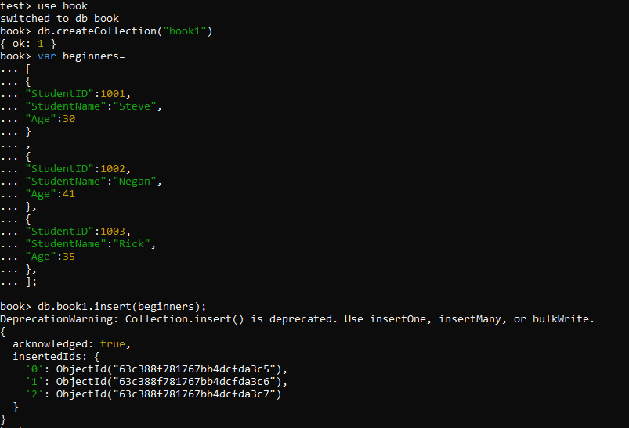

**10. Print the Output Data in JSON Format.**

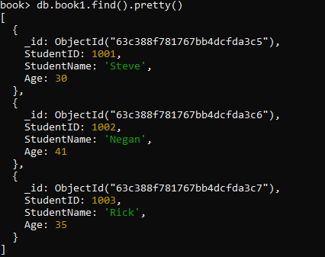

**11. Query document based on criteria.**

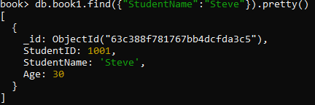

**12. Greater than Entity.**

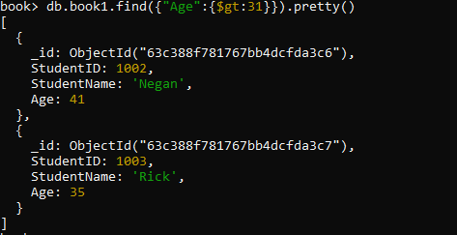

**13. Less than Entity.**

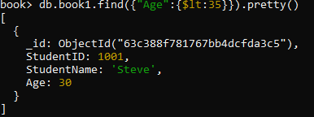

**14. Not Equals Criteria.**

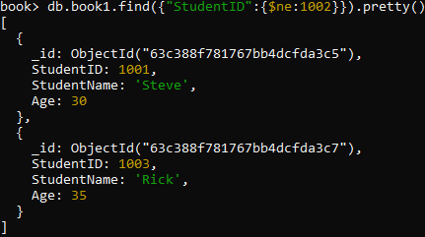

**15. Greater than Equals Criteria.**

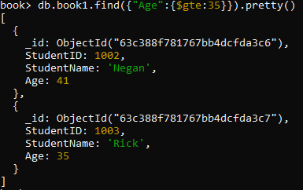

**16. Less than Equals Criteria.**

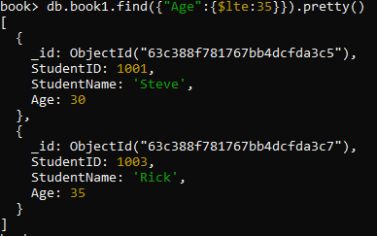

**17. Updating document using update() method.**

After using update() method, we have printed the Documents in JSON format to verify whether the specified update is done or not.

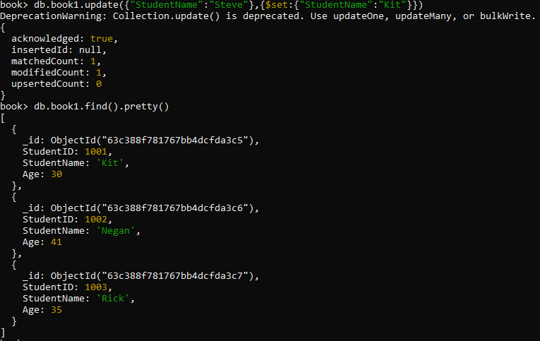

**18. Updating multiple documents with update() method.**

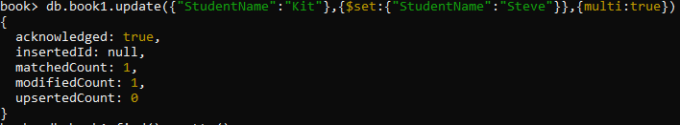

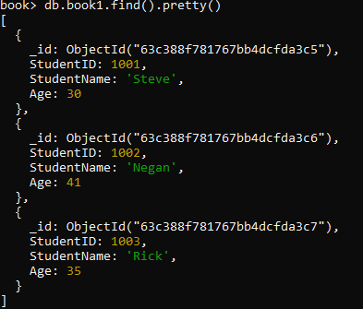

**19. Updating document using save() method.**



save() has been deprecated, thus doesn’t have any ouput.

**20. Delete document using remove() method.**

After using remove() method, we have printed the Documents in JSON format to verify whether the specified deletion is done or not.

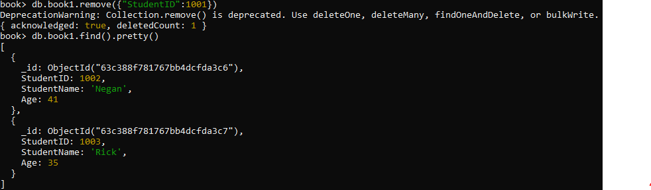

**21. Remove all documents.**

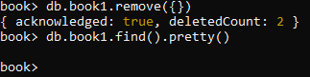

**22. MongoDB Projection.**

Since we removed all the documents from the previous collection, Create a new Collection “book2” and insert multiple documents in it using a variable. Then, use the Command for Projection.

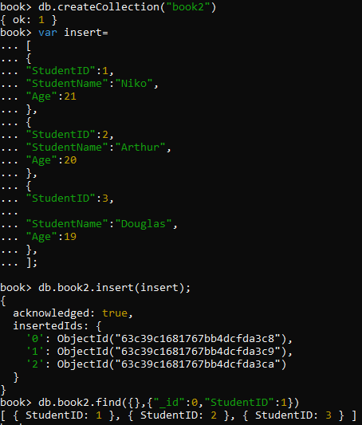

**23. Limit the Number of Documents returned in Response to a Particular Syntax.**

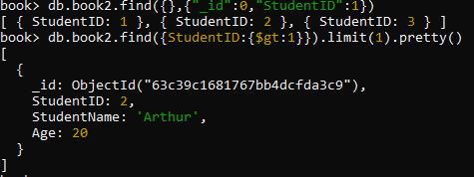

**24. Skip the given number of Documents returned in response to a particular Syntax.**

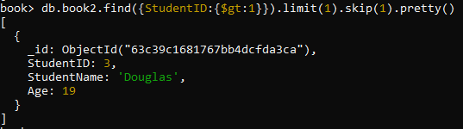

**25. Sorting Documents using sort() method.**

**i) In Descending Order.**



**ii) In Ascending Order.**



**26. Create index in MongoDB.**



**27. Finding the indexes in a collection.**

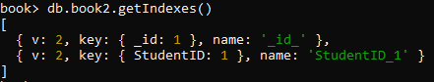

**28. Drop a specific index of a collection.**



**29. Drop all the indexes of a collection.**

