**PRACTICAL NO 8**

**AIM: Perform SQL Injection Attack.**

(1) Go to https://www.apachefriends.org/download.html and download XAMPP server.

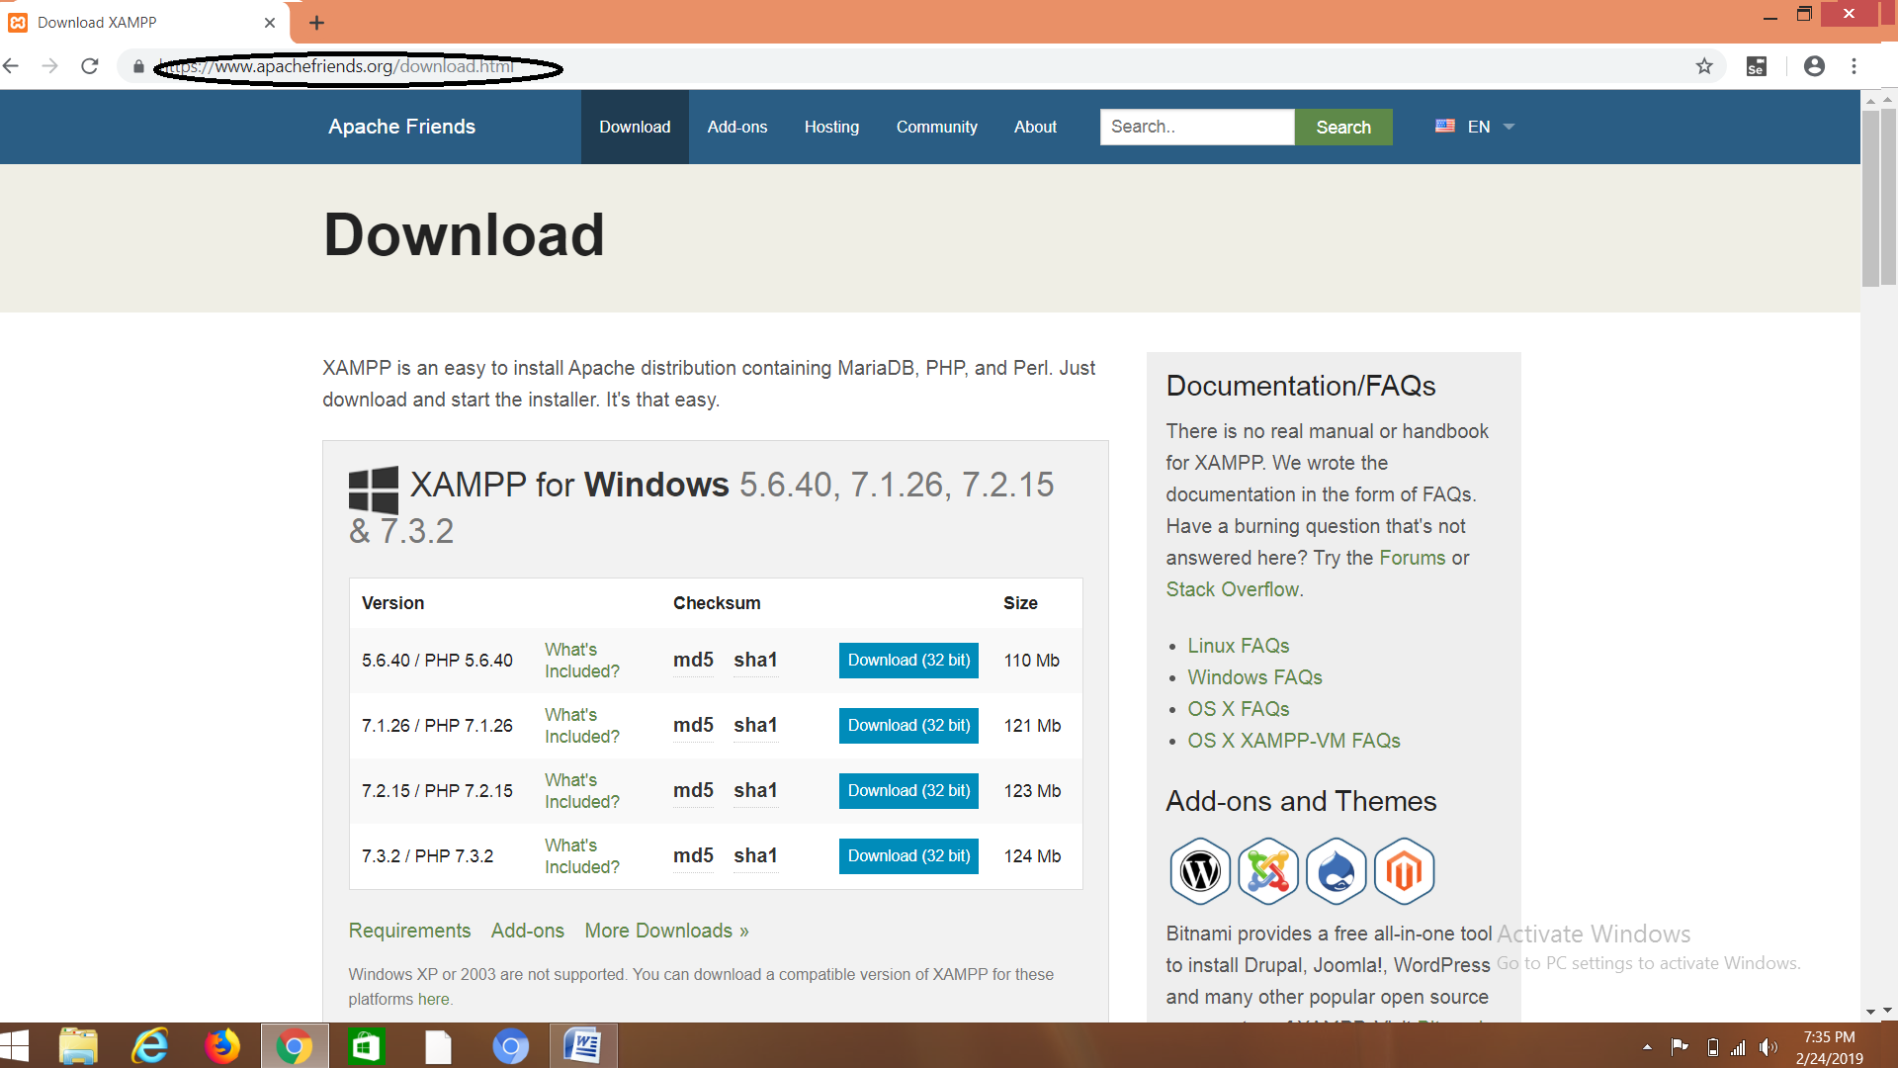

(2) After Installation,Right click on XAMPP and choose "Run As Administrator "mode

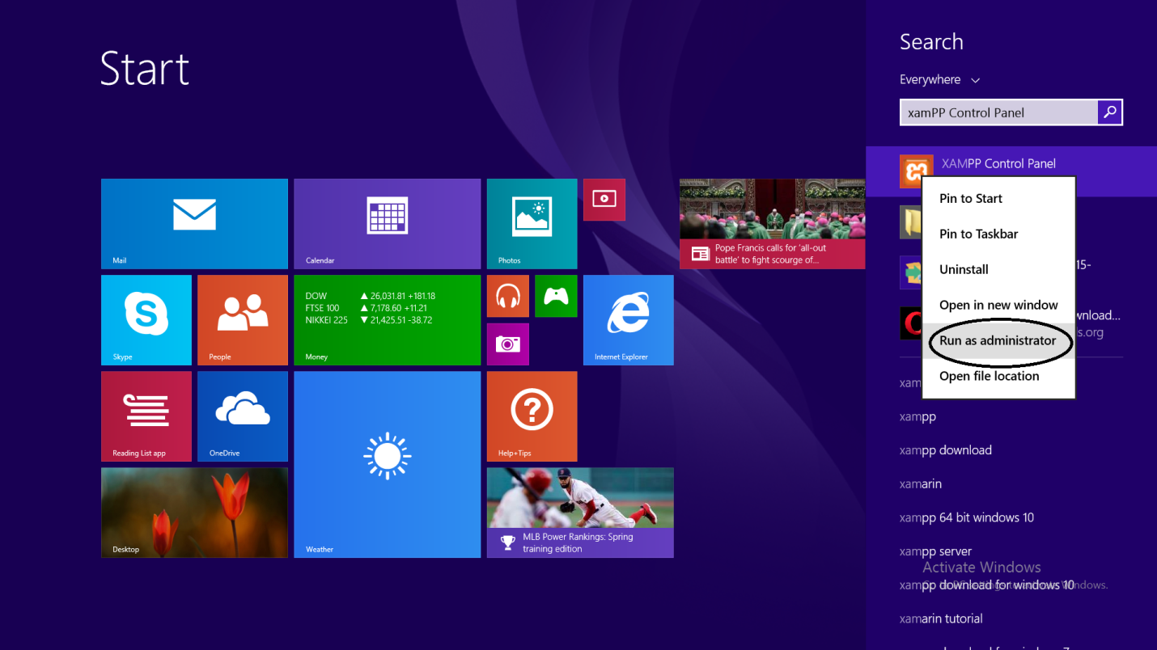

(3) Start modules apache and mysql server. allow access to the firewall.

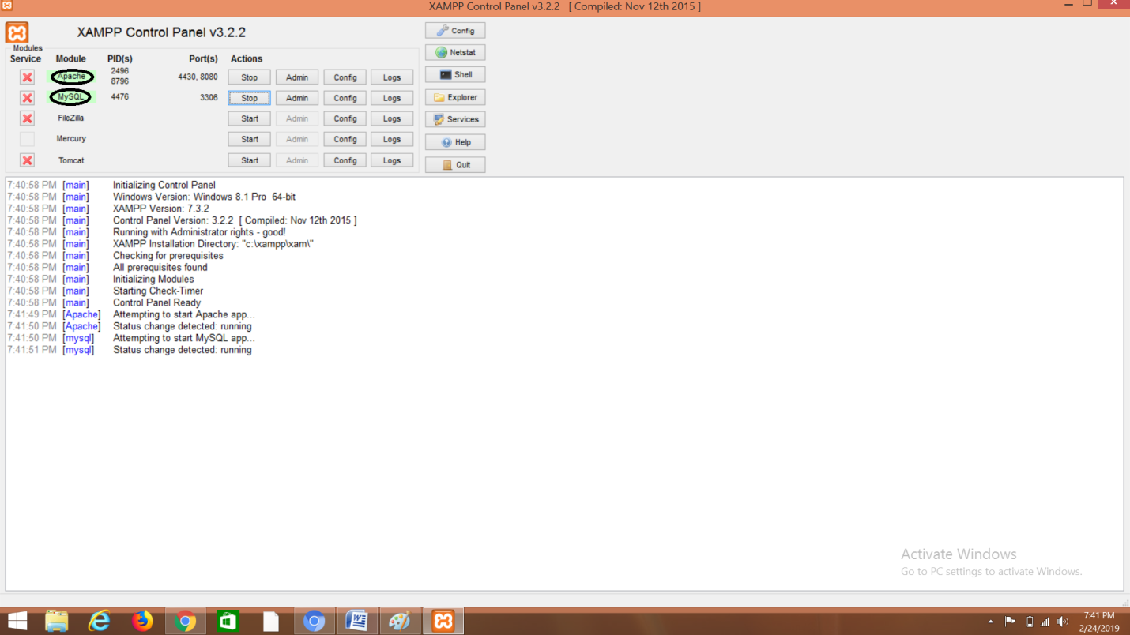

(4) Go to link: http://www.dvwa.co.uk/ and click on download.

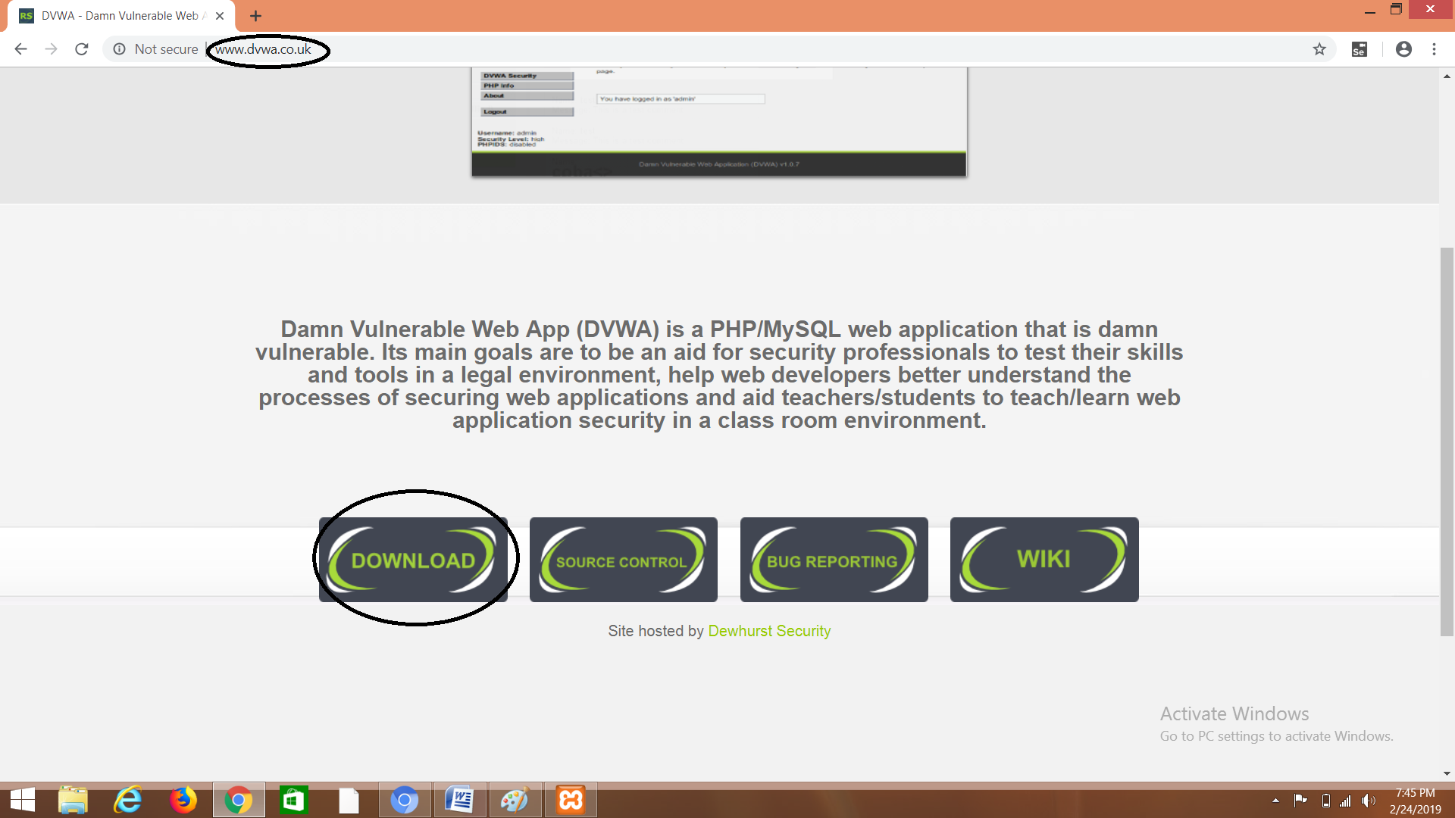

(5) Download and Extract DVWA-Master.zip file and then extract the file and rename the file as dvwa. After renaming it go to config<config.inc and make the password field empty as shown below.and then copy and paste the entire folder inside C:\xampp\xam\htdocs

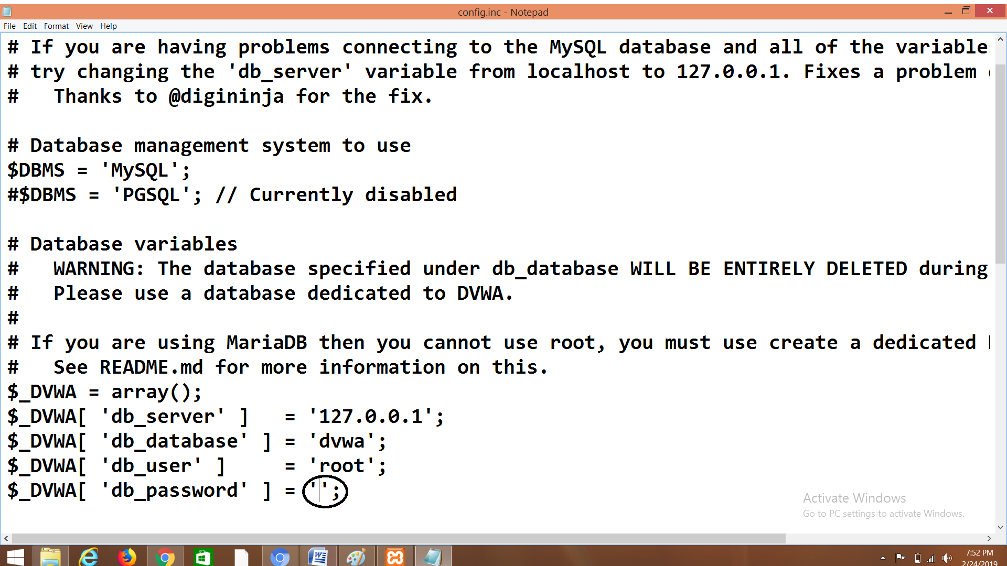

(6) Go to Web browser and enter the side <http://localhost:8080/phpmyadmin/> and then click on Databases. Enter the database name as "sql_db" and after that click on "create"

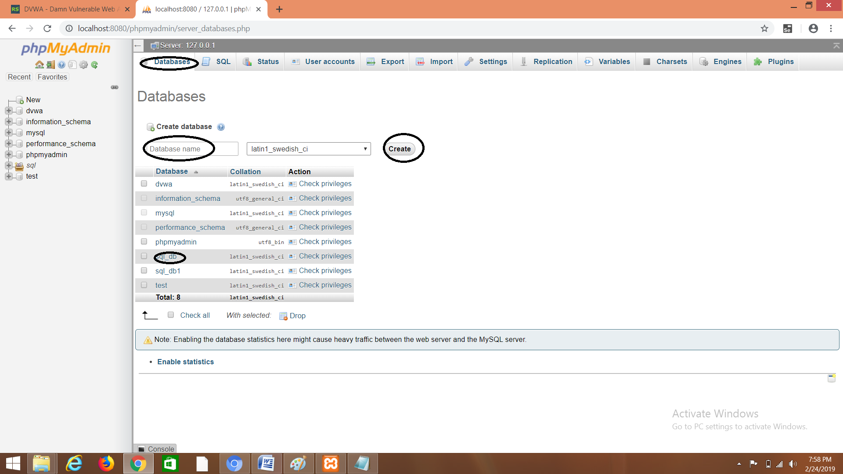

(7) Go to http://localhost:8080/dvwa/setup.php# and click on "create/reset" Database.

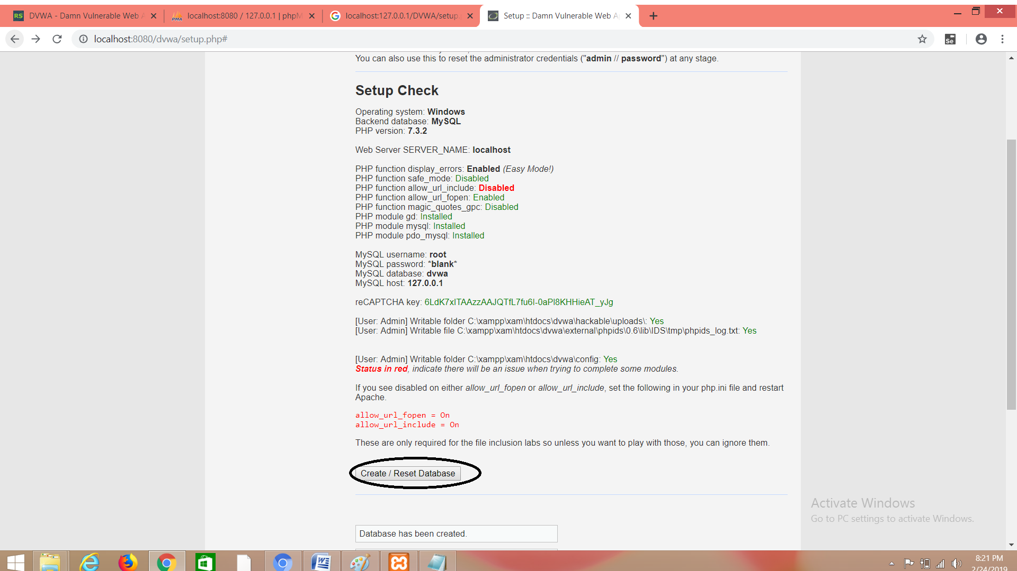

(8)Once Your click on"create/Reset Database You will be able to see the following page.

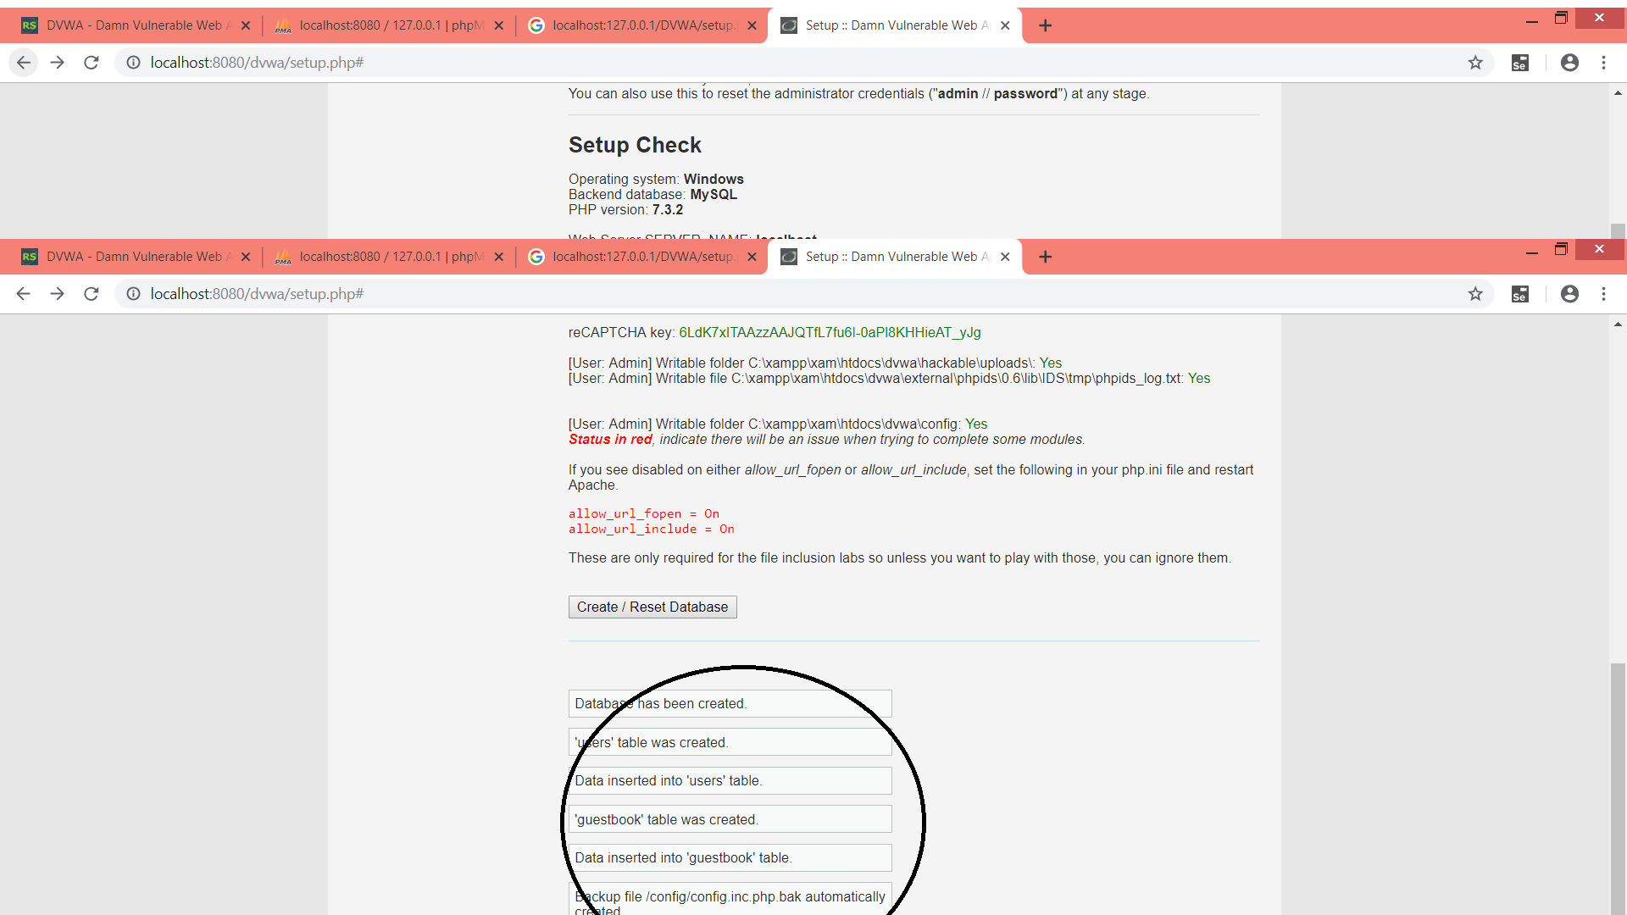

(9)Click on login and enter the username as username:admin password:password

and after that click on "Login" button.

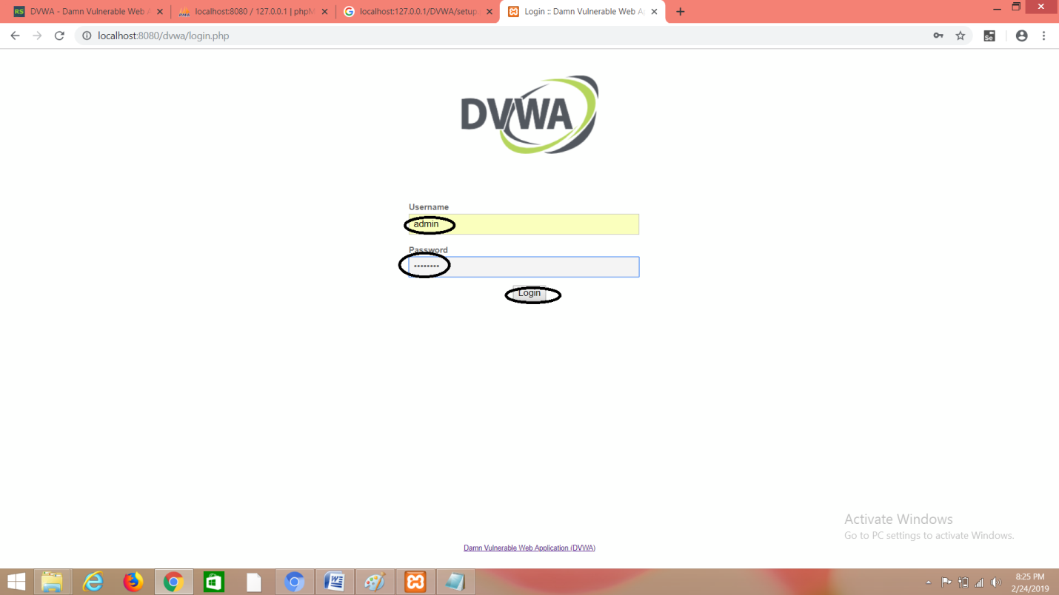

(10)You will be redirected to the home page as shown below.

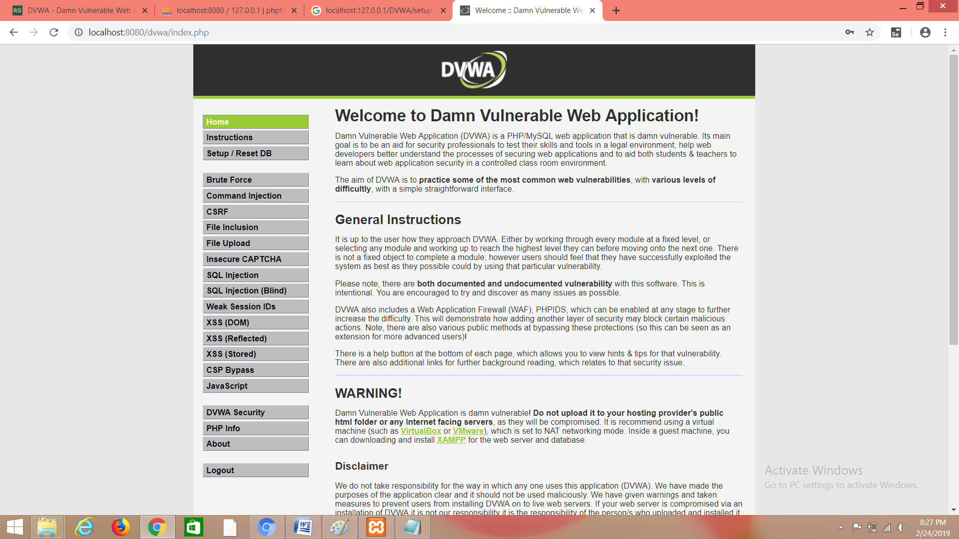

(11) Go to the DVWA security options in the left and set the security level as "Low"And click on "submit"

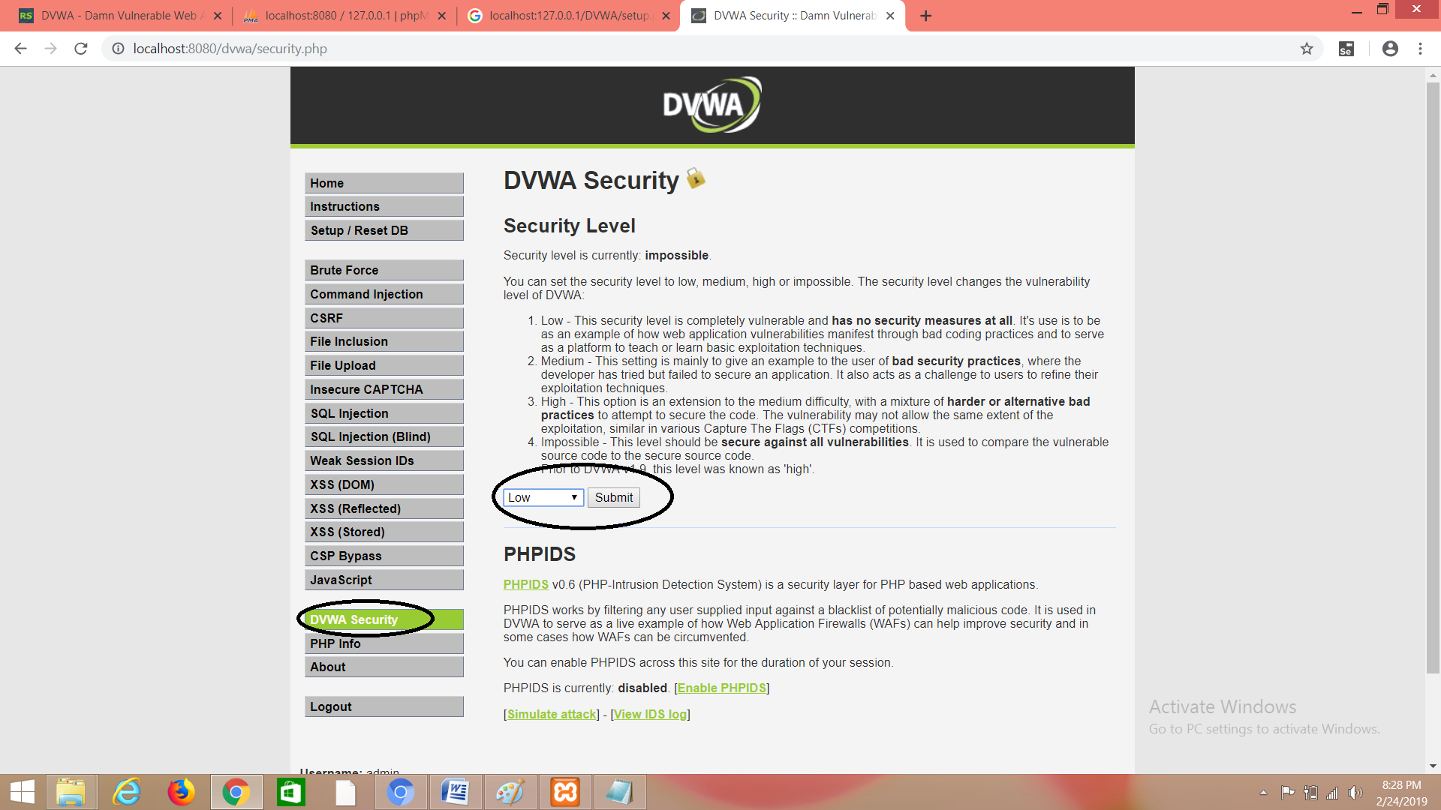

(12) Go to SQL injection in left and enter user id:1 and then click on submit

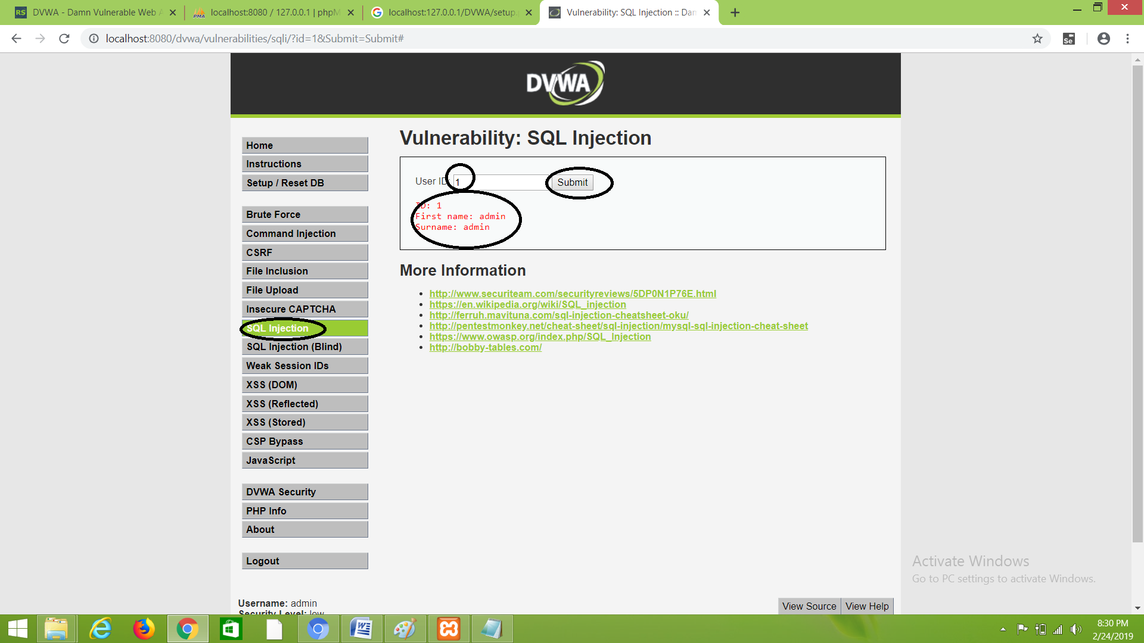

(13)Check for various fields such as 2,3

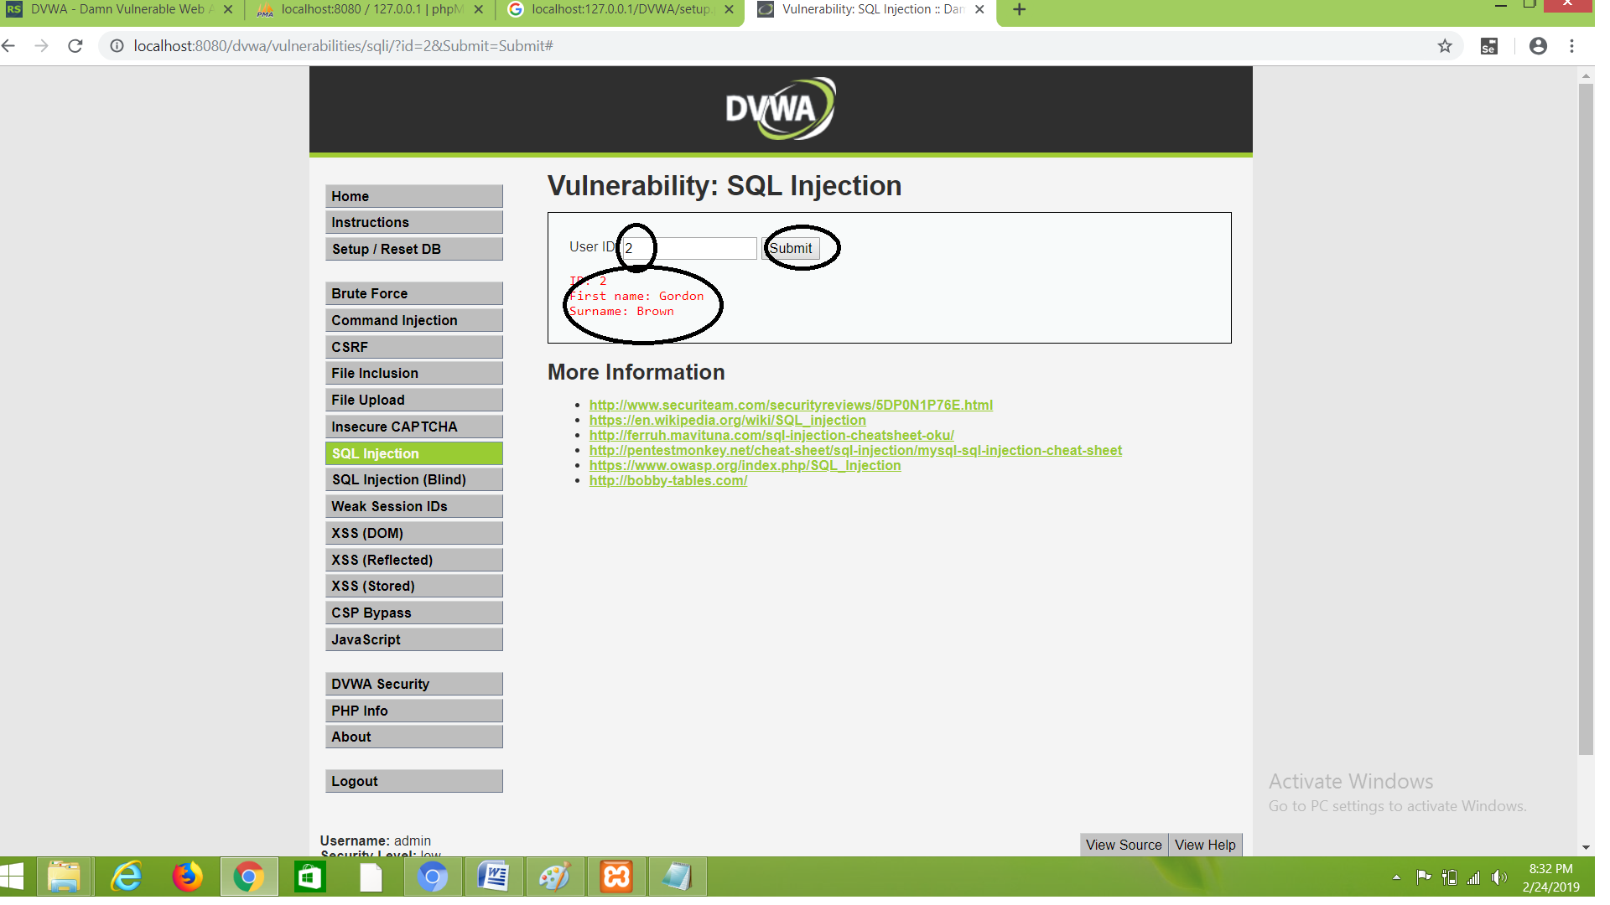

**OPTIONAL STEPS**

(1) Set the permissions to "on" in php.ini file and save it

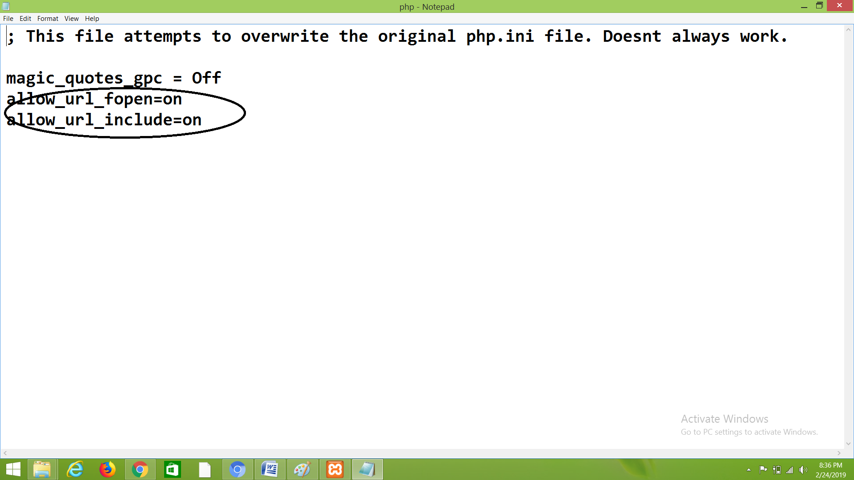

(2) Go to C:\xampp\xam\htdocs\dvwa\config and enter the recaptcha public key as shown below:

