**PRACTICAL 4**

**AIM:** Write and Test a Program to Login a Specific Web Page(Using JUnit).

**Step 1:** Open Eclipse and Create New Java Project and name it as follows, then click on Finish:

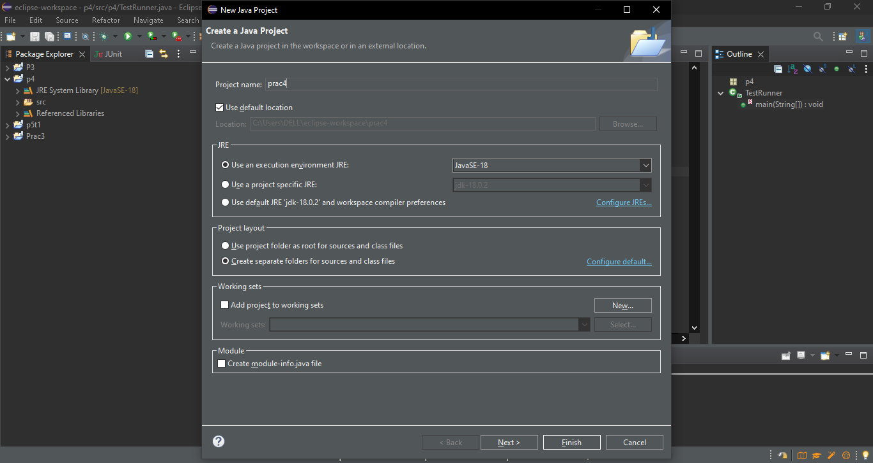

**Step 2:** Right Click on the Name of Created Java Project, and then Create Package named as follows, and then click on Finish:

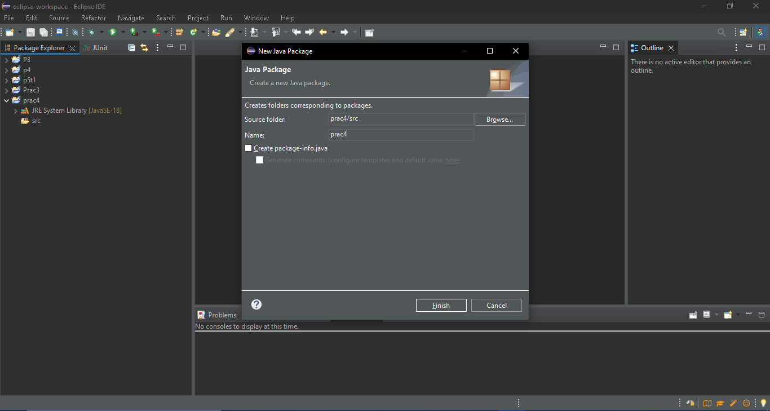

**Step 3:** Again Right Click on the Created Java Project Name, and create 2 Java Classes as named as follows:

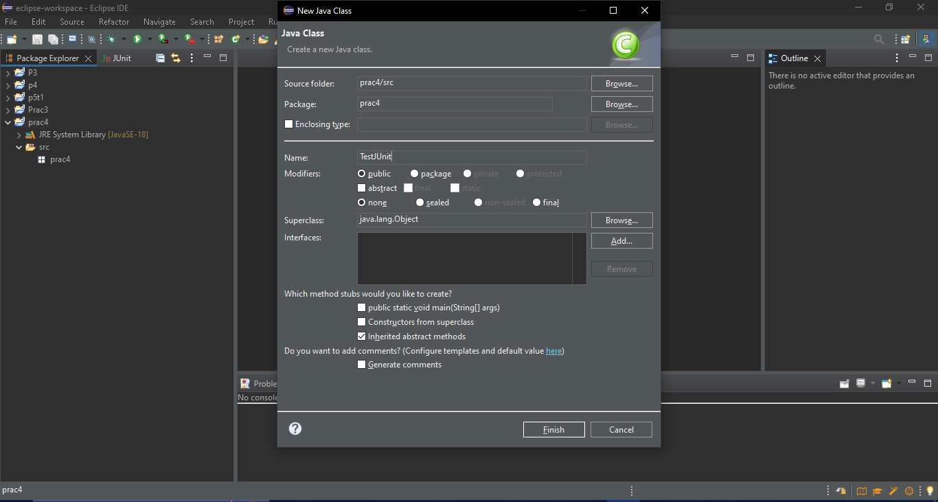

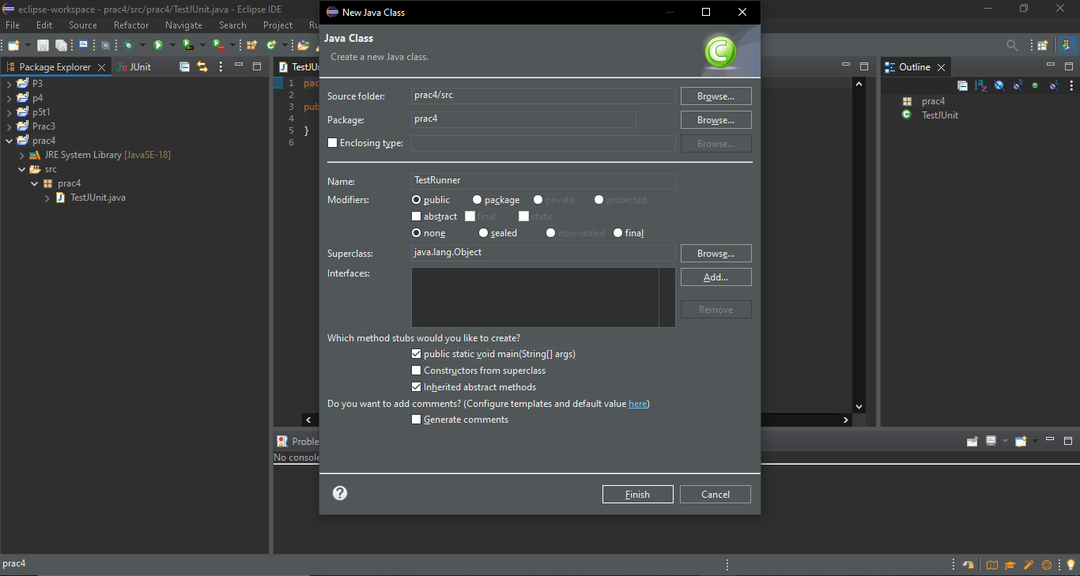

**Step 4:** Type the following code in the respective files:

TestJUnit.java

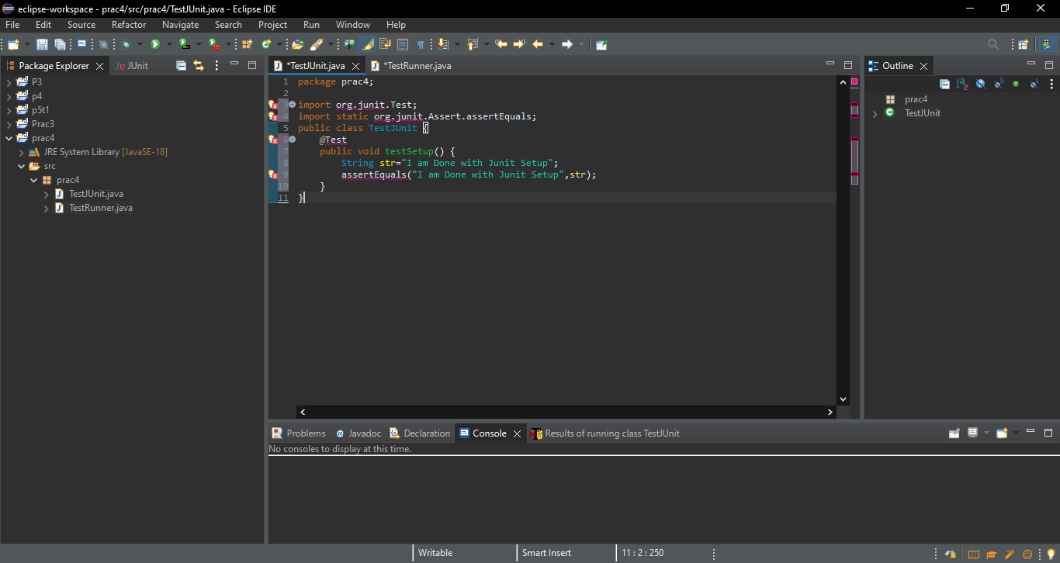

TestRunner.java

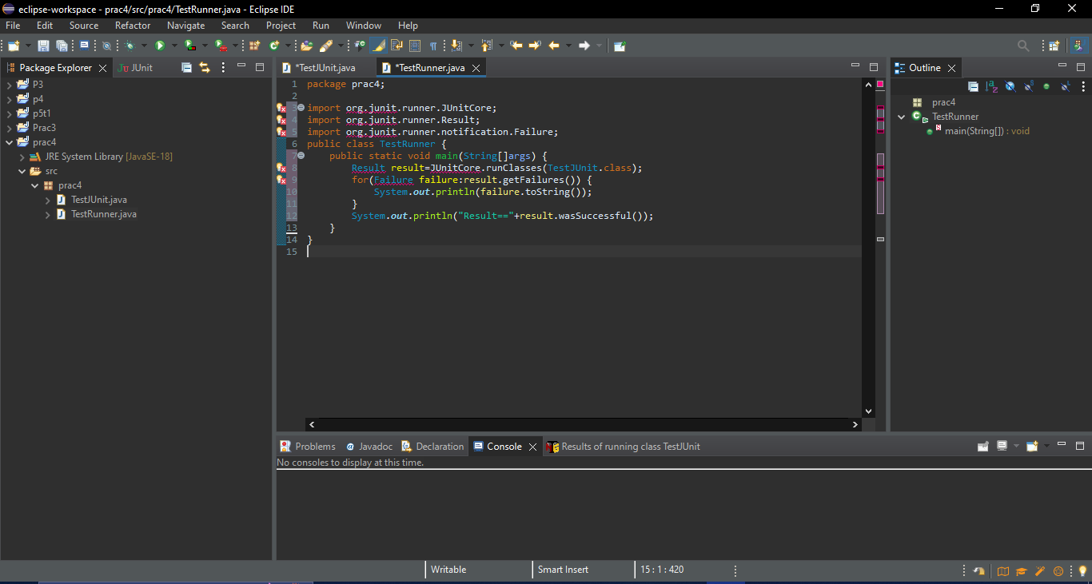

**Step 5:** Again Right Click on Name of Java Project, then Click on Build Path, then on Add External Archives.

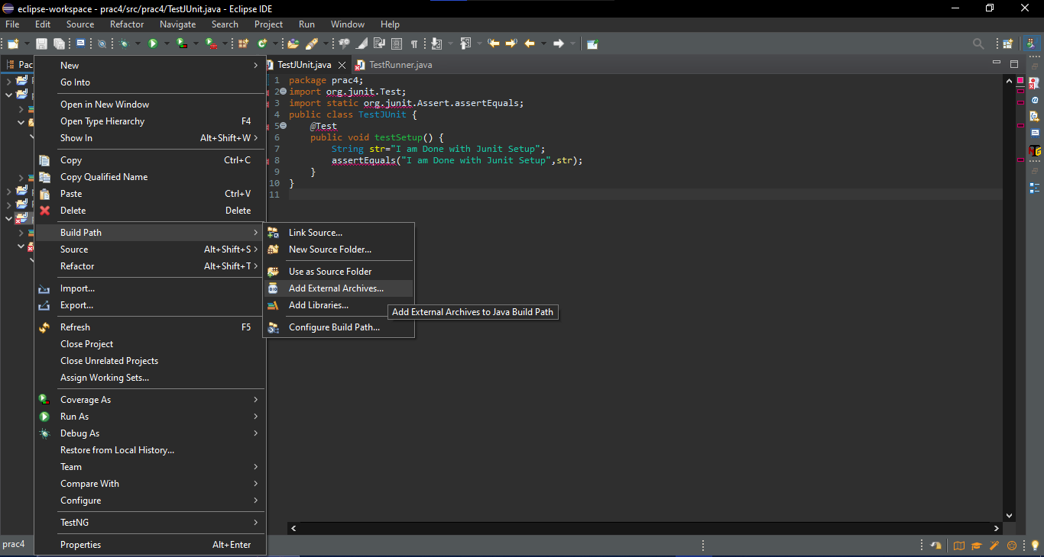

**Step 6:** Select the Following Jar file from “st” folder and then click on Open.

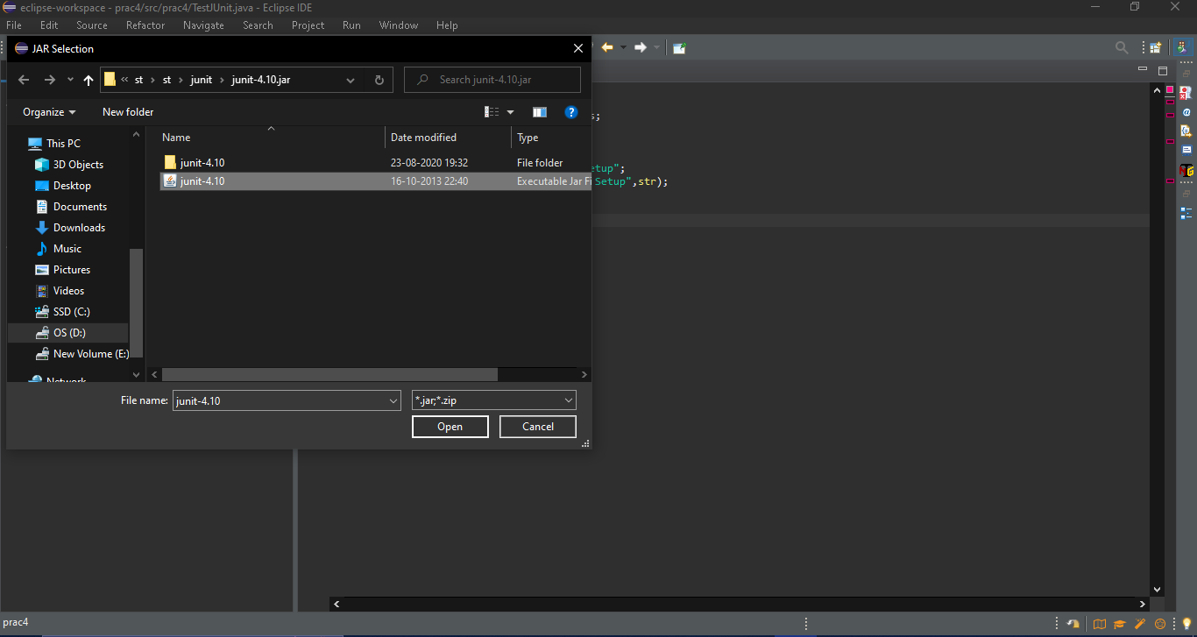

**Step 7:** Now Run the TestRunner.java as Java Application.



