**PRACTICAL 2**

**AIM:** To conduct a test suite for any 2 websites.

**Step 1:**

Open Chrome & Selenium IDE. Create a New Project named as follows:

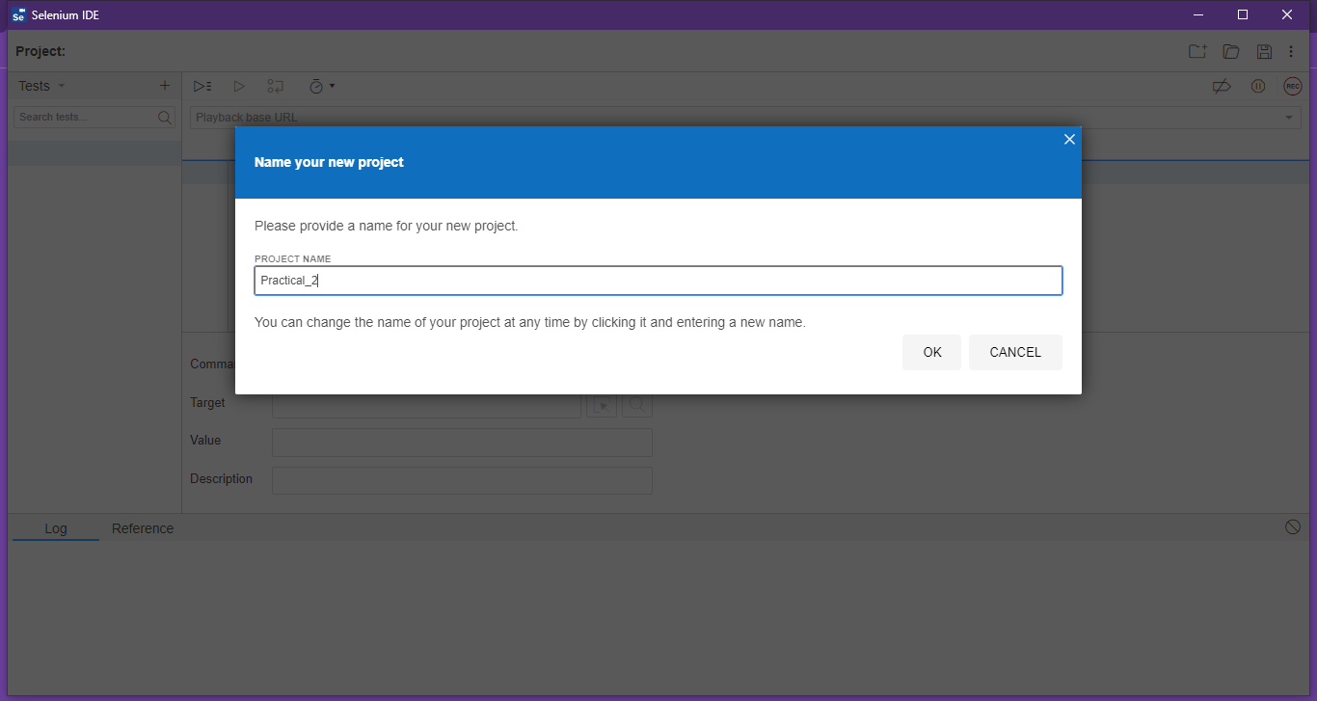

**Step 2:**

Click on “+” and Click on “Add New Test”. Name the test as follows:

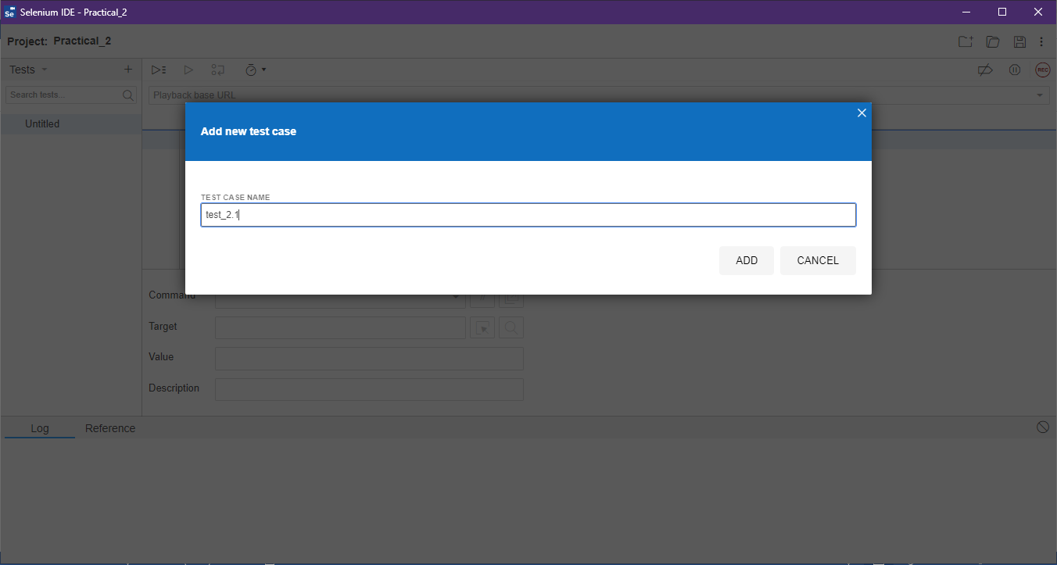

**Step 3:**

Copy the URL: <https://en.wikipedia.org/wiki/India>, and Start the Recording. Chrome will take you the page. Perform the Actions as follows:

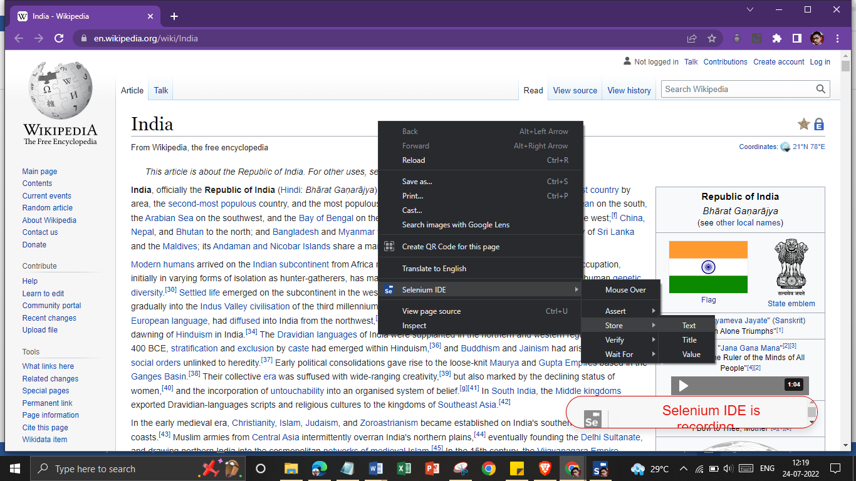

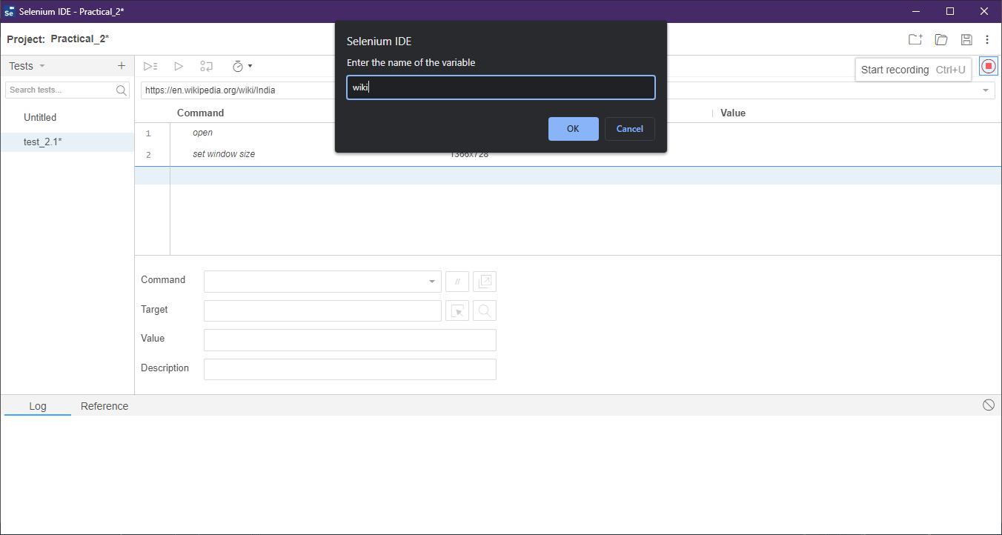

**Step 4:**

Save the Recording and Play It.

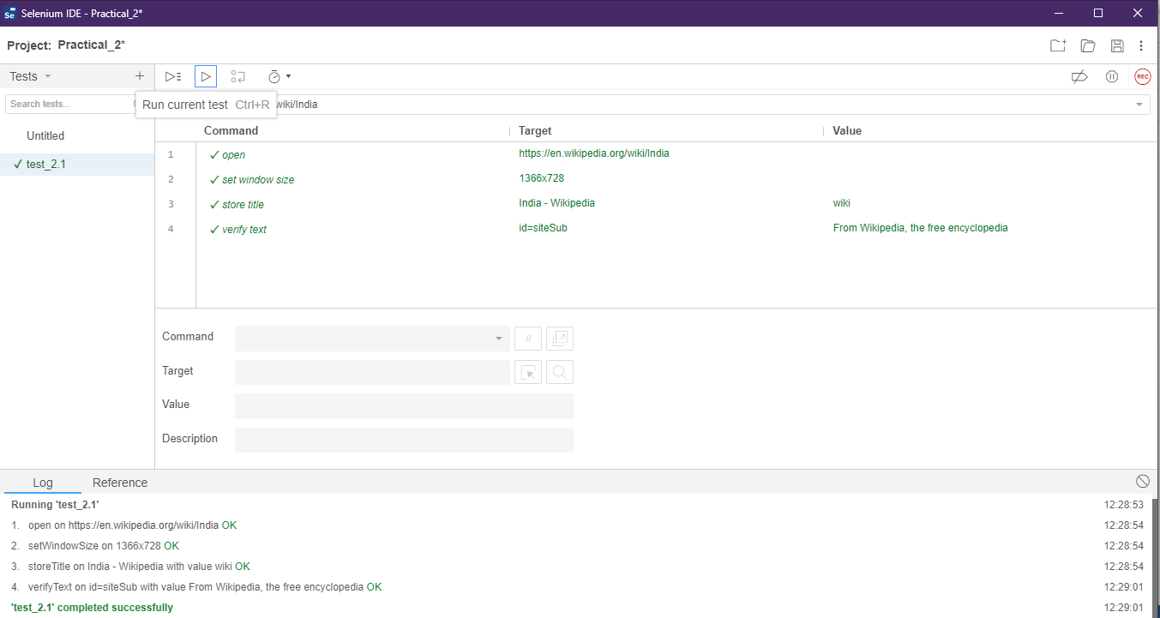

**Step 5:**

Create another Test named “test_2.2” and follow the same steps from 1 to 4 with “<https://www.att.com/>” as Base URL.

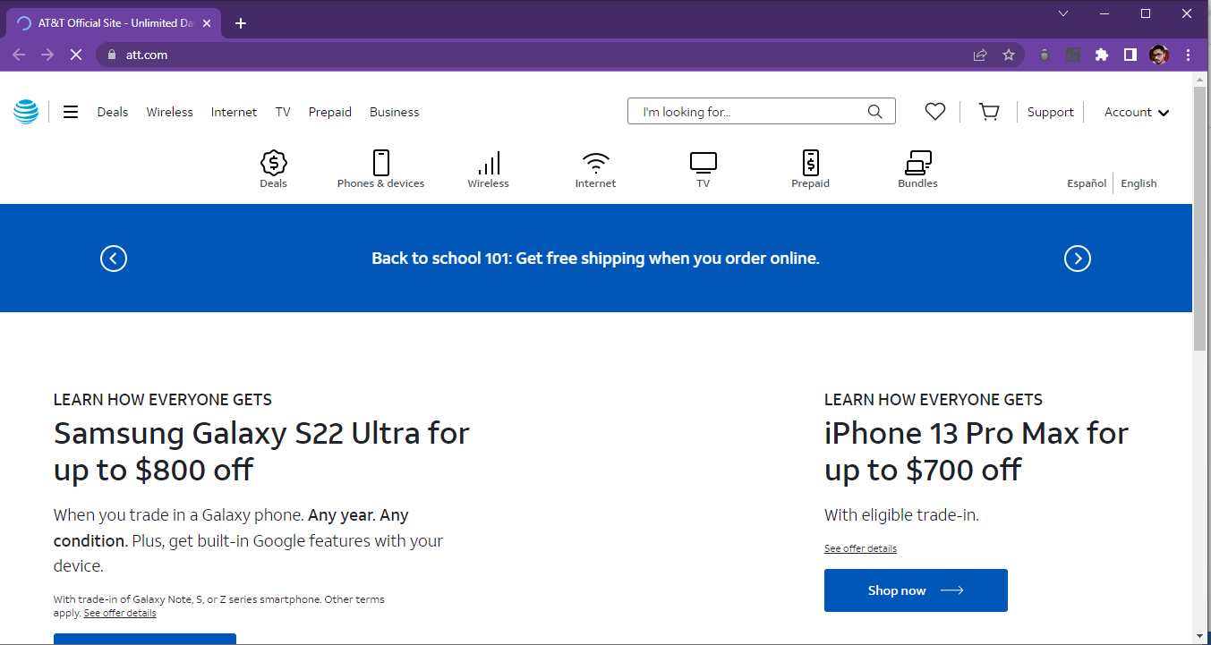

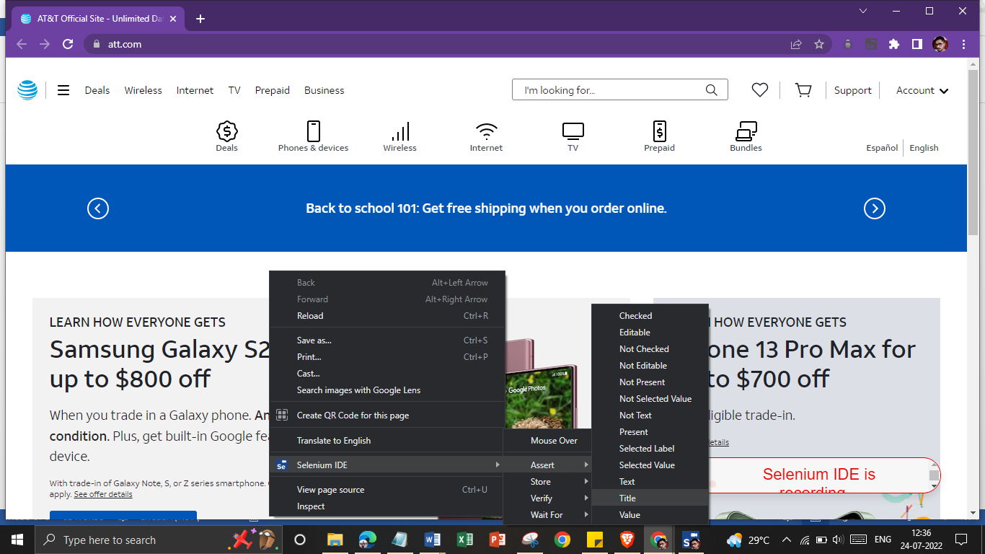

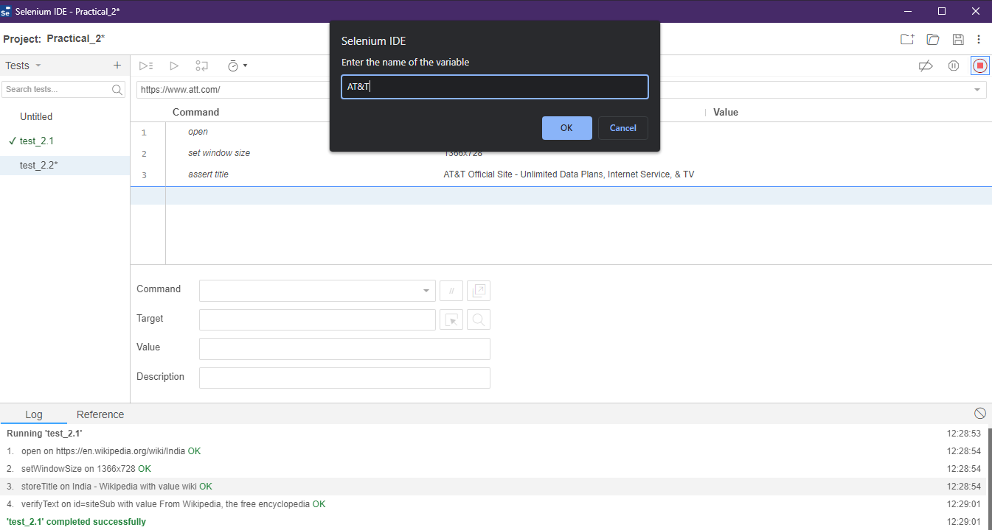

**Step 6:**

Save the Test and Play the Recording.

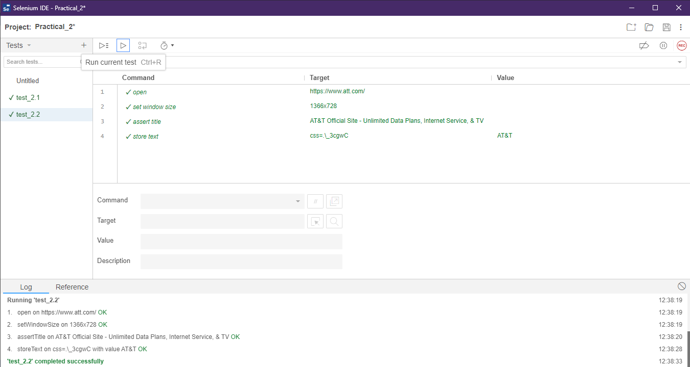

**Step 7:**

Now Click on Test, a dropdown menu will appear. Select Test suites.

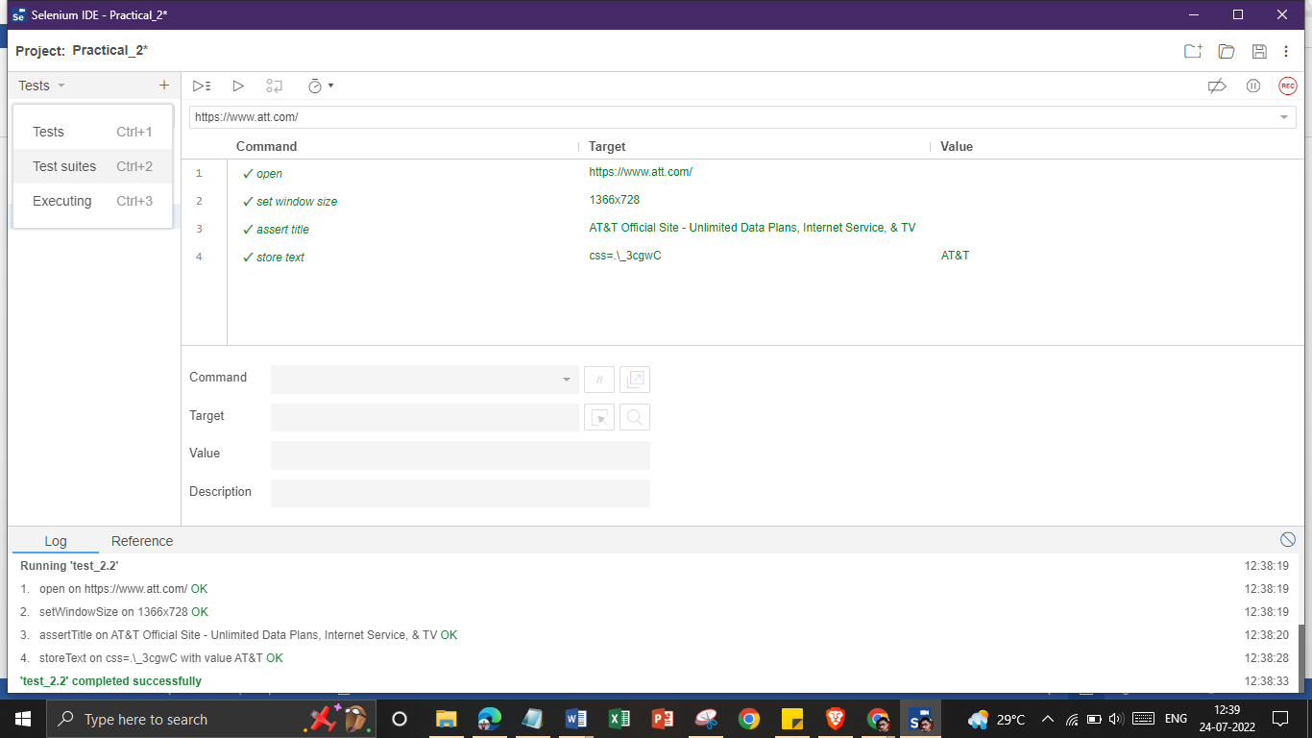

**Step 8:**

Click on “+” and name the Test Suite as follows:

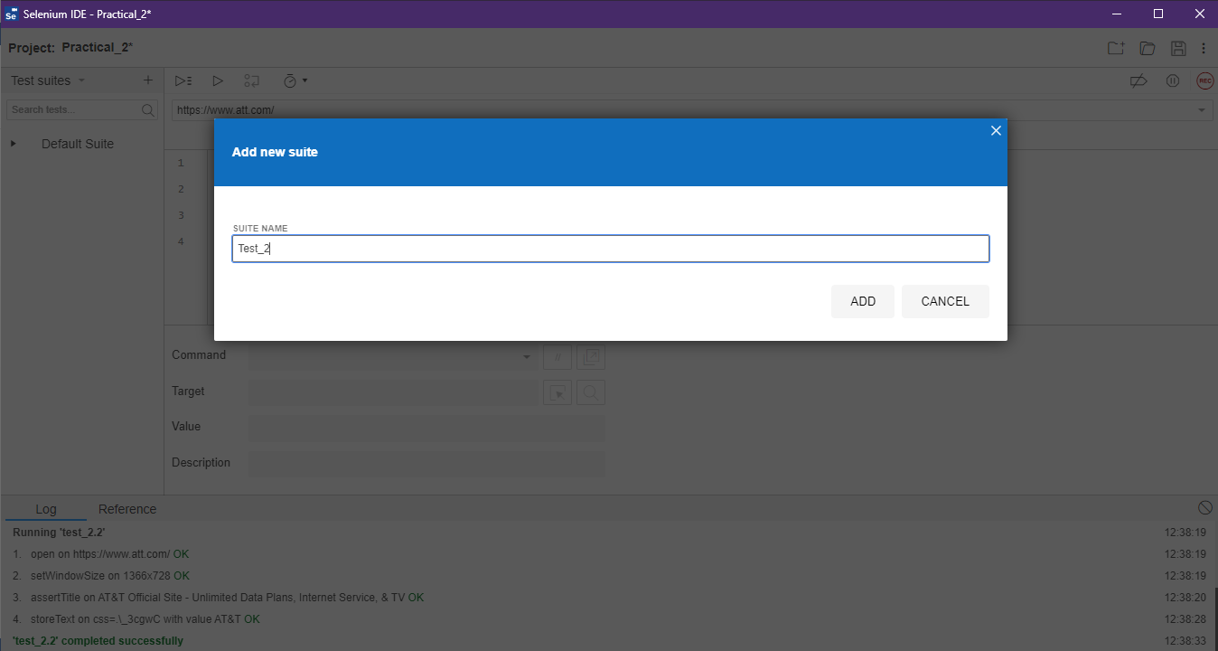

**Step 9:**

Click on Menu Option of Test_2 and click on Add tests.

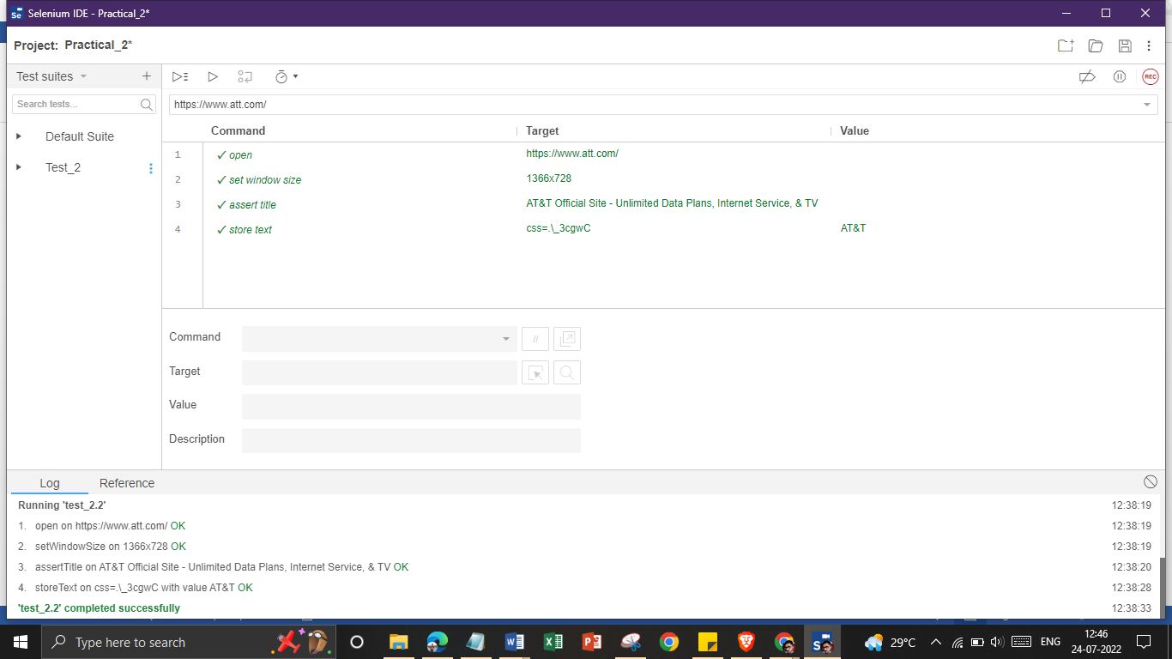

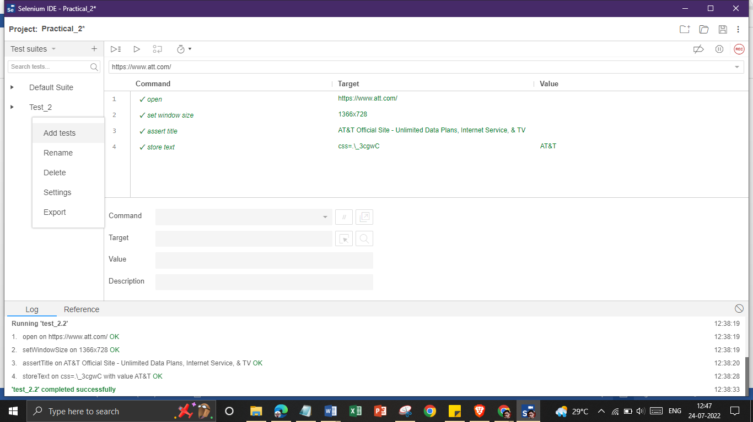

**Step 10:**

Select the below mentioned tests and click on “SELECT”.

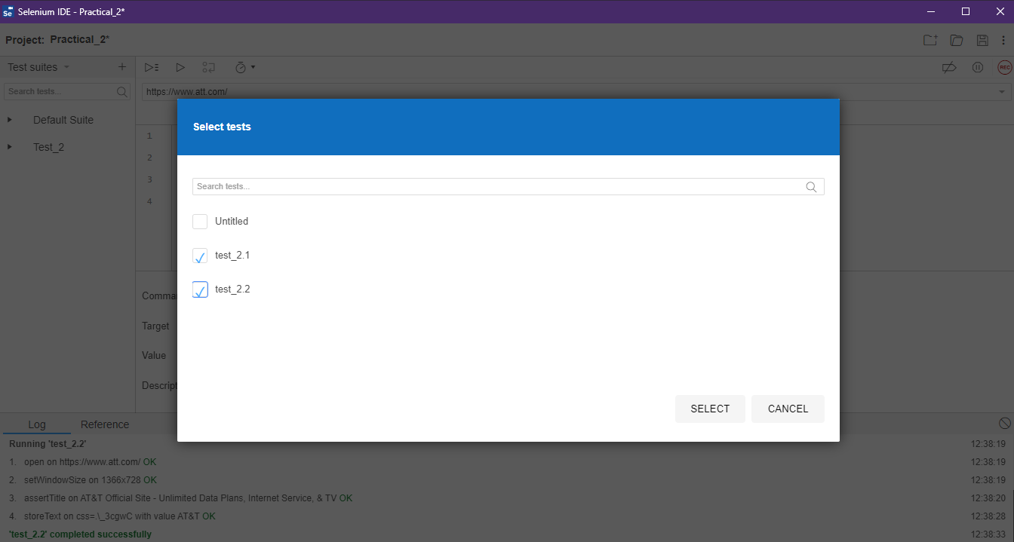

**Step 11:**

Select test_2.1 from Test_2 and Click on “Run All Tests”.

