**PRACTICAL 3**

**AIM:** Install Selenium server and demonstrate it using a script in Java/PHP.

**Installation of Selenium RC & Eclipse:**

**Step 1:**

Go to URL <https://www.eclipse.org/downloads/> and download Eclipse IDE 2022-06.

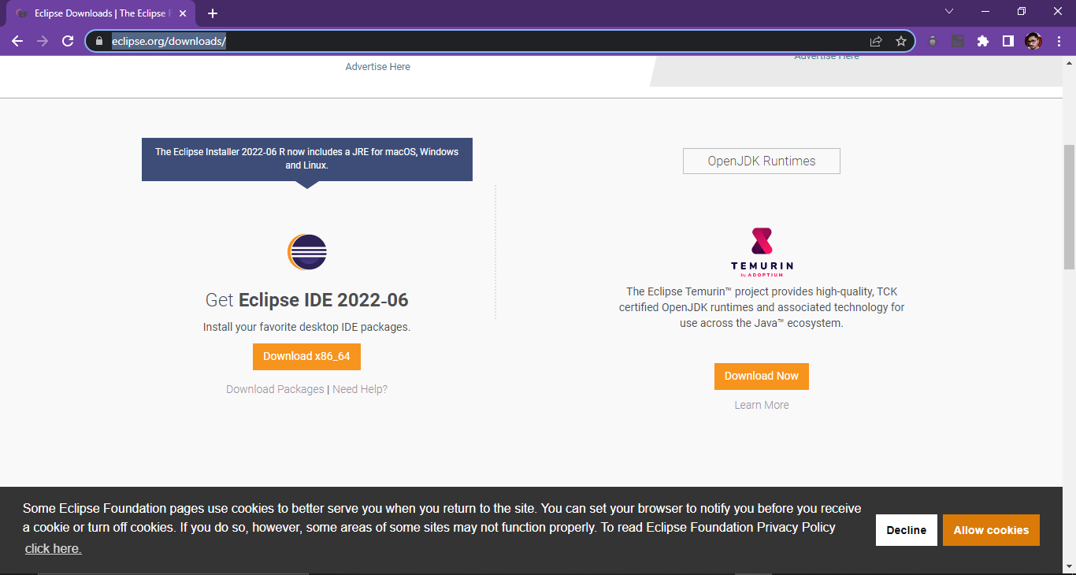

**Step 2:**

Once Downloaded, move it to your preffered drive (C:, D:, etc), and install it.

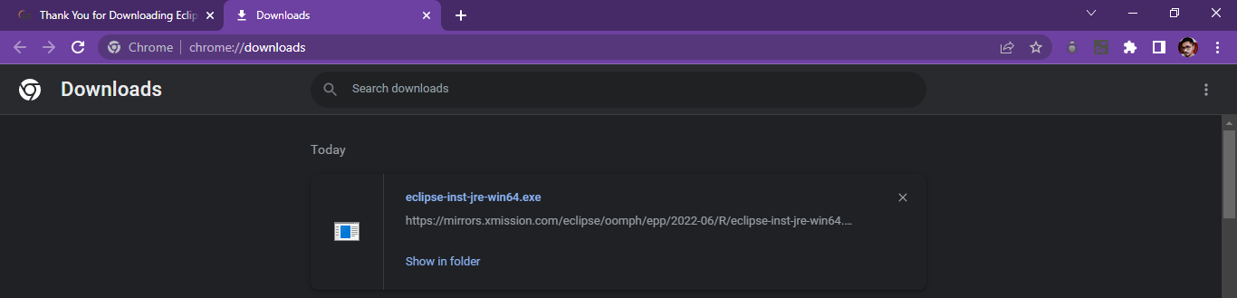

**Step 3:**

Create one more folder “Eclipse-Workspace”

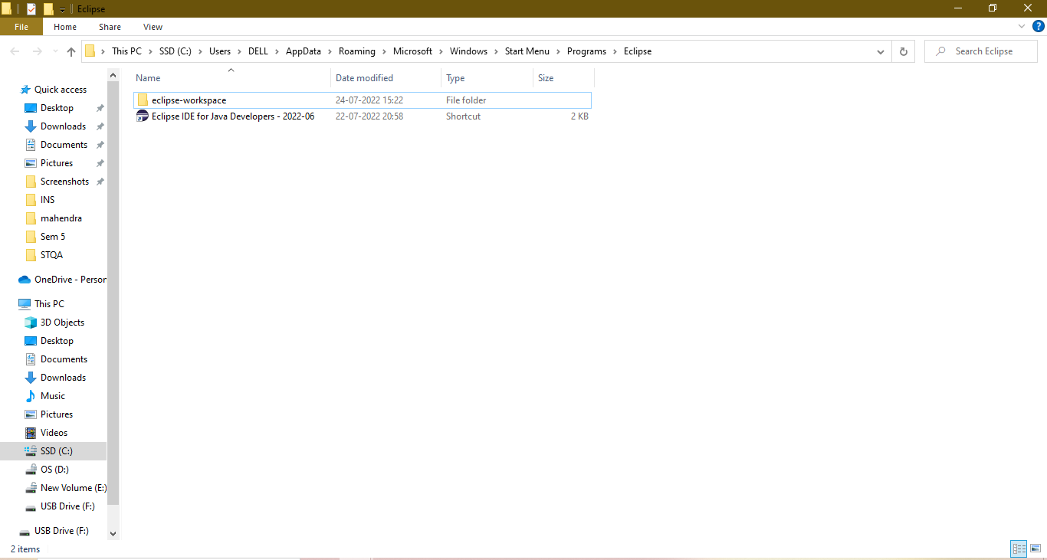

Eclipse Installation Done

**Programming Part:**

**Step 1:**

Click on Desktop Shortcut of Eclipse and select the Workspace Directory. After that Click on Launch

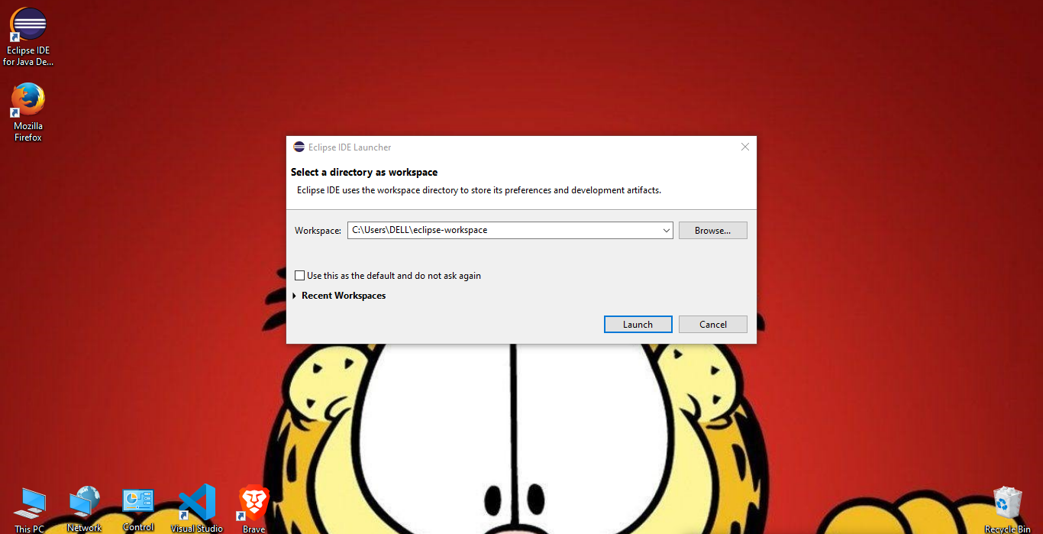

**Step 2:**

Click on File 🡪 New 🡪 Java Project

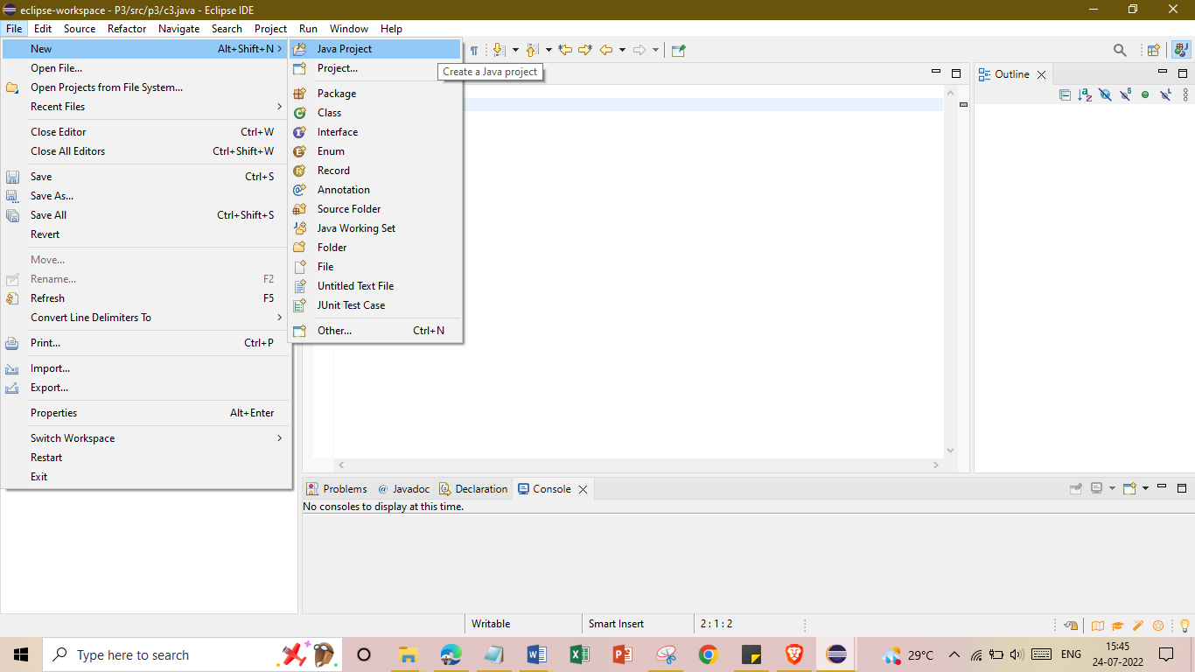

**Step 3:**

Name the project as given below and click on “Finish”.

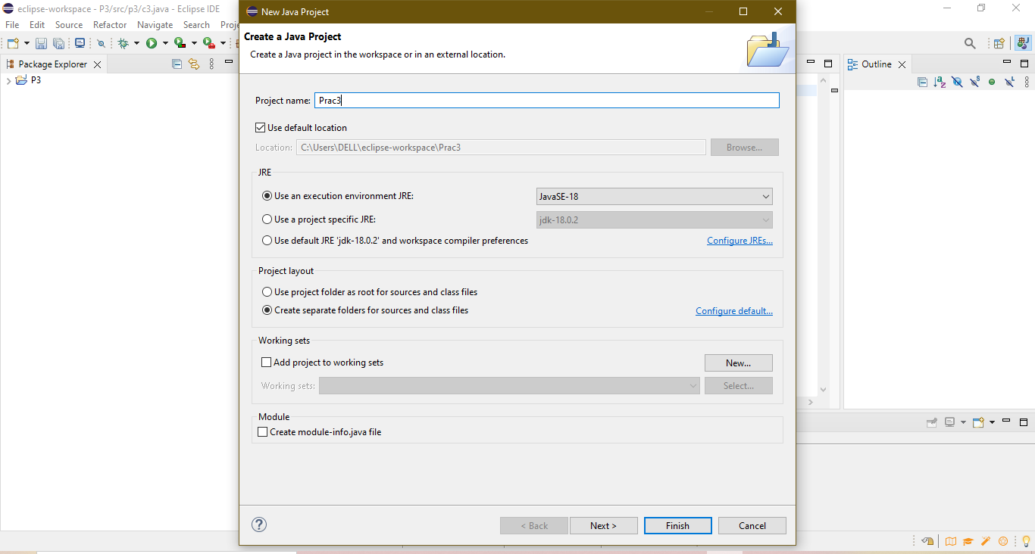

**Step 4:**

Right Click on the Project Name, then New🡪Package. Name the Package as p3 and click on “Finish”.

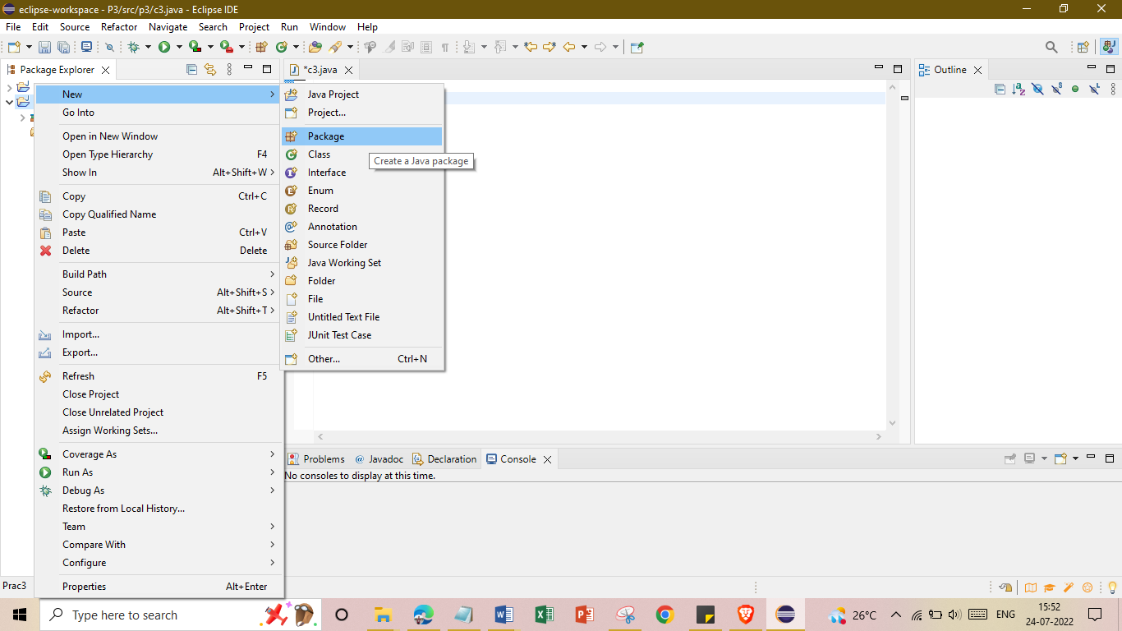

**Step 5:**

Again Right Click on Project Name, New🡪Class

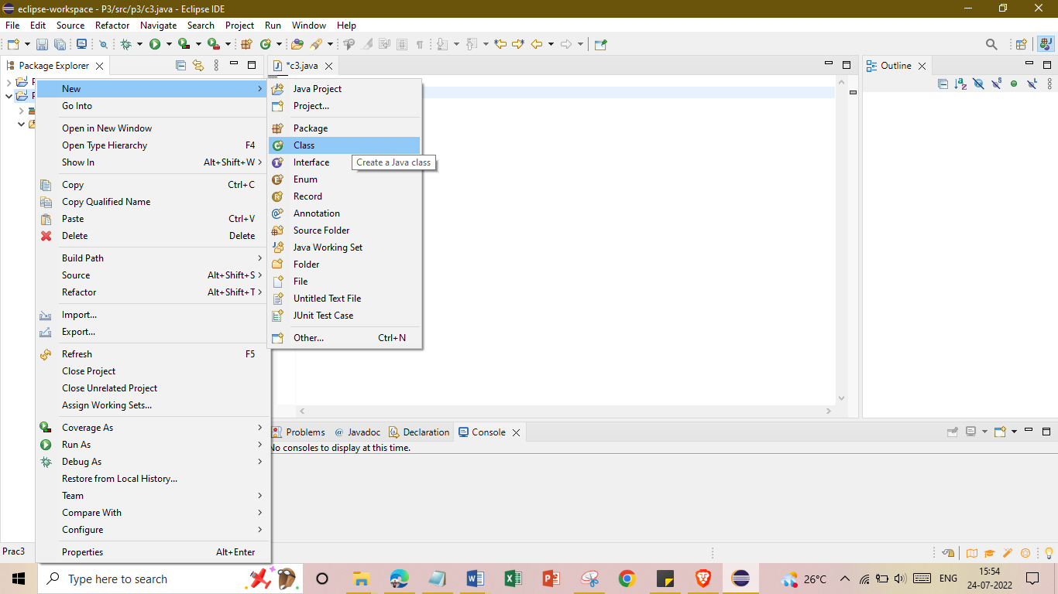

**Step 6:**

Name the class as c3 and check the checkbox of “public static void main(String[]args). After that click on “Finish”.

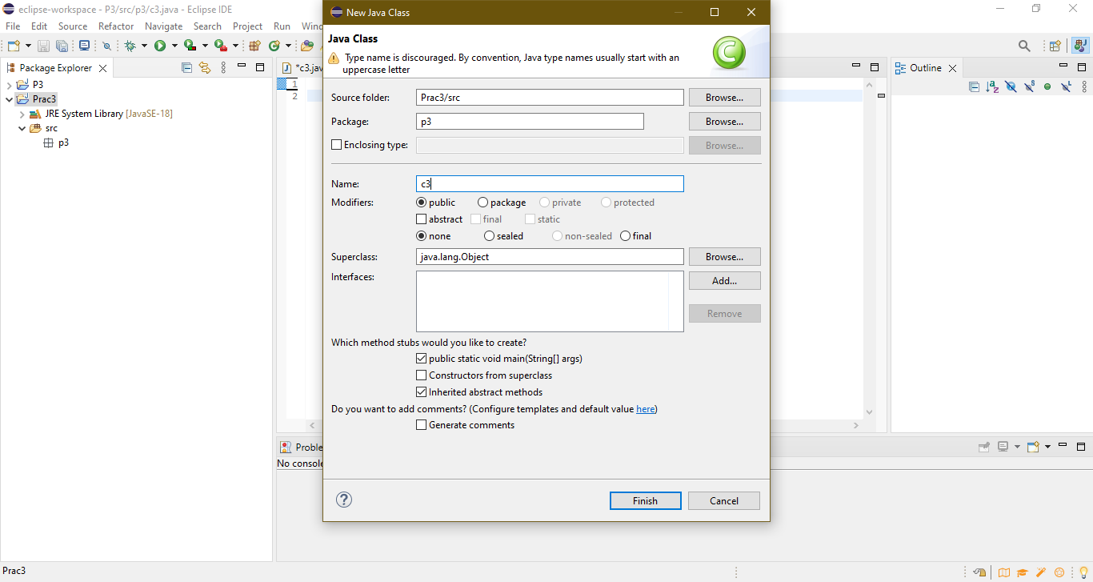

**Step 7:**

Right Click on Project Name, Build Path🡪Add External Archives

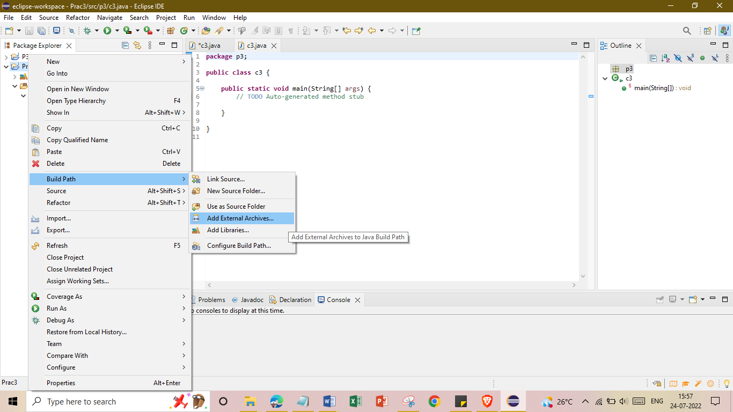

**Step 8:**

Select the Below Mentioned Files and Click on Open

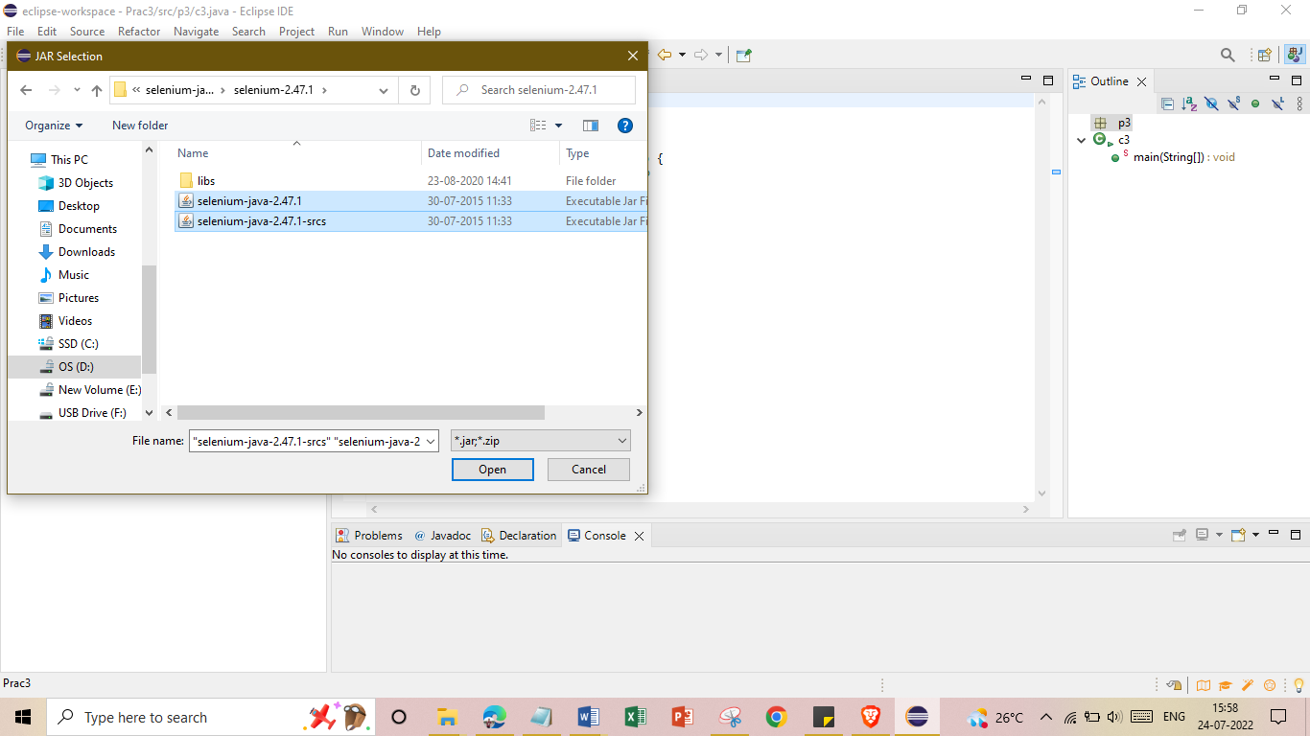

Also select all files inside the libs folder.

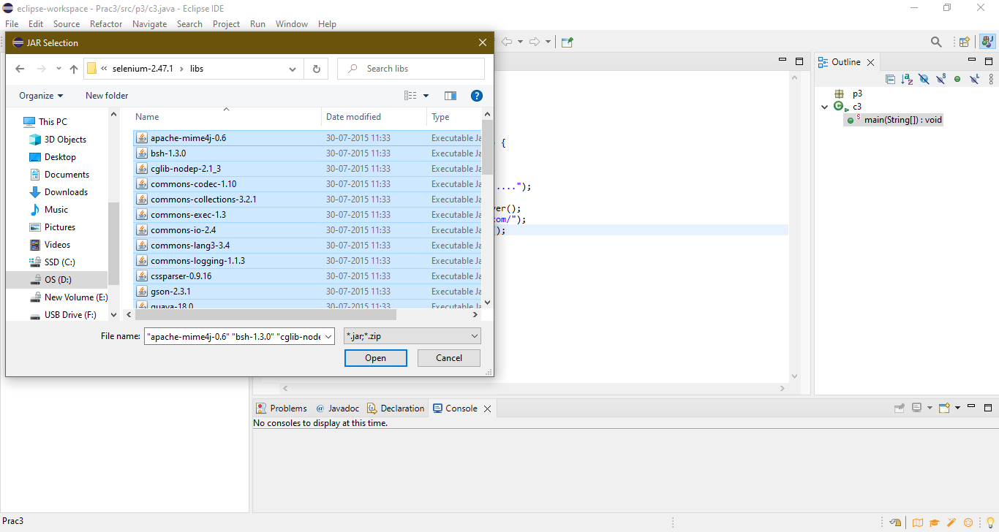

**Step 9:**

Type the Below Mentioned Code

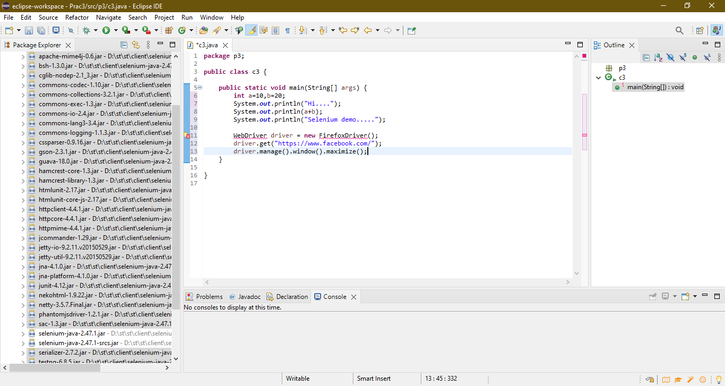

**Step 10:**

To remove the error indicating lines at WebDriver, hover over it and click on the “Import ‘WebDriver’ (org.openqa.selenium)”.

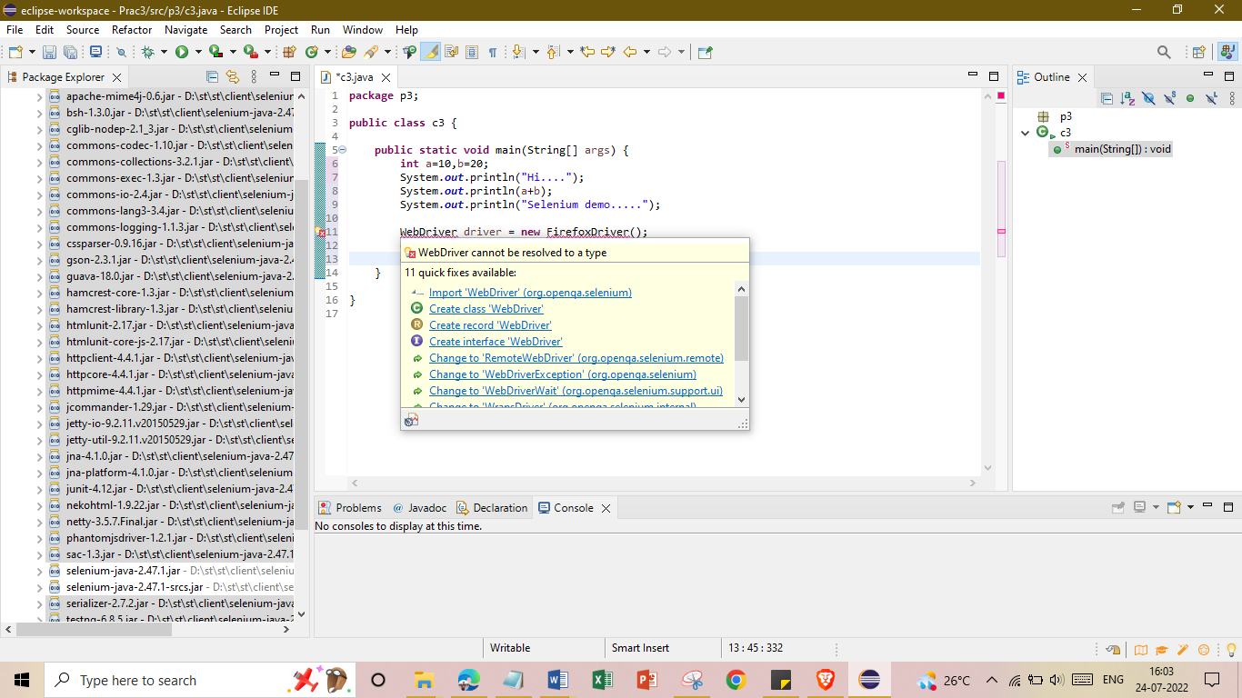

**Step 11:**

Follow Similar step for FirefoxDriver()

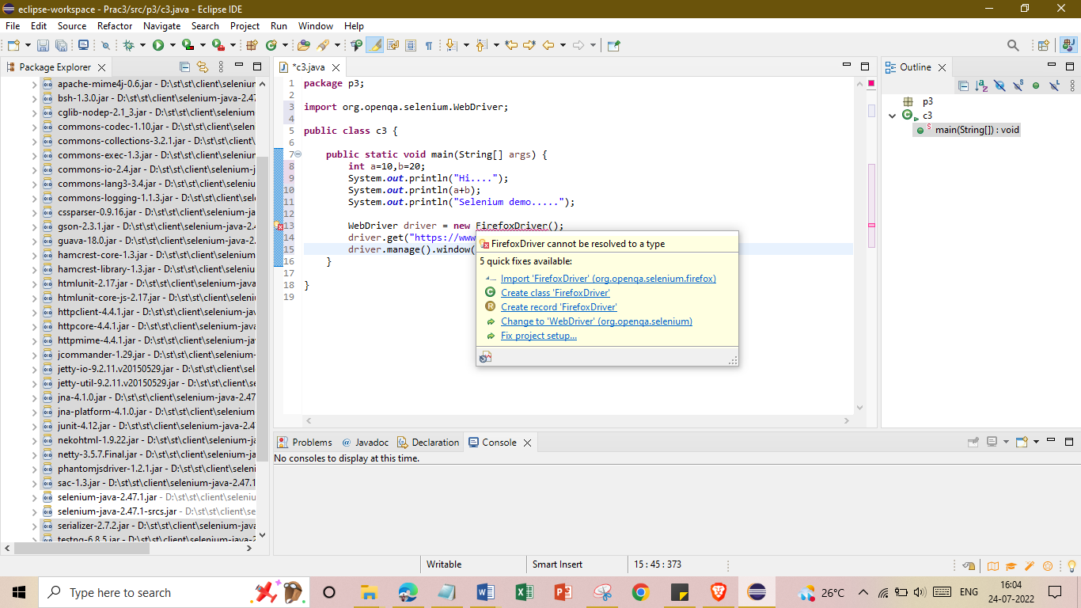

**Step 12:**

After Fixing the error indicating lines, save the code and click on “Run”. The Following Output will be generated.

