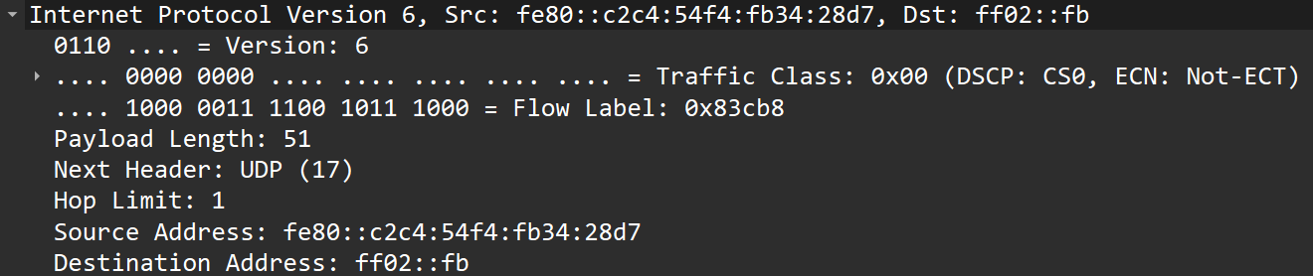

We know for a fact that the ipV6 has 40 bytes of fixed field and has 8 fields in total.
Discussion of each header field by analyzing a packet traced in the Wireshark :-
1) Version(4-bits)
→ It represent which version of ip is this. Since, the value is 0110 or 6 which represent it is a ipV6.
2) Traffic Class(8-bit)
→ he Traffic Class field indicates class or priority of IPv6 packet which is similar to Service Field in IPv4 packet. It helps routers to handle the traffic based on the priority of the packet. It is also similar in IPv4 as well as it comprises of DSCP and ECN and it uses DSCP of value cs0 of 6 bit and no use of EC which is 2 bit
3) Flow Label (20-bits)
→ Flow Label field is used by a source to label the packets belonging to the same flow in order to request special handling by intermediate IPv6 routers. It is 20 bytes of data which is used to distinguish the flow. It has value 83cb8
4) Payload length(16 bit)
→ It is a 16-bit (unsigned integer) field, indicates the total size of the payload which tells routers about the amount of information a particular packet contains in its payload. The payload Length field includes extension headers(if any) and an upper-layer packet. Since, the payload is 51 which means that the total length of the data payload (the portion of the packet following the IPv6 header) is 51 bytes. This does not include the length of the IPv6 header itself.
Total Packet Size=IPv6 Header Size+Payload Length=40 bytes+51 bytes=91 bytes

