📄 AWS CloudTrail Security Monitoring

Incident Investigation Report

Prepared By: Vikas Singh

Project: AWS CloudTrail Security Monitoring Lab

Date: 14 July 2026

Executive Summary

This report documents the investigation of unauthorized AWS management actions performed by a restricted IAM user in a controlled lab environment.

AWS CloudTrail was configured to monitor management events across the AWS account. A restricted IAM user was intentionally used to simulate unauthorized actions, including Amazon S3 bucket creation and AWS CloudShell access.

Both actions were successfully detected and recorded by AWS CloudTrail. The investigation confirmed that IAM least-privilege controls prevented resource creation and no security impact occurred.

Environment

Component | Value
Cloud Provider | AWS
Service | CloudTrail
Region | ap-south-1
IAM User | vikas-singh-21
Log Storage | Amazon S3

Attack Scenario

A restricted IAM user attempted to perform AWS management actions without the required IAM permissions.
The objective was to validate CloudTrail monitoring capabilities and verify that unauthorized API calls could be detected and investigated.

Timeline

Time | Event
10:12 | CreateBucket Attempt
10:12 | AccessDenied
10:13 | CreateEnvironment Attempt
10:13 | AccessDenied
10:14 | CloudTrail Investigation

Evidence

Unauthorized Amazon S3 Bucket Creation

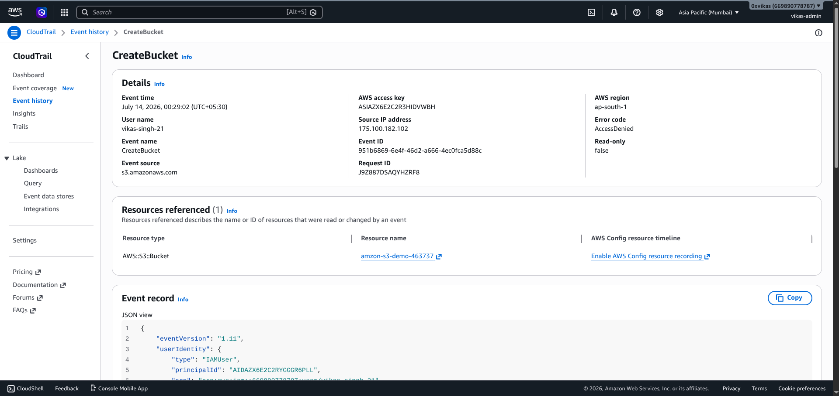

Unauthorized AWS CloudShell Access

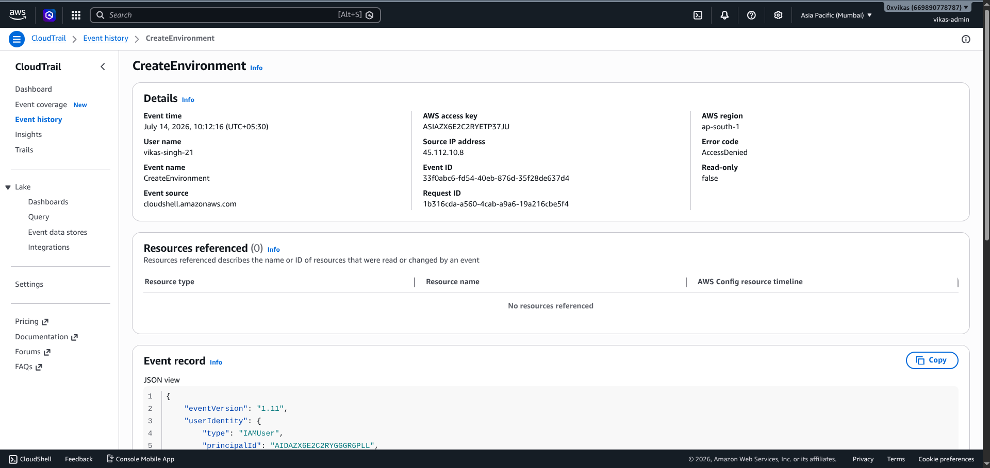

Findings

Finding 1

Restricted IAM user attempted to create an Amazon S3 bucket.

Result: AccessDenied

Status: Blocked

Finding 2

Restricted IAM user attempted to launch AWS CloudShell.

Result: AccessDenied

Status: Blocked

Security Analysis

AWS IAM Least Privilege controls successfully prevented both unauthorized management actions.

CloudTrail captured complete event details including:

- Event Name
- Event Time
- User Identity
- Source IP Address
- AWS Region
- Error Code
- Event Source

These logs provide sufficient evidence for incident investigation and auditing.

Recommendations

- Apply IAM Least Privilege across all users.
- Enable Multi-Factor Authentication (MFA).
- Continuously monitor CloudTrail Event History.
- Generate alerts for repeated AccessDenied events.
- Regularly review IAM policies and permissions.

Conclusion

The lab successfully demonstrated how AWS CloudTrail can detect and record unauthorized management activities.

Both simulated attacks were blocked by IAM permissions while CloudTrail provided detailed logs for investigation. This validates CloudTrail as an effective service for cloud security monitoring and incident response.

