PSEUDO CODE

BEGIN

INPUT a,b,c

DTB = (a + b + c) / 3

DISPLAY DTB

END

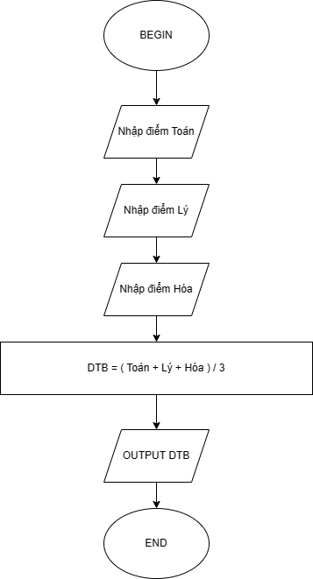FLOWCHART