PSEUDO-CODE

BEGIN

INPUT a,b,c

MAX = a

IF (a>b>c)

DISPLAY Max

ELSE

IF (b>a>c)

MAX = b

DISPLAY MAX

ELSE

IF(c>b>a)

MAX = c

DISPLAY MAX

ELSE

IF ( a=b=c)

MAX = a = b = c

DISPLAY MAX

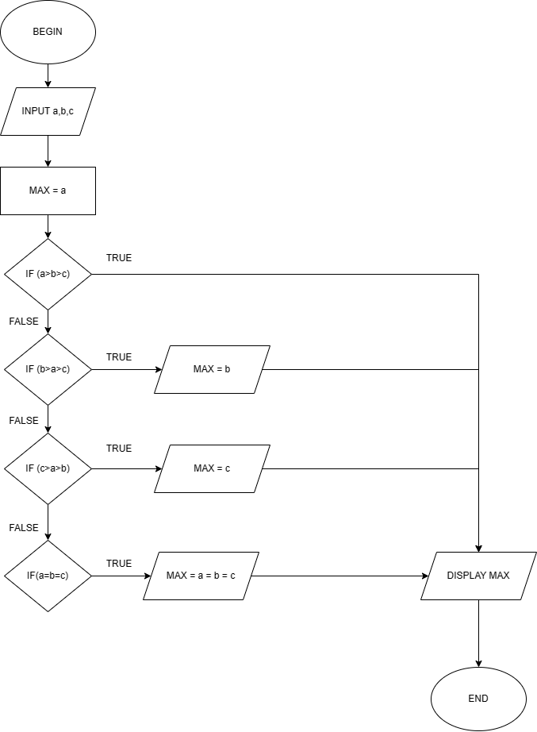FLOWCHART