|  |
| --- |
| Exp: 10 Date: 14/10/2023  **JAVA PROGRAMMING LAB 11** |

Name: VIJAI SURIA M

Reg No.: 2021503568

**UNCHECKED EXCEPTIONS:**

1. **Array Index Out of Bounds**

**CODE:**

|  |
| --- |
| import java.time.LocalDate;  import java.time.LocalTime;  import java.util.Scanner;  public class ArrayIndex3568 {  public static void main(String args[]){  System.out.println("Current Date: " + LocalDate.now());  System.out.println("Current Time: " + LocalTime.now());  System.out.println("Name: Vijai Suria M \nRegister Number: (2021503568)");  Scanner in = new Scanner(System.in);  System.out.print("Enter the array size: ");  int n = in.nextInt();  int []array = new int[n];  try {  System.out.print("Enter the any index to access: ");  int i = in.nextInt();  System.out.println("Array Element array["+i+"]: "+ array[i]);  }  catch(ArrayIndexOutOfBoundsException e){  System.out.println("Checked Runtime Exception: \n" + e);  }  catch(Exception e){  System.out.println("Other Exceptions: \n" + e);  }  }  } |

**OUTPUT:**

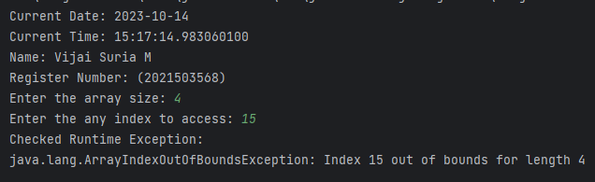

1. **Null Pointer Exception**

**CODE:**

|  |
| --- |
| package LAB11_1410;  import java.time.LocalDate; import java.time.LocalTime; import java.util.Scanner;  public class NullPointer3568 {  public static void main(String args[]){  System.*out*.println("Current Date: " + LocalDate.*now*());  System.*out*.println("Current Time: " + LocalTime.*now*());  System.*out*.println("Name: Vijai Suria M \nRegister Number: (2021503568)");  Scanner in = new Scanner(System.*in*);  int []array = null;   try {  System.*out*.print("Enter the any index to access: ");  int i = in.nextInt();  System.*out*.println("Array Element array["+i+"]: "+ array[i]);  }  catch(ArrayIndexOutOfBoundsException e){  System.*out*.println("Unchecked Runtime Exception: \n" + e);  }  catch(Exception e){  System.*out*.println("Other Exceptions: \n" + e);  }  } } |

**OUTPUT**:

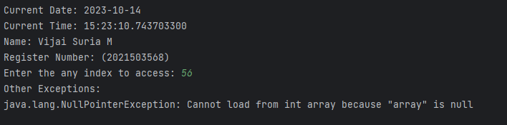

1. **Arithment Exception**

**CODE:**

|  |
| --- |
| package LAB11_1410;  import java.time.LocalDate; import java.time.LocalTime; import java.util.Scanner;  public class Arithmetic3568 {  public static void main(String args[]){  System.*out*.println("Current Date: " + LocalDate.*now*());  System.*out*.println("Current Time: " + LocalTime.*now*());  System.*out*.println("Name: Vijai Suria M \nRegister Number: (2021503568)");   Scanner in = new Scanner(System.*in*);   try {  System.*out*.print("Enter the any number to divide the number 25: ");  int i = in.nextInt();  System.*out*.println(" 25 / "+i+" = "+ (25/i));  }  catch(ArithmeticException e){  System.*out*.println("Unchecked Runtime Exception: \n" + e);  }  catch(Exception e){  System.*out*.println("Other Exceptions: \n" + e);  }   } } |

**OUTPUT**:

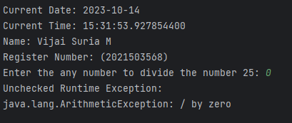

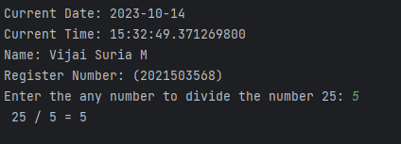

**Checked Exception:**

1. **File Not Found Exception**

**CODE:**

|  |
| --- |
| import java.io.*;  import java.util.*;  public class BufferStream {      public static void main(String[] args) throws IOException {          System.out.println("Current Date: " + LocalDate.now());          System.out.println("Current Time: " + LocalTime.now());          System.out.println("Name: Vijai Suria M \nRegister Number: (2021503568)");          try {              BufferedInputStream in = new BufferedInputStream(new FileInputStream("input.txt"));              BufferedOutputStream out = new BufferedOutputStream(new FileOutputStream("output.txt"));              int c;              while ((c = in.read()) != -1) {                  out.write(c);              }          } catch (IOException e) {              System.out.println("File Exception at \n" + e.getMessage());          }s      }  } |

**OUTPUT**:

**ERROR:**

1. **Stack Overflow Error:**

|  |
| --- |
| import java.time.LocalDate;  import java.time.LocalTime;  public class StackOverflow3568 {      public static void main(String[] args) {          System.out.println("Current Date: " + LocalDate.now());          System.out.println("Current Time: " + LocalTime.now());          System.out.println("Name: Vijai Suria M \nRegister Number: (2021503568)");          recursiveMethod(0);      }      public static void recursiveMethod(int depth) {          System.out.println("Depth: " + depth);          recursiveMethod(depth + 1);      }  } |

**OUTPUT:**

**OBJECT SERIALIZATION:**

1. **Object to File and vice versa**

**CODE:**

|  |
| --- |
| import java.io.*;  class Person implements Serializable {      public String name;      public int age;      public String address;      public String email;  }  public class Serialize3568 {      public static void main(String args[]) throws Exception {          System.out.println("Current Date: " + java.time.LocalDate.now());          System.out.println("Current Time: " + java.time.LocalTime.now());          System.out.println("Name: Vijai Suria M \nRegister Number: (2021503568)");          Person PL;          PL = new Person();          PL.name = "Java";          PL.age = 19;          PL.address = "Chennai, Tamil Nadu, India";          PL.email = "vijaisuriam@gmail.com";          // Serialization          String Filename = "File.txt";          FileOutputStream fo = new FileOutputStream(Filename);          ObjectOutputStream os = new ObjectOutputStream(fo);          os.writeObject(PL);          // DeSerialization          FileInputStream fi = new FileInputStream(Filename);          ObjectInputStream is = new ObjectInputStream(fi);          Person p = (Person) is.readObject();          System.out.println(p.name + " is " + p.age + " old living in " + p.address                  + " and you can mail at" + p.email);      }  } |

**OUTPUT:**

