|  |
| --- |
| Exp: 01 Date: 08/09/2023  JAVA PROGRAMMING LAB 2 |

Name: VIJAI SURIA M

REG NO. : 2021503568

1. Write the program and compile the code @ command line to execute

import java.time.LocalTime;

class HelloWorld3568 {

public static void main(String args[]) {

System.out.println(java.time.LocalDate.now());

System.out.println(LocalTime.now());

System.out.print("I am Vijai Suria M (2021503568), \n Hello, ");

System.out.print(args[0]);

System.out.println(" Good Morning!");

}

}

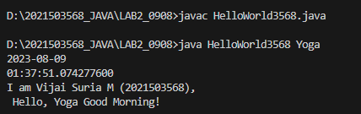

1. Write the program to print current date and time

import java.time.LocalTime;

public class Date3568 {

public static void main(String args[]) {

System.out.println("Current Date: " + java.time.LocalDate.now());

System.out.println("Current Time: " + LocalTime.now());

System.out.print("Name: Vijai Suria M \nRegister Number: (2021503568)");

}

}

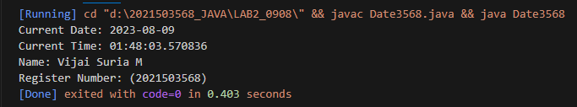

1. Find the maximum Compile time and Runtime error messages of simple one line output message.

Example

1. Delete any of the semicolons.

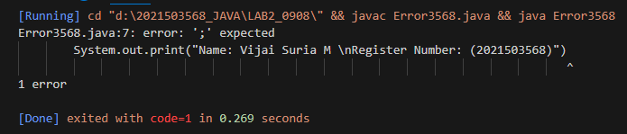

1. Misspell the word public, static, void, main

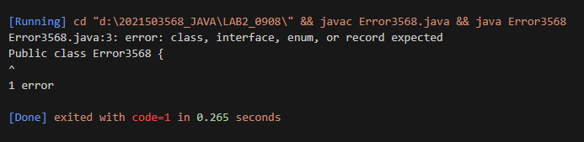

1. omit the word public, static, void, main, arg

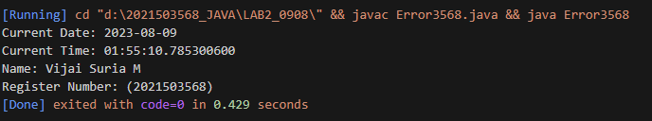

1. Remove the quotation marks around string

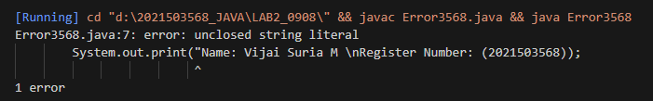

1. change the main method argument data type

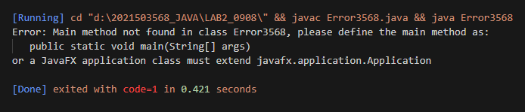

1. omit the argument

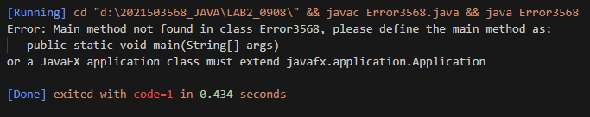

1. change the argument variable name

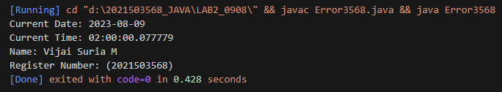

1. Remove the curly braces

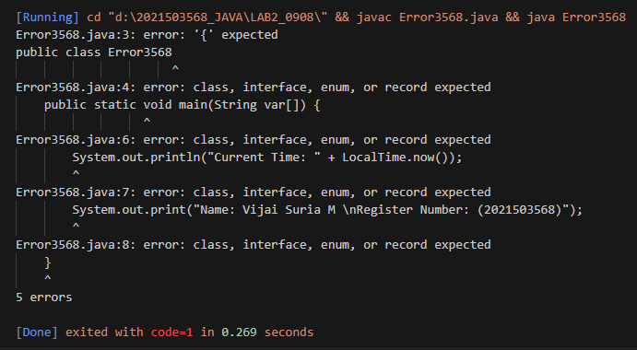

1. Copy the program and compile it. Find the error messages that the compiler finds out. Correct it out and repeat the process until the code runs.

import java.time.*;

import java.util.Scanner;

public class Bug3568 {

public static void main (String args[]) {

System.out.println("Current Date: " + java.time.LocalDate.now());

System.out.println("Current Time: " + LocalTime.now());

System.out.println("Name: Vijai Suria M \nRegister Number: (2021503568)");

String name;

Scanner in=new Scanner(System.in);

System.out.println("Hello. Please type your name: ");

name = in.next();

System.out.println("Hello "+name);

System.out.println ("Have a, nice day!");

in.close();

}

}

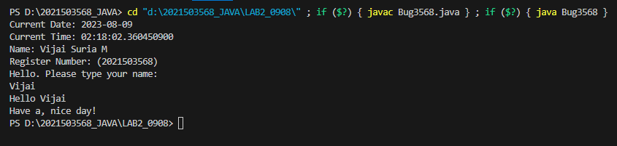

1. Data types

Write a program to learn the different Java data types and their correct / incorrect values

import java.time.*;

public class DataType3568 {

public static void main(String args[]) {

System.out.println("Current Date: " + LocalDate.now());

System.out.println("Current Time: " + LocalTime.now());

System.out.print("Name: Vijai Suria M \nRegister Number: (2021503568)");

byte byteValue1 = 127; // Correct

byte byteValue2 = 128; // Incorrect: Value exceeds the valid range (-128 to 127)

long longValue1 = 9223372036854775807; // Incorrect, require L at the end

long longValue2 = 9223372036854775807L; // Correct

long longValue3 = 9223372036854775807; // Incorrect, require L at the end

long longValue4 = 9223372036854775808L; // Incorrect: Value exceeds the valid range

// Floating-point data types

float floatValue1 = 3.14f; // Correct

float floatValue2 = 3.14; // Incorrect: Floating-point literals need 'f' or 'F' suffix

// Boolean data type

boolean booleanValue1 = true; // Correct

boolean booleanValue2= 0; // Incorrect: Use 'true' or 'false' for boolean values

}

}

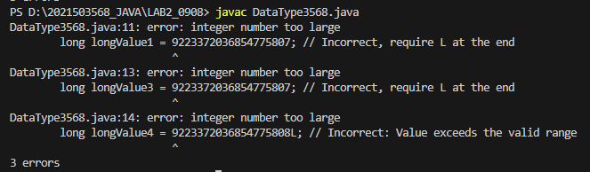

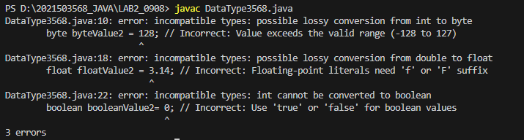

1. F2C Conversion

Write a program that takes as input Fahrenheit temperature. It converts the input temperature to Celsius and prints out the converted temperature as shown in the example. The formula for conversion between the two is: C=5/9(F−32), Where C is the temperature in Celsius and F is the temperature in Fahrenheit.

import java.math.RoundingMode;

import java.text.DecimalFormat;

import java.time.*;

import java.util.Scanner;

public class F2C3568 {

public static void main(String args[]) {

Scanner in = new Scanner(System.in);

float f, c;

System.out.println("Current Date: " + LocalDate.now());

System.out.println("Current Time: " + LocalTime.now());

System.out.print("Name: Vijai Suria M \nRegister Number: (2021503568)");

System.out.println("\n Enter your choice \n 1) Fahrenheit to Celsius \n 2) Celsius to Fahrenheit ");

int choice = in.nextInt();

DecimalFormat decimalFormat = new DecimalFormat("0.00");

switch (choice) {

case 1:

System.out.print("Temperature in Fahrenheit: ");

f = in.nextFloat();

c = (f - 32) * 5 / 9;

System.out.println("Equivalent Temperature in Celsius: " + decimalFormat.format(c));

decimalFormat.setRoundingMode(RoundingMode.DOWN);

break;

case 2:

System.out.print("Temperature in Celsius: ");

c = in.nextFloat();

f = (9 * c / 5) + 32;

System.out.println("Equivalent Temperature in Fahrenheit: "+

decimalFormat.format(f));

decimalFormat.setRoundingMode(RoundingMode.DOWN);

break;

default:

System.out.println("\n Please, Enter the valid choice......");

}

in.close();

}

}

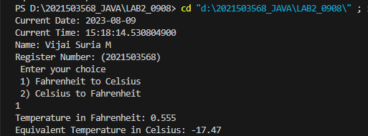

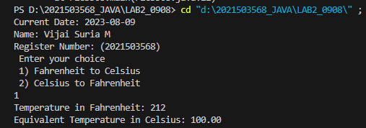

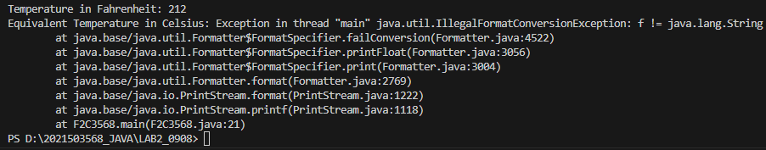

1. Final Velocity

Write a program that accepts the three numbers u, a, and t as input. Here, u denotes the starting speed, a the acceleration, and t the amount of time. The program outputs the displacement covered (d) in time (t). The program prints the final velocity (v). v=u+at. Since velocity and acceleration are continuous vectors (in physics), u and a can have any real value. Only non-negative real values, or 0 t, can be assigned to time t, i.e., 0 ≤ t. Note: round your answer to up to two decimal places.

import java.time.LocalTime;

import java.util.Scanner;

public class FinalVelocity3568 {

public static void main(String args[]) {

Scanner in = new Scanner(System.in);

System.out.println("Current Date: " + java.time.LocalDate.now());

System.out.println("Current Time: " + LocalTime.now());

System.out.println("Name: Vijai Suria M \nRegister Number: (2021503568)");

System.out.print("Enter the Starting Speed u=");

double u = in.nextDouble();

System.out.print("Enter the Acceleration a=");

double a = in.nextDouble();

System.out.print("Enter the Time t=");

double t = in.nextDouble();

while(t<0){

System.out.print("(Invalid Time Value, Enter the Time t=");

t = in.nextDouble();

}

double v = u + a*t;

System.out.println("Value of Velocity v=" + v);

in.close();

}

}

