|  |
| --- |
| Exp: 03 Date: 14/08/2023  JAVA PROGRAMMING LAB 3 |

Name: VIJAI SURIA M

Reg No. : 2021503568

1. Hello world:

|  |
| --- |
| import java.time.LocalDate;  import java.time.LocalTime;  public class Hello3568 {  public static void main(String[] args) {  System.out.println("Current Date: " + LocalDate.now());  System.out.println("Current Time: " + LocalTime.now());  System.out.println("Name: Vijai Suria M \nRegister Number: (2021503568)");  System.out.println("Hello, World.");  System.out.println("Hello, Java.");  }  } |

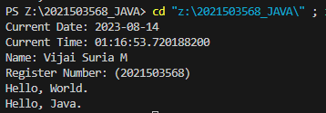

1. Number

|  |
| --- |
| import java.time.LocalDate;  import java.time.LocalTime;  public class Hello3568 {  public static void main(String[] args) {  System.out.println("Current Date: " + LocalDate.now());  System.out.println("Current Time: " + LocalTime.now());  System.out.println("Name: Vijai Suria M \nRegister Number: (2021503568)");  System.out.println("Hello, World.");  System.out.println("Hello, Java.");  }  } |

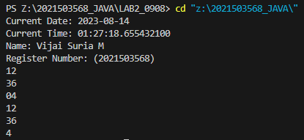

1. Given an integer, perform the following conditional actions:

* If is odd, print Weird
* If is even and in the inclusive range of to , print Not Weird
* If is even and in the inclusive range of to , print Weird
* If is even and greater than , print Not Weird

|  |
| --- |
| import java.time.LocalDate;  import java.time.LocalTime;  import java.util.Scanner;  public class Ifelse3568 {  public static void main(String[] args) {  System.out.println("Current Date: " + LocalDate.now());  System.out.println("Current Time: " + LocalTime.now());  System.out.println("Name: Vijai Suria M \nRegister Number: (2021503568)");  Scanner in = new Scanner(System.in);  int N = in.nextInt();  if(N%2==1){  System.out.println("Weird");  }  else if((N>=2 && N<=5) || (N>20)){  System.out.println("Not Weird");  }  else{  System.out.println("Weird");  }  in.close();  }  } |

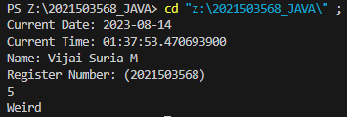

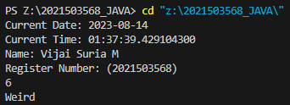

1. Data types

|  |
| --- |
| import java.time.LocalDate;  import java.time.LocalTime;  import java.util.Scanner;  public class dataType3568 {  public static void main(String[] args) {  System.out.println("Current Date: " + LocalDate.now());  System.out.println("Current Time: " + LocalTime.now());  System.out.println("Name: Vijai Suria M \nRegister Number: (2021503568)");  Scanner in = new Scanner(System.in);  int N = in.nextInt();  for(int i=1;i<11;i++){  System.out.println(N + " x " + i + " = " + (N*i));  }  in.close();  }  } |

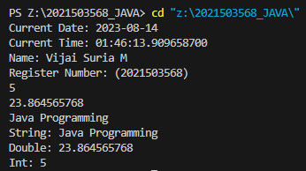

1. Data Formatting:

|  |
| --- |
| import java.time.LocalDate;  import java.time.LocalTime;  import java.util.Scanner;  public class DataFormat3568 {  public static void main(String[] args) {  System.out.println("Current Date: " + LocalDate.now());  System.out.println("Current Time: " + LocalTime.now());  System.out.println("Name: Vijai Suria M \nRegister Number: (2021503568)");  Scanner sc=new Scanner(System.in);  System.out.println("================================");  for(int i=0;i<3;i++)  {  String s1=sc.next();  int x=sc.nextInt();  System.out.printf("%-15s%03d \n", s1, x);  }  System.out.println("================================");  sc.close();  }  } |

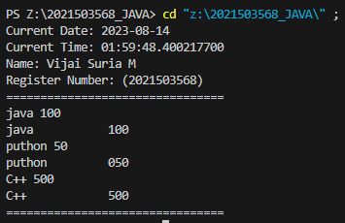

1. Multiplication table (Loops 1)

|  |
| --- |
| import java.time.LocalDate;  import java.time.LocalTime;  import java.util.Scanner;  public class MultiplicationTab3568 {  public static void main(String[] args) {  System.out.println("Current Date: " + LocalDate.now());  System.out.println("Current Time: " + LocalTime.now());  System.out.println("Name: Vijai Suria M \nRegister Number: (2021503568)");  Scanner in = new Scanner(System.in);  int i = in.nextInt();  double d = in.nextDouble();  String s = in.next();  s += in.nextLine();  System.out.println("String: " + s);  System.out.println("Double: " + d);  System.out.println("Int: " + i);  in.close();  }  } |

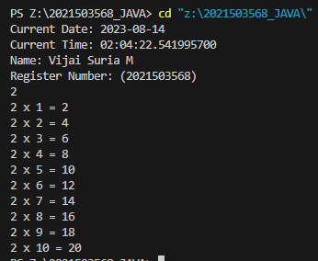

1. Loop 2

|  |
| --- |
| import java.time.LocalDate;  import java.time.LocalTime;  import java.util.Scanner;  public class Loop2_3568 {  public static void main(String[] args) {  System.out.println("Current Date: " + LocalDate.now());  System.out.println("Current Time: " + LocalTime.now());  System.out.println("Name: Vijai Suria M \nRegister Number: (2021503568)");  Scanner in = new Scanner(System.in);  int t=in.nextInt();  for(int i=0;i<t;i++){  int a = in.nextInt();  int b = in.nextInt();  int n = in.nextInt();  int prev=a;  for(int j=0;j<n;j++){  int curr=prev+(int)(Math.pow(2,j)*b);  System.out.print(curr+ " ");  prev=curr;  }  System.out.println();  }  in.close();  }  } |

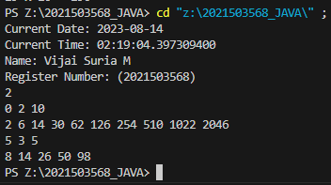

1. Data types

|  |
| --- |
| import java.time.LocalDate;  import java.time.LocalTime;  import java.util.Scanner;  public class dataType3568 {  public static void main(String[] args) {  System.out.println("Current Date: " + LocalDate.now());  System.out.println("Current Time: " + LocalTime.now());  System.out.println("Name: Vijai Suria M \nRegister Number: (2021503568)");  Scanner sc = new Scanner(System.in);  int t=sc.nextInt();  for(int i=0;i<t;i++)  {  long x=sc.nextLong();  System.out.println(x+" can be fitted in:");  if(x>=-128 && x<=127) System.out.println("* byte");  if(x>= -32768 && x<=32767) System.out.println("* short");  if(x>= -2147483648 && x<=2147483647) System.out.println("* int");  if(x>= -9223372036854775808l && x<=9223372036854775807l) System.out.println("* long");  }  sc.close();  }  } |

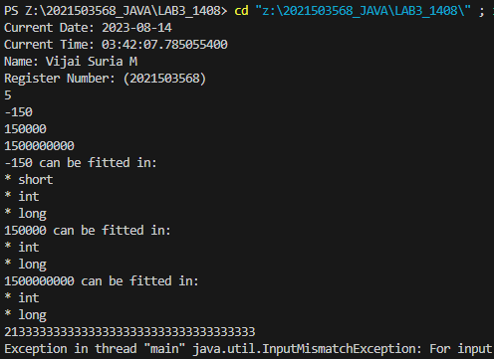

1. End of the File:

|  |
| --- |
| import java.time.LocalDate;  import java.time.LocalTime;  import java.util.Scanner;  public class EOF3568 {  public static void main(String[] args){  System.out.println("Current Date: " + LocalDate.now());  System.out.println("Current Time: " + LocalTime.now());  System.out.println("Name: Vijai Suria M \nRegister Number: (2021503568)");  Scanner scan = new Scanner(System.in);  int count=0;  while(scan.hasNext())  {  String s = scan.nextLine();  count++;  System.out.println(count+" "+s);  }  scan.close();  }  } |

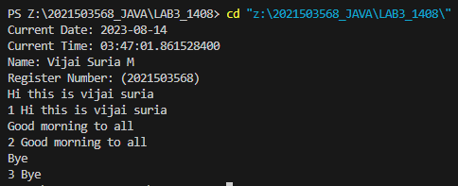

1. Integer to String conversion:

|  |
| --- |
| import java.time.LocalDate;  import java.time.LocalTime;  import java.util.Scanner;  public class InttoStr3568 {  public static void main(String[] args) {  System.out.println("Current Date: " + LocalDate.now());  System.out.println("Current Time: " + LocalTime.now());  System.out.println("Name: Vijai Suria M \nRegister Number: (2021503568)");  Scanner in = new Scanner(System.in);  int n = in .nextInt();  in.close();  String s= Integer.toString(n);  if (n == Integer.parseInt(s)) {  System.out.println("Good job");  } else {  System.out.println("Wrong answer.");  }  }  } |

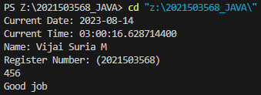

1. Find a Day

|  |
| --- |
| import java.time.LocalDate;  import java.time.LocalTime;  import java.util.Calendar;  import java.util.Scanner;  public class Day3568 {  static String[] days = {"Sunday","Monday","Tuesday","Wednesday","Thursday","Friday","Saturday"};  public static void main(String[] args) {  System.out.println("Current Date: " + LocalDate.now());  System.out.println("Current Time: " + LocalTime.now());  System.out.println("Name: Vijai Suria M \nRegister Number: (2021503568)");    Scanner in = new Scanner(System.in);  int year = in.nextInt();  int month = in.nextInt();  int day = in.nextInt();  Calendar calendar = Calendar.getInstance();  calendar.set(year, month - 1, day);  int dayOfWeek = calendar.get(Calendar.DAY_OF_WEEK);  System.out.println(days[dayOfWeek - 1].toString().toUpperCase());  in.close();  }  } |

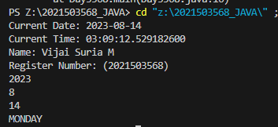

1. Currency conversion

|  |
| --- |
| import java.util.*;  import java.text.*;  public class Solution {    public static void main(String[] args) {  Scanner scanner = new Scanner(System.in);  double payment = scanner.nextDouble();  scanner.close();    NumberFormat us = NumberFormat.getCurrencyInstance(Locale.US);  NumberFormat india = NumberFormat.getCurrencyInstance(new Locale("en", "IN"));  NumberFormat china = NumberFormat.getCurrencyInstance(Locale.CHINA);  NumberFormat france = NumberFormat.getCurrencyInstance(Locale.FRANCE);  System.out.println("US: " + us.format(payment));  System.out.println("India: " + india.format(payment));  System.out.println("China: " + china.format(payment));  System.out.println("France: " + france.format(payment));  }  } |

