|  |
| --- |
| **JAVA PROGRAMMING**  **CS6308**  **DATE: 20-09-2023 NAME: VIJAI SURIA M**  **ASSIGN: 7 REG NO:2021503024** |

1. **Write a java program to perform string methods by considering the given string inputs**

String s1=”Welcome to Java”;

String s2=s1;

String s3=new String(“Welcome to Java”);

String s4=s1.intern();

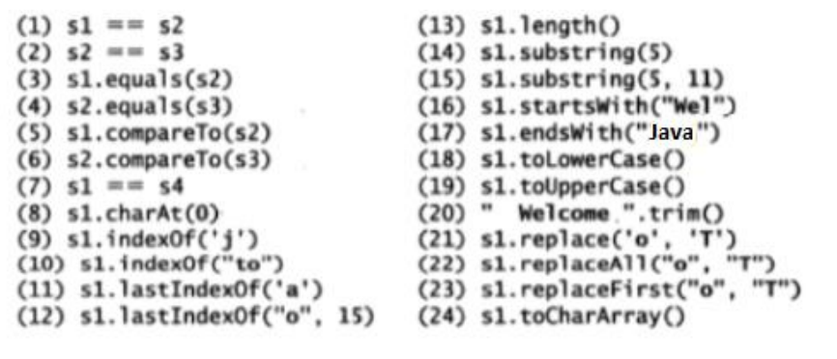

**CODE:**

|  |
| --- |
| import java.util.*;  import java.time.LocalDate;  import java.time.LocalTime;  public class String3568{      public static void main(String[] args){         System.out.println("Current Date: " + LocalDate.now());         System.out.println("Current Time: " + LocalTime.now());         System.out.println("Name: Vijai Suria M \nRegister Number: (2021503568)");         System.out.println("\n");         String s1 = "Welcome to java";         String s2 = s1;         String s3 = new String("Welcome to java");         String s4 = s1.intern();         if(s1 == s2)           System.out.println("1.String s1 and s2 are equal  checked using s1 == s2 ");         else  System.out.println("1.String s1 and s2 are not equal checked using s1 == s2");        if(s2 == s3)           System.out.println("2.String s2 and s3 are equal checked using s2 == s3");         else  System.out.println("2.String s2 and s3 are not equal checked using s2 == s3");          if(s1.equals(s2))           System.out.println("3.String s1 and s2 are equal checked using s1.equals(s2) ");         else  System.out.println("3.String s1 and s2 are not equal checked using s1.equals(s2) ");         if(s2.equals(s3))           System.out.println("4.String s2 and s3 are equal checked using s2.equals(s3)");         else  System.out.println("4.String s2 and s3 are not equal checked using s2.equals(s3) ");          if(s1.compareTo(s2) == 0)           System.out.println("5.String s1 and s2 are equal checked using s1.compareTo(s2) ");         else  System.out.println("5.String s1 and s2 are not equal checked using s1.compareTo(s2) ");         if(s2.compareTo(s3) == 0)           System.out.println("6.String s2 and s3 are equal checked using s2.compareTo(s3)");         else  System.out.println("6.String s2 and s3 are not equal checked using s2.compareTo(s3) ");           if(s1 == s4)           System.out.println("7.String s1 and s2 are equal  checked using s1 == s4 ");         else  System.out.println("7.String s1 and s2 are not equal checked using s1 == s4");         System.out.println("8. s1.charAt(0) : "+s1.charAt(0));         System.out.println("9. s1.indexOf('j') : "+s1.indexOf('j'));         System.out.println("10. s1.indexOf(\"to\") : "+s1.indexOf("to"));         System.out.println("11. s1.lastIndexOf('a') : "+s1.lastIndexOf('a'));         System.out.println("12. s1.lastIndexOf(\"o\",15) : "+s1.lastIndexOf('a'));         System.out.println("13. s1.length() : " + s1.length());         System.out.println("14. s1.substring(5) : " + s1.substring(5));         System.out.println("15. s1.substring(5,11) : " + s1.substring(5,11));         System.out.println("16. s1.startsWith(\"Wel\") : " + s1.startsWith("Wel"));         System.out.println("17. s1.endsWith(\"java\") : " + s1.startsWith("java"));          System.out.println("18.  s1.toLowerCase() : " +  s1.toLowerCase());          System.out.println("19.  s1.toUpperCase() : " +  s1.toUpperCase());          String s7 = " Welcome ";          System.out.println("20. "+ s7+".trim()"+  " : " +s7.trim());          System.out.println("21. s1.replace('o','T') : " + s1.replace('o','T') );          System.out.println("22. s1.replaceAll(\"o\",\"T\") : " + s1.replace("o","T") );          System.out.println("23. s1.replaceFirst(\"o\",\"T\") : " + s1.replaceFirst("o","T") );          System.out.println("24. s1.toCharArray() : " );          char ch[] = s1.toCharArray() ;          for(char c : ch)           System.out.print(c);      }  } |

**OUTPUT:**

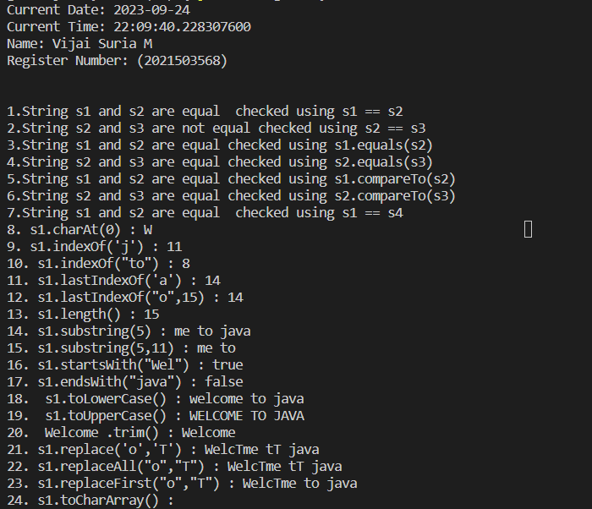

**EXCERCIE** 1.2: Write a program to show that String is immutable in java

**CODE:**

|  |
| --- |
| import java.time.LocalDate;  import java.time.LocalTime;  public class Immutable3568 {      public static void main(String[] args) {          System.out.println("Current Date: " + LocalDate.now());          System.out.println("Current Time: " + LocalTime.now());          System.out.println("Name: Vijai Suria M \nRegister Number: (2021503568)");          String originalString = "Hello, World!"; // Create an original string          // Attempt to modify the string          String modifiedString = originalString.concat(" Welcome to Java!");          // Check if the original string is modified          if (originalString == modifiedString) {              System.out.println("Original string is the same as the modified string.");          } else {              System.out.println("Original string is different from the modified string.");          }          // Print the original and modified strings          System.out.println("Original String: " + originalString);          System.out.println("Modified String: " + modifiedString);      }  } |

**OUTPUT:**

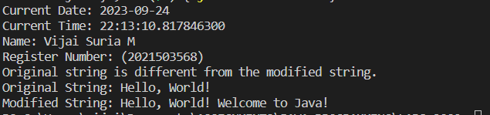

**REASON**:

We attempt to modify the string by concatenating " Welcome to Java!" to it using the **concat** method. However, instead of modifying the **originalString**, a new string is created, and **modifiedString** references the new string.

2. **Write a java program to read the string and displays the reverse of the string.**

Hint: swap first character with last character until half of the string length

**CODE:**

|  |
| --- |
| import java.time.LocalDate;  import java.time.LocalTime;  import java.util.Scanner;;  public class StringReverse3568 {  public static void main(String args[]){  System.out.println("Current Date: " + LocalDate.now());  System.out.println("Current Time: " + LocalTime.now());  System.out.println("Name: Vijai Suria M \nRegister Number: (2021503568)");  Scanner sc = new Scanner(System.in);  String s;  System.out.print("Enter a string: ");  s = sc.nextLine();  char[] charArray = s.toCharArray();  int length = charArray.length;  for (int i = 0; i < length / 2; i++) {  char temp = charArray[i];  charArray[i] = charArray[length - 1 - i];  charArray[length - 1 - i] = temp;  }  String reversedString = new String(charArray);  System.out.println("Reversed String: " + reversedString);  sc.close();  }  } |

**OUTPUT:**

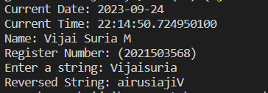

3. **Write a java program to count the number of occurrence of each letter in the given string.**

**CODE:**

|  |
| --- |
| import java.util.Scanner;  public class LettersCount3568 {      public static void main(String args[]){          //Write a java program to count the occurence of each letters in a string          System.out.println("Current Date: " + java.time.LocalDate.now());          System.out.println("Current Time: " + java.time.LocalTime.now());          System.out.println("Name: Vijai Suria M \nRegister Number: (2021503568)");          String s;          Scanner sc = new Scanner(System.in);          System.out.print("Enter a string: ");          s = sc.nextLine();          int[] count = new int[26];          for(int i = 0; i < s.length(); i++){              if(s.charAt(i) >= 'a' && s.charAt(i) <= 'z'){                  count[s.charAt(i) - 'a']++;              }          }          for(int i = 0; i < 26; i++){              if(count[i] != 0){                  System.out.println((char)(i + 'a') + " occurs " + count[i] + " times");              }          }          sc.close();      } } |

**OUTPUT:**

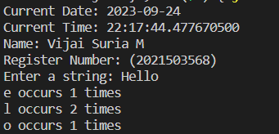

4. **Write a Java program to count the number of words in the given string**

**CODE:**

|  |
| --- |
| import java.util.Scanner;  public class WordsCount3568 {      public static void main(String args[]){          // Write a java program to count the number of words in a string          System.out.println("Current Date: " + java.time.LocalDate.now());          System.out.println("Current Time: " + java.time.LocalTime.now());          System.out.println("Name: Vijai Suria M \nRegister Number: (2021503568)");          String s;          Scanner sc = new Scanner(System.in);          System.out.print("Enter a string: ");          s = sc.nextLine();          int count = 1;          for(int i = 0; i < s.length(); i++){              if(s.charAt(i) == ' '){                  count++;              }          }          System.out.println("Number of words in the string: " + count);      }  } |

**OUTPUT:**

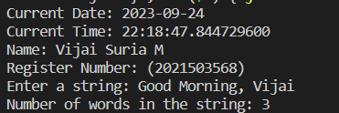

**5.**

**i) Write a java program to check the given string is palindrome or not (Example:Race car)**

**CODE:**

|  |
| --- |
| import java.time.LocalDate;  import java.time.LocalTime;  import java.util.Scanner;  public class Palindrome3568{      public static boolean isPalindrome(String s){          if(s.length() == 0 || s.length() == 1){              return true;          }          if(s.charAt(0) == s.charAt(s.length()-1)){              return isPalindrome(s.substring(1, s.length()-1));          }          return false;      }      public static void main(String[] args){          System.out.println("Current Date: " + LocalDate.now());          System.out.println("Current Time: " + LocalTime.now());          System.out.println("Name: Vijai Suria M \nRegister Number: (2021503568)");          Scanner sc = new Scanner(System.in);          String s;          System.out.print("Enter a string: ");          s = sc.nextLine();          System.out.println(isPalindrome(s));          sc.close();      }  } |

**OUTPUT:**

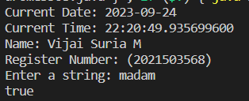

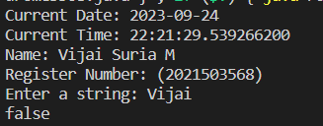

ii). **Write a java program to check the given string is anagram or not (Example Iceman vs Cinema)**

**CODE:**

|  |
| --- |
| import java.time.LocalDate;  import java.time.LocalTime;  import java.util.Scanner;  import java.util.Arrays;  public class Anagram3568 {      public static boolean areAnagrams(String str1, String str2) {          // Remove all whitespace and convert to lowercase          str1 = str1.replaceAll("\\s", "").toLowerCase();          str2 = str2.replaceAll("\\s", "").toLowerCase();          // Check if the lengths are different          if (str1.length() != str2.length()) {              return false;          }          // Convert the strings to char arrays and sort them          char[] charArray1 = str1.toCharArray();          char[] charArray2 = str2.toCharArray();          Arrays.sort(charArray1);          Arrays.sort(charArray2);          // Compare the sorted char arrays          return Arrays.equals(charArray1, charArray2);      }      public static void main(String args[]){          //Write a java program to check the given string is anagram or not          System.out.println("Current Date: " + LocalDate.now());          System.out.println("Current Time: " + LocalTime.now());          System.out.println("Name: Vijai Suria M \nRegister Number: (2021503568)");          Scanner sc = new Scanner(System.in);          String s1, s2;          System.out.print("Enter first string: ");          s1 = sc.nextLine();          System.out.print("Enter second string: ");          s2 = sc.nextLine();          if(areAnagrams(s1, s2)){              System.out.println("The given strings are anagrams");          }else{              System.out.println("The given strings are not anagrams");          }          sc.close();      }  } |

**OUTPUT:**

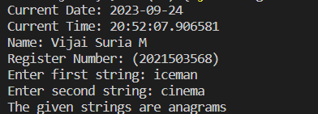

6. **Write a java program that read a two string of the given format and compares the string.**

Example:

15.10.10 is greater than 14.20.50 as 15 >14

14.12.10 is greater than 14.10.55 as 12>10

14.10.15 is greter than 14.10.11 as 15>11

Hint:GivenString.split(\\.)

**CODE:**

|  |
| --- |
| import java.util.Scanner;  public class StringCompare3568 {      public static void main(String[] args) {          Scanner scanner = new Scanner(System.in);          System.out.println("Enter the first string: ");          String str1 = scanner.nextLine();          System.out.println("Enter the second string: ");          String str2 = scanner.nextLine();          String[] parts1 = str1.split("\\.");          String[] parts2 = str2.split("\\.");          if (parts1.length != 3 || parts2.length != 3) {              System.out.println("Invalid input format. Please use dd.mm.ss format.");              return;          }          int day1 = Integer.parseInt(parts1[0]);          int month1 = Integer.parseInt(parts1[1]);          int second1 = Integer.parseInt(parts1[2]);          int day2 = Integer.parseInt(parts2[0]);          int month2 = Integer.parseInt(parts2[1]);          int second2 = Integer.parseInt(parts2[2]);          if (day1 > day2) {              System.out.println(str1 + " is greater than " + str2 + " as " + day1 + " > " + day2);          } else if (day1 < day2) {              System.out.println(str2 + " is greater than " + str1 + " as " + day2 + " > " + day1);          } else {              if (month1 > month2) {                  System.out.println(str1 + " is greater than " + str2 + " as " + month1 + " > " + month2);              } else if (month1 < month2) {                  System.out.println(str2 + " is greater than " + str1 + " as " + month2 + " > " + month1);              } else {                  if (second1 > second2) {                      System.out.println(str1 + " is greater than " + str2 + " as " + second1 + " > " + second2);                  } else if (second1 < second2) {                      System.out.println(str2 + " is greater than " + str1 + " as " + second2 + " > " + second1);                  } else {                      System.out.println(str1 + " is equal to " + str2);                  }              }          }          scanner.close();      }  } |

**OUTPUT:**

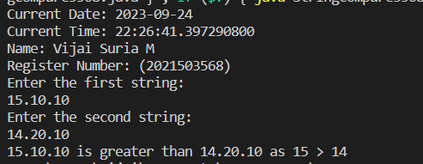

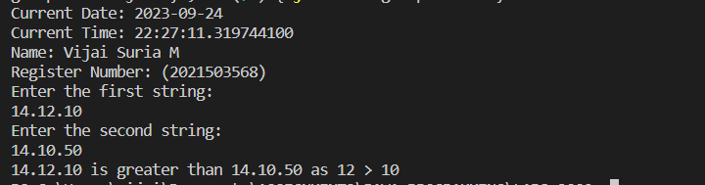

7. **Write a java program using String methods to compare the email is valid is invalid and returns the username and domain name**

i) Valid Username: numbers[0-7], alphabets[a-z][A-Z], underscore, dot, hypen and plus

characters

ii) Presence of @ symbol

iii) Presence of domainname.com or .in or .edu

Hint use givenstring.split(“@”) to find specific user(case-insensitive:jc_vp) and specific domain

(case-insensitive: gmail.com) for example jc_vp@gmail.com.

**CODE:**

|  |
| --- |
| import java.util.regex.Matcher;  import java.util.regex.Pattern;  import java.time.LocalDate;  import java.time.LocalTime;  import java.util.Scanner;  public class EmailValidator3568 {      public static void main(String[] args) {          System.out.println("Current Date: " + LocalDate.now());          System.out.println("Current Time: " + LocalTime.now());          System.out.println("Name: Vijai Suria M \nRegister Number: (2021503568)");          Scanner sc = new Scanner(System.in);          System.out.print("Enter an email address: ");          String email =sc.nextLine();          // Regular expression pattern for email validation          String emailPattern = "^[a-zA-Z0-9_+.-]+@[a-zA-Z0-9.-]+\\.(com|in|edu)$";          // Create a Pattern object          Pattern pattern = Pattern.compile(emailPattern);          // Match the input email against the pattern          Matcher matcher = pattern.matcher(email);          if (matcher.matches()) {              System.out.println("Email is valid");              // Split the email address using "@" symbol              String[] parts = email.split("@");              // Extract and print the username (case-insensitive)              String username = parts[0];              System.out.println("Username: " + username.toLowerCase());              // Extract and print the domain name (case-insensitive)              String domain = parts[1];              System.out.println("Domain: " + domain.toLowerCase());          } else {              System.out.println("Email is invalid");          }          sc.close();      }  } |

**OUTPUT:**

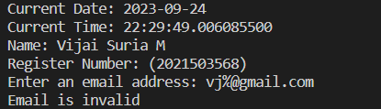

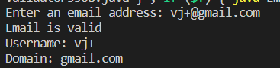

8. **Write a java program to create a dictionary using 2D string array for any 10 programming languages.**

Write a method that return the definition for the input of PL name.

Java- pure object oriented programming language by James Gosling

C++ - Object oriented programming language by Stroustrup

**CODE:**

|  |
| --- |
| import java.time.LocalDate;  import java.time.LocalTime;  import java.util.Scanner;  public class DictionaryPL3568 {      public static void main(String[] args) {          System.out.println("Current Date: " + LocalDate.now());          System.out.println("Current Time: " + LocalTime.now());          System.out.println("Name: Vijai Suria M \nRegister Number: (2021503568)");          // Define a 2D string array to store programming languages and their definitions          String[][] programmingLanguages = {              {"Java", "Pure object-oriented programming language by James Gosling"},              {"C++", "Object-oriented programming language by Stroustrup"},              // Add definitions for more programming languages here              {"Python", "High-level programming language known for its simplicity"},              {"JavaScript", "Scripting language commonly used for web development"},              {"C#", "Object-oriented language developed by Microsoft"},              {"Ruby", "Dynamic, reflective, and object-oriented language"},              {"Swift", "Apple's programming language for iOS and macOS development"},              {"Kotlin", "Modern statically-typed language for Android development"},              {"Go", "Concurrent and statically typed language developed by Google"},              {"Rust", "Systems programming language focused on safety and performance"}          };          Scanner sc = new Scanner(System.in);          // Example input programming language name          System.out.print("Enter the Programming Language: ");          String inputLanguage = sc.nextLine(); // Change this to the language you want to look up          // Call the method to get the definition and print it          String definition = getDefinition(programmingLanguages, inputLanguage);          if (definition != null) {              System.out.println(inputLanguage + " - " + definition);          } else {              System.out.println("Programming language not found in the dictionary.");          }      }      // Method to retrieve the definition for a given programming language      public static String getDefinition(String[][] languages, String languageName) {          for (String[] language : languages) {              if (language[0].equalsIgnoreCase(languageName)) {                  return language[1];              }          }          return null; // Return null if the language is not found      }  } |

**OUTPUT:**

